ON THE PERFORMANCE OF A NOVEL GRAIN REFINER IN HYPER-EUTECTIC Al-Si CAST ALLOYS

L. Bolzoni, M. Nowak, N. Hari Babu
BCAST - (Brunel Centre for Advanced Solidification Technology)
Brunel University, Uxbridge, Middlesex, UB8 3PH, UK

Keywords: Novel grain refiner, Al-Si cast alloys, primary aluminium dendrites, Al-Si eutectic structures, primary Si particles

Abstract

The stringent requirements for pollution reduction are pushing the automotive industry towards the employment of lightweight structures and, therefore, aluminium and its alloys play a remarkable role. Al-Si casting alloy with eutectic or hyper-eutectic compositions are, normally, employed for the production of high performance automotive products such as pistons and engine blocks which have to withstand critical loading conditions (i.e. high temperature, high pressure and corrosive exhaust gases). In metals, adequate mechanical properties can be easily obtained providing that a sufficiently fine grain size is achieved but this is not the case for Al-Si cast alloys where commercial grain refiner developed on the base of the Al-Ti-B ternary system are highly ineffective due to the poisoning effect of silicon on titanium. The performance of a novel grain refiner in the form of powder addition developed at Brunel University, which can efficiently and reliably refine Al-Si alloys, are assessed in this work. Particularly, the effect of the addition of this novel grain refiner on the microstructural features of both binary hyper-eutectic and commercial Al-Si alloys is studied.

Introduction

Aluminium is a lightweight metal which is normally employed in the design of engineering structural parts in the view of its lightening of the structure in comparison to other metals, like steel. This is because the specific mechanical properties (i.e. strength to density ratio) that aluminium can provide for an application are of particular importance in transportation such as in the aerospace and automotive industries. Nevertheless, the low density of aluminium is not the only factor which makes it the material of choice because aluminium and its alloys are also well known for their high corrosion resistance due to the formation of a passivation layer that protects the material from further corrosion and their excellent thermal and electrical conductivities [1-3].
As for other materials, the classification of aluminium alloys is commonly made on the base of the processing route and, thus, wrought alloys obtained from the processing of ingots by primary deformation processes (i.e. forging, rolling, extrusion, etc.) and cast alloys fabricated by different casting techniques which permit to obtain near-net-shape products are available. With respect to cast aluminium alloys, the great majority are based on the binary Al-Si phase diagram because the alloying of silicon to aluminium leads to a significant improvement of the fluidity of the melt which results in better filling of the mould cavities. Other alloying elements such as magnesium, copper, manganese and zinc are also added in smaller percentages to improve specific properties. The binary Al-Si phase diagram is characterised by the presence of an eutectic reaction for a silicon content of approximately 12.6 wt.% (eutectic temperature of 577ºC) and, therefore, the Al-Si foundry alloys are divided depending on their silicon content into three categories: hypo-eutectic alloys (Si < 10-11 wt.%), near-eutectic alloys (11 wt.% < Si < 13 wt.%) and hyper-eutectic alloys (Si > 13 wt.%). This last type of alloys are generally employed for the production of components subjected to a combination of thermal and mechanical cycling stresses like pistons for petrol and diesel engines. Consequently, high fatigue strength and good wear resistance are the mechanical properties needed for these parts and these are provided by hyper-eutectic Al-Si alloys thanks to their microstructure and, in particular, the presence of coarse, angular primary silicon particles embedded into the soft and ductile primary α-aluminium phase [4].
The characteristics of the microconstituents of the cast aluminium alloys (i.e. primary α dendrites, Al-Si eutectic phase and primary Si particles) depend on the alloy composition but they are also significantly influenced by the pouring temperature and the cooling rate employed to solidify the materials and, thus, from the casting process used. Specifically, the cooling rate increases exponentially when moving from sand casting to permanent mould casting and to high-pressure die casting. Furthermore, the features of the microconstituents of aluminium alloys can, actually, be changed and modified such as the case of the addition of few parts per million (ppm) of calcium, sodium or strontium to switch the morphology of the Al-Si eutectic phase from planar (needle-shaped) to fibrous [5-9]. Nevertheless, an effective composition able to refine the size of the primary α-aluminium dendrites of Al-Si cast alloys is not available yet as in the case of the wrought aluminium alloys. This is because commercially grain refiners for aluminium alloys are primarily based on the ternary Al-Ti-B system [10-13] but they are not effective in Al-Si alloy, especially when the silicon content is greater than 5 wt.%, because silicon reacts with titanium to form intermetallics phases such as TiSi, TiSi₂ and Ti₅Si₃ and, therefore, the grain refinement does not take place [14-18].
Development of efficient and reliable grain refiner for Al-Si cast alloys can be carried out considering the analogies between the binary Al-Ti phase diagram, which is characterised by the presence of a peritectic reaction (i.e. liquid Al + Al₃Ti → solid solution), and binary Al-X phase diagrams, where X = Nb, Ta, Mo and W [19, 20]. This is because commercially Al-Ti-B master alloys have titanium diboride particles (TiB₂) particles which form a layer of titanium aluminide (Al₃Ti) when placed in contact with the molten aluminium which act as heterogeneous nucleation sites and favours the nucleation of the primary α-aluminium dendrites [10, 21-23]. This potent effect is due to the fact that these potential heterogeneous nucleation sites have quite small lattice mismatch with the lattice parameters of aluminium and a powerful growth restriction parameters where, actually, titanium is the most effective as a growth restrictor [24].
In this study, the performance of the addition of a novel grain refiner (developed at Brunel University) in the form of powder addition to binary hyper-eutectic and commercial hyper-eutectic Al-Si alloys is asserted. Specifically, the influence if this novel grain refiner on the microstructural features of the previously mentioned alloys is studied in details.

Experimental Procedure

A preliminary study of the effect of the addition of the novel grain refiner (NGR) to hyper-eutectic alloys was done using binary Al-xSi alloys (where x = 14-25 wt.%) produced by mixing pure aluminium with an Al-50Si master alloy. In the case of commercial Al-Si alloys, near-eutectic and hyper-eutectic alloys were considered in this work and their composition is reported in Table 1.

Table 1. Chemical composition of the starting materials.

Element [wt.%] | Alloy
 | LM6 (A413) | LM13 (336)
Al | Balance | Balance
Si | 10.0-11.0 | 10.5-13.0
Fe | 0.6 | 1.0
Cu | 0.01 | 0.7-1.5
Mn | 0.5 | 0.5
Mg | 0.3 | 0.8-1.5
Zn | 0.1 | 0.5
Ti | 0.1 | 0.1

The melting of the starting materials was done in an electric resistance furnace and using clay-bonded graphite crucible. The processing temperature was set at 800ºC and the melt was left to homogenize during 1 hour. The molten metal was left to cool down to the selected casting temperature which varies as a function of the chosen moulds. However, the pre-heating temperature of the permanent steel moulds was kept constant at 200ºC whilst the dimensions of the mould itself determined the actual cooling rate employed to solidify the alloy. Moreover, a TP-1 mould was employed as specified by “The Aluminium Association”. In the case of the addition of the NGR, the contact time was set to 1 hour to allow the elements that constitute the NGR to dissolve and to interact with the molten aluminium. Furthermore, some of the binary Al-xSi alloys and some commercial Al-Si alloys were also processed with the addition of commercial Al-5Ti-1B grain refiner for the sake of comparison. The cast samples were cut and their microstructure was prepared using the classical metallographic route of SiC papers grinding plus fine polishing with OPS. A Carl Zeiss Axioskop 2 MAT optical microscope with a dedicated program for image analysis was used for microstructural analysis.

Results and Discussion

Binary Al-xSi alloys

Figure 1 shows a comparison of the microstructural features of the Al-14Si binary alloys without any grain refinement (reference), with the addition of commercial Al-5Ti-1B master alloy and with the addition of the novel grain refiner of TP-1 samples (cooling rate of 3.5ºC/s).
From the analysis of the microstructure shown in Figure 1, it can be seen that, as expected, the Al-14Si alloy is composed by primary α-aluminium dendrites, Al-Si eutectic phase and a great number of quite big primary Si particles.

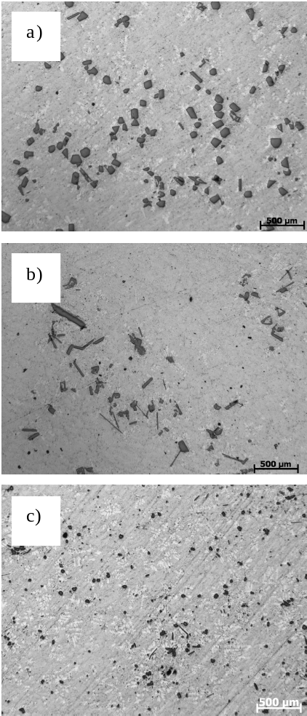

Figure 1. Comparison of the microstructural features of the binary Al-14Si alloy: a) reference, b) Al-5Ti-1B master alloy addition and c) NGR addition.

The addition of the commercial Al-5Ti-1B master alloy to the binary Al-14Si alloy was considered to confirm that this master alloy does not have any significant influence on the microstructural features, especially, the size and number of the primary Si particles, as it can be seen in Figure 1 b) and, therefore, it was not considered anymore during the evaluation of the performance of the NGR. This last, as it can be notice from Figure 1 c), permits to efficiently refine the size of the primary α-aluminium dendrites. Consequently, due to the more homogeneous distribution of silicon atoms in the aluminium matrix during solidification, the final size of the Al-Si eutectic phase is smaller and the total number and size of primary Si particles present in the microstructure is significantly reduced with respect to the reference material (Figure 1 a).
Because the final size of the microstructural features of hyper-eutectic Al-Si alloys is significantly influenced by the processing conditions (i.e. pouring temperature, cooling rate, etc.) the effect of the cooling rate on microstructure of the binary Al-14Si alloys was studied and the results are shown in Figure 2. Moreover, the amount and dimensions of the primary silicon particles formed was studied and the results summarised as statistical distribution (see Figure 3).
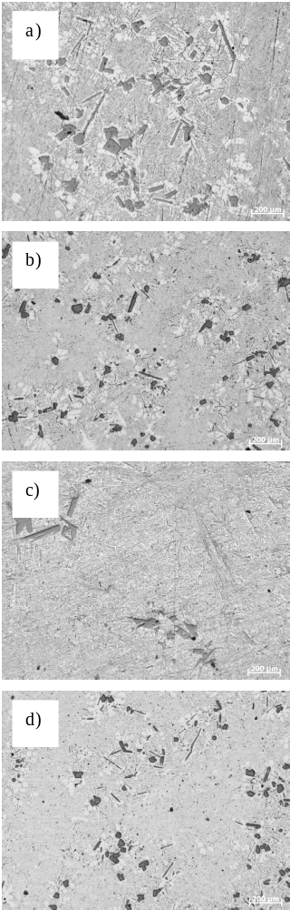

Figure 2. Micrographs of the binary Al-14Si alloy: a) reference@1ºC/s, b) reference@5ºC/s, c) with NGR addition@1ºC/s and d) with NGR addition@5ºC/s.

From the optical micrographs shown in Figure 2, it can be seen that, for the reference material, a slow cooling rate (i.e. 1ºC/s) leads to the formation of quite an important number of big primary Si particles homogeneously distributed. By the employment of a faster cooling rate (Figure 2 b) the size and number of primary Si particles seems to be reduced due to the shorter solidification time that the alloy has to form stable compound. In the case of the addition of the NGR, it can be seen that, independently of the cooling rate used, the final size and number of primary Si particles visible in the microstructure is lower with respect to the reference material.
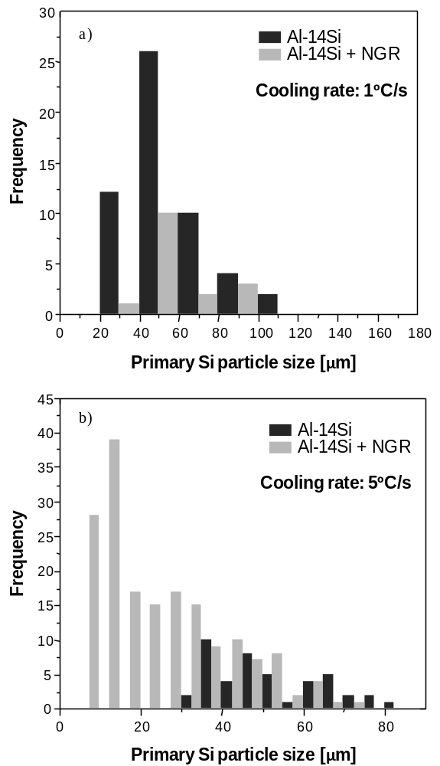

Figure 3. Influence of the cooling rate on the amount and size of the primary Si particles of the binary Al-14Si alloy without and with the addition of NGR and as a function of the cooling rate: a) cooling rate of 1ºC/s and d) cooling rate of 5ºC/s.

The results of the quantification of the amount and size of the primary Si particles found in the binary Al-14Si alloy without and with the addition of the NGR shown in Figure 3 mainly confirm what it was deduced from the analysis of the micrograph (Figure 2). That is, the addition of the NGR leads to a reduction of the size of the primary Si particles that form during the solidification of hyper-eutectic Al-Si alloy independently of the cooling rate employed. Specifically, it can be noticed that at slow cooling rate (Figure 3 a), the reference material is characterised by a much greater number of primary Si particles with respect to the refined by means of the NGR. Conversely, in the case of faster cooling rates (Figure 3 b), the addition of the NGR leads to a greater number of primary Si particles but much smaller in particle size. Remarkable it is the formation of particles of an important number of particles with particle size smaller than 20 µm which does not take place in the material without the addition of the NGR where the minimum particle size is bigger than 35 µm.
As already indicated in the introduction, another important feature of the microstructure of the hyper-eutectic Al-Si alloys is the eutectic phase. Figure 4 shows the results of the characterisation of the Al-Si eutectic phase for the binary Al-18Si alloy, results which are representative results also for the other binary Al-xSi studied. Specifically, the length of the needle-shaped eutectic phase visible on the polished cross-section of the processed samples was analysed, and it is labelled as Al-Si eutectic phase size, and its variation was graphed as frequency distribution.

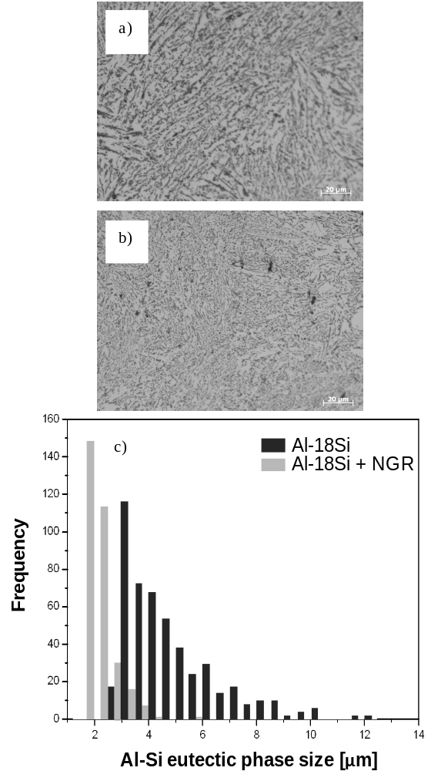

Figure 4. Influence of the addition of the NGR on the amount and size of the Al-Si particles in the binary Al-18Si alloy: a) micrograph of the Al-18Si alloy without addition of the NGR (reference), b) micrograph of the Al-18Si alloy with addition of the NGR and c) distribution of the size of the Al-Si eutectic phase.

From the micrograph and the results of the quantification of the size and distribution of the Al-Si eutectic phase of the binary Al-18Si alloy (Figure 4) without ant with the addition of the NGR, it can be clearly seen that, in general, the addition of the NGR leads to the formation of a much finer Al-Si eutectic phase in hyper-eutectic Al-Si alloys. Specifically, after the addition of the NGR the length of the needle-shaped eutectic phase is around 2-2.5 µm and its distribution is centred on these values whilst in the case of the reference material the eutectic phase has a much broader distribution and there are particles with a size greater than 8-10 µm. The reduction of both the length and distribution width of the Al-Si eutectic phase after the addition of the NGR is thought to be due to the refinement effect that the NGR has on the primary α-aluminium dendrites which, consequently, reduces the space available for the formation of the eutectic phase. Nevertheless, it is worth mentioning that the addition of the NGR does not modify the morphology of the eutectic phase to more fibrous and, therefore, it still remains primarily plate-like structure.

Commercial Al-Si alloys

As indicated in the experimental procedure, in order to verify whether, actually, the NGR can refine commercial Al-Si alloys, experiments were performed on the near-eutectic LM6 alloy (see Table 1). Figure 5 reports the results of the measurements of the primary α-aluminium dendrites grain size as a function of the pouring temperature for the LM6 alloy without and with the addition of the commercial Al-5Ti-1B master alloy and of the NGR.

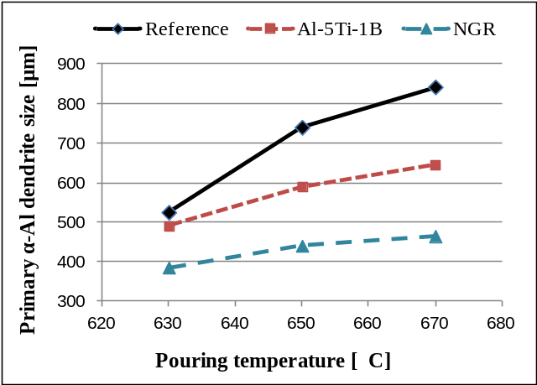

Figure 5. Comparison of the variation of the primary α-aluminium dendrites grain size as a function of the cooling rate for the LM6 alloy without and with grain refinement.

From the analysis of the data plotted in Figure 5 it can be seen, as expected, the size of the primary α-Al dendrites of the LM6 alloy increases (from approximately 500 µm to 850 µm) with the increment of the pouring temperature. The addition of the commercial Al-5Ti-1B master alloy leads to some refinement of the primary α-Al grain size where the effect of the grain refiner becomes more pronounced with the increment of the pouring temperature but still the grain size increases with the temperature. In the case of the addition of the NGR to the LM6 alloy, the final primary α-aluminium dendrites grain size increases from about 400 µm to 450 µm with the increment of the pouring temperature and the grain size is less sensitive to the increment of the temperature. In comparison to the reference and the addition of the commercial Al-5Ti-1B master alloy, the addition of the NGR permits to obtain a much finer grain size which also results into the reduction of the Al-Si eutectic phase.
The effect of the addition of the NGR was checked on the hyper-eutectic LM13 alloy. This alloy is commonly employed to produce pistons for combustion engines and its Al-Si eutectic phase is, generally, modified by means of the addition of strontium (Sr) and/or phosphorus (P).
Figure 6 shows the micrograph of the LM13 alloy without and with the addition of the NGR and with modification.

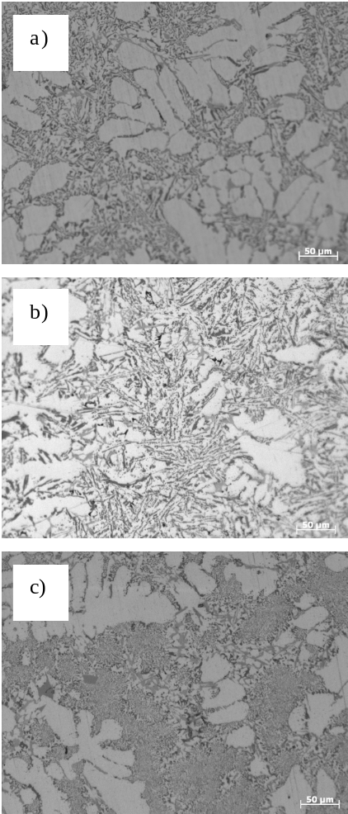

Figure 6. Micrograph of the LM13 alloy: a) reference, b) refined with NGR and c) refined with NGR + Sr modification.

From the micrograph of the reference LM13 alloy (Figure 6 a), it can be seen that it is composed of very coarse primary α-aluminium dendrites, relatively fine eutectic phase and different types of intermetallics: script-like α-phase (i.e. Al₈Fe₂Si), plate-like β-phase (i.e. Al₅FeSi), script-like π-phase (i.e. Al₈FeMg₃Si₆) and blocky-like Al₁₅(Fe,Mn)₃Si₂ (i.e. α-phase) [25].
The addition of the novel NGR to the LM13 alloy leads to the refinement of the primary α-aluminium dendrites and, it seems, to coarsening of the microstructural features (Figure 6 b) due to the refining of the Al-Si eutectic phase combined with a much more homogeneous distribution of finer iron-based intermetallics in comparison to the reference material. In the case of the modification of the LM13 alloy after the grain refinement with the NGR (Figure 6 c), the refining effect of the NGR on the primary α-aluminium dendrites and eutectic phase is maintained. Furthermore, the eutectic phase is, efficiently, modified to a fibrous morphology by the presence of Sr and no interactions between this element and the chemicals which compose the NGR could be found.

Conclusions

The main conclusion that can be drown from the study of the addition of the NGR to both binary and commercial hyper-eutectic Al-Si alloy is the fact that the NGR can actually and efficiently refine the size of the primary α-aluminium dendrites. Consequently, due to the more uniform distribution of the alloying elements, in particular silicon, and the smaller size of the solidifying pools that remain in between the primary α-aluminium dendrite arms, the addition of the NGR leads also to some refinement of the Al-Si eutectic phase and the reduction in size and number of primary Si particles typical of hyper-eutectic Al-Si alloys. The grain refinement obtained thanks to the addition of the NGR is kept throughout a great range of cooling rate; nonetheless, the most significant reduction is highlighted at very slow cooling rates (i.e. sand casting).

Acknowledgments

The authors are thankful for the financial support from the Engineering and Physical Sciences Research Council (EPSRC) through the EP/J013749/1 Project.

References

[1] I. J. Polmear, Light Alloys. From Traditional Alloys to Nanocrystals, 4th ed, Butterworth-Heinemann, UK, pp. 299-365, 2006
[2] J. R. Davis, ASM Speciality Handbook: Aluminum and Aluminum Alloys, ASM International Light Alloys, Ohio, 1993
[3] J. G. Kaufman, Mechanical Engineers Handbook: Materials and Mechanical Design, Volume 1, Third Edition, Aluminium Alloys (Chapter 3), ASM International Light Alloys, Ohio, 2006
[4] H. Ye, "An Overview of the Development of Al-Si-Alloy Based Material for Engine Applications", Journal of Materials Engineering and Performance, vol. 12, pp. 288-297, 2003
[5] S.-Z. Lu and A. Hellawell, "Growth Mechanisms of Silicon in Al-Si Alloys", Journal of Crystal Growth, vol. 73, pp. 316-328, 1985
[6] S.-Z. Lu and A. Hellawell, "The Mechanism of Silicon Modification in Aluminium-Silicon alloys: Impurity Induced Twinning", Metallurgical and Materials Transactions A, vol. 18, pp. 1721-1733, 1987
[7] M. Shamsuzzoha and L. M. Hogna, "The Crystal Morphology of Fibrous Silicon in Strontium-modified Al-Si Eutectic", Philosophical Magazine A, vol. 54, pp. 459-477, 1986
[8] S.-Z. Lu and A. Hellawell, "Modification of Al-Si Alloys: Microstructure, Thermal Analysis and Mechanism", JOM, vol. 47, pp. 38-40, 1995
[9] A. Knuutinen, et al., "Modification of Al-Si alloys with Ba, Ca, Y and Yb", Journal of Light Metals, vol. 1, pp. 229-240, 2001
[10] G. P. Jones and J. Pearson, "Factors Affecting Grain Refinement of Aluminium using Ti and B Additives", Metallurgical and Materials Transactions B, vol. 7, pp. 223-234, 1976
[11] M. S. Lee and B. S. Terry, "Effect of Processing Parameters on a Luminide Morphology in Aluminium Grain Refining Master Alloy", Materials Science and Technology, vol. 7, pp. 608-612, 1991
[12] C. D. Mayes, D. G. McCartney and T. G. J., "Influence of Microstructure on Grain Refining Performance of Al-Ti-B Master Alloys", Materials Science and Technology, vol. 9, pp. 97-103, 1993
[13] A. Hardman and F. H. Hayes, "Al-Ti-B Grain Refining Alloys from Al, B2O3 and TiO2", Materials Science Forum, vol. 247, pp. 217-222, 1996
[14] M. Johnsson and L. Bäckerud, "The Influence of Composition on Equiaxed Crystal Growth Mechanisms and Grain Size in Al Alloys", Zeitschrift für Metallkunde, vol. 85, pp. 781-785, 1994
[15] P. S. Cooper, et al., "Characterisation of a New Generation of Grain Refiners for the Foundry Industry", Light Metals, 2003
[16] M. N. Binney, et al., "Grain Refinement of Secondary Aluminium-Silicon Casting Alloys", Light Metals, 2003
[17] S. A. Kori, et al., "Poisoning and Fading Mechanism of Grain Refinement in Al-7Si Alloy", Materials Forum, vol. 29, pp. 387-393, 2005
[18] D. Qiu, et al., "A Mechanism for the Poisoning Effect of Silicon on the Grain Refinement of Al-Si Alloys", Acta Materialia, vol. 55, pp. 1447-1456, 2007
[19] N. Hari Babu, M. Nowak and L. Bolzoni, "Grain Refiner for Al-Si Alloys", Light Metals, pp. 1009-1012, 2013
[20] L. Bolzoni, M. Nowak and N. Hari Babu, "Influence of a Novel Master Alloy Addition on the Grain Refinement of Al-Si Cast Alloys", Materials Science Forum, vol. 765, pp. 311-315, 2013
[21] T. Sritharan and H. Li, "Influence of Titanium to Boron Ratio on the Ability to Grain Refine Aluminium-Silicon Alloys", Journal of Materials Processing Technology, vol. 63, pp. 585-589, 1997
[22] S. Nafisi and R. Ghomashchi, "Grain Refining of Conventional and Semi-solid A356 Al-Si Alloy", Journal of Materials Processing Technology, vol. 174, pp. 371-383, 2006
[23] G. K. Sigworth and M. M. Guzowski, "Grain Refining of Hypoeutectic Al-Si Alloys", AFS Transactions, vol. 93, pp. 907-912, 1985
[24] W. Schneider, et al., "A Comparison of the Family of AlTiB Refiners and their Ability to Achieve Fully Equiaxed Grain Structure in DC Casting", Light Metals, 2003
[25] J. A. Taylor, "The Effect of Iron in Al-Si Casting Alloys" in 35th Australian Foundry Institute National Conference, Adelaide, South Australia, pp. 148-157, 2004

