Analytical Modelling of a Photovoltaics-Thermal Technology Combined with Thermal and Electrical Storage Systems
N. Khordehgah, A. Żabnieńska-Góra and H. Jouhara*
Heat Pipe and Thermal Management Research Group, College of Engineering, Design and Physical Sciences, Brunel University London, UB8 3PH, UK
*Corresponding author: e-mail: hussam.jouhara@brunel.ac.uk

Abstract
Analyses will be conducted to indicate the energy performance of a photovoltaic-thermal (PV/T) system. In this regard, a simulation tool using the transient system simulation (TRNSYS) software will be developed to investigate if the system can be used to provide electrical and thermal energy to a household located in London, UK. Based on this, it will be indicated if the modelled system is capable of providing the required demand and how the energy output from the system can be delivered to thermal and electrical storage components. Having indicated that, it will be demonstrated how by utilising the developed model, the energy output from the system can be improved. Furthermore, it will be discovered how different thermal energy storage systems can help to store or dissipate the absorbed excessive heat from the system. The analyses will be conducted on the most optimal short- and long-term thermal storage systems and during warm seasons of the year.
Keywords: PV/T Solar Panels, TRNSYS Simulation, System Modelling, Thermal Storage, Efficiency.

Nomenclature
$$A$$ | Surface area | $$m^{2}$$
$$c_{p}$$ | Specific heat | $$J.{kg}^{-1}.K^{-1}$$
$$D$$ | Diameter | $$m$$
$$G$$ | Solar Radiation | $$W.m^{-2}$$
$$h$$ | Heat transfer coefficient | $$W.m^{-2}.K^{-1}$$
$$\dot{m}$$ | Mass flow rate | $$kg.s^{-1}$$
Q | Heat flux | $$W.m^{-2}$$
$$T$$ | Temperature | $$K$$
$$V$$ | Voltage | $$V$$
$$I$$ | Current | $$A$$
Greek Symbols
$$∆$$ | Difference
$$η$$ | Efficiency
Subscripts
$$l$$ | Length
$$P$$ | Pipe
$$PV$$ | Photovoltaic Panel
$$t$$ | Thermal
$$EL$$ | Electrical
$$W$$ | Water
Acronyms
TTES | Tank Thermal Energy Storage
BTES | Borehole Thermal Energy Storages
PV/T | Photovoltaics-Thermal
TES | Thermal Energy Storage
PCM | Phase Change Material
THS | Thermochemical Heat Storage
TRNSYS | Transient System Simulation

Introduction
With the growing increase of fuel prices over the past decade as well as the rising concern regarding greenhouse gas emission and global warming, the energy industry is more than ever challenged with the task of finding different techniques that can reduce the CO₂ emission. In this regard, utilising and harvesting green and clean energy has been indicated as an important area of research to substitute the demand from fossil fuels. In this aspect, the solar energy has been described to be the largest source of green energy, and therefore, it has been the interest of many studies to investigate and develop energy efficient systems that can be used to utilise and store the energy from the sun [1],[2].
It is investigated that solar harvesting technologies are mainly categorised into three primary categories, namely, Photovoltaic (PV), Thermal, and hybrid Photovoltaic/Thermal (PV/T) systems. Photovoltaic panels convert the solar irradiation to electricity and thermal panel absorb the solar thermal energy to produce heat and thermal energy [3]. Having mentioned that, the hybrid photovoltaic-thermal (PV/T) panels combines both technologies and absorbs the solar energy to produce both thermal and electrical outputs from the system. Moreover and as investigated by Khordehgah et al. [4], the cooling effect developed through the combined photovoltaics-thermal configuration, maximizes the power output and the overall efficiency of the panel. The technique used in this technology works by effectively taking the waste heat produced by the PV panel away and turning that into useful thermal energy through a working fluid. The PV/T technology works on the bases that the photovoltaic cell efficiency can be improved if the surface temperature of the panel is cooled effectively. It is discovered by several studies that the efficiency of photovoltaic cells can drop by approximately 0.5%/°C increase in temperature and on the other hand, the wasted heat from the panel can be utilised as a useful source of thermal energy. Because of this, it is concluded that PV/T panels provide the highest efficiency figures when compared to PV and thermal only systems.
Many studies in this regard have been conducted which have reviewed and classified different methods of cooling of photovoltaics panel into three main categories. These methods all work by absorbing and delivering the waste heat to a cooling medium and are classified as water, air or cooling techniques that includes the use of phase change material (PCM). For instance, Jordehi [5] developed a system that incudes a pump which was used to spray water over the surface a panel. Nižetić el al. [6] performed a similar experiment and investigated that the electrical output from the PV cells can be increased by approximately 6% when compared to uncooled panels. Having said that, Irwan et al. [7], attempted to cool down the solar panels by using a fan and managed to obtain an increase in the output voltage by 3.5%. Rajaram and Sivakumar [8] discovered that the performance of the electrical output of the photovoltaics cells can be increased by nearly 5% with an 8% by using a phase change material at the back of the panels. On the other hand, Chandel and Agarwal [9] also conducted a similar study and achieved comparable results in the electrical output performance.
Having indicated above investigations, it is discovered that the use of heat pipe technology can also provide avid efficiency improvements when combined with photovoltaic panels. The heat pipe technology as a super conductor can be used as a form of waste heat recovery device to effectively and efficiently absorb and deliver the discarded energy to another mean to improve the efficiency of an application [10]-[12]. In this regard, further investigations have been conducted to discover how the heat pipe technology can be enhanced to further improve the heat transfer [12]. For instance, Jouhara et al. [13],[14] investigated the effectiveness of a multichannel heat pipe and managed to develop and invent a flat heat mat or heat pipe that improved the overall heat transfer absorption area from the heat source. Another technology of such which is patented is also shown to be used in several applications such as refrigerated heat pipe shelf as a heat absorbing shelf [15], battery thermal management [16] and indeed for photovoltaics (PV) solar panel cooling [4].
The mentioned technology is rather interesting, for instance, the application for heat absorbing refrigeration shelf indicated that the use of multi-channel flat heat pipe can improve the temperature profile uniformity while helping to reduce the energy consumption of the cabinet by nearly 12%. Having said that, further investigation revealed that almost all products placed on the shelves had had almost the same pH acidity level after 20 days of experiment, indicating extended product shelf life [17]. The technology was further tested to cool down prismatic lithium-titanate (LTO) battery cells in order to improve the battery performance and longevity by managing the thermal performance of the cells [16]. In this regard, an experiment was conducted and the heat mat was placed under the surface of the battery pack and it was indicated that the maximum cell temperature can be significantly reduced, while the overall temperature uniformity can be greatly improved. The test result proven the practicality of the technology to keep the temperature of the battery cells at below 28°C while maintaining the temperature uniformity at +/-1°C. It was therefore demonstrated that the use of flat heat mat technology can be used as an effective method to thermally manage of control the temperature of batteries.
Having indicated that and as mentioned before, the technology was also used to improve the efficiency of photovoltaics solar panels [18]. In an experiment, a system of PV/T solar panels was designed and manufactured which consisted of monocrystalline and polycrystalline silicon modules which were placed on the top surface of the flat heat mat. The idea behind the experiment derived from the fact that cooling of PV panels can hugely improve the electrical energy output efficiency, while the absorbed waste heat can be used as useful thermal energy to improve the overall energy output efficiency of the system. In this regard, a full-scale experiment was conducted and it was indicated that an electrical energy efficiency improvement of about 15% can be achieved through homogenous cooling of PV panel, while, the overall system conversion efficiency can be improved to around 50% [19]. Khordehgah et al. [4] also conducted further investigations and used the capabilities of TRaNsient SYstem Simulation (TRNSYS) tool software to model the PV/T system developed by Jouhara et al. [19]. The study delivered how through cooling of the panel efficient electrical and thermal can be generated for a household. Furthermore, and through experimental validation, it was discovered that a good argument can be achieved through computational analyses from this platform. Following that, Khordehgah et al. [20] also developed a system of PV/T that incorporates thermal and electrical storage systems and investigated the energy performance of the model in a warm location in Europe.
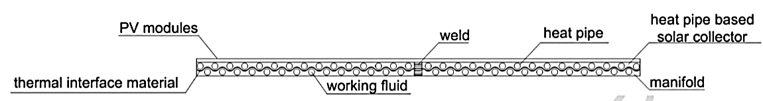
Figure 1: The heat pipe PV/T panel [19].
The heat mat as can be seen in Figure 1 consists of a manifold and comprises several tube-shaped heat pipes that carry a working fluid. The PV panel is located on top of the heat mat to allow for the absorber and generated heat from the module to be transferred to working fluid of the heat pipe. It should be mentioned that the working fluid is charged into the heat mat in a vacuum condition to offer a low boiling point temperature. On the other hand, and as can be seen from Figure 2, a manifold has also been incorporated into the configuration which allows for a cooling fluid to pass through and transfer the absorbed heat from the heat mat.
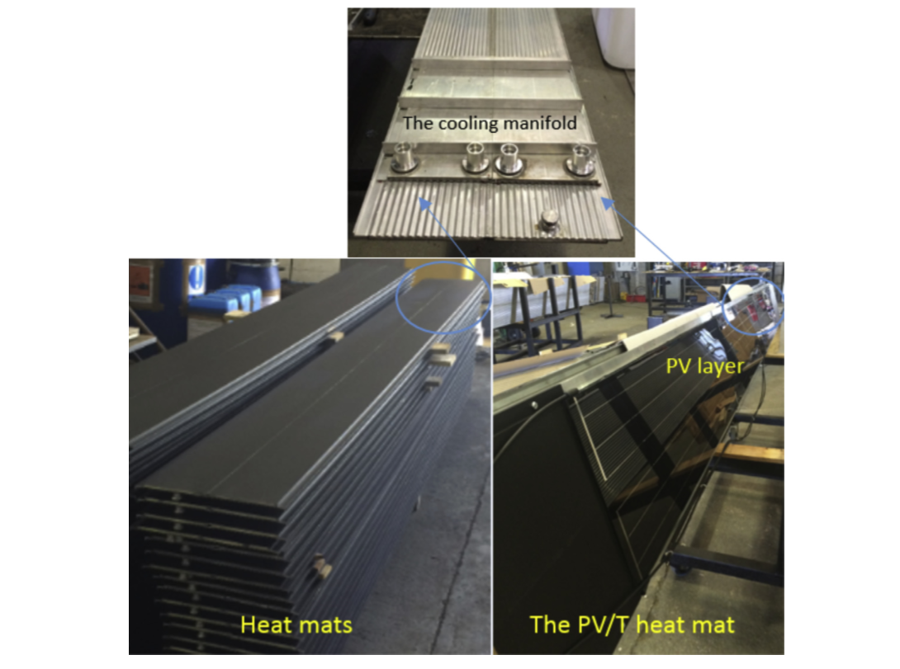
Figure 2: Heat mat heat pipe technology [21].
Nonetheless and as described by Aldubyan and Chiasson [22], another important factor to consider when developing a PV/T system is the integration of a proper thermal storage system. The thermal storage has been indicated as one of the most important components beside the PV/T module which can allow to increase the overall efficiency and reduce the cost of the system. As previously indicated, a PV/T incorporated system offers better efficiency figures when compared to other stand-alone technologies such as PV or thermal systems. Having said that and since this the case with any solar system, a PV/T system requires some sort of thermal back up system to ensure operation during the time with low or non-solar irradiation, such as nighttime. Moreover, using a thermal storage component with a solar system allows for the generated thermal energy by the solar panel to be used at different and required times which can be beneficial when it comes to managing the energy performance and output from the system.
In this article therefore, it is of interest to develop on the system proposed in the previous study by Khordehgah et al. [4],[20] and conduct different analyses on the effect of the heat absorption from the PV/T cells on warmer seasons of the year for London, UK. Furthermore, it will be demonstrated which technologies offer the best usability when it comes to long and short term thermal storage and in addition to this, a viable solution for cooling down the panel when excessive heat is generated based on the component available will be provided.

Thermal Storage System
As mentioned, when designing a PV/T system it is essential to investigate what type of thermal storage component could offer the best advantages in relation to the usability of the model. This therefore means that it is important to discover the available thermal storage systems and perform comparison to select a suitable component for analyses. As can be seen from Table 1 and since this article is dealing with system modelling for domestic sector, the available thermal storage systems have been indicated to be in the form of Tank Thermal Energy Storage (TTES), Borehole thermal Energy Storage (BTES), Phase Change Material Storage (PCMS) and Thermo-electrical Heat Storage System (THS). The table below introduces different selected thermal storage strategies and will indicate the advantages and disadvantages of each technology.

Table 1: Summery of TES technologies [23].

Type of TES | Description | Advantages | Disadvantages | Efficiency
TTES | The TTES system is designed to store hot water or other liquids such as oil and molten salts. Potentially useful for storage depending on temperature requirements. | - Improves efficiency.  - Capable of fulfilling large scale applications.  - Economical. | - Requires space.  - High heat loss in small storage.  - Not suitable for long periods of use. | ~60%
BTES | BTES is enabled through the digging of vertical holes in the ground, with the addition of heat exchange technology to transfer heat to and from the ground. | - Suitable for use in solar storage.  - Minimal requirement for invasive drilling. | - Comparably low efficiency.  - Charging and discharging limitations. | ~50%
PCMs | PCMs use organic and inorganic components to store energy in the form of heat in phase change material [24]-[27]. | - High energy density at low volume.  - Maintains constant temperature during operation. | - Not fully developed for domestic application.  - Limited availability of suitable PCM materials. | ~70%
THS | THS uses reversible chemical reactions to store vast quantities of heat at a small volume. | - High energy storage density.  - Provides long term storage without degradation. | - In development phase.  - Yet to be introduced to commercial market.  - Lack of evidence of performance in real life applications. | ~90% Experimental - but low in practical application.

By making a comparison between all of the mentioned technologies, it can be observed that PCMS and THS cannot be recommended as these technologies are yet to be developed for practical use. This therefore means that analyses on the most efficient systems for the system modelling on technologies such as thermal storage tanks and borehole design would be conducted.

Simulation Tool
Based on the objectives of the study, TRNSYS software simulation program is therefore employed to investigate the performance of a PV/T based system that is combined with a thermal storage strategy. TRNSYS stands for TRaNsient SYstem Simulation and is a computational program tool that allows dynamic simulation using different variables in order to simulate the performance of a complex system as a function of time or transiently. Through the software, several components known as Types can be linked together using different output functions. Each Types in simple term is a mathematical subroutine program which can describe a component, for example, a photovoltaic-thermal collector, thermal storage systems or any other component. When a system is modelled using different Types, the software performs calculations and outputs from the components as a function of time dependence value are called if the input value to the component is changed during a particular set of time. Having indicated that, each Type also has a set of input parameters which are generated either from other elements or implemented to the component through data files [4]. This means that TRYNSYS chronologically records input and output, creating system models through drawing together results to solve relative equations. The output of each component is therefore presented either as an input to an additional subroutine, as a datafile that can be used as a function to another component or be illustrated through printing plots.
TRNSYS simulation tool has been identified as a viable solution in solving complex system modelling problems in many areas of research [20]. By using the TRNSYS simulation tool therefore, a system of PV/T can be utilised for production of electrical and thermal energy and analyses can be conducted to investigate how output from the system can be stored for further usage. For example, hot water could be stored for night use for a house or the excessive thermal heat can be stored in an underground thermal storage system, such as a borehole. It will therefore be moreover investigated how the underground thermal storage can also potentially act as a heat sink which could result in decreasing the outlet temperature of the tank especially during hot seasons of the year. This is an important aspect for the functionality of the PV/T system as cold water should be circulated throughout the panel to absorb the waste heat, in order to improve the efficiency of the cells.

System modelling
As can be seen from Figure 3, the system in configured in a way so that the PV/T hybrid collector absorbs the thermal energy from the sun (weather data), which is then passed through a thermal storage tank unit (Type 4). The system is designed to provide a household with hot water at 60℃ by utilizing PV/T hybrid collector with a thermal storage tank that incorporates an auxiliary heating element. It has been assumed that the household has four occupants who consume about 150L of hot water each day. The hot water consumption is set for four times use of showers and 20 times use of washbasins. In order to circulate the water in the system and develop the appropriate flowrate, a pump has been utilised (Type 3) in a closed loop configuration for the PV/T system. The thermal storage water tank is also connected with a borehole (Type 557) to reduce the temperature of the water in the tank and increase the efficiency of the modelled thermal storage system as explained. The modelled strategy works by reducing the temperature of the hot water to the borehole temperature at the outlet temperature of the tank. The controller (Type 2) has been used to control the system temperatures. The controller is used to function as an On/Off system device which controls the differences between the temperatures of the outlet of the thermal storage tank and the PV/T system.
A thermal storage tank (Type 4) that comprises an auxiliary heating unit with a volume of 300L is utilized in this model simulation. The system is modelled in a way so that when solar irradiation is high, the thermal energy could be stored for later usage, especially during the period when not enough thermal energy is absorbed from the sun. The thermal storage system also incorporates an auxiliary heater element which operates when the demand from the system exceeds the supply or when high enough thermal energy is not stored in the tank. This system is set to operate only if the hot water in the storage tank is not at the required supply temperature. The storage systems incorporated in the model are responsible in storing and restricting the heat of the solar PV/T system.
It is shown by Figure 3 that the model is split into three major loops, with the first loop containing the PV/T system, the second loop illustrating the thermal storage configuration, and the third loop comprising a battery storage system. The PV/T system contains the solar collector, water tank, controller and a pump to model how thermal and electrical energy can be generated and delivered or stored in the storage systems. The thermal storage loop consists of the thermal storage tank, vertical borehole heat exchanger, pump and a controller to store and release the generated heat, supplying both the household and the PV/T panel. The electrical storage loop includes an inverter/charge controller (Type 48) which is connected to a battery bank (Type 47) that is used as an electrical storage system. The battery bank is utilised to store the electrical generation from the panel and is controlled through the charge controller that is connected to a set of predefined functions.
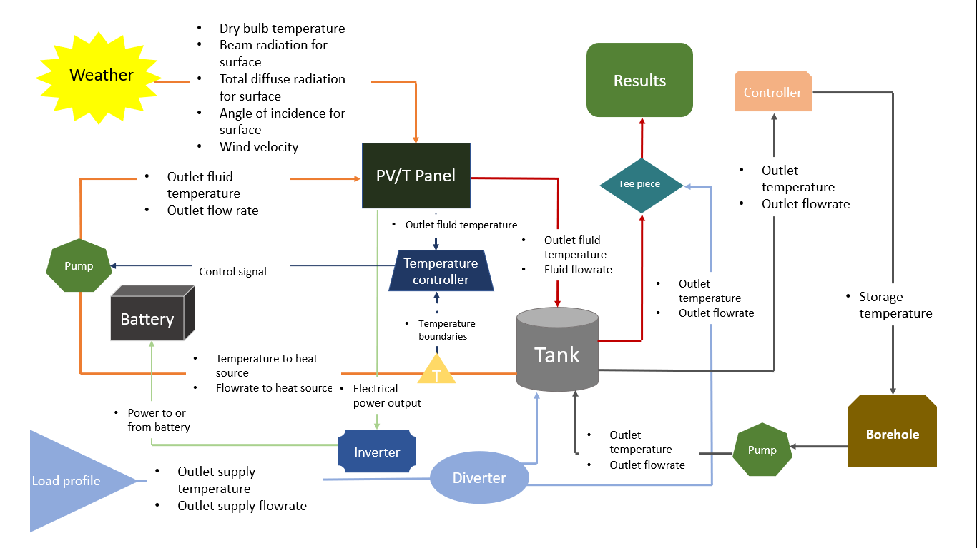
Figure 3: Flowchart of the Model

The Type used for the borehole consists a vertical ground heat exchanger that interacts thermally with the ground. The model consists of vertical tube-in-tube or U-tube heat exchangers and is arranged in a way so that the heated fluid from the system can be circulated through the heat exchanger. Furthermore, heat could be absorbed or rejected depending on temperature of the fluid and the ground temperature. The strategy functions to deliver hot water from the storage tank to the ground heat exchanger, which is placed underground at 8 meters depth. Moreover, the depth of the borehole has been selected in order to reduce the water and made it acceptable for residential utilisation [28]. A secondary pump has also been included in the loop to deliver the cooled water back to the tank from the outlet from the borehole.
The boundaries of the controller have been set up to start the pump working when the temperature (T) outlet of the working fluid from the PV/T and the thermal storage falls below 55℃. On the other hand, if the system exceeds higher limit conditions the control function contains a high limit cut-out at 60℃ which will order the auxiliary unit to switch off. In addition, if the temperature of the water in the system exceeds the limit, the controller will order the pump to stop working. Another control system has also been included in the system to manage the outlet temperature of the tank through the borehole (ground) storage system. This controller is placed in the model to allow the excessive heat from the storage tank during unused period to be diverted to the borehole for energy storage and dissipation when the first control system is switched off. The control system to the borehole is set to only operate when there is no load or demand drawn from the system. The use of borehole system will also ensure stratification is constantly achieved in the thermal storage tank, since, a difference in temperature in obtained in the inlet and outlet of the system. Figure 4 shows the configuration of the model in TRNSYS.
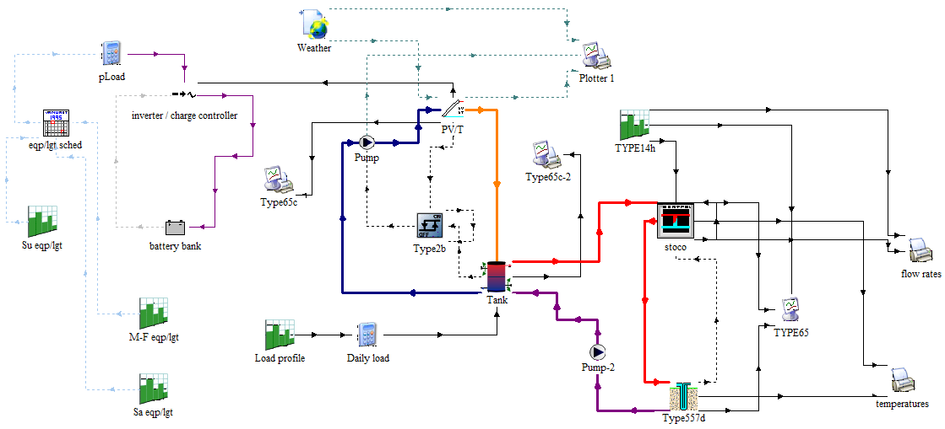
Figure 4: Configuration of PV/T System with Borehole in TRNSYS.
In order to investigate the functionality of the proposed system, the Typical Meteorological Year (TMY) weather data from London have been uploaded and the data output has been organised using the TRNSYS (Type 15). The Input data included solar radiation, dry bulb temperature, humidity, tilted surface radiation and the slope of the surface. Table 2 provides the key PV/T parameters that were used in TRNSYS. The working fluid for the PV/T loop is water and a pump has been employed to deliver the flow through the panel using the described control system.

Table 2: Key Parameters of PV/T System in TRNSYS.
Component | Type | Descriptions | Value
PV/T Module | 200 | Module Area | 6.4 m²
 |  | Fluid Specific Heat | 4.18 kJ/kg.K
 |  | PV Reference Condition Efficiency | 15 %
 |  | PV Cell Reference Temperature | 30°C
 |  | Solar Cell Efficiency Temperature Coefficient | 0.5%/K
 |  | Packing Factor | 1
 |  | Inclination Angle | 36˚
 |  | Facing Orientation | South
Pump | 3 | Maximum Flowrate | 4 kg/hr
 |  | Maximum Power | 300 kJ/hr
Pump 2 | 3 | Maximum Flowrate | 60 kg/hr
 |  | Maximum Power | 500 kJ/hr
Storage Tank | 4 | Tank Volume | 300 l
 |  | Maximum Heating Rate of Elements | 10000 kJ/hr
Borehole | 557 | Energy Capacity | 15kWh
 |  | Water Specific Heat | 4.19 kJ/kg°C
 |  | Diameter of heat exchanger Borehole | 10 cm
 |  | Borehole Depth | 8 m
Battery Bank | 47 | Energy Capacity | 15kWh

The amount of total heat which is produce from the panel can be calculated by using the following equation.
$Q_{t}=\dot{m} . c_{p} . ∆T$ (1)
The electrical output of the PV is calculated by:
$Q_{EL}=I.V/A_{PV}$ (2)

The thermal${ (η}_{t})$ and electrical $\left(η_{EL}\right)$efficiency of PV panel are obtained by:

$η_{t}=\frac{Q_{t}}{G}$ (3)
$η_{EL}=\frac{Q_{EL}}{G}$ (4)

The energy balances of the earth heat exchanger are calculated through:

$h_{p}πD_{p }\left(T_{W}-T_{p}\right)dx=-{\dot{m}}_{w}{Cp}_{w}{dT}_{w}$ (5)

And the outlet water from the borehole was obtained by:

$T_{WO}=T_{P}+\left(T_{w}-T_{p}\right)Exp ({-h}_{p}πD_{p}\frac{l_{p}}{m_{w}{Cp}_{w}}$) (6)

And the heat dissipation of the borehole can be conducted by:

$Q={\dot{m}}_{w}{Cp}_{w}(T_{w,in}-T_{w,out})$ (7)
The graph in Figure 5 demonstrates the outlet temperature of water based on the PV/T system used in the first loop of the model for a period of 6 hours during the day on the fifteenth day of July. It should be noted that the accuracy of the obtained results from the simulation relies on the predictions obtained through the indicated corrections and the standard error from the simulation data.

Figure 5: PV/T Water Temperature Outlet.
In order to compare the integrity of fit between data derived from the simulation software, the model efficiency test (EF) method is used based on the study conducted by Khordehgah et al. [4]. According to Axaopoulos et al. [29], the model efficiency test (EF) is given by:

$EF=\frac{\sum_{t=1}^{n}{{\left(H_{t}-z\right)}^{2}-\sum_{t=1}^{n}{{\left(F_{t}-H_{t}\right)}^{2}}}}{\sum_{t=1}^{n}{{\left(H_{t}-z\right)}^{2}}}$ (8)
Where, H_{t} is the recorded value, F_{t} is the value obtained from the simulation, z is the mean value of the experimental data and n is the number of periods based on time. Based on the above investigations, the highest value that can be derived from this test is 1 and it is discovered that the simulation displays a model efficiency of about 96%.

Results and Discussion
The simulation was run for three summer months in June, July and August (2184 hours) in order to study the performance of the hybrid PV/T and thermal storage systems in the summer season which has the highest irradiance through the year. This period has been considered in this study in order to investigate the performance of the thermal storage system in the hot season of the year. The results of the simulation for the inlet and the outlets temperature of the PV/T, flowrates of both storage tank and the borehole have been investigated. The system was tested by allowing water circulation from the tank to the PV/T, and the hot water entering the borehole loop in order to reduce the working fluid that is delivered to the thermal storage and subsequently to the PV panel.
Figure 6 shows the result for the electrical power output to the battery storage system when cooling is applied, shown in red, comparing to the case when cooling to the panel is not conducted, illustrated in blue. It is indicated that the electrical output from the system increases by almost 12% on average when cooling is applied to the PV panel. This therefore validates the findings in the literature and explains that cooling of the surface of the PV will have a direct link to the electrical power output of the system.
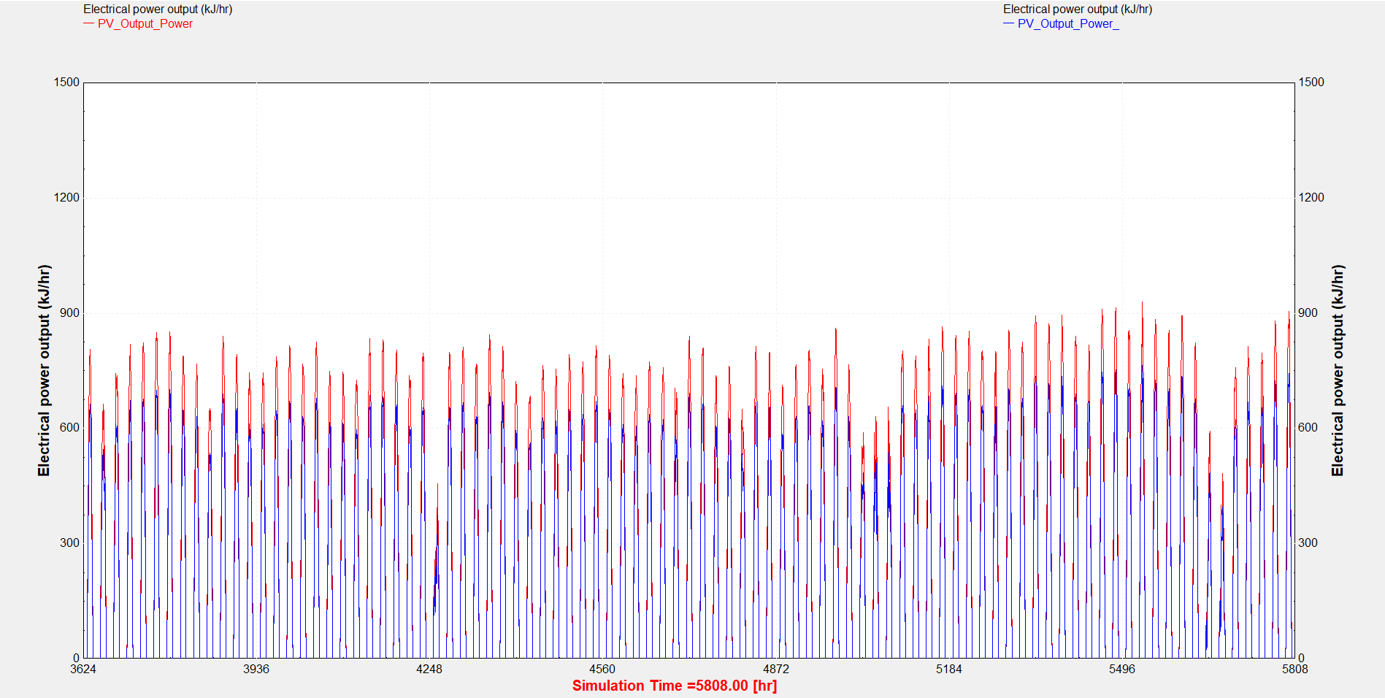
- Electrical output with cooling
- Electrical output without cooling

Figure 6: Comparison of Electrical Output Power.
Furthermore, and as can be seen from Figure 7, it is discovered that the system is capable of delivering hot water (shown in red) at the optimum output level of 60°C. As explained before a control system had to be put in place to ensure that the output temperature from the thermal storage tank stays at the set level 60°. This is an important factor since it is discovered that the thermal storage component in the system can be prone to Legionella bacteria growth which can be prevented at the mentioned set temperature [30]. Nevertheless, the auxiliary power unit implemented in the storage tank had to operate to deliver heat at a maximum of about 4000 kJ/hr, when the absorbed thermal energy is low.
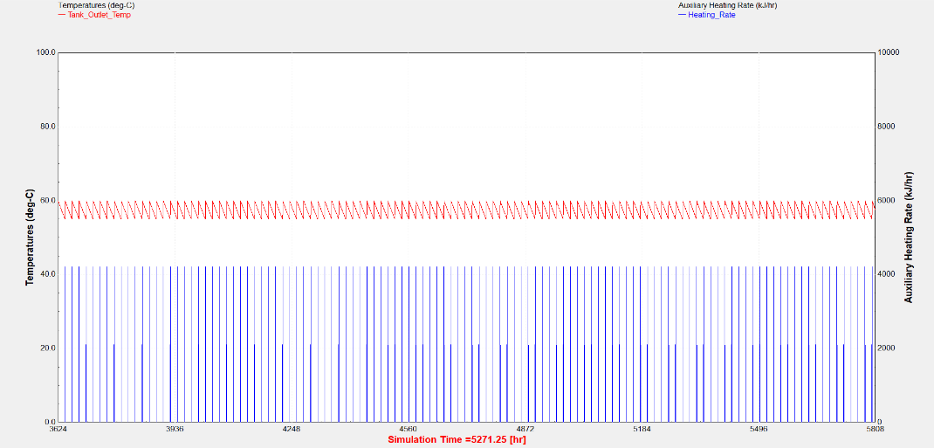
- Hot Water Output
- Auxiliary Heating Rate

Figure 7: Thermal Storage Tank Output with Auxiliary Heating Rate.
Figure 8 shows the inlet and outlet temperature of the borehole from the storage tank. As explained before and in order to cool down the temperature of stored medium, the excessive heat from the tank was delivered to the ground for heat dissipation and storage. In this regard and as indicated from the figure below, it is discovered that the outlet from the thermal storage tank as shown in red have rejected heat and has been cooled down on average by nearly 13°C as illustrated in blue. This explains that delivering the stored hot water from the panels to a borehole system, especially during hotter seasons of the year and when thermal energy is not much required can be viable solution to store or dissipate the excessive heat in the system. The cooler water can then be circulated back to the tank, where it can then be delivered back to the panel to absorb more heat from the PV/T system.
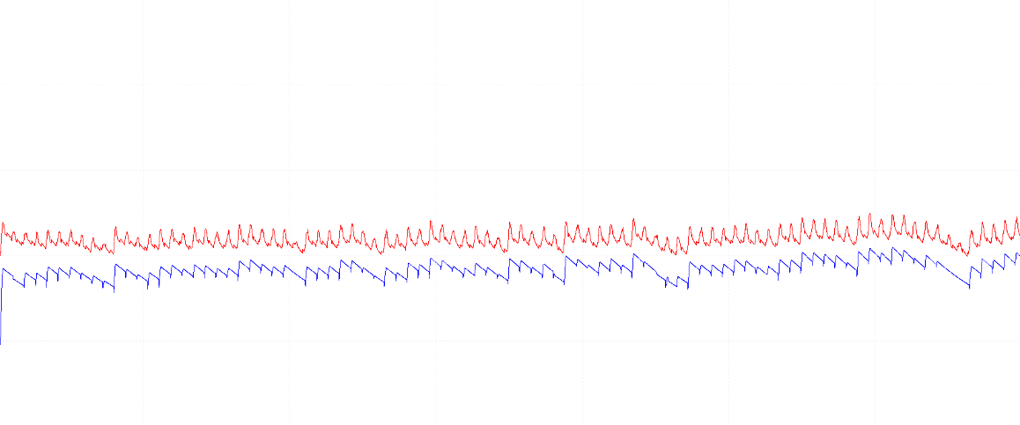
- Borehole Inlet Temperature
- Borehole Outlet Temperature
Figure 8: Borehole Input and Output Temperatures.

Conclusion
In conclusion, a PV/T system that incorporates a thermal storage system was modelled using the TRNSYS simulation tool. The proposed system included a thermal storage tank that comprised an auxiliary power unit and a control system. It was firstly investigated how cooling of panel during hot season of the year for London can affect the output efficiency from the PV cells. It was demonstrated that the power output from the panel increases by almost 12% when cooled comparing to the case when no water circulation is applied to the panel. Furthermore, the auxiliary power unit incorporated in the thermal storage tank managed to keep the output temperature of water from the system at the desired level, however, required power input at a rate of nearly 4000 kJ/hr, especially during night time. Lastly the model was simulated to investigate the functionality of the borehole system and results indicated that the water outlet temperature from the tank can be cooled down on average by almost 13°C, hence, indicating that this method can be a solution to store and dissipate the excessive heat from the system. This in return will allow conserving resources as the stored water in the thermal storage tank can be cooled down and reused by the PV/T panel.

Acknowledgements
This work has been receiving financial support from the Innovation and Networks Executive Agency (INEA), European Commission for project PVadapt under Grant Agreement number 818342.

References
[1] Y. Zhang, J. Ren, Y. Pu, and P. Wang, “Solar energy potential assessment: A framework to integrate geographic, technological, and economic indices for a potential analysis,” Renew. Energy, vol. 149, pp. 577–586, 2020, DOI: 10.1016/j.renene.2019.12.071.
[2] H. Jouhara, A. Żabnieńska-Góra, N. Khordehgah, D. Ahmad, and T. Lipinski, “Latent thermal energy storage technologies and applications: A review,” Int. J. Thermofluids, vol. 5–6, no. 6, p. 100039, Aug. 2020, DOI: 10.1016/j.ijft.2020.100039.
[3] K. Terashima, H. Sato, and T. Ikaga, “Development of an environmentally friendly PV/T solar panel,” Sol. Energy, vol. 199, no. February, pp. 510–520, 2020, DOI: 10.1016/j.solener.2020.02.051.
[4] N. Khordehgah, V. Guichet, S. P. Lester, and H. Jouhara, “Computational study and experimental validation of a solar photovoltaics and thermal technology,” Renew. Energy, vol. 143, pp. 1348–1356, 2019, DOI: 10.1016/j.renene.2019.05.108.
[5] A. R. Jordehi, “Parameter estimation of solar photovoltaic (PV) cells: A review,” Renew. Sustain. Energy Rev., vol. 61, pp. 354–371, 2016, DOI: 10.1016/j.rser.2016.03.049.
[6] S. Nižetić, D. Čoko, A. Yadav, and F. Grubišić-Čabo, “Water spray cooling technique applied on a photovoltaic panel: The performance response,” Energy Convers. Manag., vol. 108, pp. 287–296, Jan. 2016, DOI: 10.1016/j.enconman.2015.10.079.
[7] Y. M. Irwan et al., “Comparison of solar panel cooling system by using dc brushless fan and dc water,” in Journal of Physics: Conference Series, 2015, vol. 622, no. 1, DOI: 10.1088/1742-6596/622/1/012001.
[8] R. Rajaram and D. B. Sivakumar, “Experimental Investigation of Solar Panel Cooling By the Use of Phase Change Material,” J. Chem. Pharm. Sci., no. March, pp. 238–239, 2015.
[9] S. S. Chandel and T. Agarwal, “Review of cooling techniques using phase change materials for enhancing efficiency of photovoltaic power systems,” Renewable and Sustainable Energy Reviews, vol. 73. Elsevier Ltd, pp. 1342–1351, 2017, DOI: 10.1016/j.rser.2017.02.001.
[10] H. Jouhara, N. Khordehgah, S. Almahmoud, B. Delpech, A. Chauhan, and S. A. Tassou, “Waste heat recovery technologies and applications,” Therm. Sci. Eng. Prog., vol. 6, no. January, pp. 268–289, 2018, DOI: 10.1016/j.tsep.2018.04.017.
[11] V. Guichet, N. Khordehgah, and H. Jouhara, “Experimental investigation and analytical prediction of a multi-channel flat heat pipe thermal performance,” Int. J. Thermofluids, vol. 5–6, p. 100038, Aug. 2020, DOI: 10.1016/j.ijft.2020.100038.
[12] V. Guichet and H. Jouhara, “Condensation, evaporation and boiling of falling films in wickless heat pipes (two-phase closed thermosyphons): A critical review of correlations,” Int. J. Thermofluids, p. 100001, Oct. 2019, DOI: 10.1016/j.ijft.2019.100001.
[13] H. Jouhara et al., “Experimental and theoretical investigation of a flat heat pipe heat exchanger for waste heat recovery in the steel industry,” Energy, vol. 141, pp. 1928–1939, 2017, DOI: 10.1016/j.energy.2017.10.142.
[14] H. Jouhara, N. Serey, N. Khordehgah, R. Bennett, S. Almahmoud, and S. P. Lester, “Investigation, development and experimental analyses of a heat pipe based battery thermal management system,” Int. J. Thermofluids, vol. 1–2, p. 100004, Feb. 2020, DOI: 10.1016/j.ijft.2019.100004.
[15] H. Jouhara, Flint Engineering, and S. A. Tassou, “PCT Heat transfer apparatus,” 2016.
[16] H. Jouhara et al., “Applications and thermal management of rechargeable batteries for industrial applications,” Energy, vol. 170, pp. 849–861, 2019, DOI: 10.1016/j.energy.2018.12.218.
[17] H. Jouhara, T. Nannou, H. Ghazal, R. Kayyali, S. A. Tassou, and S. Lester, “Temperature and energy performance of open refrigerated display cabinets using heat pipe shelves,” Energy Procedia, vol. 123, pp. 273–280, 2017, DOI: 10.1016/j.egypro.2017.07.240.
[18] H. Jouhara, A. Chauhan, T. Nannou, S. Almahmoud, B. Delpech, and L. C. Wrobel, “Heat pipe based systems - Advances and applications,” Energy, vol. 128. Elsevier Ltd, pp. 729–754, 2017, DOI: 10.1016/j.energy.2017.04.028.
[19] H. Jouhara et al., “The performance of a heat pipe based solar PV/T roof collector and its potential contribution in district heating applications,” Energy, vol. 136, pp. 117–125, Oct. 2017, DOI: 10.1016/j.energy.2016.04.070.
[20] N. Khordehgah, A. Żabnieńska-Góra, and H. Jouhara, “Energy Performance Analysis of a PV/T System Coupled with Domestic Hot Water System,” ChemEngineering, vol. 4, no. 2, p. 22, 2020, DOI: 10.3390/chemengineering4020022.
[21] H. Jouhara et al., “The performance of a novel flat heat pipe based thermal and PV/T (photovoltaic and thermal systems) solar collector that can be used as an energy-active building envelope material,” Energy, vol. 108, pp. 148–154, Aug. 2016, DOI: 10.1016/j.energy.2015.07.063.
[22] M. Aldubyan and A. Chiasson, “Thermal Study of Hybrid Photovoltaic-Thermal (PVT) Solar Collectors Combined with Borehole Thermal Energy Storage Systems,” Energy Procedia, vol. 141, pp. 102–108, 2017, DOI: 10.1016/j.egypro.2017.11.020.
[23] BEIS, “Evidence Gathering: Thermal Energy Storage (TES) Technologies,” Renew. Sustain. Energy Rev., vol. 80, pp. 1–85, 2016.
[24] G. Dogkas et al., “Investigating the performance of a thermal energy storage unit with paraffin as phase change material, targeting buildings’ cooling needs: an experimental approach,” Int. J. Thermofluids, vol. 3–4, p. 100027, May 2020, DOI: 10.1016/j.ijft.2020.100027.
[25] M. K. Koukou et al., “Experimental assessment of a full scale prototype thermal energy storage tank using paraffin for space heating application,” Int. J. Thermofluids, vol. 1–2, p. 100003, Feb. 2020, DOI: 10.1016/j.ijft.2019.100003.
[26] C. Pagkalos, G. Dogkas, M. K. Koukou, J. Konstantaras, K. Lymperis, and M. G. Vrachopoulos, “Evaluation of water and paraffin PCM as storage media for use in thermal energy storage applications: A numerical approach,” Int. J. Thermofluids, vol. 1–2, p. 100006, Feb. 2020, DOI: 10.1016/j.ijft.2019.100006.
[27] G. Righetti, L. Doretti, C. Zilio, G. A. Longo, and S. Mancin, “Experimental investigation of phase change of medium/high temperature paraffin wax embedded in 3D periodic structure,” Int. J. Thermofluids, vol. 5–6, p. 100035, Aug. 2020, DOI: 10.1016/j.ijft.2020.100035.
[28] S. H. Hammadi, “Tempering of water storage tank temperature in hot climates regions using earth water heat exchanger,” Therm. Sci. Eng. Prog., vol. 6, no. March, pp. 157–163, 2018, DOI: 10.1016/j.tsep.2018.03.009.
[29] P. J. Axaopoulos, E. D. Fylladitakis, and K. Gkarakis, “Accuracy analysis of software for the estimation and planning of photovoltaic installations,” Int. J. Energy Environ. Eng., vol. 5, no. 1, pp. 1–8, 2014, DOI: 10.1186/2251-6832-5-1.
[30] Health and Safety Executive, “Legionnaires’ disease: Technical guidance_Part 3: The control of legionella bacteria in other risk systems,” HSE Books, pp. 1–8, 2013.

