Higher Resolution Input Image of Convolutional Neural Network of Reinforced Concrete Earthquake-Generated Crack Classification and Localization
Muammar Sadrawi^{1,a}, Husaini^{1,b*}, Jalaluddin Yunus^{1,c}, Irwansyah^{1,d},
Maysam F. Abbod^{2,e}, Jiann-Shing Shieh^{3,f}

¹ Department of Mechanical Engineering, Universitas Syiah Kuala, Banda Aceh, Indonesia
² College of Engineering, Design and Physical Sciences, Brunel University London,
Uxbridge UB8 3PH, UK
³ Department of Mechanical Engineering, Yuan Ze University, Chung-Li Dist., Taoyuan City, 32003, Taiwan
ª muammarsadrawi@yahoo.com , ^{b} husainiftm@unsyiah.ac.id, ^{c} jalaluddinyunus@unsyiah.ac.id, ^{d} irwansyah@unsyiah.ac.id, ^{e} Maysam.Abbod@brunel.ac.uk , ^{f} jsshieh@saturn.yzu.edu.tw
*Corresponding author

Abstract. According United States Geological Survey, Aceh is the northwestern part in Indonesia that has been affected by numerous strong earthquakes since 2004 tsunami. These earthquakes have generated massive impact to the buildings around the area, especially for the reinforced concrete based buildings. One of the most important problems to the reinforced concrete is the earthquake generated crack. In this study, the dataset from the normal and cracked reinforce concrete are collected by taking the normal and cracked images. Several convolutional neural network models are implemented such as LeNet based models. These models are initially applied to recognize either normal or cracked conditions. Eventually, for the last stage, the localization of the crack is visualized by imposing the original images. For the localization, this study also evaluates the relatively smaller and bigger cracks. The results show the higher input image with modified LeNet generates better results compared to the basic model in superimposing the localized crack.
Keywords: crack detection; convolutional neural network; higher resolution input image.
Introduction
Aceh was hit by tsunami generated by a 9.1 Mw earthquake on 2004. According United States Geological Survey (USGS), many relatively big earthquakes struck the area afterwards. In more detail, several earthquakes that have magnitude higher than 6.5 Mw occurred after the largest one. It can be seen on Table 1 based on the region shown on Fig. 1 [1].
Crack is one of the biggest problems caused by the earthquake. Several studies have investigated crack effects specifically to building related applications. The utilization of Gabor filter to detect crack in the tunnel has been performed in a study [2]. Also, some learning methods have been implemented for the concrete crack detection [3]. Furthermore, signal processing-based algorithm was also used for the crack detection in the building [4].
Crack may occur in other applications apart from the building. Crack can also occur in aerospace material [5]. In this study thermoelastic stress analysis and acoustic emission were involved for the fatigue crack initiation and propagation evaluation. Digital image correlation was performed in order to solve the crack problem in asphalt [6]. Crack has been studied also in polymer [7] and aluminum alloy [8].
Artificial intelligence (AI) has been widely used in applications especially for image processing [9] and unbalanced and ensemble modeling [10]. For biomedical engineering, AI has been used for biomedical image processing-based application [11] and signal processing-based application such as anesthesia [12] and arrhythmia [13, 14].
This study is a two-stage evaluation. The first stage, the classification of the cracked and normal reinforced concrete is evaluated. Meanwhile, the next stage is to investigate the location of the crack when the cracked condition appears on the previous stage. The evaluation proposes several modified CNN models with higher resolution input image in superimposing the original image.

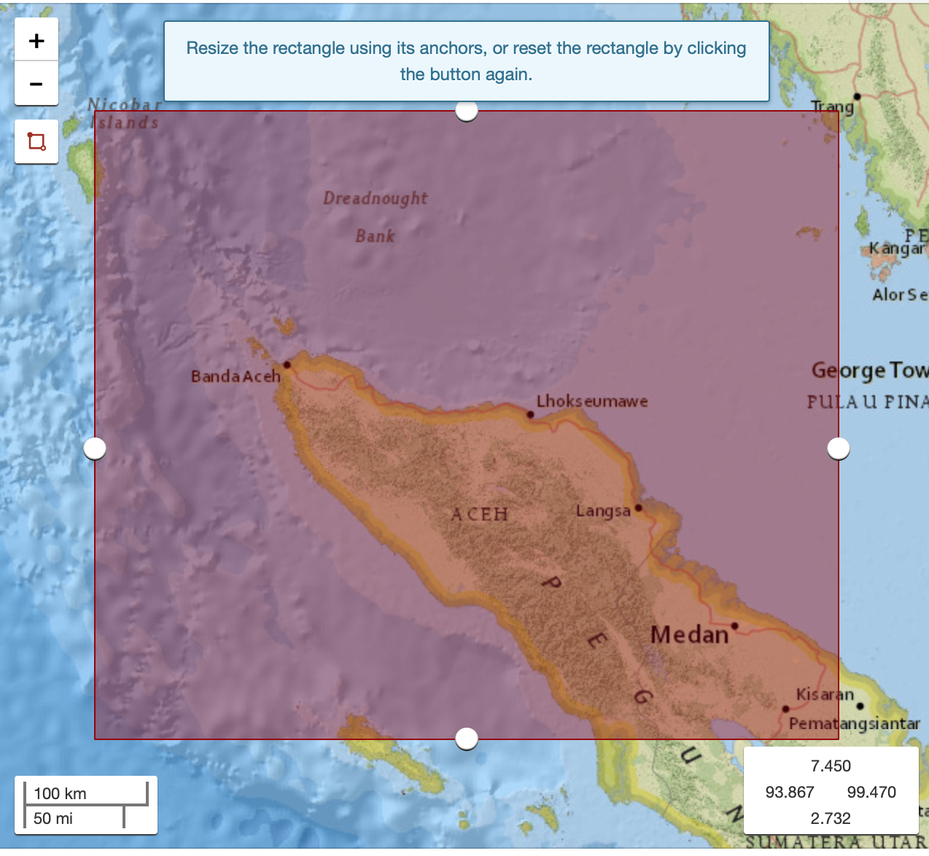
Figure 1. USGS evaluated earthquake region around Aceh.

Table 1. Largest earthquakes occurred in area of Aceh [1].
Time | Latitude | Longitude | Depth | Magnitude | Magnitude Type
2004-12-26T00:58:53.450Z | 3.295 | 95.982 | 30 | 9.1 | mw
2008-02-20T08:08:30.520Z | 2.768 | 95.964 | 26 | 7.4 | mwc
2010-05-09T05:59:41.620Z | 3.748 | 96.018 | 38 | 7.2 | mwc
2005-02-26T12:56:52.620Z | 2.908 | 95.592 | 36 | 6.8 | mwb
2011-09-05T17:55:11.220Z | 2.965 | 97.893 | 91 | 6.7 | mww
2015-11-08T16:47:02.160Z | 6.8431 | 94.648 | 10 | 6.6 | mww
2016-12-06T22:03:33.390Z | 5.2834 | 96.1678 | 13 | 6.5 | mww
2008-03-29T17:30:50.150Z | 2.855 | 95.296 | 20 | 6.3 | mwc
2005-03-30T16:19:41.100Z | 2.993 | 95.414 | 22 | 6.3 | mwb

Dataset and methodology
The dataset uses on this study is achieved by collecting the reinforced concrete images. It contains the normal and cracked reinforced concrete. The raw figure is taken by iPad Air (Apple Inc.). Total images for this study is 573 images with the raw size of 1936 pixel × 2592 pixel. The images utilized for the training is 375 images. Meanwhile, a set of 198 images for normal and cracked concrete is used for the testing the CNN models. Other setting is set as default. This study uses Macbook Pro 2.6 GHz Intel Core i7. Furthermore, Python version 3.6.8, OpenCV version 3.4.2 and Keras 2.1.2 with TensorFlow 1.4.1 [15] are the utilized software.

Table 2. Confusion matrix evaluation
 |  | Predicted
 |  | Cracked | Normal
Reference | Cracked | True Positive (TP) | False Negative (FN)
 | Normal | False Positive (FP) | True Negative (TN)

This study evaluation utilizes the confusion matrix, as shown on Table 2, with sensitivity and specificity. In more detail, the sensitivity is the ratio of the cracked material, as the reference, is well predicted to the cracked material, true positive (TP), to the cracked material, also as the reference, is miss predicted to the normal material (FN), shown on Eq. 1. Meanwhile, the specificity is the ratio of the normal condition as the reference is predicted as the normal as well, true negative (TN) compared to the miss classified the reference of the normal condition as the cracked condition, that can be seen on Eq. 2.

(1)

(2)

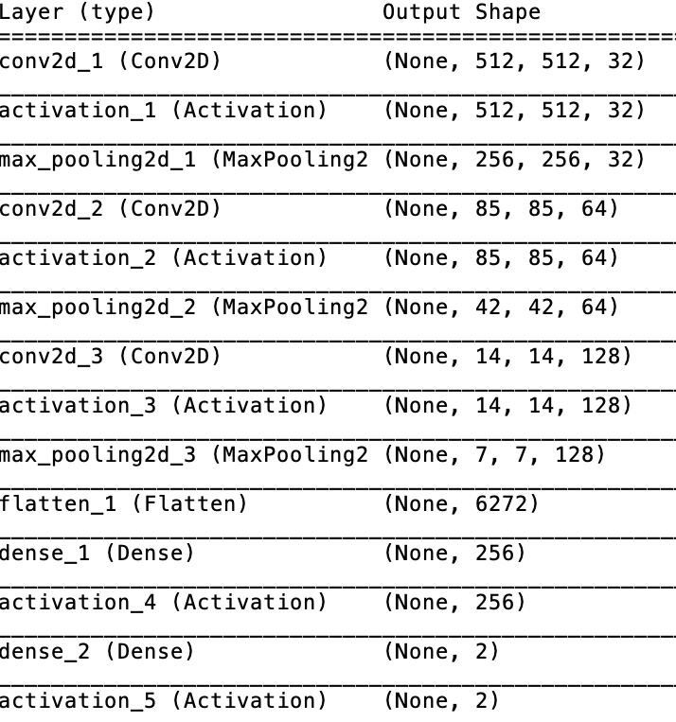

Figure 2. Higher resolution input image LeNet model summary.

For the localization, the first activation or feature map is uniformly taken from every model. This condition can be also called as the heat map. This resized matrix will be reformed to the original image size. This procedure highly likely affects the localization marking for the crack.
Result and discussion
This study uses several concrete images from several buildings. The utilized models are the LeNet based models. The uniqueness of the LeNet model is one of the simplest architectures in deep learning algorithms especially for the CNN, which has 1,212,578 of trainable parameters. The activated convolution layers are mostly followed by the max pooling procedure. Moreover, the stride shape is one by one. This small number of strides will keep the image size to have sufficient size until the flattening layer. In this study, the LeNet model provides relatively good results in both training and testing, as it can be seen on Tables 4 and 5. However, for this LeNet model, the input size is only 150 × 150 pixels. In order to localize the crack from the original image, that has much bigger image size, 1936 × 2592 pixels, the first feature map generated by this model is only 148 x 148 pixels. The reduced size is due to the valid padding set to the model. This feature map will have problem in superimposing the original image. The detail about LeNet models can be seen on Figs. 2 and 3.

Figure 4. Smaller crack localization results of LeNet models.

Table 3. Training evaluation. TP = True Positive, FP = False Positive, TN = True Negative, FN = False Negative, SEN = Sensitivity, SPE = Specificity.

Input size | Confusion Matrix |  |  |  | SEN | SPE
 | TP | FP | TN | FN
150 x 150 | 122 | 0 | 238 | 13 | 0.9037 | 1.0000
512 x 512 | 128 | 2 | 236 | 7 | 0.9481 | 0.9916

Table 4. Testing evaluation. SEN=Sensitivity, SPE=Specificity
Input size | Confusion Matrix |  |  |  | SEN | SPE
 | TP | FP | TN | FN
150 x 150 | 102 | 0 | 75 | 19 | 0.8430 | 1.0000
512 x 512 | 121 | 0 | 75 | 0 | 1.0000 | 1.0000

In order to have better superimposing to the raw image, this study proposes a higher resolution input image. This proposed method has 512 × 512 pixels for the first feature map. The average value of the all channels will be the final feature map for superimposing the original image. This model has bigger architect, which is 1,699,650 trainable parameters. This modified algorithm even tough has slightly worse in specificity than the basic model, this updated model provides better sensitivity in training. Moreover, in testing, the higher resolution input image has an improved result for the sensitivity. The detail can be seen on Tables 3 and 4.

Figure 5. Bigger crack localization results of LeNet models.

For the crack localization it can be seen on Figures 4 and 5. Figure 4 provides the localization results for relatively smaller cracks. It can be seen that the higher resolution LeNet that has 512 × 512 pixels, produces much better result in superimposing the raw images compared to the basic LeNet model that has 150 x 150 pixels. The result of the bigger crack localization can be seen on Fig. 5. From this figure the higher resolution input image model produces a better localization compared to the basic model. Especially for the bigger crack cases, the model is still able to differ the surface damage and the obvious crack as shown by the heat map distribution in the superimposed images.
Conclusion
This study evaluates the crack classification and localization. Furthermore, it initially classifies the material either normal or cracked concrete. Furthermore, if the condition is detected as the crack material, the crack localization will be performed sequentially. For the results, it can be seen that the higher resolution input image model provides a better classification and localization results. This study with some further works can be applied for the AI based automatic crack detector.

Acknowledgement
The authors would like to express their gratitude to Universitas Syiah Kuala for financial support partly for research through the Professor's research grant No. 03 / UN11.2 / PP / PNBP / SP3 / 2019.
References
[1]https://earthquake.usgs.gov/fdsnws/event/1/query.csv?starttime=2004-07-12%2000:00:00&endtime=2019-07-19%2023:59:59&maxlatitude=7.45&minlatitude=2.732&maxlongitude=99.47&minlongitude=93.867&minmagnitude=5&orderby=magnitude (Accessed on July 19th 2019).
[2] Medina R, Llamas J, Gómez-García-Bermejo J, Zalama E, Segarra M. Crack detection in concrete tunnels using a gabor filter invariant to rotation. Sensors. 2017;17(7):1670.
[3] Wang B, Zhao W, Gao P, Zhang Y, Wang Z. Crack Damage Detection Method via Multiple Visual Features and Efficient Multi-Task Learning Model. Sensors. 2018 Jun;18(6):1796.
[4] Mu W, Sun J, Liu G, Wang S. High-Resolution Crack Localization Approach Based on Diffraction Wave. Sensors. 2019 Jan;19(8):1951.
[5] Middleton CA, McCrory JP, Greene RJ, Holford K, Patterson EA. Detecting and Monitoring Cracks in Aerospace Materials Using Post-Processing of TSA and AE Data. Metals. 2019 Jul;9(7):748.
[6] Hasheminejad N, Vuye C, Margaritis A, Ribbens B, Jacobs G, Blom J, Dirckx J, Vanlanduit S. Investigation of Crack Propagation and Healing of Asphalt Concrete Using Digital Image Correlation. Applied Sciences. 2019 Jan;9(12):2459.
[7] Husaini, Kishimoto K, Notomi M, Shibuya T. Fracture behaviour of PC/ABS resin under mixed‐mode loading. Fatigue & Fracture of Engineering Materials & Structures. 2001; 24(12): 895-903.
[8] Husaini, Kishimoto K, Hanji M, Notomi M. Investigations of The Mixed Mode Crack Growth Behavior of An Aluminum Alloy. Journal of Engineering and Applied Sciences. 2016;11(2): 885-890.
[9] LeCun Y, Bottou L, Bengio Y, Haffner P. Gradient-based learning applied to document recognition. Proceedings of the IEEE. 1998 Nov 11;86(11):2278-324.
[10] Sadrawi M, Sun WZ, Ma M, Yeh YT, Abbod M, Shieh JS. Ensemble Genetic Fuzzy Neuro Model Applied for the Emergency Medical Service via Unbalanced Data Evaluation. Symmetry. 2018;10(3):71.
[11] Sadrawi M, Fan SZ, Abbod MF, Jen KK, Shieh JS. Computational depth of anesthesia via multiple vital signs based on artificial neural networks. BioMed research international. 2015;2015.
[12] Ronneberger O, Fischer P, Brox T. U-net: Convolutional networks for biomedical image segmentation. InInternational Conference on Medical image computing and computer-assisted intervention 2015 Oct 5 (pp. 234-241). Springer, Cham.
[13] Sadrawi M, Lin CH, Lin YT, Hsieh Y, Kuo CC, Chien J, Haraikawa K, Abbod M, Shieh JS. Arrhythmia evaluation in wearable ECG devices. Sensors. 2017;17(11):2445.
[14] Rajpurkar P, Hannun AY, Haghpanahi M, Bourn C, Ng AY. Cardiologist-level arrhythmia detection with convolutional neural networks. arXiv preprint arXiv:1707.01836. 2017 Jul 6.
[15] Abadi M, Agarwal A, Barham P, Brevdo E, Chen Z, Citro C, Corrado GS, Davis A, Dean J, Devin M, Ghemawat S. Tensorflow: Large-scale machine learning on heterogeneous distributed systems. arXiv preprint arXiv:1603.04467. 2016 Mar 14.

