Renewables for district heating: The case of Lithuania
Rolandas Jonynas¹, Egidijus Puida¹, Robertas Poškas^{1,2,*}, Linas Paukštaitis¹, Hussam Jouhara³, Juozas Gudzinskas¹, Gintautas Miliauskas¹, Valdas Lukoševičius¹
¹ Kaunas University of Technology, Faculty of Mechanical Engineering and Design, Department of Thermal and Nuclear Energy, Studentu 56, Kaunas LT-51424, Lithuania
² Lithuanian Energy Institute, Nuclear Engineering Laboratory, 3 Breslaujos, Kaunas LT-44403, Lithuania
³Brunel University London, Institute of Energy Futures, College of Engineering, Design and Physical Sciences, UB8 3PH Uxbridge, United Kingdom
Abstract. Lithuania, as other European countries with cold climates, has well developed district heating systems. Lithuania’s national energy strategy aims to reduce the dependence on imported fossil fuels, reduce the amount of greenhouse gas emitted into the atmosphere and increase the security of energy supply, and therefore, one of its principal objectives is to include sustainable renewable energy sources into the district heating system. This article serves as an overview of how Lithuania’s district heating sector uses renewable energy resources, in what state it is, and what perspectives and future trends are foreseen.
1. Introduction
District heating (DH) is an attractive technology because it can save energy and serves an important role in the strategy of sustainable energy. It is also very advantageous as regards the efficiency of local resources and local environment, meaning that a) it is much safer than individual combustible heat sources, b) it requires no heat generating facilities, c) it does not burden consumer premises with related capital and operational cost, d) no nearby chimneys are required, e) there is no need for fuel supply or storage facilities, f) it makes less pollution and noise, g) heat may be supplied all year round and the heat supplier takes the responsibility for everything, and finally, h) a cooling service is also possible [1]. Given high quality heating scheme designs and small heat losses in pipeline networks, the price to the final consumer is usually lower compared to heating prices from alternative thermal energy sources.
The countries with the largest markets for district heating in the European Union (EU) include Sweden, Poland, Germany and Finland. Southern Europe with warmer climates has a lower percentage of citizens supplied with DH, but in Northern and Eastern Europe this percentage is rather high (Table 1) [2].
The use of DH is increasing in most countries with cold climates [3] compared to other heating alternatives showing that this heating supply system is becoming a growing segment of heating markets [4, 5].

Table 1. Share of citizens served by DH [6]

Top five countries in Europe | 1 | 2 | 3 | 4 | 5
Citizens served by district heating | Iceland  (92 %) | Latvia  (65 %) | Denmark  (63 %) | Estonia  (62 %) | Lithuania  (57 %)

As Lithuania is a cold climate country, centralised heating systems cover approximately 60 per cent of heating demand (Table 1). By contrast, in Poland the percentage reaches approximately 30 per cent and only about 10 per cent in Germany [7]. In Lithuania, the biggest share of the DH services are provided to apartment building residents - in 2016 they consumed 73 per cent of the total heat amount sold in the market (and this percentage is gradually increasing as newly built houses are connected to the DH system; Fig.1). Budget institutions and industries use the remaining amounts (14 per cent and 13 percent respectively). In other European countries the numbers align as follows: in Finland 50 percent of households are covered by DH [1]; in Sweden 60 percent of households, 30 per cent of the service sector and 10 percent of industries [8]; in Denmark 65 per cent of households and 5 per cent of industries; and in Poland 70 per cent of households and 5 per cent of industries are covered by DH [7].

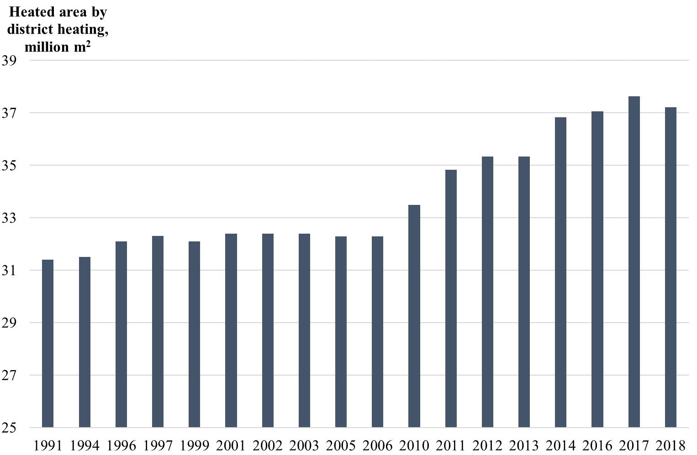

Fig. 1 Statistics of DH served heated area of apartment buildings and individual living houses in Lithuania in years 1991–2018

Central and Eastern European countries have their DH systems regulated [9–12]. The aforementioned countries had used fossil fuels to generate energy and therefore experienced “fuel poverty” [13]. However, with the new European Commission policy on renewable energy sources (RES) and with the gradual introduction of renewable energy sources, e.g., geothermal, solar energy, and biofuel, the situation has changed in Europe and therefore in Lithuania [14].
Cold climate European countries mainly use biofuel as a renewable source. Lithuania has started its industrial development of biofuel in 1994 when the first boiler houses were installed that used sawdust or wood chips as fuel. These biofuels are still the most popular in Lithuania while Western European countries prefer wood pallets. In 1999, this industry had already been fully functioning. The further development of DH systems using biofuels followed because of increased environmental requirements [15], the opening of the heating market to independent heat producers [16], increased natural gas and fuel oil prices, the development of the biofuel production sector and the creation of the first biofuel market in Europe. Today Lithuania sets an example of how to become energy independent in a short period through local biomass use (Fig. 2).

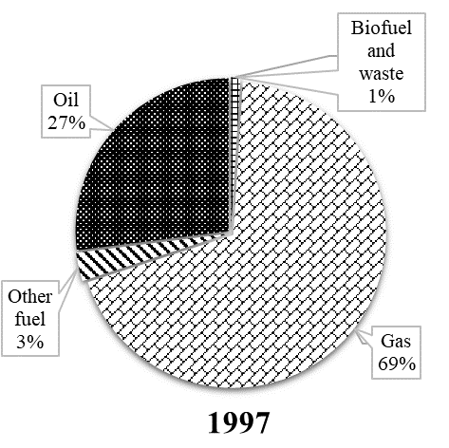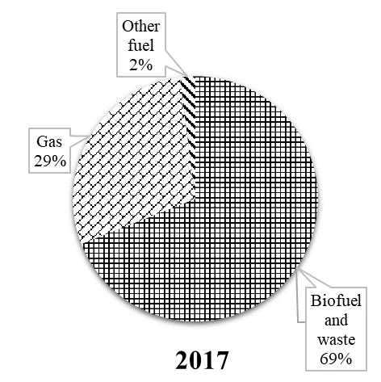
Fig. 2. Fuel consumption structure in Lithuania’s DH system.
2. Biofuels in district heating
DH systems can use various fuels: renewable sources, industrial and environmental waste, fossil fuels, etc. It ensures diversification of energy sources and heat supply at the lowest cost [1].
In Switzerland and Denmark, quite a fair share (approximately 40 per cent) of renewable energy is devoted to district heating, and half of the share consists of waste and biomass [7]. In Lithuania, biomass (mainly wood chips) and waste have been the most important fuels for district heating since 2014 (Fig. 3) [17].

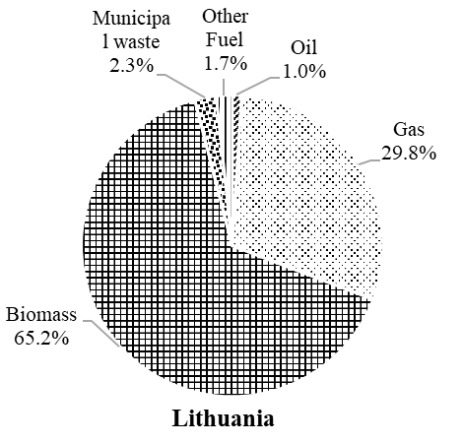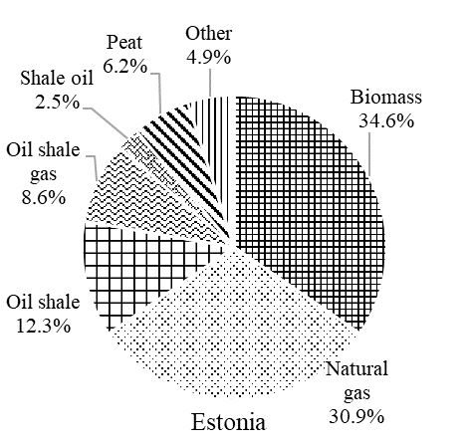
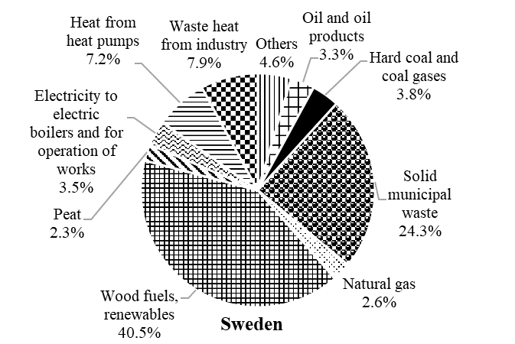

Fig. 3. Original energy sources used for heat supplied into Lithuanian, Estonian and Swedish district heating systems in 2014.

As Fig. 3 demonstrates, in 2014 Estonia had about 37 per cent of its DH market covered by biomass [18] and Sweden about 70 per cent [8]. Comparing the numbers with the rest of the countries of the European Union, biomass also is the key renewable energy source; however, only 16 per cent goes to DH [19].
Nowadays, about 40 per cent of Lithuania’s land surface is wooded (approx. 2 mln. ha) [20]. Based on [21], Lithuania’s annual growth of timber is approx. 17 mln. m³, and potential timber removals could be approximately 10 mln. m³ per year. However, statistically only ~8 mln. m³ of timber removal is registered. The biggest producers of wood waste in the industry are sawmills and plywood producers. Approx. 1.5 mln. m³ of such waste per year could be used as an energy source [22].
Table 2 presents a prognosis for solid biofuel types and their consumption in the heating sector in 2020 ([23]).
In many countries, landfills become overfilled with municipal solid waste, and therefore their utilization to produce heat is a reliable solution. One possible disposal method is waste incineration. In Lithuania, municipal waste is the second most popular fuel of renewable energy sources in DH, despite the fact that even in 2012 approximately 80 per cent of this waste was disposed of in landfills. Figure 4 presents the situation of municipal waste management in the EU in 2012 (including Lithuania) [20].

Table 2. Solid biofuel types potential and planned consumption in the heating sector in 2020.

Solid biofuel type | Solid biofuel potential, ktoe | Planned consumption of solid biofuel, ktoe | Planned consumption part of solid biofuel potential, %
Fuel wood | ~600 | ~600 | 100
Felling waste | ~200 | ~70 | 35
Wood processing industry waste | ~300 | ~300 | 100
Energy plantations | ~30 | ~30 | 100
Straw | ~500 | ~100 | 20

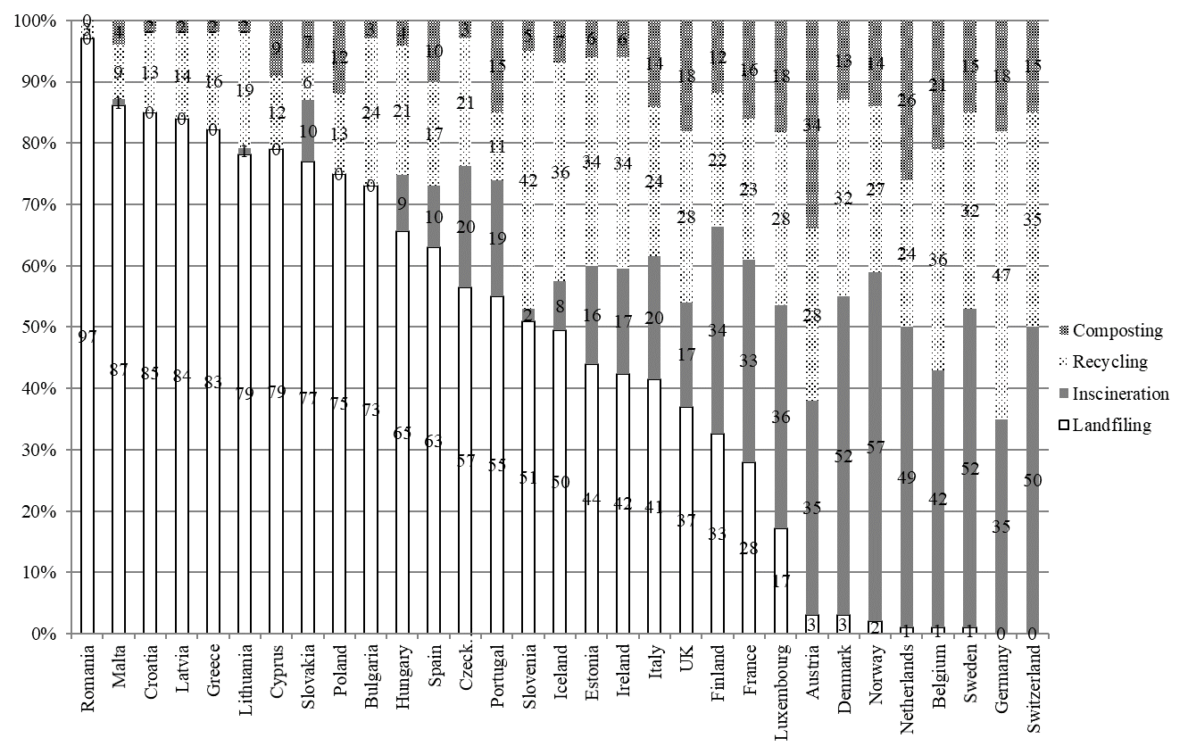
Fig. 4. Municipal waste management in EU countries in 2012

Figure 5 shows the present state of municipal waste in Lithuania - only 27 per cent reaches landfills.

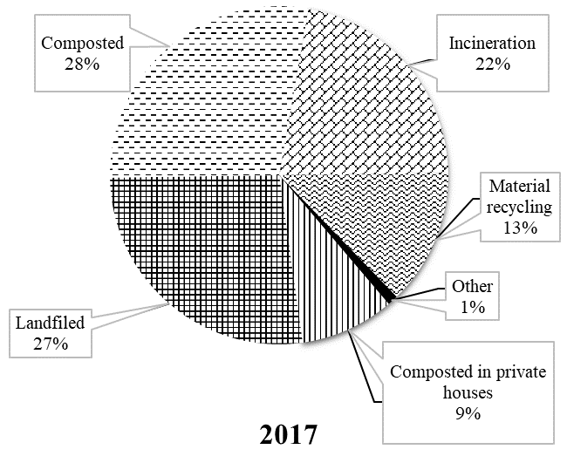

Fig. 5. Ways of municipal waste management in Lithuania in 2017 [24].

The use of biomass for energy production causes a worldwide reduction in environmental pollution, and Lithuania is no exception (Fig. 6). Therefore, it can be concluded that, with renewable energy sources in DH, a lower generation of CO₂, NO_{x}, SO₂ emissions and other pollutants results [1], hence efficiently combating climate change [4].

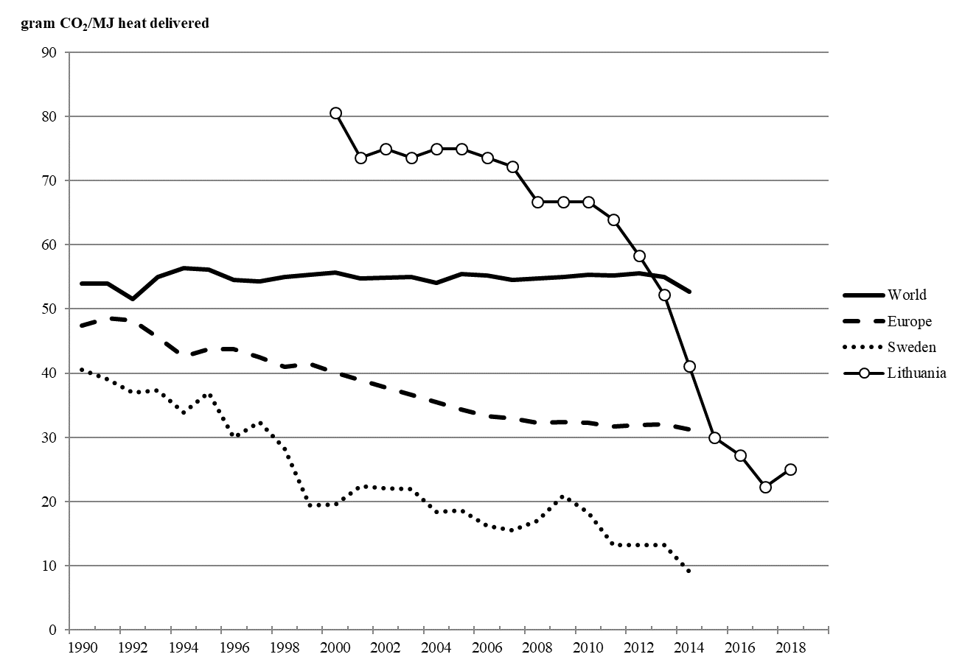

Fig. 6. CO₂ emissions in the world, Europe [25], Sweden ([4], [8]) and Lithuania.

3. RES technologies in Lithuanian DHS
Today Lithuania’s results in DH are as good as the ones of Northern European countries. This has been achieved through such steps as connecting cogeneration units (combined heat and energy production) to the heating network and hence reducing losses in heat supply (Fig. 7), gradually optimising the capacities of heat generation units, and using local fuels instead of imported ones.

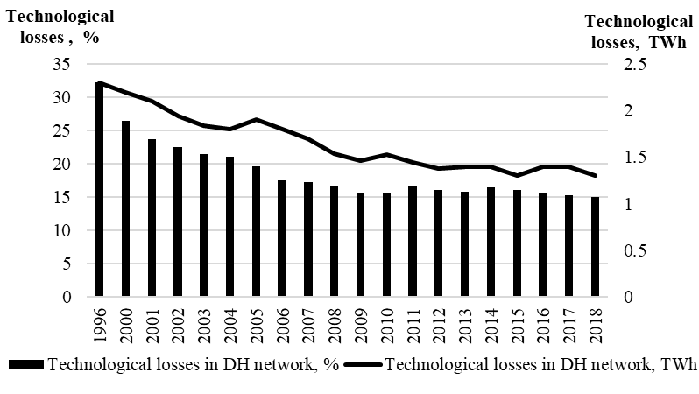
Fig. 7. Technological losses in DH network (Lithuania) [26]

The DH sector strives to achieve as low a cost as possible for the thermal energy. The cost is composed of two elements: fixed cost and variable cost. The fixed cost is an energy producer’s expenditure for generating and supplying energy to users and it is independent of the quantity of the heat generated and supplied. The cost includes expenditure for repairs, remunerations, environmental protection and other taxes, etc.
The variable cost includes the main components for heat generation and supply: electricity, water, fuel, and chemicals. Today, the main component is local biofuel and it is not expected to change soon (Fig. 8). What is more, biofuel production is a reason for the growth of the local economy, new workplaces and reduced costs of energy generation [14, 27].

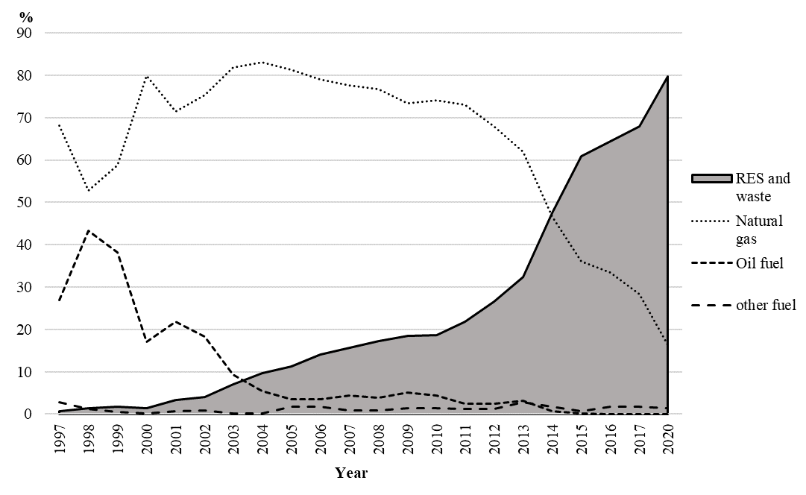
Fig. 8. Tendency and prognosis for RES share in Lithuania’s DH

Lithuania inherited the old DH systems from the Soviet Union where the main consumers were industrial companies. In the 1990s heat energy prices increased significantly due to increased prices of fossil fuels. Industrial companies disconnected from the district heating supply networks saving their money because the thermal efficiency of the old steam and water heating boilers (burning heavy fuel oil or natural gas) was rather low (78–88 %). Lithuanian heat producers then made a decision to reconstruct the old boilers and make them suitable to burn biofuels. EU Structural Funds provided subsidies (Fig. 9) for the modernization of the DH pipelines and boilers and it helped to reduce energy prices.

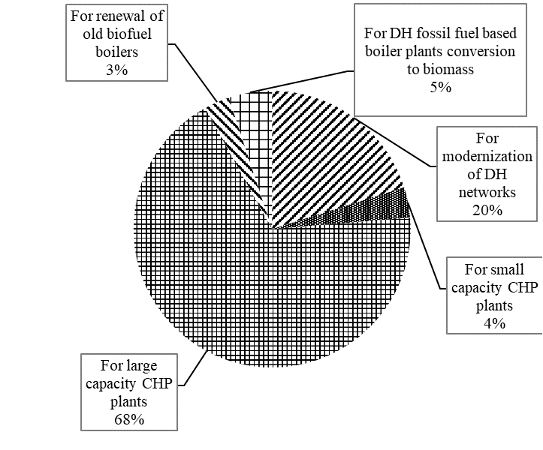

Fig. 9. EU Structural Funds distribution for 2014-2020 in Lithuania’s DH sector [17]

The new environmental requirements adopted [28, 29] were yet another factor that invited technological progress. With the introduction of biofuel, the efficiency of the old boilers reduced (to ~70%) and the necessity of cleaning the combustion products was recognized, and therefore, heat producers started installing flue gas condensing economizers [1, 30]. The EU financial support also resulted in new biofuel boilers in boiler houses, and new boiler houses designed for burning straw (85% of efficiency) as well as wood waste [31].
Currently, the Lithuanian DH sector operates approximately at 1590 MW of biofuel boilers and in winter the sector nearly reaches the base heat load (1700 MW) [32].
A distinctive feature of the Lithuanian DH sector is that independent heat producers control a large part of solid biofuel installations that supply heat to the centralized network. Heat supply companies are most often municipal companies, which operate the heat supply network and heat generation facilities. However, under Lithuanian law, a private company can build a heat-generating unit, a boiler house using biofuel or a cogeneration unit and supply heat to the centralized network, if the selling cost is lower than the generation expenses incurred by the producing company. Such companies are called independent heat producers (IHP). At the end of 2018, units with condensing economizers used by heat supply companies and IHP had a combined thermal capacity of almost 1 590 MW. IHP boiler houses and power plants house about 600 MW of these units.
As the number of new biofuel-efficient plants in the Lithuanian DH sector increases, the overall comparative cost of primary fuel production per unit of energy decreases. In 2018, this indicator was about 89–90 kg.o.e / MWh. This significantly improves the energy efficiency of the DH sector (Fig. 10).

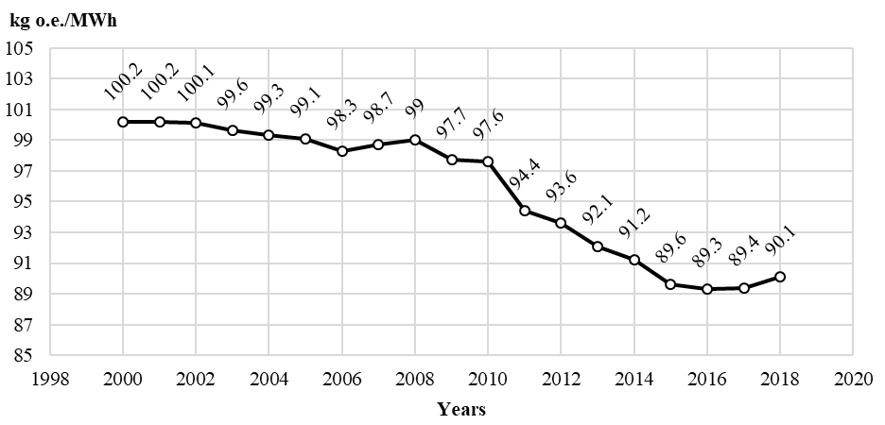
Fig. 10. Comparative cost of primary fuel in Lithuania’s DH supply sector in 2000–2018 [26].

In 2000 in many cities, the temperature of hot water returning to the DHS network was 50–60 °C, and thus too high for condensing economizers to perform at their maximum efficiency. Investments in heat supply networks have reduced heat carrier parameters and increased the utilization efficiency of biomass.
According to the EU Energy Efficiency Directive, an efficient DH system should use at least 50 per cent of renewable energy. As Fig. 7 demonstrates, the Lithuanian DH sector has already reached this threshold in 2014. Currently, only a few cities remain in Lithuania, where less than 50 per cent of heat is produced using renewable energy.
Combustion of shredded wood (chips) in high-power boilers with condensing economizers is very efficient (usually above 95 %) and, under good combustion conditions and equipped with flue gas emission reduction equipment, less pollution is emitted to the environment compared to low-power small-scale biomass boilers. Considering this advantage, the Lithuanian government, ministries and other responsible institutions set forth a series of strategic documents (National Energy Independence Strategy, National Air Pollution Reduction Plan, Project of National Integrated Energy and Climate Change Plan) in 2018 to promote the development of DH systems and support existing and new consumers.
Biomass combined heat and power (CHP) is not very popular in Lithuania. In 2016, cogeneration units generated about 3.6 TWh of heat. This represented approximately 41 per cent of the total heat produced in the DH system. The installed electricity capacity of cogeneration plants that use biofuel and waste as fuel is 79 MW. Two new cogeneration plants are to start their operation in 2020 (a plant for biofuels and municipal waste with thermal capacity of 229 MW and electrical capacity of 92 MW; another plant for waste with thermal capacity of 70 MW and electrical capacity of 24 MW) [33].
The EU Strategy for Heating and Cooling (2016) as well as the National Strategic Legislation provide for the promotion of efficient cogeneration. A separate measure for the construction of low-power biofuel cogeneration plants is foreseen in Lithuania during the period 2014–2020 of EU Structural Funds (Fig. 8). However, due to current unfavourable conditions, part of the support has not yet been used.
Compared to separate power generation in thermal power plants, CHPs have a huge potential to reduce CO₂ emissions. Therefore, in order to further raise cities’ decarbonisation levels and increase the country’s electricity generation capacity, certain decisions have to be made and obstacles removed so that investments into such projects can yield good results.
The National Energy Independence Strategy [32] indicates that the share of renewable energy sources in the DH system should increase gradually. High-efficiency biofuel CHP plants will continue the development, and heat and electricity will be generated using municipal waste (with waste energy remaining after sorting and recycling), and waste from non-hazardous production.
Another type of RES is also of interest because of the significant advances in the use of solar and geothermal energy in DH systems of other EU counties. For example, solar thermal energy is being incorporated into DHS on a large scale, with some major projects in some European countries. Denmark being the leader in the field, commissioned the world’s largest solar thermal power plant in 2016. The remaining parts of Europe, especially Poland and Germany, have followed the success of Denmark and have started project development too.
During recent years, some European countries have also expanded the use of geothermal DH plants. In 2016, the UK started supplying hot water and heat to houses using a demonstration hybrid district heating project combining solar heat, heat pumps and energy storage [34].
Meanwhile, other types of RES (geothermal systems, solar systems with seasonal storage tanks, etc.) in Lithuanian DH networks would require significant amounts of money and state subsidies, and would be successful only in the event of stricter environmental requirements and higher prices for natural gas and biofuels [35].
4. Impact of regulations
There are two types of DH markets in the world: regulated and unregulated markets. Either type operates facing some advantages or disadvantages. Examples show that continuous adaptation by DH suppliers and consumers can ensure the proper functioning of both types of DH markets. There is a global consensus - a competitive model should be used for the effective functioning of the DH market [36].
In 1997, Lithuania established an independent state regulator that was supposed to regulate the companies in the energy sector as well as to exercise state supervision of the said sector. This body aims to increase the efficiency of businesses and their integration into the European Union’s single market and regulatory area. It also controls fixed costs to eliminate unjustified and excessive heating costs (as in other Eastern Europe countries, Table 2, Fig. 11).

Table 2. Type of DH market regulation.

Alternative-based heat pricing | Promotion of DH as alternative to other heating and cooling solutions
Competitive/cost-reflective  prices | DH company sets competitive / cost-reflective prices; authorities control changes in prices and their levels according to competition law.
Ex-ante price control | Regulations adopted according to established methodologies and heavy discretion of the regulator (also in Lithuania).
Heavy-touch ex-ante price  control | Multi-level approval needed: from state, regional and local authorities, etc.

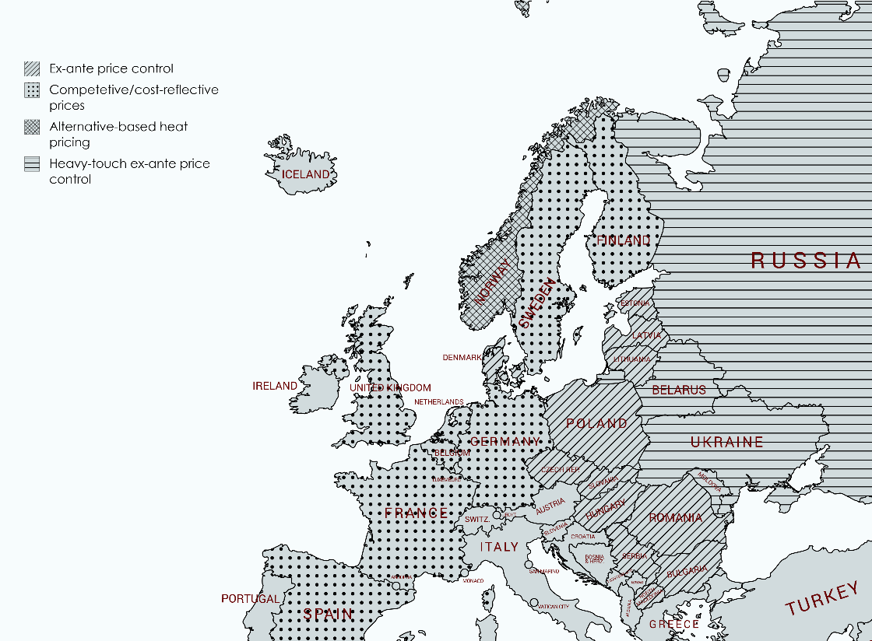

Fig. 11. European DH market regulation policies [37]

Existing laws and Lithuania’s energy policy (e.g., EU funds, price setting methodologies) have influenced the creation of a situation common to many Eastern European countries: small-scale biofuel-fired water heating boiler houses satisfy a significant share of the district heating market and produce a bas load for heat. In contrast, in Scandinavia, CHP plants satisfy the main heating demand, and boiler houses produce heat only during the cold season. This unique and controversial situation creates inconveniences even for the most efficient cogeneration plants trying to enter the DHS sector. The situation of the Lithuanian DH sector is characterized by the following:
- The present licensed DH operator must ensure that it provides quality heating to its consumers despite the fact that other heat producers could also be supplying heat. This is not the only, however, most significant reason why a large generated heat surplus exists in many DHS. The actual capacity of the current heat supply installations is about 8000 MW while the maximum demand reaches only about 3000–3500 MW;
- Controlled and not controlled independent heat producers are allowed to produce heat if heat supply costs (variable) will be reduced during a particular month i.e. in that case individual devices of the DH operator will be replaced. Regulations do not provide for detailed assessments of heat production over a specific period of time;
- The heat supplier must ensure continuous heat production and supply equipment (consumers must pay for it), regardless of the number of external producers in a separate district heating supply system (Fig. 12);
- Investors are reluctant to install their equipment only for the cold season as the period is too short, which means that there is a lack of participants in the market who can effectively compete during the coldest months;
- The prediction of one month’s demand for heat production is difficult and this is risky for stable operation and a return on investment for cogeneration units combusting waste and other fuels;
- The development of IHP undergoes stagnation in the main cities and smaller cities have no such companies at all. The reasons for such a situation are fluctuating amounts of annual heat production, minimum investment return and other risks.
- In a longer period of time, preservation of the economic role of IHPs could result in a concentration of investors, bankruptcies or an emergence of oligopoly;
- The present regulatory conditions clearly limit the space for competition;
- This regulatory environment also encourages inaction because it calls for risky investment actions from heat suppliers;
- Too strict regulation results in reduced motivation from heat suppliers for innovation and development of the DHS market or services;
- Unless something changes, DHS services might be replaced by gas heating, heat pumps (using ambient energy), etc.

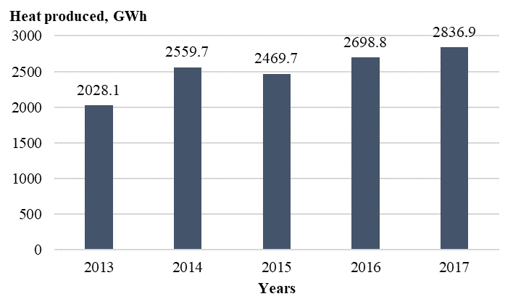
Fig. 12. Total heat produced by independent heat producers (GWh per year) [38].
5. Discussion
The current situation in Lithuania determines that the energy regulator only calculates or limits actual costs in specific lines. Although the current regulatory system helped to save the DHS infrastructure some time ago, it is now preventing further development of heating equipment and cogeneration (using RES), and therefore must be upgraded. It looks like the economic “motivation”, mechanically adapted from the electricity and gas infrastructure regulation, based on the permission to make profit only from the used asset value in the regulated activities, does not generate economic motivation to generate and supply cheaper heat for users. In the DHS sector, where there is more space for effective investments, incentive regulation marketing should be introduced. Another solution is the stimulation of equivalent and long-term competition in the heat generation area, when a heat supplier has more freedom and motivation to make long-term contracts with more efficient (compared to his own equipment) heat generators, which would account for an optimal heat production equipment park.
Considering the development of district heating in Western European countries, it becomes clear that in order to form a competitive and user-attractive district heating supply network, energy suppliers, irrespective of their ownership, should be encouraged to take the initiative and be more motivated. Despite the level of the energy regulator effectiveness, the regulator cannot implement these innovations instead of the heat supplier. The regulator’s task is to create a minimal, yet effective regulatory environment that would encourage DHS companies to take initiatives and receive a reward for good results.
6. Conclusions
The National Heat Sector Development Programme (2015–2021) provides the following goals:
      - heat price and environmental pollution reduced by 20 % ;
      - transmission losses reduced up to 14 %;
      - usage of RES in DHS increased by 70 %.
It should be noted that these goals have already been achieved by the end of 2019.
The new National Energy Strategy of 2019 provides for the implementation of the following measures in the coming decades:
      - focus on technologies that help to increase use of RES in the district heating sector (e.g., heat pumps, solar energy, heat accumulation);
      - install high efficiency biofuel CHP plants;
      - it is planned that by 2030 the share of energy from RES and local energy sources in DHS systems will reach 90 per cent, and, in the longer term, these energy sources will fully satisfy the DH system’s energy demand by 2050;
      - further develop centralised supply of heat and, especially, cooling services to consumers as is usual for 4th generation DH systems. Therefore, it is essential to correctly assess the current situation and perspectives of the cooling energy potential and set guidelines for the use of such systems.
Although the plans for the optimization of the centralised heating sector are being successfully implemented, a unique situation has formed in Lithuania’s DHS heat generation sector: heat is produced by boiler houses owned by DHS companies as well as by heat generation units owned by independent heat producers. Independent heat producers coming into the heat production market means competition and creates conditions for heat price reduction to consumers. However, different economic activity controlling mechanisms applied to DHS companies and independent heat producers mean an unfair competitive environment.
It should be noted that the regulator ensures fair and rational activities of DHS companies producing and supplying thermal energy to consumers. However, too strict regulation can stop heat producers from innovations because an innovative introduction inevitably means less successful investment, and therefore nobody wants to launch pilot projects which are a key component to successful development of the DHS sector.

References
- V. Lukoševičius, L. Werring. Regulatory Implications of District Heating. Inogate Textbook (2011)
- European Commission, 2016b, p. 115
- European climate zones and bio-climatic design requirements. Project report. 2016. www.pvsites.eu
- S. Werner. Global Challenges for District Heating and Cooling. Proc. of 15th DHC Symposium (2016).
- Andrei David, Brian Vad Mathiesen, Helge Averfalk, Sven Werner and Henrik Lund. Heat Roadmap Europe: Large-Scale Electric Heat Pumps in District Heating Systems // Energies. 2017. Vol. 10. P. 1-18. doi:10.3390/en10040578
- Solarthermalworld. Top district heating countries – euroheat &amp; power 2015 survey analysis (2016). https://www.euroheat.org/news/district-energy-in-the-news/top-district-heating-countries-euroheat-power-2015-survey-analysis/ (accessed 04-08-2019).]
- Renewable energy in district heating and cooling. A sector roadmap for remap. IRENA. 2017.
- S. Werner. District heating and cooling in Sweden // Energy. 2017. Vol. 126. P. 419-429. http://dx.doi.org/10.1016/j.energy.2017.03.052
- D. Poputoaia, S. Bouzarovski. Energy Policy. 38, 7 DOI://doi.org/10.1016/j.enpol.2010.03.002 (2010)
- D.M. Sneum, E. Sandberg, H. Koduvere, O.J. Olsen, D. Blumberga. Utilities Policy. 51, P. 61-72. DOI: //doi.org/10.1016/j.jup.2018.02.001 (2018)
- J. Ziemele, I. Pakere, N. Talcis, D. Blumberga. Energy Procedia. 61, P. 2172-2175. DOI: //doi.org/10.1016/j.egypro.2014.12.102 (2014)
- H. Lund, G. Šiupšinskas, V. Martinaitis. Applied Energy. 82, 3 DOI: //doi.org/10.1016/j.apenergy.2004.10.013 (2005)
- S.T. Herrero, D.U. Vorsatz. Energy Policy. 49, P. 60-68. DOI: //doi.org/10.1016/j.enpol.2011.08.067 (2012)
- V. Kveselis, E.F. Dzenajavičienė, S. Masaitis. Energy Policy. 100, P. 227-236. DOI: //doi.org/10.1016/j.enpol.2016.10.019 (2017)
- Directive 2008/1/EC of the European Parliament and of the Council of 15 January 2008 concerning integrated pollution prevention and control (2008)
- Description of procedures and conditions for purchasing heat from independent producers. Resolution on approval of the description of the procedure and conditions for purchasing heat from independent heat producers. 2010 October 4 No. O3-202, Vilnius (2010)
- V. Stasiūnas. Energy Efficiency in District Heating Supply Sector: from generation to the final consumer. Proceedings of conference “Thermal energy and technologies”. Kaunas, Lithuania. 2018.
- M. G. Fernández, C. R. Lacan, U. Gährs, V. Aumaitre. Efficient district heating and cooling systems in the EU. 2016. doi:10.2760/371045
- European Commission, 2016b, p. 122
- Europe in figures. Eurostat yearbook 2012.
- Lithuanian Forestry Statistics 2012. Ministry of Environment, State Forest Service 2012. P. 184.
- Kuliešis A. Energy wood resources in the Context of Europe’s Wood Sector Sustainable Development to 2030. “Influence of sustainable development aspects on municipal action plans for development of renewable resources energy use” seminar material. 31-01-2013. P. 25.
- Darius Verbickas, Romualdas Juknys, Arūnas Kleišmantas. Use of solid biomass in Lithuanian heat sector, development and environmental impact // Power Engineering, 2013. Vol. 59. No. 3. P. 144-152.
- Algirdas Reipas. Waste Management in Lithuania in 2017. Proceedings of the conference Relevant issues of waste management in Lithuania.
- S. Werner. International review of district heating and cooling // Energy. 2017. Vol. 137. P. 617-631. http://dx.doi.org/10.1016/j.energy.2017.04.045
- Lithuanian District Heating Association. Lithuanian District Heating Sector Review for 2018. 2019
- I. Konstantinaviciute, V. Bobinaite, D. Tarvydas, R. Gatautis. Energy Policy. 59, P. 32-43. DOI: //doi.org/10.1016/j.enpol.2013.04.016 (2013)
- C.B.B. Guerreiro, V. Foltescu, F. Leeuw. Atmospheric Environment. 98, P. 376-384. DOI: //doi.org/10.1016/j.atmosenv.2014.09.017 (2014)
- P. Vajda: ERA Forum, DOI: 10.1007/s12027-016-0441-4 (2016).
- V. Ramanauskas, M. Maziukienė, G. Miliauskas. Power Engineering. 63, 2 https://doi.org/10.6001/energetika.v63i2.3522 (2017).
- L. Raslavičius, L. Narbutas, A. Šlančiauskas, A. Džiugys, Ž. Bazaras. Ren. Sustain. En. Reviews. 16, 5 DOI: //doi.org/10.1016/j.rser.2012.02.060 (2012)
- National Energy Independence Strategy of Lithuania. 2018.06.30 (2018)
- https://www.le.lt/index.php/vykdomi-projektai/kauno-kogeneracine-jegaine/3318
- Renewables 2017. Global status report. REN21. 2017. www.ren21.net/gsr
- M. Marčiukaitis, E.F. Dzenajavičienė, V. Kveselis, J. Savickas, E. Perednis, A. Lisauskas, A. Markevičius, K. Marcinauskas, G. Gecevičius, R.E. Marčiukaitienė. Power Engineering. 62, 4 https://doi.org/10.6001/energetika.v62i4.3394 (2016).
- Li, Hailong, Qie Sun, Qi Zhang, et al. A review of the pricing mechanisms for district heating systems (42) (2015) 56-65, http://www.sciencedirect.com/science/article/pii/S136403211400820X.
- Kristian Rehnström. Overview of the heat market in the Baltic countries and future prospects. https://www.lsta.lt/files/events/160502_VKEKK/Siluma/K_Rehnstrom_Heat_Mini_Forum_Rehnstrom.pdf ed. 30-07- (2019) (2016) Vilnius.
- National Control Commission for Prices and Energy. Independent Heat Producer Heat Market Review for 2017. (2018)

