PRACTICE: Physical Rehabilitation Core Outcomes In Critical illness; results of a Delphi consensus study to develop a core outcome set
Bronwen Connolly^{1, 2, 3}, Matthew Barclay¹, Evelyn Corner⁴, Chantal Davies⁵, Nicholas Hart^{1, 2}, Natalie Pattison⁶, Gordon Sturmey⁵, Linda Denehy³, Dale Needham⁷, Paula Williamson⁸, Bronagh Blackwood⁹

¹Lane Fox Clinical Respiratory Physiology Research Centre, Guy’s and St.Thomas’ NHS Foundation Trust, London, UK, ²Centre for Human and Applied Physiological Sciences, King’s College London, UK, ³Department of Physiotherapy, The University of Melbourne, Australia, ⁴Department of Physiotherapy, Brunel University, Middlesex, UK, ⁵Independent ICU Patient representative, UK, ⁶School of Health and Social Work, University of Hertfordshire and East & North Hertfordshire NHS Trust, Hertfordshire, UK, ⁷Division of Pulmonary & Critical Care Medicine, Johns Hopkins University, Baltimore, US, ⁸MRC North West Hub for Trials Methodology Research, University of Liverpool, Liverpool, UK, ⁹Wellcome Wolfson Institute for Experimental Medicine, Queen’s University Belfast, Northern Ireland, UK

Rationale
Existing trials of physical rehabilitation in critical illness are challenged by heterogeneity in selection and definition of outcomes, and their metrics, used for evaluation. This can preclude meta-analysis of data, limiting the cumulative value of individual trials for informing evidence-based clinical decision-making. A core outcome set (COS) of agreed, standardised outcomes to be used across all future trials may facilitate outcome transparency and consistence. The aim of this study is to develop a COS for trials of physical rehabilitation interventions delivered across the continuum of recovery from within the ICU to hospital discharge to the community (PRACTICE).
Methods
A two–stage, mixed methods, consensus-based study, integrating background systematic reviews of quantitative and qualitative literature, qualitative interviews with patients and caregivers, and a Delphi consensus process to determine i) ‘what’ outcomes to include in the PRACTICE COS (Stage 1), and ii) ‘how’ these outcomes should be measured (Stage 2). Delphi participants comprised researcher, clinician, and patient/caregiver stakeholder groups, who were required to rate importance of outcomes for inclusion in the COS on a Likert scale (1-3, not important; 4-6, important but not critical; 7-9, critical). Consensus for inclusion of an outcome by a particular stakeholder group was defined as ≥70% of responses rating the outcome as ‘critical’, and less than or equal to 15% of responses rating the outcome ≤3. Core outcomes were those agreed on by all three stakeholder groups.
Results
Delphi participants totalled 329 (58 researchers (17.6%), 247 clinicians (75.1%), 24 patients/caregivers (7.3%); 26 countries represented). Thirty outcomes were included in the first Delphi survey round, with 4 outcomes reaching consensus for inclusion in the COS - activities of daily living, physical function, health-related quality of life, and survival. Respondents proposed 2 additional new outcomes for consideration in the second survey round, following which, 4 further outcomes were identified for the COS – exercise capacity, cognitive function, emotional and mental wellbeing, and frailty. Figure 1 highlights the final COS and additional outcomes rated as of critical importance by individual stakeholder groups.
Conclusion
Results of Stage 1 of this large, international, methodologically rigorous core outcome set development study, have determined what outcomes should be adopted for trials of physical rehabilitation in critical illness. Stage 2, to prioritise outcome measurement instruments or definitions, is currently underway.

Research Funding Source
BC is funded by a National Institute for Health Research (NIHR) Postdoctoral Fellowship (PDF-2015-08-015). The views expressed are those of the authors and are not necessarily those of the NHS, the NIHR or the Department of Health.

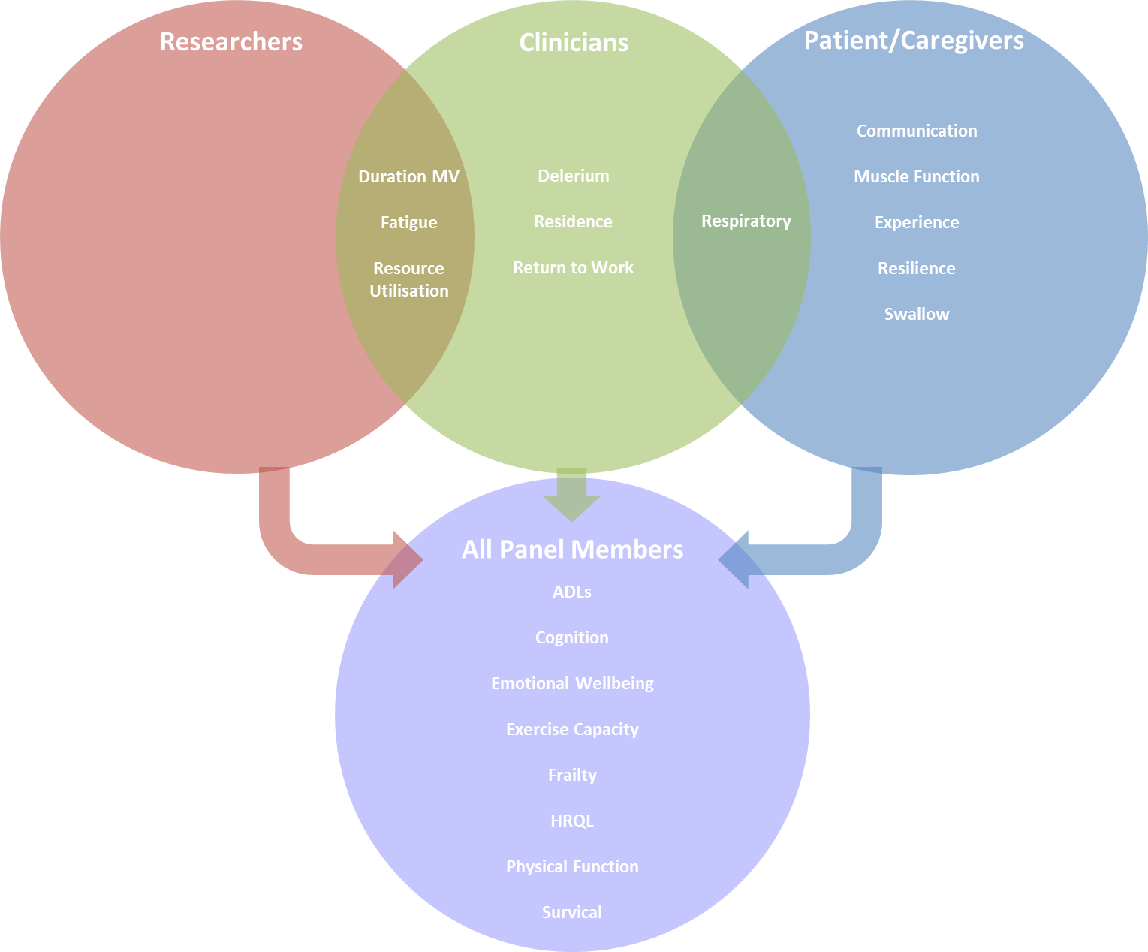
Figure 1. Core outcomes for inclusion in the PRACTICE core outcome set

