# Integrity testing of cast in situ concrete piles based on impulse response function method using sine sweep excitation from a shaker

Haitao Zheng a, Jens-Peter Ertel b, Ernst Niederleithinger b,

Miltiadis Kourmpetis a, Jamil Kanfoud a, *Tat-Hean Gan a,

a Brunel Innovation Centre (BIC), TWI, Granta Park, Cambridge, CB21 6AL, United Kingdom

b Federal Institute for Materials Research and Testing (BAM), Unter den Eichen 87, 12205 Berlin, Germany

*Corresponding author: Professor Tat-Hean Gan

Professor and Director of Brunel Innovation Centre, Brunel University London

(Tat-Hean.Gan@brunel.ac.uk)

## Abstract:

In this study, Impulse Response Function analysis of pile response to sine-sweep excitation by a low cost, portable shaker was used to identify defects in piles. In straightforward impact-echo methods, echoes from the pile toe and defects are visible in the time domain measurements. However, these echoes are not present in time domain records of piles subjected to sine-sweep excitations due to interactions between the input and output signals. For this reason, the impulse response function has been calculated to represent the response to an input impulse, and is able to identify the echoes due to pile impedance changes.

The proposed methodology has been evaluated numerically and experimentally. A one dimensional pile-soil interaction system was developed and finite difference methods used to calculate the pile response to sine-sweep excitation. The simulations indicated that impulse response measurements with a synthesized logarithmic sine-sweep excitation could be an effective tool to detect defects in piles. The methodology was further tested by field trials on 6 cast in situ concrete test piles including 1 intact piles and 5 defective piles subjected to sine-sweep excitations by a shaker. In 5 of 6 cases the echoes from the pile toe could be identified from the deconvolved waveforms – the impulse response functions. Damage detection is more difficult and depending on the selection of the optimal regularization parameter. Further research and optimization of the deconvolution process is needed to evaluate the effectiveness compared to standard pile integrity testing methods.

## Key words

Pile integrity testing;

Impulse response function;

Sine sweep excitation; Shaker;

Nondestructive testing;

Nondestructive evaluation

## Introduction

A hand held hammer is usually used in integrity testing for pre-cast or cast-in-situ deep foundation piles. This testing method is often called low strain integrity testing, also known as pile integrity testing (PIT). The impact of a hand held hammer on the pile head surface generates a compressive stress wave (bar wave) in the pile (ASTM, 2013) (DGGT, 2012). Depending on the hammer type, typically two PIT methods are used:

* ‘Pulse-echo testing’ when a non-instrumented hand-held hammer is used. In this case, only the pile head motion is measured by vibration transducers;
* ‘Transient frequency response testing’ when an instrumented hand-held hammer is used. In this case, both pile head motion and force are measured by vibration and force transducers.

The ‘pulse-echo testing’ method is performed in the time domain by identifying changes in measured velocity after the initial impact pulse. Changes in pile impedance are identified by observing reflections prior to the toe response. Reflections of same sign as the input are caused by a decrease in pile impedance, for example a reduction in cross section area or necking while reflections of opposite sign caused by an increase in pile impedance. Since the pile’s impedance is a function of its density, the pile’s stiffness and the cross-sectional area that represent changes in concrete quality, can also cause similar reflections.

The ‘transient frequency response testing’ method, also called the ‘impulse response evaluation’ method, is performed in the frequency domain. Fourier transform is performed on the input force-time-signal from the hammer and the pile velocity response. A mobility plot (mobility as a function of frequency) is derived by dividing the velocity spectrum by the force spectrum. According to pile elastic theory, consistent frequency spacing between resonance peaks depends on pile length and propagating wave velocity. The pile’s mobility is therefore able to provide information on pile integrity (Finno & Gassman, 1998).

Impulse hammer excitation is a relatively cheap, easy and quick method. However, a hand-held hammer may suffer from limitations such as poor signal-noise ratio and lack of control of force amplitude and duration (Reynolds & Pavic, 2000). In this study, a low cost, portable shaker was adopted to place on the pile head to generate excitation instead of using a hand held hammer. It is not a novel use of a shaker as the exciter in the pile testing, which was pioneered in 1970s. Davis and Dunn (1974) outlined the principles of practical pile testing method in the UK and presented the ‘steady-state frequency-response testing’ results obtained from cylindrical concrete piles excited by a shaker. The test was undertaken by placing an electrodynamic shaker on the pile head. The shaker applied sinusoidally varying vertically force over a typical frequency range of between 20 and 2000 Hz. Like the above mentioned ‘transient frequency response testing’, the results from ‘steady-state frequency-response testing’ were also analysed in the frequency domain by plotting a signal-response curve, i.e., the mobility plot. Therefore, the term ‘frequency-response testing’ method refer to either type of test, regardless of the source of the external excitation force either using a hand-held hammer or a shaker (CIRIA, 1997).

Sine-sweep excitation from a shaker has been extensively used as input signal for the measurement of system transfer functions or impulse responses (Farina, 2000). The shaker supplies the pile with repeatable, controllable sweeps with tailored amplitudes and spectra. In the traditional pulse-echo method, echoes from any impedance changes like defects or the pile toe are visible, whereas they are not available in the time domain records of pile response to sine sweep excitations due to the interaction of the input and output signals. For this reason, the impulse response function (IRF) can be extracted by deconvolution of the pile response from sine-sweep excitation. Defect and pile toe echoes may be identified from the deconvolved waveform, i.e. the IRF curve.

This technique is similar to Green’s function or receiver-function analysis commonly used in reflection seismology for determining source-time functions or for identifying subsurface structures after removing source effects (Schuster, 2009). In civil engineering, the impulse response function has been used to determine wave propagation behaviour (Kohler, Heaton, & Bradford, 2007) (Snieder & Şafak, 2006), soil-structural interactions (Todorovska, 2009) and seismic response prediction (Zheng & Megawai, 2011) of multi-level buildings by deconvolving the motion recorded at different floors from the base level in the instrumented building.

The presented study in this paper is an application of the impulse response function acting as the damage indicator for the testing of pile integrity. Compared with the current PIT practice, the method proposed in this study is applying a low cost potable tactile shaker I-Beam VT200 (http://www.ibeam.de/) as the exciter rather than a hand-held hammer. Compared with the ‘steady-state frequency-response testing’ using excitation by a shaker, the method proposed in this study is performed in the frequency domain and analysed in the time domain by identifying the echoes from the deconvolved IRF curve, rather than analysing the pile mobility in the frequency domain.

In this paper, the use of the impulse response function to identify pile defects was investigated numerically in the first part. To simulate the pile response to shaker or hammer excitation, a one dimensional (1D) pile-soil model was built. The pile was divided into pile segments and the soil resistance surrounding and beneath the pile was modelled by a set of springs and dashpots (Rausche 1970 and Lee, Chow, Karunaratne, & Wong, 1988 and Liu 2000). A finite difference method was used to solve the wave equation for the pile elements and simulate the response under determined initial and boundary conditions. A logarithmic sine-sweep pre-shaped in the frequency domain was used as the shaker excitation. Signal processing based on impulse response function interpretations was applied on the simulated pile responses in the various pile damage scenarios. The simulation results proved the effectiveness of the impulse response function for identifying echoes in piles subjected to sine-sweep excitations. The proposed method was furtherly validated by field trials. Pile tests were carried out on the well-prepared cylindrical concrete piles at BAM-TTS test site: (www.tts.bam.de). The tested piles included 1 intact and 5 defective piles. The last part of this paper concerns observations of the pile diagnosis results from the field trials.

## 1D pile-soil model

To simulate pile vibration response to hammer and shaker excitations, a one dimensional pile-soil model was built, as shown in Fig.1, with the pile is modelled as *N* pile elements ${ P}_{i}, i=1, 2…, N$. The key to the solution of pile-soil interaction is the description of the surrounding soil’s resistance to the pile motion. As shown in Fig.2, the soil resistance was modelled using a series of springs and dashpots. The formulation of soil resistance to the pile motion at each pile element is given by

|  |  |  |
| --- | --- | --- |
|  | $$Q=c\frac{∂u}{∂t}+ku$$ | (1) |

$Q$ is the soil resistance per unit length of the pile, $k$ is the stiffness of the soil spring per unit length of the pile; $c$ is the radiation damping coefficient of the soil dashpot per unit length of the pile; and w is the pile displacement. The soil resistance consists of two parts: a dashpot force proportional to element velocity and a spring force proportional to element displacement. The coefficients of stiffness and radiation damping of pile-surrounding soil are given by: (Lee, Chow, Karunaratne, & Wong, 1988)

|  |  |  |
| --- | --- | --- |
|  | $c=2πr_{0}\sqrt{ρ_{s}G_{s}} , k=2.75G_{s}$*,* | (2) |

where ${ρ_{s}, G}_{s}, r_{0}$ are density, shear modulus and the radius of the pile.

At the pile toe element, an additional soil resistance is provided by a vertically vibrating rigid disc on the surface of an elastic half-space. This was modelled using a spring with elastic constant and a damped dashpot. The approximate coefficients of soil spring stiffness and damping, as proposed by (Lysmer & Richart, 1966), are:

|  |  |  |
| --- | --- | --- |
|  | $$c_{b}={3.4{r_{0}}^{2}\sqrt{ρ_{b}G_{b}}}/{\left(1-v_{b}\right)}, { k}_{b}={4G_{b}r_{0}}/{\left(1-v_{b}\right)}$$ | (3) |

where ${ρ_{b},G}_{b},v_{b}$ are the density, shear modulus and Poisson ratio of the soil.

The force diagram of the pile element is shown in Fig.2. In equilibrium, the differential equation of motion of the pile segment can be expressed by

|  |  |  |
| --- | --- | --- |
|  | $$F+\frac{∂F}{∂x}dx-F-\left(c\frac{∂u}{∂t}+ku\right)dx=ρA\frac{∂^{2}u}{∂t^{2}}dx$$ | (4) |

where $F=EA\frac{∂u}{∂x}$ is internal force of the pile element, $A,E$ are the cross section and elastic modulus of the pile, and $ρ$ is the density per unit length. Simplifying, Equation (4) can be rewritten as:

|  |  |  |
| --- | --- | --- |
|  | $$AE\frac{∂^{2}u}{∂x^{2}}-c\frac{∂u}{∂t}-ku=ρA\frac{∂^{2}u}{∂t^{2}}$$ | (5) |

## Numerical simulation of pile response

Numerical analysis – typically Finite Element Method (FEM), Boundary Element Method (BEM), Finite Difference Method (FDM) and Elastodynamic Finite Integration Technique (EFIT) - is often used to investigate the low-strain pile driving with soil-pile interactions. For example: in (Huang, Ni, Lo, & Charng, 2010) and (Liao & Roesset , 1997), FEM models have been developed to simulate the transient response of shafts to hammer impact, and to investigate the effects of defect size, defect depth-to-shaft diameter ratio, and shaft-to-soil stiffness ratio; in (Masoumia, Degrandea, & Holeymanb, 2009), a coupled FEM and BEM model was used to investigate pile responses as well as the free field vibrations due to hammer impact on a single pile; in (Liu, 2000), the finite difference method was used to simulate the impact-echo response of an intact concrete pile; in (Niederleithinger, 2006), the Cylindrical Elastodynamic Finite Integration Technique (CEFIT) was used to perform simulations of low strain pile integrity testing method and the parallel seismic technique.

In the present study, the finite difference method was adopted due to its numerical simplicity. By using FDM to solve the differential equation of motion (Equation (5)) under initial and boundary conditions, the pile response to a hammer or shaker could be calculated. The authors first considered an intact pile, fully embedded in the soil, as shown in Fig.3. The system consisted of a circular concrete pile and the surrounding soil. Two types of excitations were used: impact excitation generated by a hammer and sine-sweep excitations generated by a shaker.

The intact pile had a length of $l=12 m$ and a circular cross-section with a uniform diameter of $d=0.8 m$.The material properties of the concrete pile and the soil are given in Table 1. For the pile properties, $C$ is the longitudinal wave propagation velocity, $ρ$ is the density and *E* is the Young modulus. For the soil properties, ${ G}_{s}$ and ${ G}_{b}$ are the shear moduli of the pile-surroundings and at the pile-toe, $ρ_{s}$ and $ρ_{b}$ are the soil density of the surrounding soil and at the pile-toe, $V_{s}$ and $V_{b}$ are the shear wave soil propagation velocities of the soil and at the pile-toe, and $v_{b}$ is the Poisson ratio at pile-toe. Theoretically the longitudinal wave propagation time of the first reflection from the pile-toe can be derived as: $2*l/C=6.7$ ms.

### Pile response to impact excitation

To simulate the impact force generated by a handheld hammer, a transient impact excitation was defined as the time function:

|  |  |  |
| --- | --- | --- |
|  | $$F\left(t\right)=\left\{\begin{aligned}\frac{I}{t_{0}}\left(1-cos\frac{2π}{t_{0}}t\right), t_{0}≥t≥0 \\ & \\ 0, &t<0\end{aligned}\right.$$ | (6) |

where $I, t_{0}$ were are the impulse and duration of the impact force. Fig.4 (a) shows the time history of the transient impact force of duration 1 ms. Fig.4 (b) shows the pile response for an intact pile. The velocity response at the pile top is depicted in the figure. The first peak is the incident wave at the pile top, i.e., the downward pile motion at the pile top subjected to the transient impact force. The negative velocity following the first peak is the rebound of the pile top due to soil resistance of the surrounding soil. The second and third peaks are the first and second reflection waves from the pile toe. The arrival times of the first and second reflection waves were about 6.7 and 13.4ms, which match the theoretical values.

Next, two types of defective pile, one necking and one bulging, are considered. As shown in Fig. 5, the defects in both were located at a depth from 3m to 4m. For the necking defect, the diameter of the pile was decreased to 0.7 m, while for the bulging defect the diameter was increased to 0.9 m. The responses of both defective piles were calculated, as shown in Fig.6. In each case, the incident wave at the pile top up to 1 ms and the reflection from the pile toe at around 6.7 ms were found to overlap. The waveforms were similar to the response of the intact pile as shown in Fig.4 (b). However, the reflected waves of necking and bulging piles had opposite phases. They both arrived at around 1.7 ms, which is the travel time for the reflected wave at the depth of the first impedance change cross section, i.e., 3 m. The reflected wave with the same phase as the incident wave is due to a decrease in pile impedance, caused by a decrease in cross section. Conversely, an increase in pile impedance, for example the second necking section (4 m depth), resulted in a reflection wave with a phase opposite to the incident wave. At around 3.4ms, minor reflection waves from the necking and bulging sections arrived at the pile top a second time. The reflected waves from the defect sections can also be observed after one whole round trip of the pile at around 8.4 ms. Based on the above simulation results, it can be concluded that the proposed one dimensional pile-soil model permits interpretation of the pile motion under the effects of pile-soil interaction during low strain pile driving.

### Pile response to sine sweep excitation

In this section, simulated sine sweep excitation in the axial direction was applied to the pile top of the system. This case simulated the sine-sweep signals generated by a shaker, as shown in Fig.3 (b). Due to inaccuracies at the start and end frequencies of the sweep signals, pre-ringing could affect the interpretation of the transfer function and impulse response measurements. To suppress pre-ringing, a logarithmic sine-sweep was synthesised by defining the magnitude and group delay in the sweep spectrum and transforming the constructed spectrum into the time domain by IFFT (Muller & Massarani, 2001). Fig.7 (a) shows the synthesised sine-sweep signal for the simulated shaker excitation applied to the piles. The sine-sweep had a starting frequency of 100 Hz, ending frequency of 1000 Hz and duration of 0.1 s.

Fig.7 (b) – (d) show the pile response to sine-sweep excitation in the case of an intact pile, a pile with necking and a bulging pile, respectively. The defect locations and sizes were the same as those in the simulation of impact excitation, as shown in Fig 5. Although there were minor variations in the waveforms, it was difficult to discriminate between intact and defective pile states. The echoes from pile toe and defects were visible in the time domain responses in the straightforward impact-echo methods as shown in Fig.6. However, these echoes were not present in the time domain responses of piles subjected to sine sweep excitations.

## Pile diagnosis based on IRF

In this study, the impulse response function of the pile-shaker system was used to interpret the reflection waves in piles subjected to sine-sweep excitation. The impulse response function was calculated by deconvolution of the pile response with the shaker excitation. First, the system function was obtained from the frequency spectra ratio. Let $u_{p}$ be the pile response, which is the velocity response of the pile at the top; and let ${ u}_{s}$ be the shaker excitation, which is the input force or acceleration of the shaker. The system transfer function can then be expressed as:

|  |  |  |
| --- | --- | --- |
|  | $$H\left(ω\right)=\frac{{\hat{u}}_{p}\left(ω\right)}{{\hat{u}}_{s}\left(ω\right)}$$ | (7) |

where the hat symbol indicates the Fourier transform. This simple spectral ratio representation is unstable when the input spectrum is near to zero. For this reason, a regularisation parameter $ε$ wasused to stabilise the deconvolution (Vogel 2002 and Snieder & Şafak, 2006):

|  |  |  |
| --- | --- | --- |
|  |  | (8) |

where the asterisk denotes the complex conjugate. By computing the inverse Fourier transform of the system transfer function $H\left(ω\right)$*,* the impulse response function is obtained from

|  |  |  |
| --- | --- | --- |
|  | $$h\left(t\right)={FT}^{-1}H\left(ω\right)$$ | (9) |

where ${FT}^{-1}$ denotes the inverse Fourier transform. As Equation (9) indicates, the impulse response function $h\left(t\right) i$ s a time domain representation of the system transfer function $H\left(ω\right)$, physically representing the pile response to an input impulse (Todorovska, 2009). Although equivalent to the pile response to a direct impulse response, the shaker has advantages over the hand held hammer in terms of repeatability and controllability in excitation amplitude and frequency range. Therefore, stable and reliable results may be obtained from the impulse response function measurement with sine-sweep excitation.

The proposed pile integrity methodology based on impulse response measurement with sine-sweep excitations is shown schematically in Fig.8:

* Step 1: Both the shaker excitation (input) and pile response (output) are transformed into the frequency domain. The input spectrum ${\hat{ u}}_{s}\left(ω\right)$ and output spectrum ${\hat{u}}_{p}\left(ω\right)$ are calculated using a FFT algorithm;
* Step 2: The input-output transfer function of the pile system is calculated as the spectral ratio. A regularisation parameter $ε$ is used to stabilise the deconvolution, as expressed in Equation (8).
* Step 3: Computing the inverse Fourier transform of the transfer function $H\left(ω\right)$, the pile’s impulse response function $h\left(t\right)$ is calculated using Equation (9).

Following the above signal processing procedure, impulse response functions were calculated for the intact and defective piles. The sine-sweep had a starting frequency of 100 Hz, ending frequency of 1000 Hz and a duration of 0.1 s. The size and location of defects was the same as the defective piles depicted in Fig. 5. Fig.9 (a) and 9 (b) give the results for the intact and defective piles with neck and bulge, respectively. It should be noted that there is a slight difference in the time stamps of the reflected waves in Fig.6 and Fig.9. This is due to the time offset of the impact source, which is a half period of the simulated impact force, i.e., 0.5 s. The reflected wave from the pile toe at 6.7 ms can be identified in all cases. For the defective pile, the impulse response function gave similar results to the pile responses when subjected to impact excitation, as shown in Fig.6. It can be observed that the reflections from the defects both arrived at around 1.7 ms, the echo time of the reflected wave from the first section of impedance change, i.e., 3 m. The impulse response functions at necking and bulging defects had opposite phases, which make it possible to identify defect types. The simulations indicate that a loss of impedance produces a peak in the IRF function of the same shape as in the time domain analysis for the hammer method, i.e. a peak in the same direction of the initial peak at the time of the impact. Based on the simulation results, it can be concluded that the impulse response function can be used as a damage indicator for assessment of pile integrity.

## Experimental validation

The proposed method was further validated by field trials. The tests were conducted at BAM-TTS pile test site located in Horstwalde, which is about 50 km south of Berlin, Germany (Fig 10). In 2003 BAM’s division 8.2, which is focused on non-destructive testing in civil engineering, started to set up a test and validation facility for various investigation purposes and techniques (Niederleithinger et al. 2009). Experimental set-up resembling parts of foundations, bridges, walls or concrete railway tracks are now all available as well as real objects, e. g. bored piles or parts of deconstructed bridges.

The site is part of the northern German Basin, which consists of various sediments with a thickness of several thousand meters, affected by salt tectonics. Local geology is affected by a glacial valley (“Baruther Urstromtal”). The near surface geology is dominated by post glacial sediments of the Nuthe-Nieplitz lowland. The main part of the site (including the test site discussed here) consists mainly of sandy layers of varying grain size and admixtures of silt and organic material. Peat lenses are known to exist locally. The groundwater table is about 3 ± 1 m below the surface, varies seasonally and is influenced by a nearby water works. The southern part of the area is covered by palaeodunes with a height up to 15 m, whilst the northeast encloses some swampy areas.

In the frame of a national project dedicated to the comparison of static and dynamic load tests (Baeßler et. al, 2012), 8 concrete cast in situ piles were produced. The photo and layout of the test site are shown in Fig 11. The piles tested were 11 m long and all hade a diameter of 0.9 m. The pile head was located 1 m above ground level. The topmost part of the pile was covered by a steel casing to support the loads induced by the static and dynamic load tests, as shown in Fig 12. As some of the piles were seriously damaged during the dynamic load tests due to tensioning they could be used for validation of the proposed methodology. Two of the piles (Pile 4 and Pile 7) were partially excavated to verify the damages which are cracks at 3.5 m and 3.75 m depth. The tension cracks found at Pile 7 are shown in Fig 13.

This study compared the results from twice PIT tests (using an instrumented hammer) and once IRF test (using a shaker):

* The first PIT measurement using PDI’s PIT-FV was performed in 2012 after the completion of dynamic pile load tests. During the testing, Pile 1 and Pile 2 were not accessible at the time of testing. The pile tests were carried out on the remaining 6 piles, namely Pile 3, Pile 4, Pile 5, Pile 6, Pile 7 and Pile 8.
* To track the change of pile integrity over the years, the second PIT was performed on these 6 piles in 2015 by using Piletest’s PET system. The hand held hammer induced frequencies up to 1000 Hz.
* A pile-shaker testing system based on the proposed IRF method was developed in this study. The system was tested on the same 6 piles in September 2016.

As shown in Fig.14, the experimental set-up of the pile-shaker system is composed of:

* A shaker (a low cost, portable tactile transducer “I-Beam VT200”), was positioned in the centre of the pile top without any fixation. The specification from the manufacturer indicates that the shaker provided an acoustic frequency response of approximately 20 Hz – 15 kHz, with power in the range 100 - 300 W, and a force of 9.7 N/W;
* A vibration sensor (piezoelectric accelerometer with sensitivity 10 mv/g) mounted directly on top of the shaker (A0) to measure its acceleration. Another vibration sensor (piezoelectric accelerometer with higher sensitivity 100 mv/g) is mounted on the pile top surface to measure the response of the pile;
* A Hi-Fi audio amplifier was connected to the shaker using a two wire speaker cable. The amplifier was operated at maximum volume with the balance set solely to the connected shaker;
* A laptop headphone jack was connected to the amplifier’s input channel via an RCA cable. Programmed sine-sweep signals were generated by the laptop as the input source.
* A NI Data Acquisition (DAQ) card was connected between the accelerometers and the laptop, to record the sensor measurements. The sampling rate for acceleration measurement is 25.6 kHz.

To generate excitation of the shaker and acquire the vibration measurements from the sensors mounted on the shaker and pile top a system control and data acquisition software was developed using LabVIEW programming. The input sweep is calculated before each test by setting of the frequency range, sweep duration and sweep type. Two types of logarithmic sine sweeps were used, i.e. Muller’s type of sweep (Muller & Massarani, 2001) and Farina’s type of sweep (Farina 2000). As show in Fig 15, both sweeps have a start frequency of 100Hz, end frequency of 1000Hz and duration of 0.1s. The upper plot in the software panel shows the waveform of the input sweep and the lower plot shows the pre-ringing artefact calculated by the deconvolution of the impulse response from the input signal itself (Farina 2007). By comparison of these two types of logarithmic sweeps, it can be seen that significant pre-ringing appears in the Farina’s type of sweep. At the same time, pre-ringing was suppressed significantly in the Muller’s type of sweep. The unwanted pre-ringing can make it difficult to identify the defect echoes from the impulse response function. Therefore, the Muller type of input sweep may give better results of impulse response function.

The proposed pile diagnosis software based on IRF calculation was developed using LabVIEW programming, the GUI interface of which is shown in Fig 16. A0 and A1 curves plot the acceleration measurements of the shaker excitation and pile response on the pile top. The result of IRF curve is plotted in the right window. Before the processing procedure as shown in Fig. 8, the measured acceleration was integrated to velocity, filtered by a second order Butterworth bandpass filter (100 to 1000 Hz) and normalized. Fig. 16 presents the example measurement taken from Pile 5 which was excited by a sine sweep of 300 to 1000 Hz of 1 second length. To stabilise the spectral division in Equation (8), the regularisation parameter was calculated from $ε=ε_{0}*max\left({\left|{\hat{u}}_{s}\left(ω\right)\right|}^{2}\right)$ where ${\hat{u}}_{s}\left(ω\right)$ is the velocity spectrum of the shaker and $ε_{0}$ is the stabilization factor (Yilmaz 2001 and Nakata 2013). In this case, stabilization factor 1% (= 0.01) was used to stabilize the spectral ratio during calculation of the impulse response function.

A variety of tests with different sweeps in terms of frequency and period were carried out. Due to the limited performance of the shaker, satisfactory results were found in the frequency range between 300 and 1000 Hz. This range could escape two resonance frequencies of the shaker which are at around 150 Hz and 1100 Hz. Fig 17 – Fig 22 give the comparison results of IRF and PIT methods for Pile 3 – Pile 8 respectively. The IRF results are all using 1 second sine sweep excitation from the shaker and fixed stabilization factor of 1% for calculating IRF.

The PIT results from 2012 were obtained using the Pile Integrity Tester from PDI Inc., whereas the results from 2015 were produced by the Pile Echo Tester from Piletest.com Ltd. All relevant signal processing settings of the results of 2012 are depicted in the corresponding result figure. Parameters are

* MA: exponential magnification
* PV: pivot ratio, type of hi pass filter to rotate the result curve
* MD: magnification delay
* LO: low pass filter
* HI: high pass filter
* WL: wavelet filter as alternative to LO
* WS: wave speed

The settings used to process the results of the 2015 measurements are low pass filtering and exponential amplification.

The comparison of the results of all three tests including 2 sets of data collected using the hammer PIT method and one using the shaker IRF method is presented in Table 3 in terms of estimated wave speed and damage location. The main findings from the comparison studies are :

* Pile 3: Pile toe echoes are identifiable on PIT reflectogram and IRF curve. The PIT result shows a minor loss of impedance at ~1.7 m which is produced by the end of the iron casing. Unusual high wave speed 4400 m/s is measured in the PIT result in 2015. The PIT result in 2015 and IRF result in 2016 gave similar wave speeds which are 4264 m/s and 4332 m/s. The curve progression of the IRF shows minor perturbations before the pile toe reflection. It can be concluded from the PIT and IRF results that Pile 3 is an intact pile.
* Pile 4: On the PIT reflectogram, a change of impedance can be observed between 3 and 4 m. Multiple reflections from this defect can be observed after this point. It can be concluded that Pile 4 is defective pile. Pile toe echo is detectable on the PIT reflectogram. The estimated wave speed around 4000 m/s from PIT in 2015 is in the reasonable range of a concrete of this age. A toe echo is rather difficult to identify on the IRF curve. The wave speed is estimated by V = 4081 m/s which is close to the wave speed of the PIT result. The curve progression of the IRF curve shows multiple strong oscillations compared to the presumable pile toe reflection. It is difficult to observe the defect location compared to the PIT result.
* Pile 5: On the PIT reflectogram measured in 2015, one defect echo is observed at ~3.2 m. The IRF curve shows a clear peak at ~3.4 m which matches with that of the PIT result in 2015. The PIT result in 2012 shows multiple reflection which make it difficult to identify the damage location. High wave speed 4400 m/s is measured in the PIT result in 2015. From the PIT result in 2015 and the IRF result in 2016, the estimated wave speeds are 4260 m/s and 4267 m/s respectively. The curve progression after that location is only slightly perturbed. It can be concluded that Pile 5 is a defective pile.
* Pile 6: On the PIT reflectogram measured in 2015, the pile toe echo is clearly identified. Wave speed is 4250 m/s. Even though results of 2012 show a defect location at around 3.2 m, the defect is not visible anymore in recent PIT reflectogram measured in 2015. It is theorized that a self-healing process may be in progress. The IRF curve shows minor perturbations at ~3.1 m and ~5.5 m and the estimated wave speed 4332 m/s is the same as the intact pile P03. Also on the PIT result there are very slight perturbations at the deeper location. The pile toe reflection can be clearly observed in the IRF curve.
* Pile 7: The results of PIT and IRF are both similar to those of Pile 5. On the IRF curve, a single defect echo appears at the depth of around 3.4 m and a clear pile toe echo is identifiable. The same results can be observed in the PIT result in 2015. The wave speed of the latter, 4400 m/s, is unusually high. From the PIT test in 2012 and IRF test in 2016, the estimated wave speeds are 4260 m/s and 4299 m/s respectively. It can be concluded that Pile 7 is a defective pile.
* Pile 8: The results of PIT and IRF are both similar to those of Pile 5 as well. On the IRF curve, a single defect echo appears at the depth of 3.2 m and clear pile toe echo is identifiable. From the PIT tests in 2012, 2015 and IRF test in 2016, the estimated wave speeds are 4260 m/s, 4150 m/s and 4203 m/s respectively. It can be concluded that Pile 8 is a defective pile.

In summary it can be observed that the pile toe reflection can be identified well from IRF curves, except for pile 4. The defect identification is a more difficult feature but can also be observed for all the defective piles except pile 4. This is possibly due to the low stabilization factor of 1% used in the deconvolution processing. The under-regularized deconvolution may result in high noise and disturbances in the IRF curve. Higher stabilization factors 5% and 10% were used for IRF calculation. For comparison, three IRF curves calculated from three stabilization factors of 1%, 5% and 10% are plotted, as shown in Fig 23. With higher stabilization factors 5% and 10%, the pile toe reflections become clearer and it is also found that the defect appears at the depth of 3.2 m.

## Conclusion

In this study, impulse response measurements with sine-sweep excitation have been proposed for defect detection in piles. As an alternative to a hand-held hammer used in traditional PIT, a shaker was used to create a sine-sweep signal for pile excitation in integrity testing. Echoes at pile toe and defect locations were visible in the time domain records in the straightforward impact-echo methods using a hammer for PIT. However, these echoes were not discernible in the time domain records of piles subjected to sine sweep excitations. The impulse response function was therefore calculated to present the pile response to an input impulse, which enabled identification of the echoes in the piles due to the pile’s impedance changes. The procedure for calculating the impulse response function of the pile-shaker system requires three steps: first, calculating the output (pile response) spectrum to the input (shaker excitation) spectrum; second, calculating the transfer function by spectral ratio using a regularisation parameter for calculation stabilisation; and finally, calculating the impulse response function by inverse transformation of the system transfer function.

The proposed methodology has been evaluated both numerically and experimentally. The theoretical soil-pile system has been modelled to simulate the pile responses to sine-sweep excitations. The simulation results verified that the proposed pile diagnosis method is sensitive to identify pile toe and defects on the IRF curve. In addition, the method was tested via field trials on 6 piles which include 1 intact and 5 defective piles. Thanks to the wide-spectrum sine excitation, it can be generally concluded that the proposed method based on IRF gave good results in 5 of 6 the piles in terms of assessing the pile length. The damage diagnosis, however, is more difficult and could not be achieved in all piles beyond doubt. The deconvolution process is mostly dependant on the choice of the optimal regularization parameter. It is known from the literature (Vogel, 2002) that a regularization parameter which is too small will result in the magnification of noise and other disturbances in the IRF. Thus, the depth information may be masked in high oscillations, which might be the case in pile 4. If, on the other hand, the regularization parameter is too high, over-smoothening occurs and defect locations may be filtered out of the IRF curve. This technique may offer potential to be a complementary method to the traditional PIT if the processing is enhanced and the role of the optimal regularization factor is investigated in detail. Since the simulations indicate the effectiveness of the proposed method, investigation in the experimental procedure regarding the cause for the deviation of the results need to be performed. The tested concrete piles have very similar characteristics, such as material properties, dimensions, and defect locations. Therefore, future testing should be then carried out with other pile types and more damage scenarios.

## Acknowledgements

This research has received funding from the European Commission through the FP7 Programme (FP7-SME-2013-2) under the grant agreement no. 605676, as part of a collaborative project “PileInspect”. See project website: http://pileinspect-project.eu/ for more information. “PileInspect” is a collaboration between the following organisations: HANDT -Hungarian Association for Non-destructive Testing (Hungary), DFI - Deep Foundations Institute – Europe (Netherlands), AEND - Association Espanola De Ensayos No Destructivos (Spain), Piletest Sp. z o.o. (Poland), GSP Mannheim (Germany),Bouwservice Management Nederland B. V. (Netherlands), Per Aarsleff Limited (UK), Cranfield University (UK), BAM - Federal Institute for Materials Research and Testing (Germany), Brunel University London (UK).

## Reference

ASTM (2013) Standard Test Method for Low Strain Impact Integrity Testing of Deep Foundations (ASTM D5882-07). West Conshohocken, PA: ASTM International

Baeßler M, Niederleithinger E, Georgi S, Herten M (2012) Evaluation of the Dynamic Load Test on Bored Piles in Sandy Soil. The 9th International Conference on Testing and Design Methods for Deep Foundations, Kanazawa, Japan.

CIRIA report R144 (1997) Integrity Testing in Piling Practice, CIRIA

Davis AG and Dunn CS (1974) From theory to field experience with the non-destructive vibration testing of piles, Proceedings of the Institution of Civil Engineers, Vol. 57, Part 2, p571-593

DGGT (2012). Recommendation on piling (DGGT AK 2.1),Berlin: Ernst und Sohn

Farina A (2000) Simultaneous Measurement of Impulse Response and Distortion with a Swept-Sine Technique. 108th AES Convention, Paris, France, Feb. 19-24 2000

Farina A (2007) Advancements in impulse response measurements by sine sweeps. 122nd AES Convention, Vienna, Austria, May 5-8 2007

Finno R, Gassman S (1998) Impulse Response Evaluation of Drilled Shafts. J Geotech Geoenviron Eng 124(10): 965-975

<http://pileinspect-project.eu/>

<http://www.ibeam.de/>

<http://www.tts.bam.de/>

Huang YH, Ni SH, Lo KF, Charng JJ (2010) Assessment of identifiable defect size in a drilled shaft using sonic echo method: Numerical simulation. Comput Geotech 37(6): 757–768

Kohler M, Heaton T, Bradford S (2007) Propagating waves in the steel, moment-frame factor building recorded during earthquakes. Bull Seismol Soc Am 97 (4): 1334–1345

Lee S, Chow Y, Karunaratne G, Wong K (1988) Rational wave equation model for pile-driving analysis. J Geotech Eng 114(3): 306-325

Liao S, Roesset J (1997) Identification of defects in piles through dynamic testing. Int J Numer Anal Methods Geomech 21(4): 277–291

Liu D (2000) Simulation and calculation of transient longitudinal vibration of integrate piles. (in Chinese) J Hefei Univ Technol Nat Sci 23: 683 - 687

Lysmer J, Richart F (1966) Dynamic response of footing to vertical loading. J Soil Mech Found Div 2(1): 65-91

Masoumia H, Degrandea G, Holeymanb A (2009) Pile response and free field vibrations due to low strain dynamic loading. Soil Dyn Earthq Eng 29(5): 834–844

Muller S, Massarani P (2001) Transfer-Function Measurements with Sweeps. J Audio Eng Soc 49: 443-471

Nakata N, Snieder R, Kuroda S, Ito S, Aizawa T, Kunimi T (2013) Monitoring a building using deconvolution interferometry, I: earthquake-data analysis. Bull Seismol Soc Am 103: 1662 -1678

Niederleithinger E (2006) Numerical Simulation of Non-Destructive Foundation Pile Tests. 9th ECNDT, Berlin, Germany

Niederleithinger E, Wiggenhauser H, Taffe A (2009) The NDT-CE test and validation centre in Horstwalde. 7th ECNDT. Nantes, France

Rausche, F., (1970) Soil Response from Dynamic Analysis and Measurements on Piles. PhD thesis presented to the Case Western Reserve University, at Cleveland, Ohio, USA

Reynolds P, Pavic A (2000) Impulse hammer versus shaker excitation for the modal testing of building floors. Exp Tech 24(3): 39-44

Schuster G (2009). Seismic interferometry. Cambridge University Press, U.K.

Snieder R, Şafak E (2006) Extracting the building response using seismic interferometry: Theory and application to the Millikan Library in Pasadena, California. Bull Seismol Soc Am 96(2): 586–598

Todorovska M (2009) Seismic interferometry of a soil-structure interaction model with coupled horizontal and rocking response. Bull Seismol Soc Am 99(2A): 611-625

Vogel, C. R. (2002). Computational Methods for Inverse Problems (Philadelphia, PA: SIAM).

Yilmaz, O. (2001). Seismic Data Analysis, Investigations in Geophysics, Vol. 10, Second Ed., Society of Exploration Geophysicists, Tulsa, Oklahoma, doi: 10.1190/1.9781560801580

Zheng H, Megawai K (2011) System identification and response prediction using impulse response of a high-rise building. Proc 5th SHMII-5, Cancun, Mexico

**Tables**

**Table 1.** Material Properties of Pile and Soil

|  |  |
| --- | --- |
| **Concrete pile** | **Soil** |
| $$C=3600 s/m$$ | $${ G}_{s}={ G}_{b}=4.05×{10}^{7}Pa$$ |
| $$ρ=2400 kg/m^{3}$$ | $$ρ_{s}=ρ_{b}=1800 kg/m^{3}$$ |
| $$E=23.11×{10}^{10} N/m^{2}$$ | $$V_{s}=V_{b}=150 s/m$$ |
|  | $$v_{b}=0.35$$ |

**Table 2:** Comparison results of IRF and PIT methods

| **Pile No.** | **PIT method (Year 2012)** | **PIT method (Year 2015)** | **IRF method (Year 2016)** | **Comments** |
| --- | --- | --- | --- | --- |
| 3 | Wave speed: V = 4264 m/s  Small impedance change  Pile toe detectable | Wave speed: V = 4500 m/s  Small impedance change  Pile toe detectable | Wave speed: V = 4332 m/s  Small impedance change  Pile toe detectable | All results indicate P03 is an intact pile |
| 4 | Wave speed: V = 4200 m/s  Damage found at 3.8 m depth  Pile toe detectable but not clear | Wave speed: V = 4000 m/s  Damages but depth not clear  Pile toe detectable | Wave speed: V = 4081 m/s and  Damages but depth not clear  Pile toe detectable | All results indicate P04 is a defective pile  Wave speed is much lower than intact pile (P03) indicating stiffness reduction due to dynamic load test |
| 5 | Wave speed: V = 4260 m/s  Damage found at 3.8 m depth  Pile toe detectable but not clear | Wave speed: V = 4400 m/s  Damage at 3.2 m below pile head.  Pile toe detectable | Wave speed: V = 4267 m/s  Damage found at 3.4 m depth  Pile toe detectable | All results indicate P05 is a defective pile |
| 6 | Wave speed: V = 3918 m/s  Damage found at 3.2 m depth  Pile toe detectable | Wave speed: V = 4250 m/s  Small impedance change  Pile toe detectable | Wave speed: V = 4332 m/s  Small impedance change  Pile toe detectable | PIT result in 2012 indicate P06 is a defective pile  However, defect disappear in PIT test in 2015 and IRF test in 2016, possibly due to concrete self-healing |
| 7 | Wave speed: V = 4260 m/s  Damage at 3.8 m below pile head  Pile toe detectable but not clear | Wave speed: V = 4400 m/s  Damage found at 3.2 m depth  Pile toe detectable | Wave speed: V = 4299 m/s  Damage found at 3.2 m depth  Pile toe detectable | All results indicate P07 is a defective pile |
| 8 | Wave speed: V = 4260 m/s  Damage found at 3 m depth  Pile toe detectable but not clear | Wave speed: V = 4150 m/s  Damage found at 3.2 m depth  Pile toe detectable | Wave speed: v = 4203 m/s  Damage found at 3.2 m depth  Pile toe detectable | All results indicate P08 is a defective pile |

**Figures**

•

•

•

$$F\left(t\right)$$

$$P_{1}$$

•

•

•

$$k_{1}$$

$$k_{N}$$

$$k_{i}$$

$$c_{1}$$

$$c_{i}$$

$$c_{N}$$

$$k_{b}$$

$$c_{b}$$

$$x$$

$$P_{2}$$

$$P_{i}$$

$$P_{N}$$

**Fig.1.The pile-soil system**

$$F+\frac{∂F}{∂x}d_{x}$$

$$\left(c_{i}\frac{∂u}{∂t}+k_{i}u\right)d_{x}$$

$$F$$

**Fig.2.Force diagram of pile segment**



Hammer



Soil

Pile

Soil

Pile

Shaker

1. **Impact excitation by hammer (b) Sine sweep excitation by shaker**

**Fig.3.Pile-soil system and excitations**





**1st toe echo**

**2nd toe echo**

1. **Impact force**
2. **Pile response**

**Fig.4.Response of intact pile to impact excitation**

1. **Necking**

**(b) Bulging**

3m

4m

12m

**Fig.5. Defects of pile subjected to impact excitation: (a) necking and (b) bulging**



**Toe**

**Defect**

**Fig.6. Responses of defective piles to impact excitation**



**Fig.7.Pile response of sine sweep excitation**

**(a) Synthesised logarithmic sine-sweep; (b) Pile response – intact; (c) Pile response – necking; (d) Pile response – bulging**

Input:

Shaker excitation

Output:

Pile Response

Input

Spectrum

Output

Spectrum

System Transfer Function

Impulse Response Function

**Step 1**

**Step 2**

**Step 3**

**Fig.8.Schematic signal processing methodology of pile diagnosis based on IRF**



**Toe**

(a) Intact pile



**Toe**

**Defect**

(b) Defective pile

**Fig.9.Impulse response function of pile response to sine-sweep excitation**

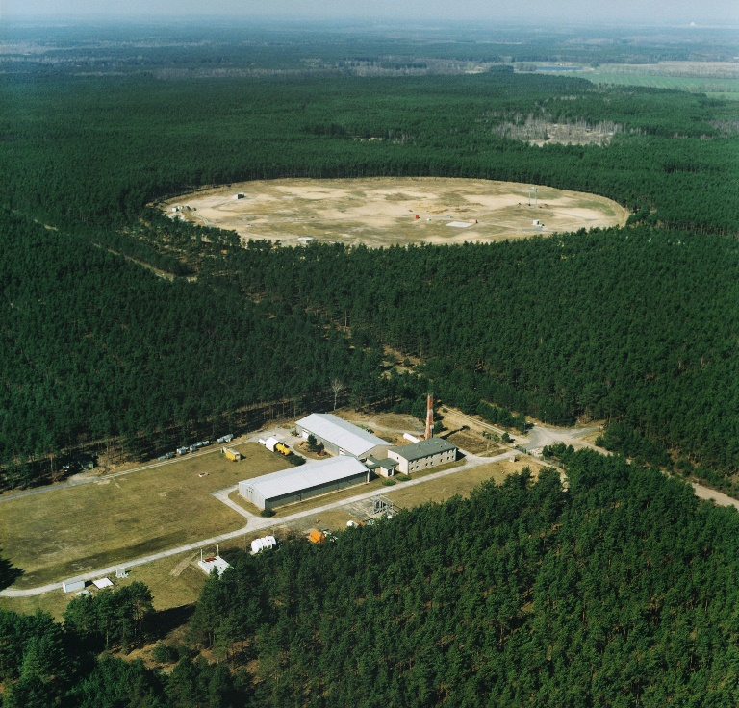

**B**

**A**

**Fig.10. Aerial photograph of parts of the BAM-TTS test site at Horstwalde**

**A: new pile test site. B: NDT-CE test and validation centre. Photo: BAM.**

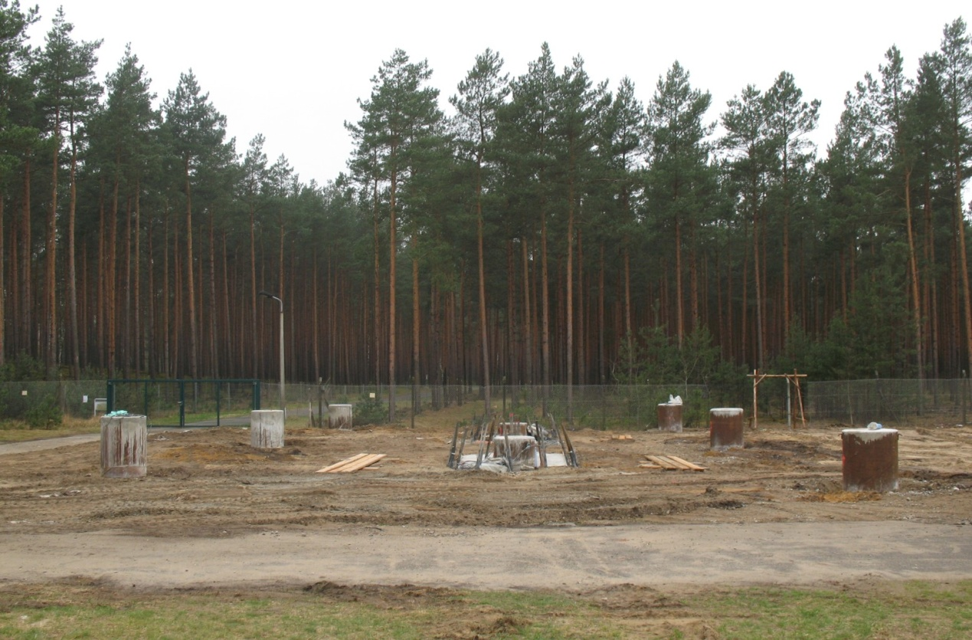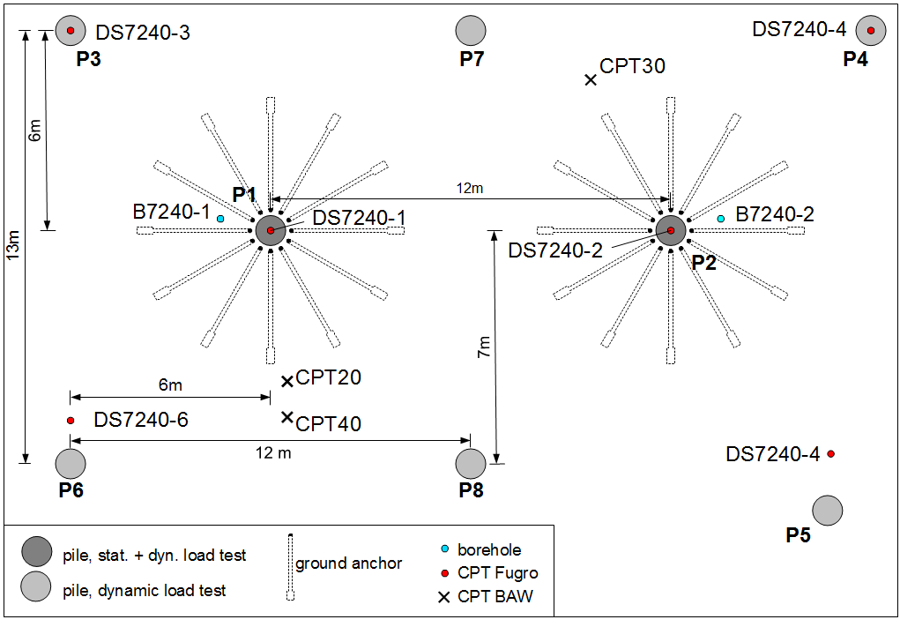

Layout of the pile test site

BAM-TTS test site at Horstwalde, Germany

**Fig.11. Pile test site at Horstwalde and Layout of the pile test site (Baeßler et al., 2012).**

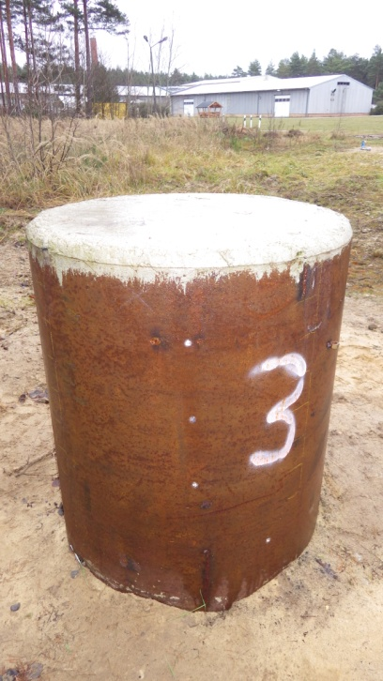

**Fig.12. Topmost part of Pile above the ground surrounded by steel ring (Baeßler et al., 2012).**

|  |  |
| --- | --- |
|  |  |
|  |

Fig.13. Pile 7 after excavation. Tension cracks visible at 3.75 m depth below pile head (Baeßler et al., 2012).

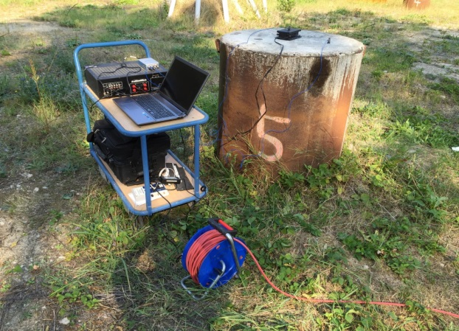

Fig.14 Experimental setup

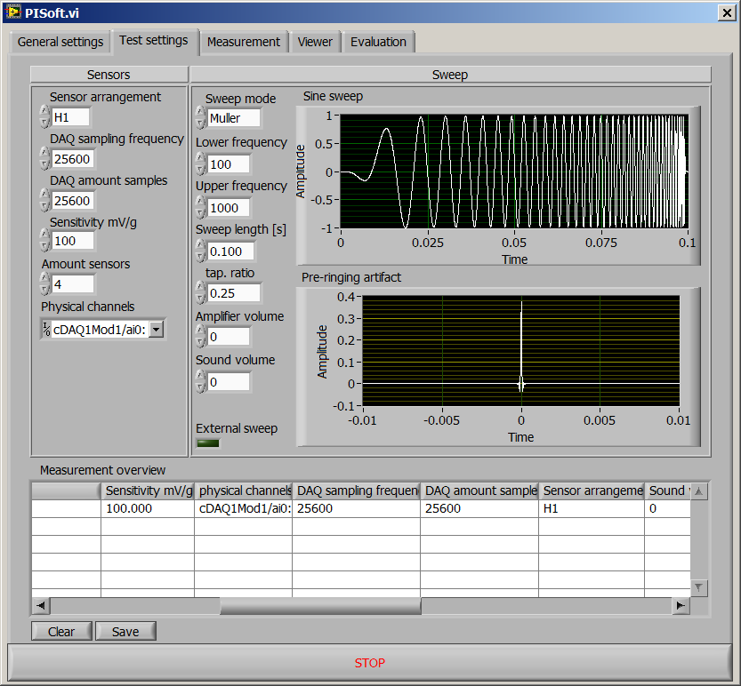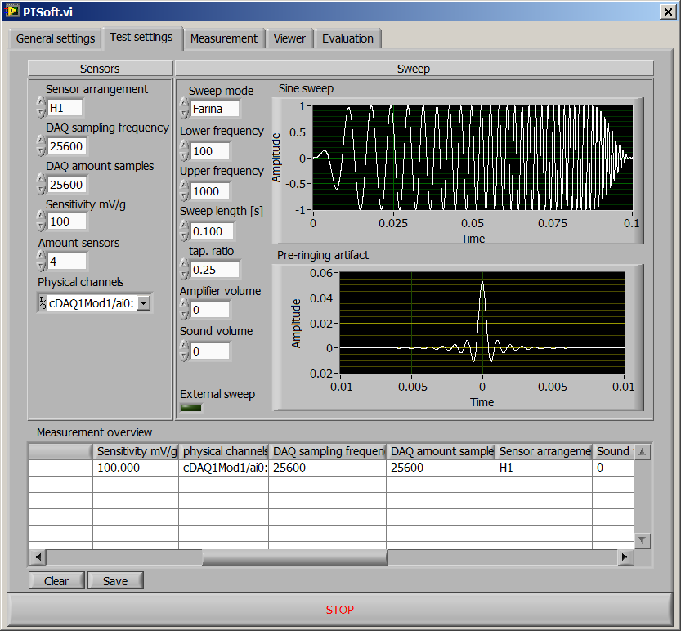

1. Muller sweep
2. Farina sweep

**Fig.15. Data acquisition software**

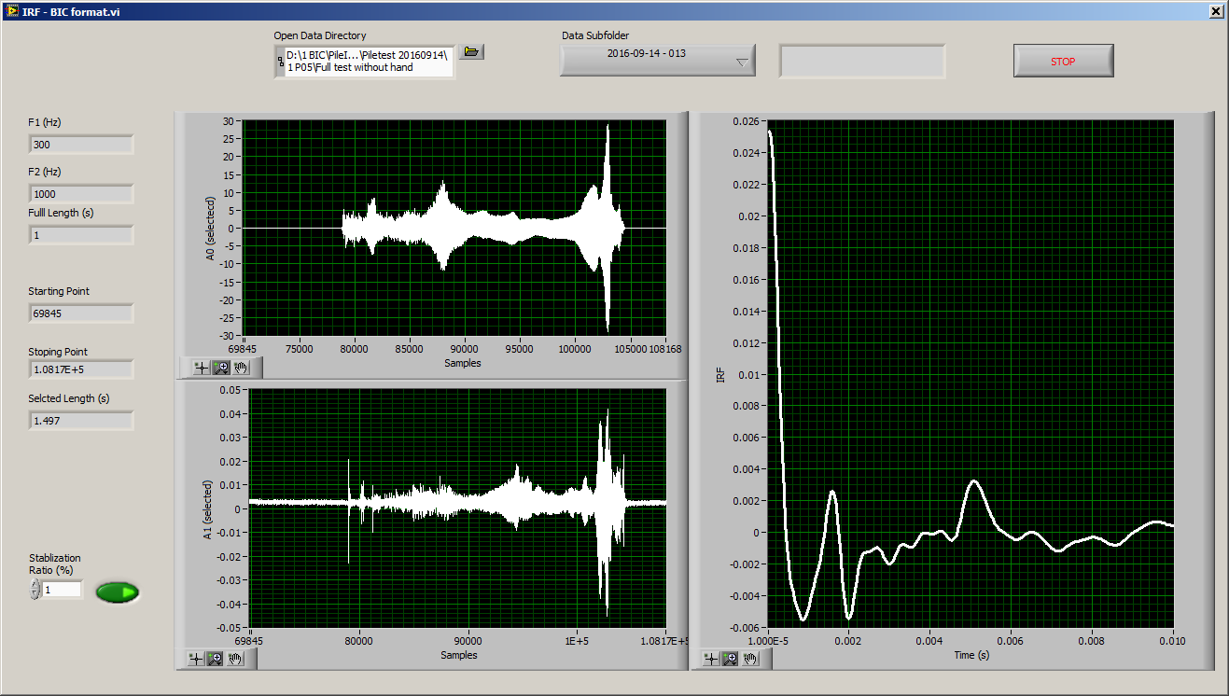

**Fig.16. Pile diagnosis software**



Toe

IRF curve (2016)

PIT reflectogram (2015)

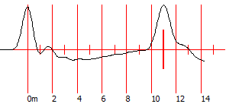

C = 4400 m/s; Amp:23; Filter:4



PIT reflectogram (2012)

**Fig.17.: Comparison results of PIT and IRF methods for Pile 3**

IRF curve (2016)

PIT reflectogram (2015)



Toe

C = 4000 m/s; Amp: 5; Filter:6

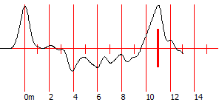

PIT reflectogram (2012)

**Fig.18.: Comparison results of PIT and IRF methods for Pile 4**

IRF curve (2016)

PIT reflectogram (2015)



Toe

Defect

C = 4400 m/s; Amp: 6; Filter: 4

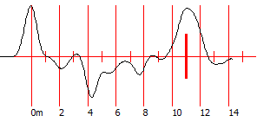

PIT reflectogram (2012)

**Fig.19.: Comparison results of PIT and IRF methods for Pile 5**

IRF curve (2016)

PIT reflectogram (2015)



Toe

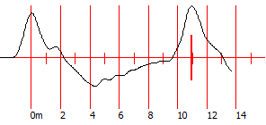

C = 4250 m/s; Amp: 4.6; Filter: 4



PIT reflectogram (2012)

**Fig.20.: Comparison results of PIT and IRF methods for Pile 6**

IRF curve (2016)

PIT reflectogram (2015)  
)



Toe

Defect

C = 4400; Amp: 6; Filter: 4

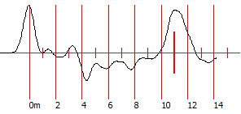

PIT reflectogram (2012)

**Fig.21.: Comparison results of PIT and IRF methods for Pile 7**

IRF curve (2016)

PIT reflectogram (2015)



Toe

Defect

C = 4150 m/s; Amp:4.1, F:0

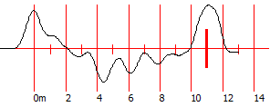

PIT reflectogram (2012)

**Fig.22.: Comparison results of PIT and IRF methods for Pile 8**



Toe

Toe

Toe

Defect

Defect

**Fig.23.: Comparison results of stabilization factor**