Figures.

Figure 1

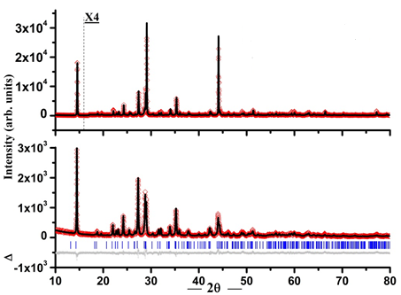

b

a

Figure 2.

|  |
| --- |
| **(a)**  **C:\Users\nali\Desktop\Dr Zahida Malik\IIINvd Sb4Cl2O5._Code24029-1.png** |
| **(b)**  **C:\Users\nali\Desktop\Dr Zahida Malik\IINvd Sb4Cl2O5._Code24029.png** |
|  |

Figure 3.

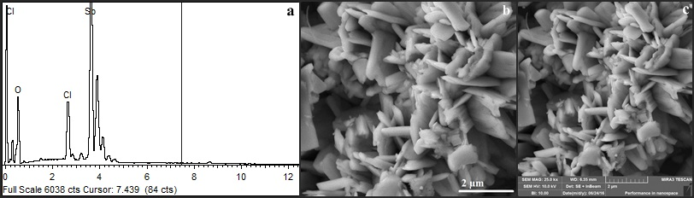

Figure 4.

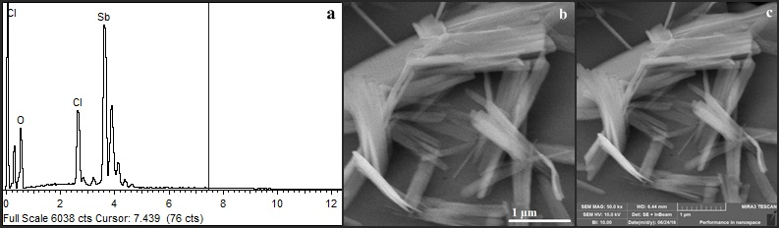

Figure 5.

|  |  |
| --- | --- |
| C:\Users\Nitasha koaml\Desktop\Capture.JPG  a | C:\Users\Nitasha koaml\Desktop\2.JPG  b |

Figure 6.

