Pain Evaluation Using Analgesia Nociception Index During Surgical Operation

Jiann-Shing Shieh
Dept. Mechanical Engineering and Innovation Center for Big Data and Digital Convergence Yuan Ze University.
Chung-Li, Taiwan
jsshieh@saturn.yzu.edu.tw
Bhekumuzi Mathunjwa
Dept. Mechanical Engineering and Innovation Center for Big Data and Digital Convergence Yuan Ze University.
Chung-Li, Taiwan
mathunjwabhekie@gmail.com
Muammar Sadrawi
Dept. Mechanical Engineering and Innovation Center for Big Data and Digital Convergence Yuan Ze University.
Chung-Li, Taiwan
muammarsadrawi@yahoo.com
Maysam F. Abbod
Dept. Electronic and Computer Engineering
Brunel University London
Uxbridge, UK
maysam.abbod@brunel.ac.uk

Abstract—The international association for the study of pain (IASP), describes pain as an unpleasant sensory and emotional experience associated with actual or potential tissue damage. Pain is a system of defense mechanism that prompts the body to avoid the source of noxious stimulation and a potential area of tissue damage. Electrocardiogram (ECG) is the electrical activity of the heart. ECG gives transthoracic interpretation of the electrical activity of the heart over a period of time. Detailed examination of ECG signal give information concerning the condition of the heart at a given moment. The analgesia nociception index (ANI) is an index that is associated with the autonomic nervous system. It is employed to find pain levels, heart rate variability, and sympathetic system activity during general anesthesia. In this paper we aimed to test the potential of ANI to notice painful situations during surgical operation. To test this ability, we examined ANI’s response during surgical operations. The analysis reveals that the index decreases during events where more pain is induced.
Keywords—Surgical Operation, pain evaluation, Analgesia Nociception index, Electrocardiogram.

Introduction
Anesthesiology has changed from just relieving pain and inducing unconsciousness for a clinical procedure to a complex set of interactions and a wide range of procedures [1]. Now anesthesia has evolved from being a dangerous procedure to involve qualified anesthesiologists, advanced equipment, number of drugs, and an endless list of governing regulations. Anesthesiology has become one of the leading technology dependent and safe procedure due to the care and the level of accuracy that is demanded from clinicians. The first anesthesia administration surgical procedure occurred in October 16, 1846. The procedure was wrapped in controversy due to the use of secret compound (sulfuric ether). Ether use was only registered two years before, for short dentistry procedures, only in the referred public demonstration. A longer surgical intervention took place at the Massachusetts General Hospital [2, 3]. Later more drugs were introduced and the concept of anesthesia began to gain form.
The international association for the study of pain (IASP) [4], describes pain as a detestable sensory and emotional experience associated with a potential tissue damage. Pain can also be described in terms of some studied features like conduction velocity, site of occurrence, and pathways [5]. Based on factors like complex reactions of physiology, anxiety, social expectations, past history and communication skills, pain analysis and the optimization of analgesic therapy remain a challenge [5]. Self-evaluation pain scales like the visual analog scale (VAS) express a subjective occurrence of nociception and cannot be obtained on a continuous basis. Their use may lead to a delay in administration of analgesic drugs in cultures where pain expression is viewed differently. A VAS is a 10 centimeters calibrated equipped which is moved by the patient to score the pain. A VAS over 3 reflects a sign of pain. Due to the fact that such a measure gives subjective and timely information, it can only be used for conscious patients and during critical care units [6].
Lately, encouraging results of an index based on detecting the patient’s hemodynamic responses to surgical stimuli and analgesic medications during general anesthesia (surgical pleth index, SPI) were reported [7, 8]. SPI indicates the patient’s responses from increased sympathetic activity as a response to painful situation. Preceding researches applied the ECG signal to continuously measure the ANS reaction and its activity to anesthesia medication and further to nociceptive stimuli [9] which is called the analgesia nociception index (ANI) to develop an original HRV index. Numerous clinical validations proposed the potential for ANI to evaluation the analgesia/nociception balance [9]. This is evident that the index is capable of identifying noxious stimulus with an increased sensitivity and specificity than clinical parameters like arterial blood pressure and heart rate.
The main purpose of the research is to find a proper way for modern medicine to identify and quickly alleviate pain which has always been difficult to qualify, quantify, and treat adequately during a surgical operation.

Methods and Materials

ANI computation

After filtering, RR series are then re-sampled at 8 Hz using a linear interpolation. In order to compute the RR series analysis, RR samples are isolated into a 64-second moving window (512 samples). The signal is then normalized inside the moving window for patients’ comparability. The mean value (M) calculated as the first step of normalization as shown in (1).
 | $$M= \frac{1}{N}\sum_{i=1}^{N}{({RR}_{i}})$$ | (1)
Where ${RR}_{i}$ represents the RR samples values and N represents the number of samples in the window. The mean value M is then deducted from each sample of the window as shown in (2) [10].
 | $${RR}_{i}=\left({RR}_{i}-M\right)$$ | (2)

The RR series that we obtain is used for the computation of the norm (S) value.
 | $$S=\sqrt{\sum_{i=1}^{N}{{\left({RR}_{i}\right)}^{2}}}$$ | (3)
Lastly, the norm value S is obtained from the RR series.
 | $${RR}_{i}={{RR}_{i}}/S$$ | (4)
The RR series is bandpass filtered between [0.15-0.4 Hz]. This is because the method is constructed on the analysis of HF changes [10].

Area under the curve (AUC) parameter computation
The heart respiratory interaction is evaluated by measuring its area of influence on the RR series as shown in Fig. 1. Local minima and local maxima are then detected, and the upper and lower covers are plotted by connecting the upper and lower envelop. After detecting the upper and lower envelop, the delineated surface is measured which is the total enveloped area (Env_Tot). This Env_Tot estimation permits obtaining an index which does not depend on respiratory frequency changes.
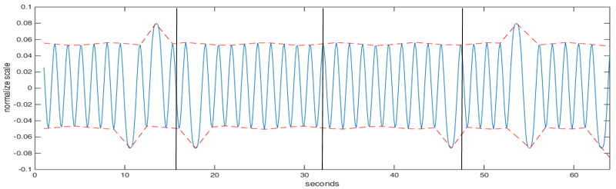
Fig. 1. Normalized, mean centered and band pass filtered RR series.
We divided the 64 sec moving window into four sub-windows of 16 sec to boost the time sensitivity of the method. The smallest area under the curve is then calculated (AUCmin).

 | ANI = 100*[a*AUCmin+b]/12.8 | (5)
Where a=5.1 and b=1.2 have been determined to acquire a better correlation between the visual pattern of the parasympathetic influence on RR series and the quantitative measurement of ANI. ANI is calculated to show a fraction of the total window surface leading to values between 0 and 100.

Data source
In this study, ECG signals were collected from subjects between the age of 20 and 80 years old that underwent a general anesthesia surgery at the national Taiwan university hospital (NTUH). Patients with a severe respiratory system, ANS altering diseases, or medications did not take part in the study. The equipments used in the operation room include a physiological monitor (IntelliVue MP60) as shown in Fig. 2.
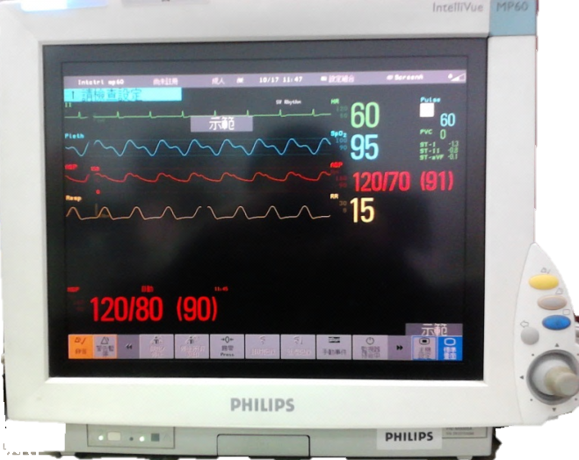
Fig. 2. Philips IntelliVue MP60
Patient’s physiological signals, such as peripheral capillary oxygen saturation (SpO2), blood pressure (BP), electroencephalogram (EEG), electrocardiogram (ECG) and arterial blood pressure (ABP) are displayed in this equipment in real time. When the data is being collected, a researcher writes down the physical response of the patient and surgical events including the time of occurrence. The main focus of this research was on ECG signals analysis which is then used to calculate the RRi of the patient. Electrodes were attached on the patient’s body which was then connected to the ECG monitoring equipment as shown in Fig. 3. ECG signals were recorded with a sampling rate of 512 Hz. Fig. 4 shows the surgical process underwent by the patients. The protocol received approval for a prospective non interventional study from the institutional review board (IRB) of national Taiwan university hospital, and all subjects gave informed consent before the study.
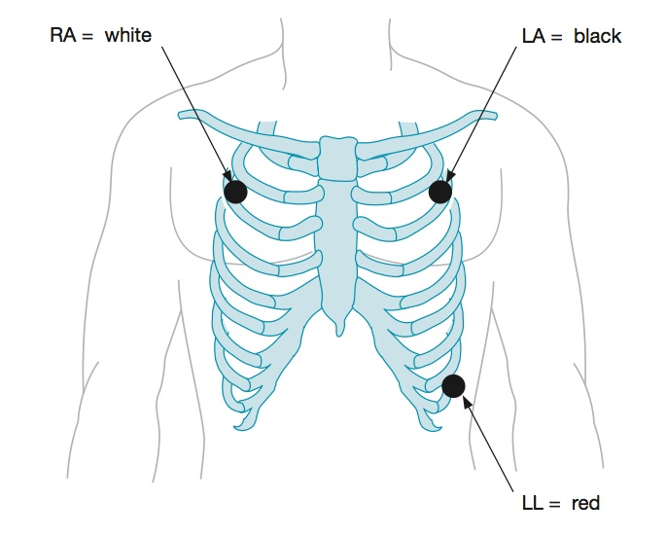
Fig. 3. ECG electrode attachment
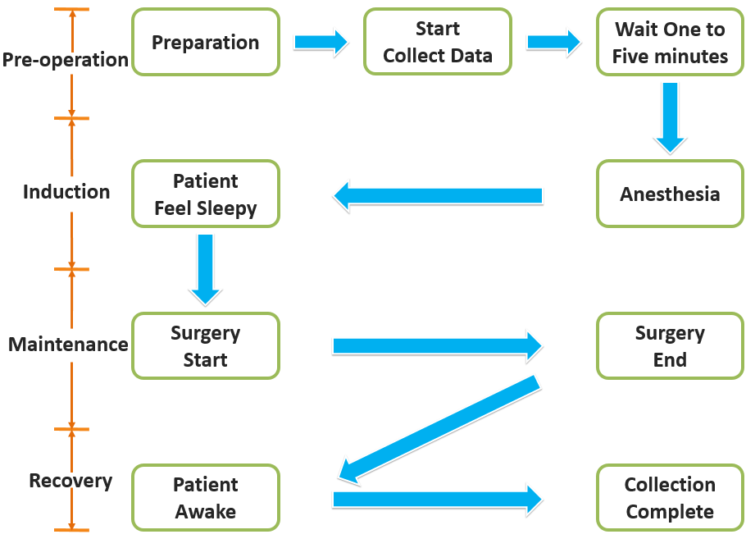 Fig. 4. Surgery process

Results

ANI analysis
We investigated 15 patients aged between 20 to 80 year undergoing surgical operations at NTUH. ECG signals were collected from each of the patient using a physiological monitor (IntelliVue MP60). R waves were detected from the ECG. RR interval series were mean centered, normalized, and bandpass filtered between [0.15Hz-0.5Hz].
Fig. 5 shows an ANI index with surgical events for a patient undergoing 112 minute of surgical operation. The events were recorded by a nurse and a research student inside the operating room. They recorded the events and the time of occurrence to help match the recorded data with the events during analysis. The recorded events include the time and duration, the beginning of surgery, during intubation, pain relief drug administration, the time when the doctor is making an incision with the electric knife, during stitching, and the time the surgery ends.
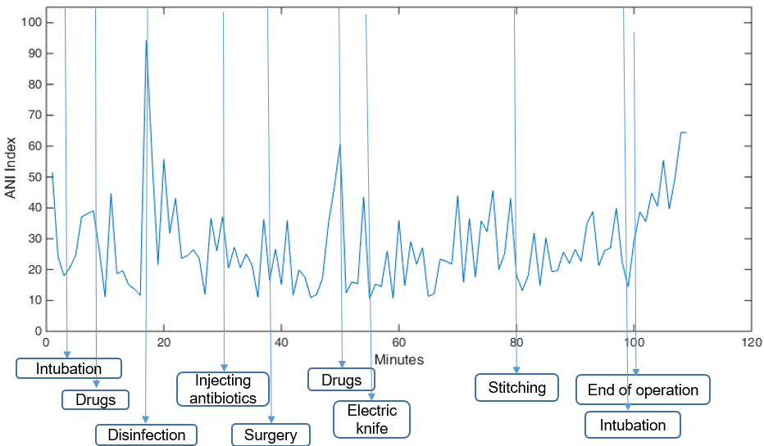
Fig. 5. ANI index with surgical events for a patient undergoing 112 minute of surgical operation. The figure shows the ANI index and surgical event at that period.
Table 1 shows the mean and standard deviation of the ANI index for 15 patients before the surgery, at the end of surgery, during drug administration (usually Propofol, Lidocaine and Fentanyl), during intubation, surgery and stitching. The table also shows the total time taken for each one of the surgical operations. The time only include the duration from when the electrodes were plugged into the patient’s body to start recording the ECG data to the time they were removed. The results show ANI mean and SD of 40.77±9.99 before the surgery, 44.62±10.69 after the surgery, 39.52±8.36 during drug administration, 30.39±7.50 during intubation, 24.26±7.04 during electric knife incision, and 34.47±8.62 during stitching. The mean and standard deviation for the period of the surgery is 154±62.64 min. ANI index was not available (N-A) when the electrode was accidentally detached from the patient’s body.

CONCLUSION

In this research, the ANI index is applied to evaluate pain during a surgical operation. The study presented in this research shows that a more painful situation in the surgical operation is associated with a reduced ANI index, which is evidence that ANI calculation is an instrument capable of computing a difference in the level of pain during surgery.
Despite the possibility that the opening trial on 15 subjects undergoing surgery gives good initial results, investigations to a bigger number of subjects are still going on to correctly evaluate the system's regulation performances.

Table 1. Shows the mean and standard deviation of the ANI index for the 15 patients before the surgery, at the end of surgery, during drug administration, during intubation, during surgery and stitching. The Table also shows the total time taken for each operation.

Case | Time  (min) | Before Surgery | End Of Surgery | Drugs  (Propofol) | Intubation | During Surgery | Stitching
1 | 211 | 40.15±N-A | 51.33±13.94 | 49.26±12.89 | 26.30±N-A | 24.54±9.87 | 42.61±14.70
2 | 303 | 44.97±22.86 | 41.16±15.58 | 38.89±13.42 | 40.16±28.39 | 22.31±7.82 | 32.61±13.14
3 | 159 | 41.89±15.32 | 53.89±31.30 | 46.41±23.61 | 44.53±31.49 | 20.32±10.92 | 40.08±15.67
4 | 111 | 30.28±11.95 | 50.39±20.82 | 30.37±15.68 | 26.08±18.44 | 25.39±9.18 | 31.49±11.37
5 | 129 | 51.50±13.73 | 59.57±10.48 | 47.85±N-A | 24.69±N-A | 32.07±14.94 | 42.23±18.19
6 | 107 | 57.51±13.14 | 54.18±12.48 | 44.72±10.22 | 35.33±N-A | 26.43±10.86 | 39.01±11.52
7 | 118 | 33.34±7.75 | 29.54±6.70 | 25.77±8.03 | N-A | 12.65±3.94 | 23.98±0.42
8 | 238 | 50.41±11.47 | 60.39±8.26 | 49.58±N-A | N-A | 35.23±15.86 | 52.75±19.92
9 | 101 | 37.01±11.96 | 40.39±11.46 | 23.35±N-A | 19.49±N-A | 21.69±8.40 | 34.31±4.75
10 | 211 | 57.71±27.79 | 33.67±9.64 | 40.61±15.68 | 24.29±N-A | 23.36±7.41 | 39.46±5.52
11 | 106 | 29.08±6.18 | 28.32±15.33 | 41.69±7.75 | 30.58±N-A | 26.12±7.48 | 27.70±9.92
12 | 145 | 27.77±4.52 | 35.28±9.49 | 35.45±19.17 | 28.74±N-A | 16.02±3.67 | 24.72±8.41
13 | 102 | 42.20±13.73 | 53.27±9.02 | 45.31±11.36 | 40.61±N-A | 38.95±25.33 | N-A
14 | 182 | 37.06±9.74 | 39.66±5.94 | 32.773±6.39 | 28.57±N-A | 17.21±6.68 | 28.69±13.22
15 | 87 | 30.71±11.39 | 38.22±6.35 | 40.84±N-A | 25.83±N-A | 21.63±7.64 | 22.95±0.67
mean±SD | 154±62.64 | 40.77±9.99 | 44.62±10.69 | 39.52±8.36 | 30.39±7.50 | 24.26±7.04 | 34.47±8.62

Lastly, we propose that applying this system to a big number of subjects would permit to express the perfect regulation constants values for each analgesic drug permitting to get a set of effective analgesia regulation models. We also plan to do a statistical significance testing to produce a statement that the observation represents a true causal relationship and not a chance occurrence.
ACKNOWLEDGMENT
This research was supported by the two centers of Innovation Center for Biomedical and Healthcare Technology, and Innovation Center for Big Data and Digital Convergence, Yuan Ze University, Taiwan.
REFERENCES
[1] R. D. Miller, editor, “Miller's Anesthesia,” The Journal of the American Society of Anesthesiologists, vol. 103, no. 3, pp. 673-673, 2005.
[2] S. P. Desai, M. S. Desai, R. Maddi, and G. E. Battit, “A tale of two paintings: Depictions of the first public demonstration of ether anesthesia. Anesthesiology,” The Journal of the American Society of Anesthesiologists, vol. 106, no. 5, pp. 1046-1050, 2007.
[3] F. D. Moore, “John Collins Warren and his act of conscience - a brief narrative of the trial and triumph of a great surgeon,” Annals of Surgery, vol. 229, no. 2, pp. 187, 1999.
[4] H. Merskey and N. Bogduk, editors. “Part III Pain Terms, a Current List with Definitions and Notes on Usage.” Classification of Chronic Pain, Task Force on Taxonomy, IASP Press, 2nd edition, pp. 207-214, 1994.
[5] M. L. Guen, M. Jeanne, K. Sievert, M. A. Moubarik, T. Chazot, P. A. Laloe, J. F. Dreyfus, M. Fischler. "The
Analgesia Nociception Index: a pilot study to evaluation of a new pain parameter during labor", International Journal of Obstetric Anesthesia, vol. 21, no. 2, pp. 146-151, 2012.
[6] R. Logier, M. Jeanne, A. Dassonneville, M. Delecroix, B. Tavernier. "PhysioDoloris: a monitoring device for Analgesia / Nociception balance evaluation using Heart Rate Variability analysis," Annual International Conference of the IEEE Engineering in Medicine and Biology, pp. 1194-1197, 2010.
[7] I. K. Song, J. I. Sang-Hwani, E. H. Kim, J. I. Lee, J. T. Kim, H. S. Kim. "Comparison of the effect of different infusion rates of sufentanil on surgical stress index during cranial pinning in children under general anaesthesia: a randomized controlled study," BioMed Center Anesthesiology, vol. 17, no. 1, pp. 167, 2017.
[8] M. Gruenewald, C. Ilies, J. Herz, T. Schoenherr, A. Fudickar, J. Hocker, B. Bein. "Influence of nociceptive stimulation on analgesia nociception index (ANI) during propofol-remifentanil anaesthesia", British Journal of Anaesthesia, vol. 110, no. 6, pp. 1024-1030, 2013.
[9] J. D. Jonckheere, M. Delecroix, M. Jeanne, A. Keribedj, N. Couturier, R. Logier. "Automated analgesic drugs delivery guided by vagal tone evaluation: Interest of the Analgesia Nociception Index (ANI)." Annual International Conference of the IEEE Engineering in Medicine and Biology Society, pp. 1952-1955, 2013
[10] D. Rommel, J. L. Nandrino, M. Jeanne, R. Logier. "Heart rate variability analysis as an index of emotion regulation processes: Interest of the Analgesia Nociception Index (ANI)." Annual International Conference of the IEEE Engineering in Medicine and Biology Society, pp. 3432-3435, 2012.

