Antibacterial Activity of Mg_{1-x}Ni_{x}O(x=0.5) Nano-Solid Solution; Experimental and Computational Approach
M. Qammar^{[a]}, Z. Malik^{[*a, d]}, F. Malik^{[b]}, T. Baig^{[c]}, Abdul J Chaudhary^{[d]}

[a] Memoona Qammar, Department of chemistry, School of Natural Sciences, National University of Sciences & Technology, H-12, Islamabad-44000, Pakistan

[*a, d] Dr. Zahida Malik, Assistant Professor, Department of chemistry, School of Natural Sciences, National University of Sciences & Technology, H-12, Islamabad-44000, Pakistan, Email: zahida.malik@sns.nust.edu.pk
[b] Dr. Fouzia Parveen Malik, Assistant Professor Research Center For Modeling & Simulation, National University of Science & Technology, H-12, Islamabad-44000, Pakistan

[c] Dr. Tahir Baig, Assistant Professor Atta-Ur-Rahman School of Applied Sciences and Biotechnology, National University of Science & Technology, H-12, Islamabad-44000, Pakistan,

[d] Dr. Abdul J. Chaudhary, Institute for Environment, Health and Societies, Brunel University London, Uxbridge, UB8 3PH, United Kingdom

Antibacterial Activity of Mg_{1-x}Ni_{x}O (x=0.5) Nano-Solid Solution; Experimental and Computational Approach
M. Qammar^{[a]}, Z. Malik^{[*a, d]}, F. Malik^{[b]}, T. Baig^{[c]}, Abdul J Chaudhary^{[d]}

Graphical Abstract
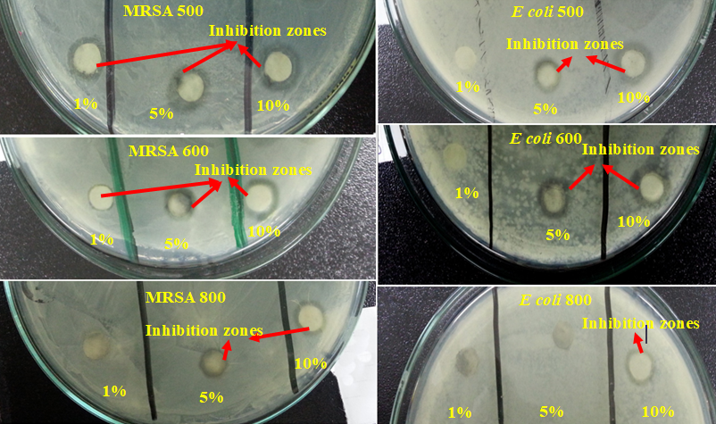
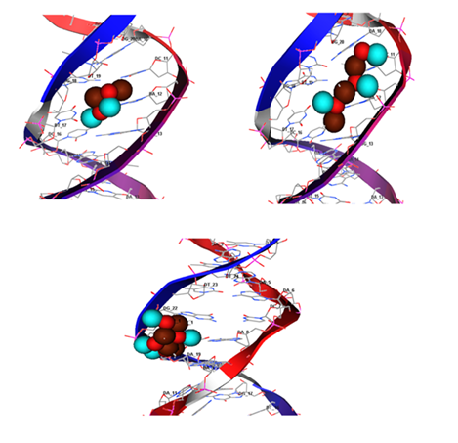
Experimental studies
Computational studies

Abstract
A wet chemical route was followed for the synthesis of Mg_{1-x}Ni_{x}O(x=0.5) nano-solid solution. The nanoparticles were characterized by using XRD, SEM and EDX analytical techniques. The nano particles were crystallized in NaCl structure type with crystallite size range; 10-30nm with spherical geometry and average particle size range; 54-63nm for the materials annealed at 500, 600 and 800ºC, respectively. Antibacterial activities of the materials were investigated and compared against E. Coli and MRSA via disc diffusion method with respect to the surface O²⁻ and particle size. DFT studies were carried out for structural and geometric analysis of Mg_{1-x}Ni_{x}O slab using Generalized Gradient Approximation (GGA). Energetic behavior of the compound was determined by band gap and density of state (DOS) at the same level of theory. Molecular docking studies of the material with bacterial DNA revealed spontaneity of the reaction depicting highest binding strength with DNA in case of MgNiO dimer.
Keywords: Bioorganic chemistry; Nanostructures; Mg_{1-x}Ni_{x}O (x=0.5) Nano-solid solution; Antibacterial activity; Computational Studies.

Introduction.
Certain bacteria are the causative agent of most of the waterborne diseases. The major reason behind this issue is the increase in urbanization and anthropological activities [1]. At present nano-materials have numerous applications in every field like agriculture, biomedicine, environmental, biotechnology and electronics [2-6], e.g. metal oxides like MgO, ZnO, CaO and NiO are research target as ceramic-based antibacterial agents [7-9]. MgO [10] and NiO [11] show antibacterial activity in small amounts and in the absence of light. There are two major factors responsible for the antibacterial action of such materials; the generation of super oxide ion (O²⁻) and increase in pH of suspensions [12]. The solid solution has enhanced antibacterial activity as compared to pure MgO up-till now Zn_{x}Mg_{1-x}O [13] and Ni_{x}Mg_{1-x}O(x=0.05, 0.10, 0.20, 0.50 and 0.80) [14] bulk solid solutions are studied in this regard.
NiO and MgO show 100% solid solubility in the bulk form due to the comparable atomic radii i.e. Mg²⁺ = 0.670 and Ni²⁺= 0.650Å [15]. According to our literature survey the MgNiO has been synthesized and studied mostly in form of thin films and there is very little literature available for MgNiO nanoparticles [15, 17-19]. The antibacterial potential of various oxides such as CaO, MgO and ZnO [20] has been studied but the antibacterial applications of MgNiO solid solution in the nano dimension have not been studied yet. Effect of temperature on composition and the antibacterial activity of bulk Mg_{1-x}Ni_{x}O has been studied by T. Ohira [14].
The present study intends to investigate the inhibition potentials of the Mg_{1-x}Ni_{x}O solid solution nanomaterials against gram positive and gram negative bacteria, along with the thermal effect on the size and composition of nanoparticles. Finally, it aims on computational studies for the optimization of geometry, energetics and molecular docking to see the antibacterial activity of the material in order to verify the experimental results.
- Methods
2.1. Experimental Studies
2.1.1. Material preparation. The precursors with 99.99% purity; Ni (NO₃)₂.6H₂O (BDH Chemicals Ltd.), Mg(NO₃)₂.6H₂O, ethylene glycol (Sigma Aldrich) and NaOH (Merck Millipore) were used for synthesis via sol-gel method. The 0.25M solution of metal salts in ethylene glycol was prepared in which NaOH (aq) was added drop wise under constant stirring until the formation of a homogenous gel. After aging the gel was centrifuged @ 10000rpm for 20min followed by washing with water and ethanol. The samples were vacuum dried at 150°C and subjected to annealing at 500°C for 3h. As a first step, molarity of the gelating agent was optimized by testing the effect of 0.1, 0.5, 1 and 1.5M aqueous NaOH solutions upon morphology and composition of the nano-solid solution (NSS). The experiment was repeated as above by using the optimized molarity of NaOH and finally dried material was than annealed at three different temperatures i.e. 500, 600 and 800°C for 3h.

2.2. Characterization
2.2.1. X-Ray Diffraction (XRD). The XRD data were collected for each sample in as cast and annealed state employing diffractometer, Model STOE Germany operating at 40kV with ${Cuk}_{α1}$monochromatic radiation in range of 20º<2θ<80º. For qualitative analysis POWDER CELL program was used [21] while quantitative Rietveld refinements of the X-Ray powder diffraction data were performed with the FULLPROF program [22].
    - Scanning Electron Microscopy (SEM). The SEM via Electron Probe Micro-Analyses (EPMA) was performed on a MIRA3 TESCAN microscope equipped with an EDX system operated at 40kV. The as-cast and annealed powder samples were coated with graphite using standard procedures before analyses.
2.3. Antibacterial Activity Test Experiment
2. 3.1. Bacterial Suspension. NSS suspensions were tested against two types of bacteria: gram-negative; Escherichia Coli DH5α (E. Coli), and gram-positive; Methicillin-Resistant Staphylococcus Aureus (MRSA). Both bacteria were cultured in L.B broth (Merck, Germany) having yeast extract 5.0g/L, NaCl 10g/L and peptone10g/L. The medium was prepared as 2.5w/v% of aq solution of broth that was autoclaved at 121°C. Almost 10mL medium was added to different test tubes which were incubated at 37°C for 18-24h in order to check any bacterial growth/contaminations. The contaminated media were discarded and desired bacteria were added to the clean ones, under laminar flow cabinet and were subjected to shaking at 37°C for 24h.
2.3.2. Growth medium. The growth medium was prepared by using 2.5w/v% aq solution of nutrient agar (OXOID Ltd., England), autoclaved at 121°C. Before its solidification 30mL agar solution was poured in different autoclaved petri plates under laminar flow cabinet. The agar plates were sealed with plastic foil and incubated at 37°C for 18-24h in order to check the contaminations and neat agar plates were used for antibacterial tests.
2.3.3. Sample Disks. The discs with 6mm diameter were prepared by punching the (autoclaved) filter paper. The aqueous suspensions (1, 5 and 10 w/v %) of NSS were prepared and sonicated for 30min for homogenization.
2.3.4. Test. Antibacterial activity was tested via Disk Diffusion Method [23]. The bacterial suspensions after removing from shaker were diluted by pouring 1mL in 0.9% saline solution. Agar plates were prepared by adding 80µL diluted bacteria in labeled agar plates and were spread with the help of fire autoclaved glass spreader under laminar flow cabinet. After spreading filter paper disc was dipped in the respective suspension and was inserted onto the prepared agar plate. All sample plates were prepared in the same manner and were sealed with plastic wrap and placed in incubator at 37ºC for 18-24h. After 24h plates were removed from incubator and zones of inhibition were measured.
2.4. pH analysis
As the pH is very important factor for the antibacterial activity of the material. The pH analysis of all the samples was executed out at the room temperature by preparing 0.63g/dm³ suspensions in DI water after keeping static for 1h by using the reported method [14].
2.5. Theoretical Studies and Calculations
The calculations were performed, using ADF-BAND [24, 25] employing the generalized gradient approximation (GGA) due to Becke and Perdew [26] in conjunction with the PerdewWang (PW91) density functional [27]. The basis sets signifying the electron density consist of both Herman–Skillman numerical atomic orbitals (NAOs) and Slater-type orbitals (STOs) with a frozen core. Scalar relativistic corrections were included through the zeroth-order regular approximation [28]. A three-dimensional translational symmetry was used for the slab calculations of band structure and density of state. In all results overall convergence was well within 0.1eV, with the GGA and the unit cell size including the number of layers as the only remaining approximation.
Docking procedure. The MgNiO nanoparticles interactions with bacterial DNA were studied by molecular docking technique using MOE-dock through chemical computing Inc. at a Pentium 1.6GHz with memory comprising of 512MB and Windows as an operating system. The molecular structure of Mg_{1-x}Ni_{x}O (x=0.5) was drawn and optimized on MOE 2017 window using AMBER force field. Semi-empirical method PM3 was utilized to determine the values of binding free energy (ΔG) and the electrostatic binding constant (K_{b}) of MgNiO-DNA complex. This study was executed by the Optimization of the geometrical structure. The DNA duplex receptor was accessed from Protein Data Bank (PDB ID: 6FLQ), with a resolution of 3.6Å. 6FLQ was imported to MOE workstation using MOPAC 7.0 as an energy optimization tool. Water molecules were removed from the structure using MOE sequence editor followed by the protonation of 6FLQ. This model was administered to the site finder for a systematic conformational, all the parameters were set at default whereas RMS gradient was 0.01kcalmol⁻¹. In order to obtain maximum accuracy in the value of the final binding position, eighty (80) cycles for calculations were run. On the basis of the energetics ground, the best conformation was selected. Lastly, the minimum Final Docking energy (ΔG) was computed by running the docking procedure [29].
Results

3.1. Synthetic Chemistry.

In order to explain the chemistry involved in the whole synthesis protocol, our assumptions are summarized in the schematic diagram shown in Figure 1. In the 1st first step ${Mg}_{1-x}^{2+}{Ni}_{x}^{2+} {\left(OCH_{2}{CH}_{2}O\right)}^{2-}$ was obtained upon addition of Ni and Mg nitrates to EG which got converted to ${Mg}_{1-x}{Ni}_{x}(OH)_{2}$ upon addition of the NaOH (aq) solution. Both of these steps can be summarized as follows,
$${Mg}_{1-x}{Ni}_{x}(OH)_{2}+ 4 {NaOH}_{\left(aq\right)}→ {Mg}_{1-x}{{Ni}_{x}\left(OH\right)}_{2}+ {4NaNO}_{3}$$
In the next step washing with ethanol and water was carried out in order remove of NaNO₃ and EG, consequently oily appearance of materials was vanished. Next was the drying at 150°C which resulted in an evaporation of water and solidification of the gel. This gel was finally subjected to annealing at three different temperatures i.e. 500, 600 and 800°C for 3h in order to get Mg_{1-x}Ni_{x}O as single phase nanomaterial.
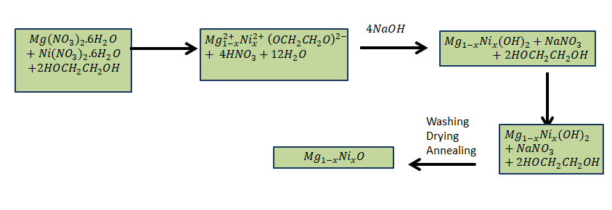
Fig. 1. Schematic diagram of the reactions involved in the synthesis of Mg1-xNixO (x = 0.5).

3.2. Characterization
3.2.1. Structural Analysis. X-Ray powder diffractrometry revealed the samples with 0.5M NaOH as a single phase solid solution of NiMgO with FCC symmetry (space group$Fm\overline{3}m$; #225) and NaCl type structure. The Rietveld refinement of the XRD patterns of the samples annealed at 500, 600 and 800°C showed a strong agreement between the measured and calculated pattern as observed in Figure 2 and reduced residual factors as mentioned in the Table 1. A negligible variation in lattice parameters has been observed due to same compositions of the samples annealed at different temperatures. The values of lattice parameters for Mg_{1-x}Ni_{x}O solid solution annealed at different temperatures lies intermediate between those of the pure bulk NiO and MgO [30]. Ni and Mg stay at 4a (0, 0, 0) position with 50% occupancy while O lies at 4b (½, ½, ½) position with 100% occupancy. Formula from refinement for all samples is the same if we take into account the standard deviations. The summary of refined parameters with standard deviations (mentioned in parenthesis) is given in Table 1.

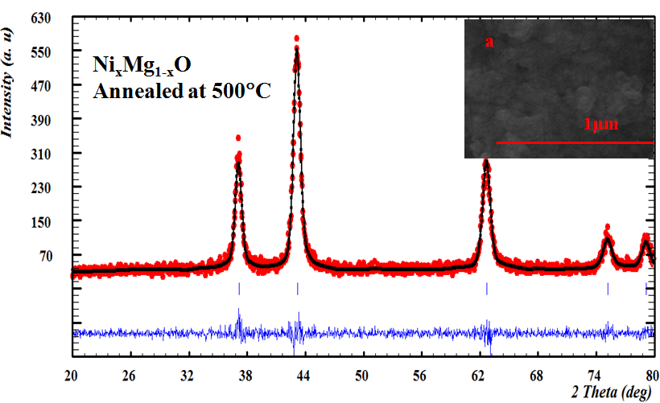
(222)
(311)
(220)
(200)
(111)
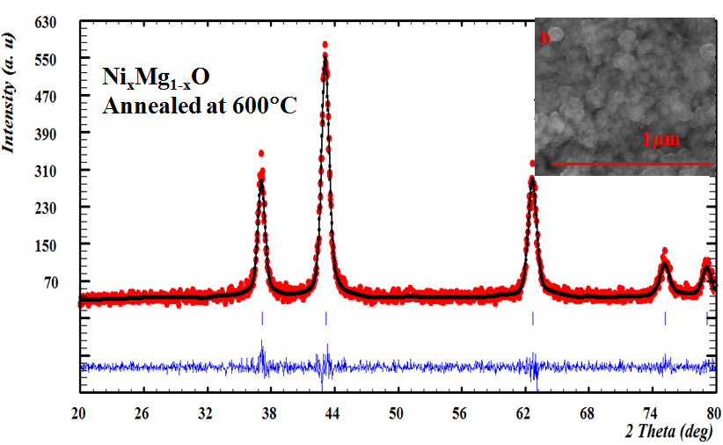
(222)
(311)
(220)
(200)
(111)
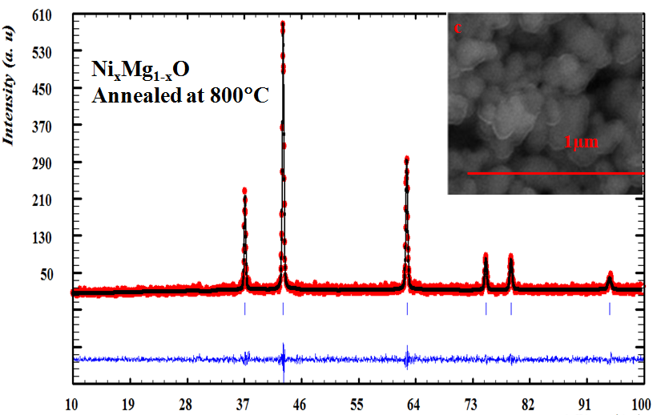
(311)
(222)
(200)
(111)
(220)
Fig. 2. Rietveld reﬁnements of PXRD patterns, showing observed patterns in red, calculated in black and difference in blue with insets of SEM images showing spherical morphology for the samples annealed at 500ºC, 600ºC and 800ºC for 3h.

Table 1. Rietveld refinement results for Mg_{1-x}Ni_{x}O(0.5) [this work] nanomaterials in comparison with bulk all crystallized in space group$Fm\overline{3}m$; 225 with NaCl structure type.
Parameters | Crystals data for Mg_{1-x}Ni_{x} O  XRD nanoparticles [this work] |  |  | Bulk XRD
 | 500ºC | 600ºC | 800ºC | [30] | [31] | [32]
Formula from refinement | Mg_{0.49}Ni_{0.51}O | Mg_{0.52}Ni_{0.50}O | Mg_{0.49}Ni_{0.50}O | NiO | MgO | Mg_{0.97}Ni_{0.03}O
a (nm) | 0.41886(14) | 0.41849(8) | 0.41920(8) | 0.41795(2) | 0.4217(2) | 4.2115
M*(x=y=z=0)  Occ. | 0.506(31)+  0.521(14) | 0.53(3)+  0.516(12) | 0.50(4)+  0.491(17) | 1.00 | 1.00 | 0.97+0.03
U_{iso} | 0.36(17) | 0.30(13) | 0.47(19) | - | - | -
O(x=y=z=½)  Occ. | 0.98(2) | 1.01(1) | 0.998(2) | 1.00 | 1.00 | 1.00
U_{iso} | 0.78(29) | 0.83(24) | 0.51(1) | - | - | -
V (Å³) | 73.486(0.04) | 73.291(0.02) | 73.667(0) | 73 | 75 | 73.8
d (g/cm³) | 5.147 | 5.144 | 5.167 | - | - | 5.18
2θº | 37.26 | 37.18 | 62.48 | - | - | -
FWHM (º) | 0.8013 | 0.4363 | 0.2770 | - | - | -
Crystallite size(nm) | 10.457 | 19.272 | 30.165 | - | - | -
R_{f} | 1.58 | 1.62 | 6.24 | - | - | -
R_{bragg} | 3.02 | 2.93 | 6.52 | - | - | -
χ² | 1.12 | 1.38 | 1.13 | - | - | -
GOF | 2.626 | 7.15 | 2.509 | - | - | -
M*-Ni+Mg

The XRD data was also employed to calculate the crystallite size of the via Scherer formula taking into account for the correction in peak broadening. The comparative data regarding particle size obtained by Scherer and WH plot has been summarized in Table 2.

Table 2. Showing the Crystallite sizes, Strain (ε) and Particle sizes of Mg_{1-x}Ni_{x}O (x=0.5) annealed at different temperatures.
Temperature  (°C) | 2θº | (kkl) | *Crystallite size (nm) | **Strain ε (%) | #Particle size (nm)
500 | 37.26 | (111) | 10.46 | 0.00122 | 54
600 | 37.18 | (111) | 19.3 | 0.00408 | 57
800 | 62.48 | (220) | 30.12 | -0.00031 | 63
*calculated from the Scherer Formula.
**calculated from WH plot.
# values from SEM analysis.

The least crystallite and particle size has been observed for the sample annealed at 500°C i.e., 10.46 and 54nm while at 800°C values of these parameters have increased i.e., 30.12 and 63nm. The XRD patterns of the samples revealed the obvious broadening in all peaks for the samples annealed at 500 and 600°C that is why calculations have been carried out at highest intensity peak at (111) at low 2θ and positive values for the strain in the structure (as shown in Table 2) are also the manifestation of the small crystallite sizes for these samples. The sharp peaks with least values for the FWHM has been observed for the sample annealed at 800°C due to bigger crystallite and nanoparticles sizes.
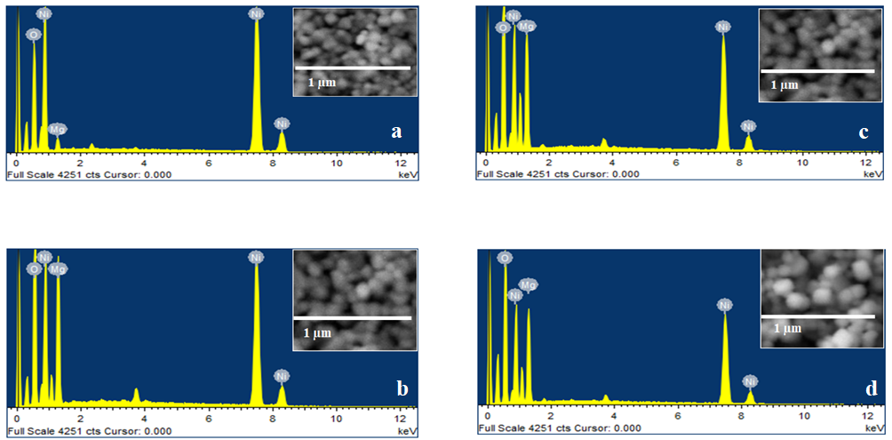
3.2.2. Morphological and elemental analysis. The morphology, particle size and composition of samples were assessed by using SEM and EDX, for the samples prepared by using different molarities (0.1, 0.5, 1 and 1.5M) of NaOH with constant metal ions concentrations. The best results were obtained for the sample prepared by using 0.5M NaOH (aq) solution, justified from the smallest average particle size i.e. 65nm with 21.49 at% of Mg. However, the sample prepared with 0.1M NaOH resulted in 82nm average particle but with 3.6 at% Mg concentration which is too small to be reliable. The samples prepared by using 1M (19.97 at % Mg) and 1.5M (20.24 at % Mg) NaOH had desirable Mg content but both of them have higher average particle sizes i.e. 84nm and 103.31nm, respectively as shown in Figure 3. So it has been concluded that 0.5 M (aq) gelating agent results in synthesis of monodispersed and uniform nanoparticles of Ni-Mg oxide.
Fig. 3. SEM and EDX spectra of sample prepared with (a) 0.1M (b) 0.5M (c) 1M and (d) 1.5M NaOH.

The single phase and monodispersed material was synthesized by using 0.5M NaOH aq solution and was subjected to anneal at three different temperatures (500, 600 and 800°C) for 3h in order to check the thermal effect upon morphology, structure, composition, and antibacterial activity. The average particle size of 54nm 57nm and 63nm was observed for the samples annealed at 500°C, 600 and 800°C, respectively and shown in Figure 2. Due to presence of more oxygen, sample annealed at 500°C was also black in color while others two were grey in color.

3.2. pH Analysis.

The pH analysis of 0.63g/L suspensions in DI water of all three materials reveals the values as 11.21, 10.84 and 10.73 for 500, 600 and 800ºC, respectively. Higher oxygen contents in the sample annealed at 500ºC is obvious from it higher pH, as shown by bulk Mg_{1-x}Ni_{x}O with higher oxygen contents [14].

3.3. Antibacterial activity.
The Mg_{1-x}Ni_{x}O nanoparticles were subjected to the antibacterial test against MRSA and E Coli; strains. All results compared with that of the positive control i.e. co-amoxiclav. The bar charts for the measured inhibition zones (shown in Figure 4) for different suspension concentrations have been plotted as shown in Figure 5.
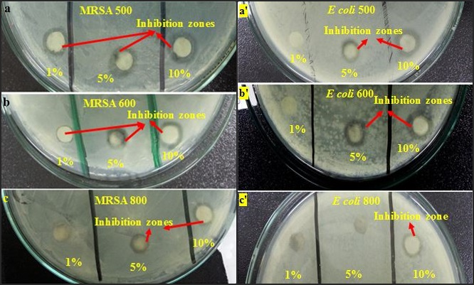
Fig. 4. Antibacterial activity of 1, 5 and 10% suspensions of samples annealed at; (a & a’) 500ºC, (b & b’) 600ºC and (c& c’) 800ºC [a,b,c - against MRSA and a’,b ’,c’-against E. Coli].

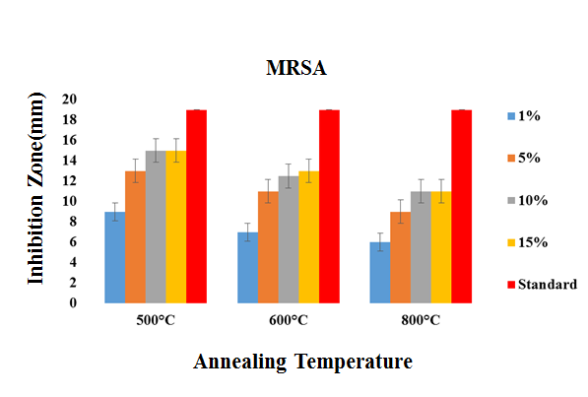
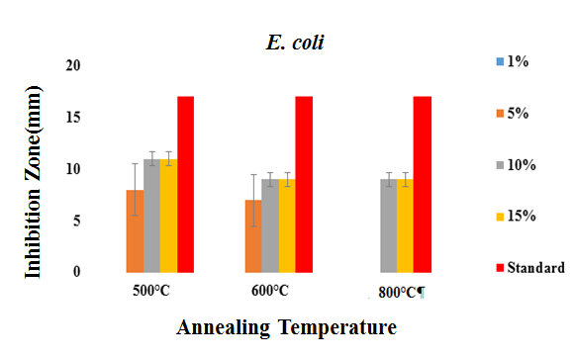
Fig. 5. Antibacterial activity of different concentrations i.e.; 1, 5, 10 and 15% (w/V) of Mg1-xNixO (x = 0.5) nanoparticles against; a. MRSA, b. E. Coli. The error bars indicate the standard error of mean. [Smaller the error bars, lesser will be the deviation in duplicate reading. All the error bars are small except for 5% concentrations used for E Coli. The reason behind this large error bar is the inactivity of 1% concentration].

3.3.1. Sample annealed at 500ºC. The material annealed at 500ºC showed antibacterial activity against both MRSA and E. Coli but more pronounced against MRSA. In case of MRSA 1% suspension of 500ºC annealed sample was also active but was inactive in case of E. Coli. Maximum antibacterial activities against both bacteria were obtained by 10% suspension of this sample.
3.3.2. Sample annealed at 600ºC. In case of sample annealed at 600ºC, results have shown its activity against both MRSA and E. Coli. but the magnitude of zones of inhibition stayed intermediate between those of the samples annealed at 500 and 800ºC.
3.3.3. Sample annealed at 800ºC. In this case, 1 % suspension remained inactive against MRSA while 1 % and 5 % suspensions remained inactive against E coli. The zones of inhibition were much smaller than those of 500ºC annealed sample.

3.4. Computational results.
3.4.1. Quantum chemical calculations and Structural Analysis. Three dimensional slab of MgNiO was drawn and optimized using GGA with good numerical accuracy and 3d core taken as frozen (Figure 6a). A number of geometric and energetic parameters were calculated for MgNiO slab. Band gap value was found to be 2.01eV (Figure 6b) characteristics of electrical properties of semiconductor materials density of state. Number of particles per unit states has been described in density of state (DOS) graph (Figure 6c). The energetic parameters of MgNiO slab calculated from PW91 functional are listed in Table 3.
Table 3. Energetic parameters of Mg_{x}Ni_{x-1}O calculated using LDA Generalized gradient approximation method
Energies | eV | kCal/mol
Kinetic | 666.82 | 15377.84
Exchange correlation | -106.60 | -2458.39
Electrostatic | -128.33 | -2959.45
Potential E (atomic) | -404.40 | -9325.72
Potential E (def) | 14.983 | 345.62
Final Bond Energy | 42.492 | 979.90

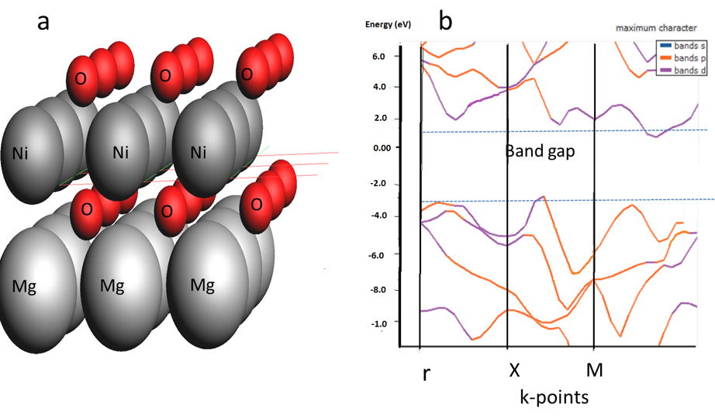
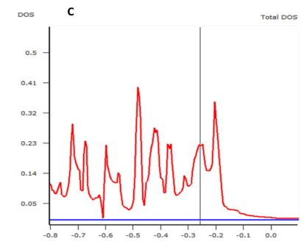
Fig. 6 Mg_{1-x}Ni_{x}O crystal slab optimization (a) and band structure calculations (b) Density of states (C) using Generalized Gradient Approximation
3.4.2. Docking Analysis. Structural analysis and docking studies of MgNiO with bacterial DNA was carried out using semi empirical PM3 method. Figure 7 represents bacterial Vs. DNA with its replication enzyme optimized by MOE 2017 and viewed by VMD 1.9.3. Molecular docking analysis evaluated possible conformations of 2, 3 and 4 units of MgNiO to interpret the effect of particle size on its interaction with DNA Figure 8 (a-c). It is revealed that increasing number of MgNiO units i.e., increasing particle size decreases its affinity with 4CHU due to enhanced intra-particulate interactions as depicted by highest value of binding constant (K_{b}) for single unit MgNiO (Table-4). Figure 8(a) revealed interaction of MgNiO dimer with 4CHU via intercalation between base pairs leading to highest value of K_{b}. Intramolecular interactions of MgNiO trimer resulted weakening of its interaction with DNA presenting van der Waal’s interaction with DNA strand shown in Figure 8(b). Strong electrostatic interaction within the units of tetramer MgNiO (Figure 8c) instigated agglomeration of units ejecting it from hydrophobic core of DNA hence further reducing binding affinity with bacterial DNA and developing minor groove interactions.
For the comprehension of interactions between different sized MgNiO units and bacterial DNA some of the steric descriptors including molar refractivity (M_{R}), hydrophobic surface area (V_{surf}) and octanol-water partition coefficient have been calculated. It is evident from table 4 that all steric descriptors presented inverse correlation with binding constant values. Partition coefficient (slogP) is representative of hydrophobicity of the molecule. slogP furnished an inverse correlation with the K_{b} stating that dimer with lower slogP is projected to constitute stronger complex. Similar trend was observed for M_{R} and V_{sur} correlation with K_{b.}

Table 4. Free energy (∆G), binding constant (K_{b}) and steric descriptors of different MgNiO units calculated from molecular docking data.
Complex | -∆G/kJmol⁻¹ | Binding constant (K_{b})/M⁻¹ | SlogP | V_{surf} | M_{R} | Dipole
MgNiO (dimer) | 22.66 | 9.37×10³ | 0.0834 | 127.24 | 9.544 | 0.000
MgNiO (trimer) | 17.28 | 1.06×10³ | 0.1248 | 201.36 | 14.290 | 0.000
MgNiO (tetramer) | 8.97 | 3.17×10¹ | 0.1664 | 245.233 | 19.036 | 0.000

Fig. 7. Optimized structure of bacteria (enzyme bound DNA) PDB ID: 4CHU.

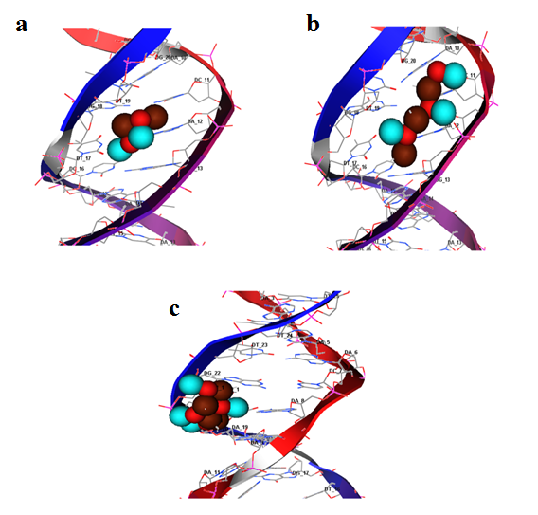

Fig. 8. Pose analysis and molecular docked complex of MgNiO with 4CHU, (a). Dimer MgNiO (b). Trimer MgNiO (c). Tetramer MgNiO.

4. Discussion
In experimental studies, single phase monodispersed and metal-equimolar nano solid solution; Mg_{1-x}Ni_{x}O (x=0.5) synthesis has been ascertained with 0.5M NaOH aq gelating agent. The effect of thermal treatment showed a direct relation between crystallite-particle size and annealing temperature. Samples prepared by this method were further subjected to anneal at 500, 600 and 800°C. A good agreement between calculated and the observed patterns has been observed. WH plot data tells us about small strain in the structures. The PXRD data show that the crystallite size increases from 10 to 30nm with increase in annealing temperature. A very same trend has been observed via SEM analysis, particle size increases from 54 to 63nm with temperature. The black color of sample annealed at 500°C shows the more surface oxygen content as compared to other two sample appearing grey, this observation can be attributed to the smallest particle size with greater surface area and more O⁻² dandling bonds, such property has been already reported for pure NiO [33]. The higher oxygen content can also be justified on the basis of higher pH = 11.21 for that sample, it can be related to the results as shown by bulk Mg_{1-x}Ni_{x}O with higher oxygen contents [14]. The difference between results for the activity against MRSA and E. coli is attributed to the complex and thick cell wall structure made up of layers of peptidoglycan of E. Coli as compared MRSA which is lacking the outer membrane. It is easier for a material to obstruct the growth of MRSA [34]. It can be seen from the results of our materials too that antibacterial activity is inversely proportional to the crystallite size. The bar charts shown in figure 4 depict the highest antibacterial activity of sample synthesized at 500°C which is due to the smallest particles size and higher oxygen contents. The bactericidal behavior of Mg_{1-x}Ni_{x}O (x=0.5) is due to surface oxide ion, O²⁻ [34]. The stability of oxide ions also depends upon the pH of the suspension as more basic pH supports the stability of the ion. As in acidic environments it gets converted to H₂O₂ by combining with free H⁺ ions and the antibacterial activity is inversely proportional to the crystallite size which [14] can justify these results. In our case the highest pH was observed for 500°C sample and the best antibacterial results are also associated with this sample. The energetic parameters of MgNiO calculated from DFT studies provided a value of E_{LUMO} suggesting suggestive of electron acceptor behavior of the MgNiO making it suitable electron acceptor from electron rich DNA base pairs of bacterial strains. Molecular docking analysis of 2, 3 and 4 units of MgNiO revealed that increasing number of MgNiO units (i.e., increasing particle size) decreases its affinity with 4CHU due to enhanced intra-particulate interactions. A highest binding constant (K_{b}) value was obtained for dimer MgNiO due to its stronger interaction with 4CHU via intercalation between base pairs. Intramolecular interactions of MgNiO trimer resulted in weakening of interaction with DNA presenting mainly the van der Waal’s. Strong electrostatic interaction within the units of tetramer MgNiO instigated agglomeration of units resulting in ejection from hydrophobic core of DNA hence further reducing binding affinity with bacterial DNA and developing minor groove interactions.The steric descriptors including; Molar refractivity (M_{R}), hydrophobic surface area (V_{surf}) and octanol-water partition presented inverse correlation with binding constant values K_{b}. Computational findings complemented the experimental results revealing that increase in particle size led to decrease in cell inhibition and hence reduced binding affinity. Results of antibacterial activity anticipate the possible utilization of the nano solid solution of the Mg_{1-x}Ni_{x}O(x=0.5) for water purification.

- References
[1] F. Nabeela, A. Azizullah, R. Bibi, S. Uzma, W. Murad, S. Khan Shakir, W. Ullah, M. Qasim and D.-P. Häder. "Microbial Contamination of Drinking Water in Pakistan—a Review." Environ. Sci. Pollut. Res. 21, no. 24 (2014): 13929-42.
[2] C.-C. Chen , A. B. Herhold, C. S. Johnson, and A. P. Alivisatos. "Size Dependence of Structural Metastability in Semiconductor Nanocrystals." Science 276, no. 5311 (1997): 398-401.

[3] H. Chen and R.Yada. "Nanotechnologies in Agriculture: New Tools for Sustainable Development." Trends in Food Sci Technol 22, no. 11 (2011): 585-94.
[4] K. Fujihara, A Kumar, R Jose, S. Ramakrishna, and S. Uchida. "Spray Deposition of Electrospun TiO2 Nanorods for Dye-Sensitized Solar Cell." Nanotechnology 18, no. 36 (2007): 365709-13.
[5] H. R. Mahmoud, , S. M. Ibrahim and S. A. El-Molla. "Textile Dye Removal from Aqueous Solutions Using Cheap Mgo Nanomaterials: Adsorption Kinetics, Isotherm Studies and Thermodynamics." Adv. Powder Technol. 27, no. 1 (2016): 223-31.
[6] E. Roduner, "Size Matters: Why Nanomaterials are Different." Chem. Soc. Rev. 35, no. 7 (2006): 583-92.
[7] T. Kavitha and H. Yuvaraj. "A Facile Approach to the Synthesis of High-Quality Nio Nanorods: Electrochemical and Antibacterial Properties." J. Mater. Chem. 21, no. 39 (2011): 15686-91.
[8] S. Makhluf, R. Dror, Y. Nitzan, Y. Abramovich, R. Jelinek and A. Gedanken. "Microwave‐Assisted Synthesis of Nanocrystalline Mgo and Its Use as a Bacteriocide." Adv. Funct. Mater. 15, no. 10 (2005): 1708-15.
[9] J. Sawai, "Quantitative Evaluation of Antibacterial Activities of Metallic Oxide Powders (Zno, Mgo and Cao) by Conductimetric Assay." J. microbiol. methods 54, no. 2 (2003): 177-82.
[10] J. Sawai, H. Kojima, N. Ishizu, M. Itoh, H. Igarashi, T. Sawaki and M. Shimizu. "Bactericidal Action of Magnesium Oxide Powder." J. Inorg. Biochem. 67, no. 1-4 (1997): 443-43
[11] H. Pang, , Q. Lu, Y. Li and Feng Gao. "Facile Synthesis of Nickel Oxide Nanotubes and Their Antibacterial, Electrochemical and Magnetic Properties." Chem. Commun., no. 48 (2009): 7542-44.
[12] J. Sawai, , H. Igarashi, A. Hashimoto, T. Kokugan and M. Shimizu. "Effect of Particle Size and Heating Temperature of Ceramic Powders on Antibacterial Activity of Their Slurries." J. chem. Eng. Jpn. 29, no. 2 (1996): 251-56.
[13] T. Ohira, , M. Kawamura, Y. Iida, M. Fukuda and O. Yamamoto. "Influence of the Mixing Ratio on Antibacterial Characteristics of Mgo-Zno Solid Solution in Two Phase Coexistence Region." J. Ceram. Soc. Jpn. 116, no. 1359 (2008): 1234-37.
[14] T. Ohira and O. Yamamoto. "Effective Factor on Antibacterial Characteristics of Mg1− Xnixo Solid Solution." Chem. Eng. Res. Des. 91, no. 6 (2013): 1055-62.
[15] Y. Wang, Y.-F. Zhang, H.-R. Liu, S.-J. Yu and Q.-Z. Qin. "Nanocrystalline Nio Thin Film Anode with Mgo Coating for Li-Ion Batteries." Electrochim. Acta 48, no. 28 (2003): 4253-59.
[16] J. S. Choi, H. Y. Lee and K. H. Kim. "Electrical Conductivity of Nickel Oxide-Magnesium Oxide Single Crystals." J. Phys. Chem. 77, no. 20 (1973): 2430-33.
[17] M. B. Amor, A. Boukhachem, K. Boubaker and M. Amlouk. "Structural, Optical and Electrical Studies on Mg-Doped Nio Thin Films for Sensitivity Applications." Mate. Sci. Semicond. Process. 27 (2014): 994-1006.
[18] Z. Ji., Z. He, K. Liu, S. Zhao and Zhenjie He. "Synthesis of Mgxni1− Xo Thin Films with a Band-Gap in the Solar-Blind Region." J. Cryst. Growth 273, no. 3-4 (2005): 446-50.
[19] Y. H. Kwon, S. H. Chun and H. K. Cho. "Controllable Band-Gap Engineering of the Ternary Mg_{x}Ni_{1− X}O Thin Films Deposited by Radio Frequency Magnetron Sputtering for Deep Ultra-Violet Optical Devices." Thin Solid Films 529 (2013): 417-20.
[20] J. Sawai, H. Kojima, H. Igarashi, A. Hashimoto, S. Shoji, A. Takehara, T. Sawaki, T. Kokugan and M. Shimizu. "Escherichia Coli Damage by Ceramic Powder Slurries." J. Chem. Engn. Jpn. 30, no. 6 (1997): 1034-39.
[21] W. Kraus and G. Nolze. "Powder Cell – A Program for the Representation and Manipulation of Crystal Structures and Calculation of the Resulting X‐Ray Powder Patterns." J. Appl. Crystallogr. 29, no. 3 (1996): 301-03.
[22] T. Roisnel and J. Rodríguez-Carvajal. "WinPLOTR: a Windows tool for powder diffraction patterns analysis". Materials Science Forum, Proceedings of the Seventh European Powder Diffraction Conference (EPDIC 7), (2000): 118-123.
[23] Balouiri Mounyr, Moulay Sadiki, and Saad Koraichi Ibnsouda. "Methods for in Vitro Evaluating Antimicrobial Activity: A Review." Journal of pharmaceutical analysis 6, no. 2 (2016): 71-79
[24] A. D. Becke, “Optical Gap in Polyacetylene from a Simple Quantum Chemistry Exciton Model” J. Chem. Phys. 149, (2018): (081102) 1-3,
[25] M. Puchalski, A. Spyszkiewicz, J.Komasa and K. Pachucki “Nonadiabatic Relativistic Correction to the Dissociation Energy of H2, D2, and HD” Phys. Rev. Lett. 121, (2018) :(073001)1-5.
[26] W. A. R. Leon, W. Tiznado, E. Osorio and F. Ferraro, “Exploring the Potential Energy Surface of Small Lead Clusters using the Gradient Embedded Genetic Algorithm and an Adequate Treatment of Relativistic Effects” RSC Adv, 8, (2018): 145–152 .
[27] M. Lubasch, J. I. Fuks, H. Appel, A. Rubio, J.I.irac and M.CBanuls “Systematic Construction of Density Functionals Based on Matrix Product State Computations” New J. Phys. 18, (2016): 1-11.
[28] P. M. Sanchez, A. J. Cohen and W.Yang “Localization and Delocalization Errors in Density Functional Theory and Implications for Band-Gap Prediction” PRL 100, (2008)146401: 1-4.
[29] Z. Feng and M. S Seehra. "Phase Diagram and Magnetic Properties of the Diluted Fcc System Ni_{P}Mg_{1−P}O." Phys. Rev. B 45, no. 5 (1992): 2184-89.
[30] H. Vincent, M. Audier, S. Pignard, G. Dezanneau and J. P. Senateur. "Crystal Structure Transformations of a Magnetoresistive La_{0.8}MnO_{3–δ}Thin Film." J. Solid State Chem. 164, no. 2 (2002): 177-87.
[31] Z. Feng, V. S. Babu, J. Zhao and M. S. Seehra. "Effect of Magnetic Dilution on Magnetic Ordering in Ni _{P} Mg_{1− P} O." J. Appl. Phys.70, no. 10 (1991): 6161-63.
[32] K. M. Honorio and A. B. F. Da Silva. "An AM1 Study on the Electron‐Donating and Electron Accepting Character of Biomolecules." Int. J. Quantum chem. 95, no. 2 (2003): 126-32.
[33] L. C Bartel and B Morosin. "Exchange Striction in NiO." Phys. Rev. B3, no. 3 (1971): 1039.
[34] M. R. Bindhu, M. Umadevi, M. K. Micheal, M. V. Arasu and N. A. Al-Dhabi. "Structural, Morphological and Optical Properties of Mgo Nanoparticles for Antibacterial Applications." Mater. Lett. 166 (2016): 19-22.

