**A novel design concept of low cost 3D printed ambidextrous robotic arm**

Mashood Mukhtar and Tatiana Kalganova

***Abstract*—A novel design of low cost 3D printed five degree of freedom ambidextrous robotic arm is presented in this letter. Due to its ambidextrous nature, it offers much greater range of movement than human arm as shown in table 2. One of the key challenges in robotic industry is to make robot learn from the observation of human behaviours. However, due to difference in human and robot mechanisms such as range of movements and mechanical structure, a robot may not imitate human’s movement precisely. For a robot arm, task is often not completed as efficiently as human counterpart does due to discrepancy in range of movements and flexibility of joints. The aim of this research is to develop a robot arm that offers greater range of motion and perform tasks faster than human. Structure of an ambidextrous arm is designed in Solidworks software and cost estimations are assessed systematically using SimMechanics. In joints, range of motion is defined by the level of flexibility. Greater the flexibility of joints, higher the range of movements. By using absolute range of motion values in each individual joint, human arm is compared with an ambidextrous arm. Solution based on forward kinematic and inverse kinematic approach is presented and results are verified using derived equation in Matlab.**

1. INTRODUCTION

The term robot comes from the Czec word robota. Mainly, there are two types of robots: Industrial robots and service robots. Industrial robots are on the verge of revolutionizing manufacturing as they are relatively safer, reliable and incredibly cost-effective than manpower. Robots are currently being employed in various industrial roles. For instance, use of robotic arms in manufacturing industry to move heavy parts from point A to point B and attempting hazardous tasks in chemical industry. Numbers of robotics arms have been developed in the past few decades to offer solution to industry and humankind [1]. In 1495, Da Vinci designed four degrees-of-freedom wrist sophisticated robotic arm, Von Kemplen presented an arm that plays chess, Unimate work was focused on the industrial robot arm that was later evolved into the PUMA arm [2]. In 1963, the Rancho arm was presented; Minsky’s Tentacle arm appeared in 1968, in 1970 Stanford university developed a computer-controlled robot arm in 1973 and MIT’s Silver arm in 1974. DLR lightweight robot III developed in 2003, KUKA robot arm LBR iiwa in 2013, Robonaut arm by NASA [3], Elu2-arm by ELumotion Ltd, Kinova six degree of freedom robotic arm with unlimited rotation on each axis [4].

|  |
| --- |
| Mashood Mukhtar and Tatiana Kalganova (Department of Electronic & Computer Engineering Brunel University, Uxbridge, UB8 3PH, London, United Kingdom)  Email: [Mashood.Mukhtar@brunel.ac.uk](mailto:Mashood.Mukhtar@brunel.ac.uk) |

Robotic arms are composed of links that are interconnected by joints to form a kinematic chain. Ambidextrous robot arm has five joints as shown in figure 2. Ambidextrous robot arm consists of one fixed link and five movable links that are fixed with ambidextrous robot hand [5]. Ambidextrous robot arm is connected with the13 degree of freedom hand that also possess ambidextrous feature hence, it can bend its fingers in both ways left side and right side [6]. In robotics, mainly two types of joints are used: revolute denoted by R and prismatic denoted by P. In our case, all the links are connected by revolute joints through a serial link mechanism.

1. FORWARD KINEMATICS OF AMBIDEXTROUS ARM

First of all, we will use geometric parameters to define the ambidextrous robot arm as shown in figure 1. Let the length of each link is defined to be the distance between adjacent joint axes. In our design, servo motor that is driving link 1 is permanently fixed to the base of an ambidextrous arm, $θ_{1}$ represents the angle between x-axis and link 1. Let $θ_{2}$ be the angle generated between link 1 and link 2, $θ_{3}$ between link 2 and link 3, actuator driving link 4 generating $θ_{4}$ and $θ_{5}$ is generated by actuator driving link 5. Robotic manipulators are designed to perform various tasks mostly using end effectors. So in order to perform such tasks, position and orientation of end-effector must be known. We will calculate the position and orientation of end-effector in terms of joint variable. This technique is called Forward kinematics.

The D-H convention, describe a systematic way to develop the forward kinematics of any robot. Kinematic analysis allows the designer to obtain key information on the position and orientation of each joint and link within the mechanical structure. This information is necessary for subsequent dynamic analysis along with control paths.Transformation set given below can be used to locate i - 1 axes of a point (revolute joint) placed on the ith link:

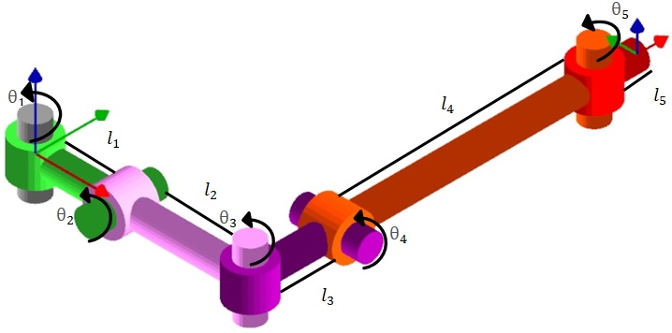

Figure 1.Illustration showing kinematic configuration and joint model of five-joint ambidextrous robotic arm.

**A**i = **H**(d,zi-1) **H**($θ$,z i-1) **H**(a,xi) **H**($α$,x i) (i = 1, ...n)

Where **H**($α$,xi)= 

**H** (a,xi) = 

**H** ($θ$, zi-1) = 

**H** (d, zi-1) = 

Applying the matrix multiplication

**A**i=…..(1)

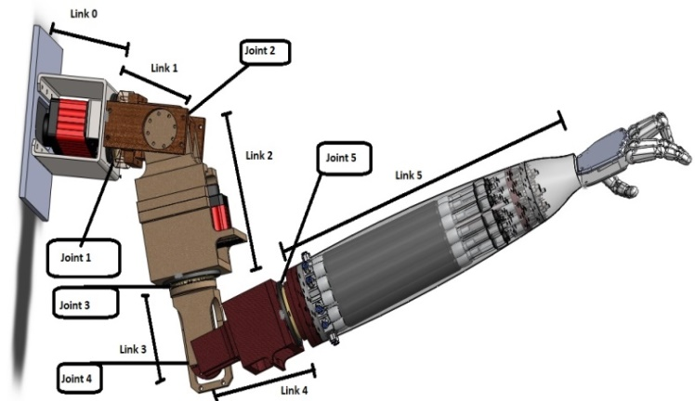

Figure 2. 3D model of an ambidextrous robot arm.

Using the D-H convention, θ_i describes joint angle of xi axis relative to xi-1 axis defined according to the right hand rule about zi-1 axis, distance from the origin is denoted by di of the i-1 axes to the intersection of the zi-1 axis with the xi axis and measured along the zi-1 axis, ai is minimum distance between zi-1 and zi and α_i describes offset angle of z_i axis relative to zi-1 axis measured about the xi axis using right hand rule. To obtain the forward kinematics transformation matrix $T_{n}^{0}$ based on homogenous transformations and DH convention we first located all the reference systems needed making sure the DH coordinate frame assumptions are satisfied. Then table of link parameter is created as shown in table 1. Homogeneous transformation matrices $A_{i}$ is formed that was later used to compute position and orientation of the end-effector.

|  |  |  |  |  |
| --- | --- | --- | --- | --- |
| Link | $$a_{i}$$ | $$d_{i}$$ | $$α_{i}$$ | $$θ_{i}$$ |
| 1 | 0 | $$l_{1}$$ | +90 | $$θ_{1}$$ |
| 2 | 0 | 0 | -90 | $$θ_{2}$$ |
| 3 | 0 | $l_{2}$ + $l_{3}$ | +90 | $$θ_{3}$$ |
| 4 | 0 | 0 | -90 | $$θ_{4}$$ |
| 5 | 0 | $l_{4}$ + $l_{5}$ | 0 | $$θ_{5}$$ |

Table 1- DH parameters (ambidextrous robot arm).

Since we now have all the parameters that are required to form the homogeneous transformation matrices $A_{i}$, we will input these in equation 1 to find $A_{1}$, $A_{2}$, $A_{3}$, $A_{4}$, $A_{5}$ and $T_{1}^{0}$, $T_{2}^{1}$, $T_{3}^{2}$, $T_{4}^{3}$ and $T_{5}^{4}$. Position and orientation of the tool frame expressed in the base coordinates can be located easily from $T_{5}^{0}$

$T_{1}^{0}$ = $A_{1}=$

$T_{2}^{1}$ = $A_{2}$ =

$T_{3}^{2}$ = $A_{3}$ =

$T_{4}^{3}$ = $A_{4}$

$T_{5}^{4}$ = $A_{5}=$

${ T}_{5}^{0}$ = 

$T_{5}^{0}$ = $A_{1} A_{2}A_{3}A_{4}A_{5}$ = $T_{1}^{0} T_{2}^{1} T_{3}^{2} T_{4}^{3}$ $T_{5}^{4}$

Where ${ r}_{11}$ = $\left[(cos{θ_{1}}\cos{θ_{2}}\cos{θ_{3}}-\sin{θ_{1}}\sin{θ_{3}})cosθ_{4}-(cos{θ_{1}\sin{θ_{2}}\sin{θ_{4}}}\right]cosθ_{5}+$ (- $\cos{θ_{1}}\cos{θ_{2}}\sin{θ_{3}}-\sin{θ_{1}}\cos{θ_{3}})\sin{θ_{5}}$

$r_{12}$ = $\left[(cos{θ_{1}}\cos{θ_{2}}\cos{θ_{3}}-\sin{θ_{1}}\sin{θ_{3}})cosθ_{4}-(cos{θ_{1}\sin{θ_{2}}\sin{θ_{4}}}\right]$

(- $\sin{θ_{5}})$ + $(-cos{θ_{1}}\cos{θ_{2}}\sin{θ_{3}}-\sin{θ_{1}}\cos{θ_{3}}$) $cosθ_{5}$

$r_{13}$ = $-(cos{θ_{1}}\cos{θ_{2}}\cos{θ_{3}}-\sin{θ_{1}}\sin{θ_{3}})\sin{θ_{4}}-(cos{θ_{1}\sin{θ_{2}}\cos{θ_{4}}}$)

$r_{21}$ = $\left[(sin{θ_{1}}\cos{θ_{2}}\cos{θ_{3}}+\cos{θ_{1}}\sin{θ_{3})cosθ_{4}}-({\sin{θ_{1}}\sin{θ_{2}}sin{θ_{4}}}\right]cosθ_{5}$

$+$ (- $\sin{θ_{1}}\cos{θ_{2}\sin{θ_{3}}+}$ $\cos{θ_{1}}\cos{θ_{3}})\sin{θ_{5}}$

${ r}_{22}$ = $\left[(sin{θ_{1}}\cos{θ_{2}}\cos{θ_{3}}+\cos{θ_{1}}\sin{θ_{3})cosθ_{4}}-({\sin{θ_{1}}\sin{θ_{2}}sin{θ_{4}}}\right]\left(-\sin{θ_{5}}\right)$ $+(-\sin{θ_{1}}\sin{θ_{2}}sin{θ_{3}}+\cos{θ_{1}}\cos{θ_{3}})\cos{θ_{5}}$

${ r}_{23}$ = $-(sin{θ_{1}}\cos{θ_{2}}\cos{θ_{3}}+\cos{θ_{1}}\sin{θ_{3})\sin{θ_{4}}}-\sin{θ_{1}}\sin{θ_{2}}$ ($cosθ_{4})$

${ r}_{31}$ = $(sin{θ_{2}}\cos{θ_{3}}\cos{θ_{4}}+\sin{θ_{4}\cos{θ_{2}})cosθ_{5}}-\sin{θ_{2}}\sin{θ_{3}}sin{θ_{5}}$

$r_{32}$ = $(sin{θ_{2}}\cos{θ_{3}}\cos{θ_{4}}+\sin{θ_{4}\cos{θ_{2}})\left(-\sin{θ_{5}}\right)}-\sin{θ_{2}}\sin{θ_{3}}sin{θ_{5}}$

${ r}_{33}$ = $-sin{θ_{2}}\cos{θ_{3}}\sin{θ_{4}}+\cos{θ_{2}\cos{θ_{4}}}$

${ d}_{x}$ = $\left[-(cos{θ_{1}}\cos{θ_{2}}\cos{θ_{3}}+\sin{θ_{1}}\sin{θ_{3}})\sin{θ_{4}}-(cos{θ_{1}\sin{θ_{2}}\cos{θ_{4}}}\right] \left(l_{4}+l_{5}\right) -\left(l_{2}+l_{3}\right)-((cos{θ_{1}\sin{θ_{2}})}$

$$d_{y}=\left[-(sin{θ_{1}}\cos{θ_{2}}\cos{θ_{3}}+\cos{θ_{1}}\sin{θ_{3})\sin{θ_{4}}}+\sin{θ_{1}}\sin{θ_{2}}(-cosθ_{4})\right]$$

$\left(l_{4}+l_{5}\right)-\left(l_{2}+l_{3}\right)$ ($\sin{θ_{1}}\sin{θ_{2}})$

$$d_{z}= (-sin{θ_{2}}\cos{θ_{3}}\sin{θ_{4}}+\cos{θ_{2}\cos{θ_{4}})}\left(l_{4}+l_{5}\right)-\left(l_{2}+l_{3}\right)\cos{θ_{2}}+l_{1}$$

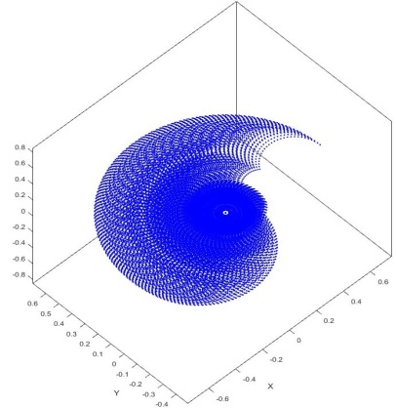

Figure 3. Workspace of human arm.

The forward kinematics matrix computed above has been implemented and verified in Matlab. Results of mathematical equation and Matlab output were same. Maximum range of motion in X-Y plane of human arm is shown in figure 3 and ambidextrous robot arm in figure 4. The plot was generated by cycling through different combinations of theta values and deducing x and y co-ordinates for each theta values. From the both plots we concluded that the ambidextrous robot arm is capable of reaching several points more than the human arm.

|  |  |  |  |  |  |  |
| --- | --- | --- | --- | --- | --- | --- |
|  | **Shoulder rotation** | **Shoulder flexion/**  **extension** | **Shoulder abduction/adduction** | **Elbow Flexion/**  **Extension** | **Forearm (Pronation Supination)** | **End Effector Rotation** |
| Ambi-dextrous  robot arm | 360° | 270° | N/A | 270° | 360° | 360° |
| Human arm | 70° | 200° | 180° | 150° | 160° | N/A |

Table 2.Comparison of range of motion in human arm and ambidextrous robot arm.

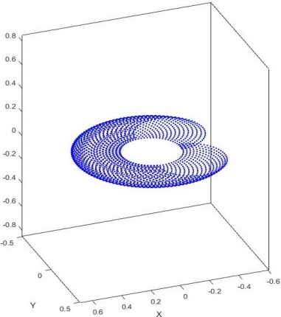

Figure 4. Workspace of the ambidextrous robot arm.

The workspace of a manipulator is the total area covered by the end effector while manipulator executes all possible motions. In figure 5, workspace of an ambidextrous arm is presented while in full extension mode. Workspace plot only takes into consideration position of an end-effector.

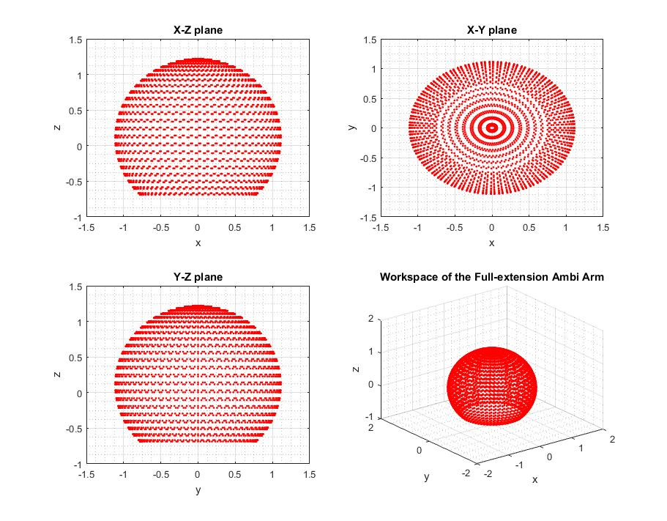

Figure 5. Workspace of the ambidextrous robot arm in full extension mode..

1. results

Derived equation using forward kinematic approach is verified using MATLAB programme. Figure 6 shows the snapshot of different the robot arm in different angles and table 3 list the values of theta and position of end-effector at each plot.

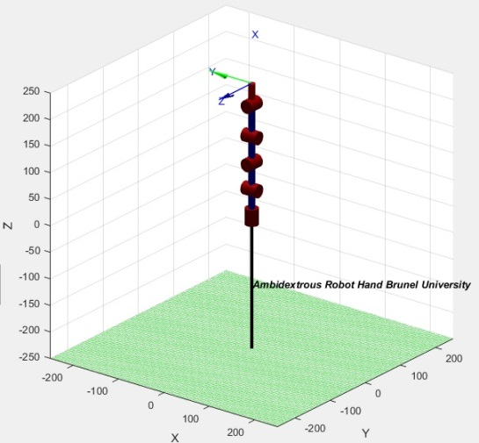

*(a)*

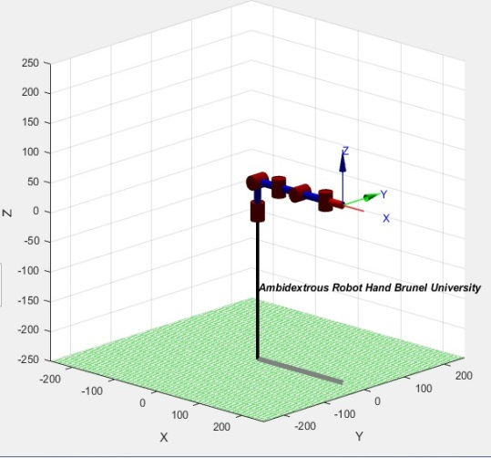

*(b)*

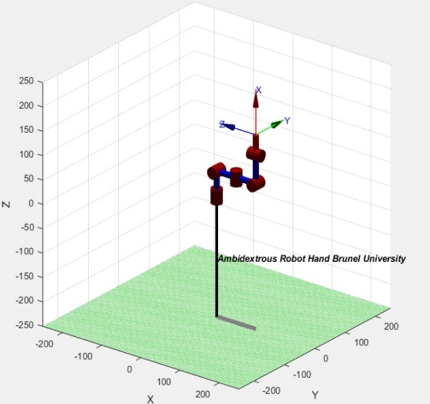

*(c)*

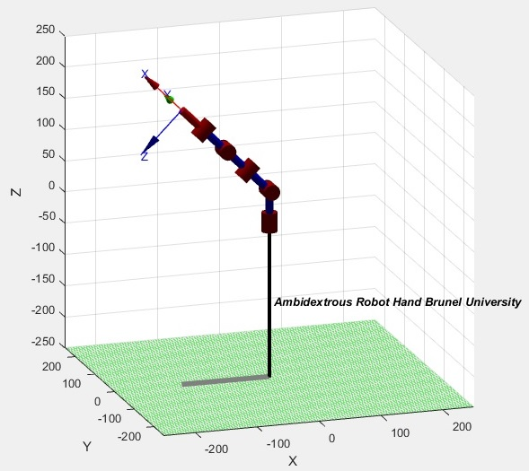

*(d)*

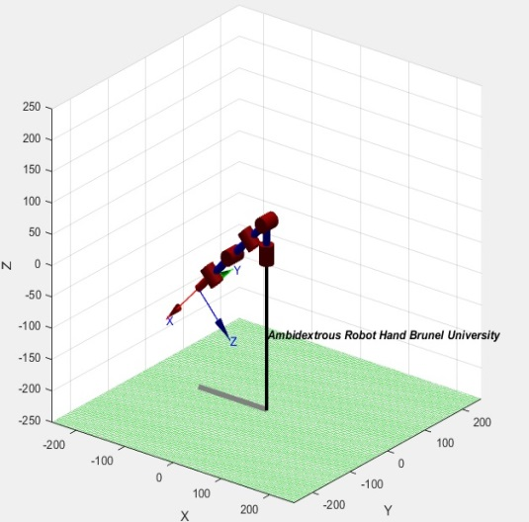

*(e)*

|  |  |  |  |  |  |  |  |  |
| --- | --- | --- | --- | --- | --- | --- | --- | --- |
|  | Theta values | | | | | Position of End Effector | | |
| $$θ_{1}$$ | $$θ_{2}$$ | $$θ_{3}$$ | $$θ_{4}$$ | $$θ_{5}$$ | X-axis | Y-axis | Z-axis |
| a | 90 | 90 | 0 | 0 | 0 | -1 | 0 | 250 |
| b | 0 | 0 | 0 | 0 | 0 | -51 | -100 | -1 |
| c | 0 | 0 | 0 | 90 | 0 | 100 | 0 | 150 |
| d | 0 | 135 | 0 | 0 | 0 | -142 | 0 | 191 |
| e | 0 | -135 | 0 | 0 | 0 | -142 | -1 | 191 |
| f | 0 | 0 | 0 | -70 | 0 | 134 | -1 | -44 |
| g | 0 | 0 | 90 | 0 | 0 | 50 | 150 | 50 |
| h | 20 | 45 | 10 | 5 | 30 | 104 | 85 | 189 |

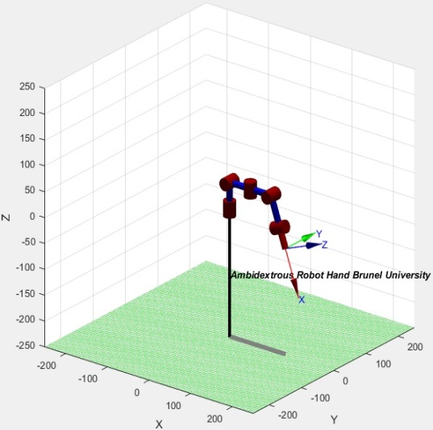

*(f)*

Figure 6. Forward kinematic equation verified at different robot angles.

Table 3. Theta values and position of end-effector for each plot.

Number of 3D modelling software exists in the market to calculate the forward dynamics of the robot arm. We employed RoboAnalyzer to design a 5 Degree of freedom robot arm and assigned the input parameters such as joint type, joint offset, link lengths, twist angles, initial and final values to replicate the ambidextrous robot arm movements. We first run simulation of forward dynamics of the designed robot arm. Figure 7 shows the velocity and acceleration graph of each joint. Figure 8: Link values in X-axis,Y-axis, Z- axis and Force/Torque Graph of each joint.

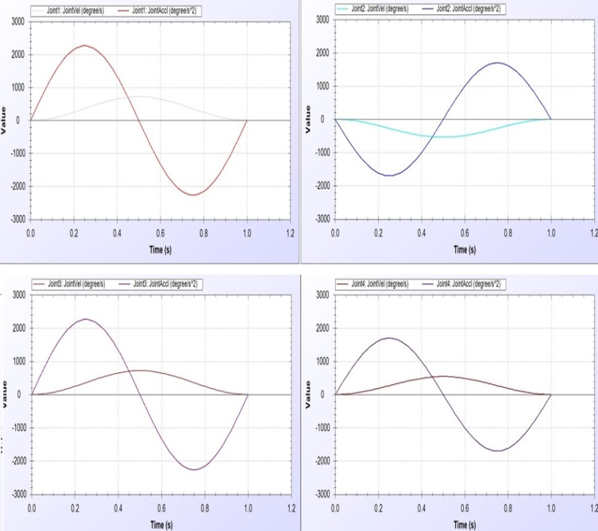

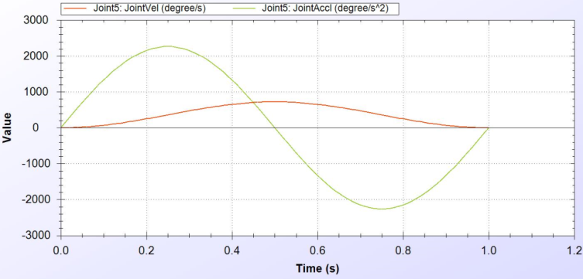

Figure 7. Joint velocity/Acceleration graphs.

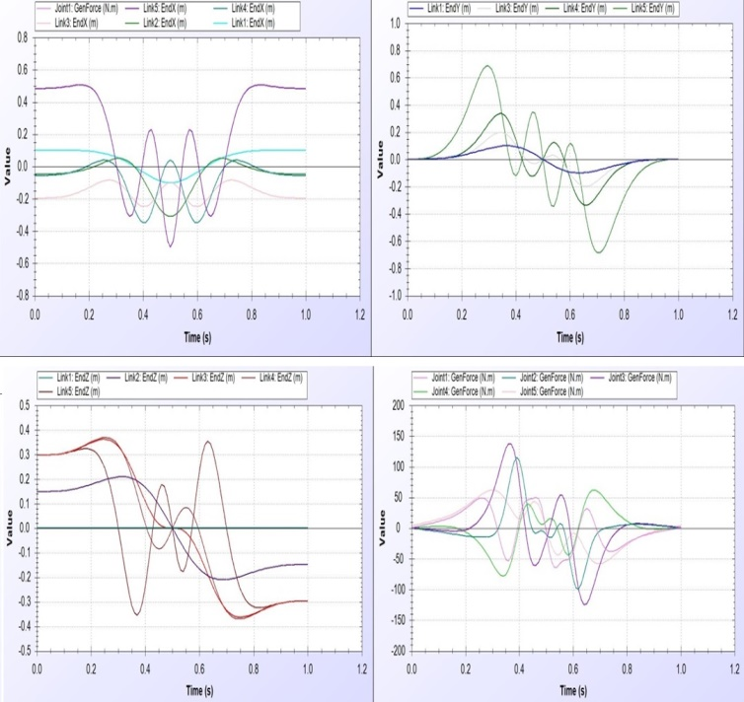

Figure 8. Link values in X-axis,Y-axis, Z- axis and Force/Torque Graph of each joint.

1. INVERSE KINEMATICS OF AMBIDEXTROUS ARM

Inverse kinematics refers to calculate the relation between joint angles and an end effector position. Given inputs are coordinates of the end effector and task is to find the out joint angles. Unlike forward kinematics, finding best inverse kinematic solution is relatively hard in particular when dealing with multiple degree of freedom robots. Normally there are always more than one inverse solutions and choosing the best solution by specifying the type of configuration user prefer is key to move robot arm to desired position. For instance a 1 revolving joint robot arm will have only 1 possible inverse solution to define the position of end-effector while a 6 revolving joint robot may have 16 different solutions to define the same position of an end-effector. The relationship between Joint space and Cartesian Space as well as forward kinematics and inverse kinematics is shown in figure.

Homogeneous transformation matrix = H = $\left[\begin{matrix}R_{n}^{0} & O_{n}^{0} \\ 0 & 1\end{matrix}\right]$

Lets take an example, Imagine if the desired end effector positionis given by:

$H= \left\lceil \begin{aligned}1 0 0 7 \\ 1 0 1 8 \\ 0 1 1 5 \\ 0 0 0 0 1\end{aligned}\right\rceil$

Where H is a desired end-effector position.

H =

= 

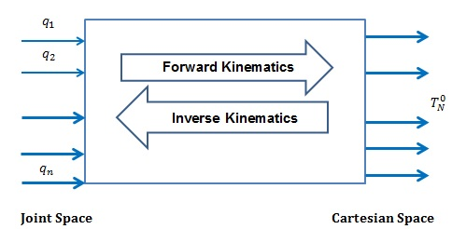

Figure 9:Forward and Inverse Kinematics Relationship

Where

${ r}_{11}$ =1= $\left[(cos{θ_{1}}\cos{θ_{2}}\cos{θ_{3}}-\sin{θ_{1}}\sin{θ_{3}})cosθ_{4}-(cos{θ_{1}\sin{θ_{2}}\sin{θ_{4}}}\right]cosθ_{5}+$ (- $\cos{θ_{1}}\cos{θ_{2}}\sin{θ_{3}}-\sin{θ_{1}}\cos{θ_{3}})\sin{θ_{5}}$

$r_{12}$ = 0 = $\left[(cos{θ_{1}}\cos{θ_{2}}\cos{θ_{3}}-\sin{θ_{1}}\sin{θ_{3}})cosθ_{4}-(cos{θ_{1}\sin{θ_{2}}\sin{θ_{4}}}\right]$

(- $\sin{θ_{5}})$ + $(-cos{θ_{1}}\cos{θ_{2}}\sin{θ_{3}}-\sin{θ_{1}}\cos{θ_{3}}$) $cosθ_{5}$

$r_{13}$ =0 = $-(cos{θ_{1}}\cos{θ_{2}}\cos{θ_{3}}-\sin{θ_{1}}\sin{θ_{3}})\sin{θ_{4}}-(cos{θ_{1}\sin{θ_{2}}\cos{θ_{4}}}$)

$r_{21}$ =1= $\left[(sin{θ_{1}}\cos{θ_{2}}\cos{θ_{3}}+\cos{θ_{1}}\sin{θ_{3})cosθ_{4}}-({\sin{θ_{1}}\sin{θ_{2}}sin{θ_{4}}}\right]cosθ_{5}+$ (- $\sin{θ_{1}}\cos{θ_{2}\sin{θ_{3}}+}$ $\cos{θ_{1}}\cos{θ_{3}})\sin{θ_{5}}$

${ r}_{22}$ = 0 = $\left[(sin{θ_{1}}\cos{θ_{2}}\cos{θ_{3}}+\cos{θ_{1}}\sin{θ_{3})cosθ_{4}}-({\sin{θ_{1}}\sin{θ_{2}}sin{θ_{4}}}\right]\left(-\sin{θ_{5}}\right)$ $+(-\sin{θ_{1}}\sin{θ_{2}}sin{θ_{3}}+\cos{θ_{1}}\cos{θ_{3}})\cos{θ_{5}}$

${ r}_{23}$ =1 = $-(sin{θ_{1}}\cos{θ_{2}}\cos{θ_{3}}+\cos{θ_{1}}\sin{θ_{3})\sin{θ_{4}}}-\sin{θ_{1}}\sin{θ_{2}}$ ($cosθ_{4})$

${ r}_{31}$ =0 = $(sin{θ_{2}}\cos{θ_{3}}\cos{θ_{4}}+\sin{θ_{4}\cos{θ_{2}})cosθ_{5}}-\sin{θ_{2}}\sin{θ_{3}}sin{θ_{5}}$

$r_{32}$ =1 = $(sin{θ_{2}}\cos{θ_{3}}\cos{θ_{4}}+\sin{θ_{4}\cos{θ_{2}})\left(-\sin{θ_{5}}\right)}-\sin{θ_{2}}\sin{θ_{3}}sin{θ_{5}}$

${ r}_{33}$ =1 = $-sin{θ_{2}}\cos{θ_{3}}\sin{θ_{4}}+\cos{θ_{2}\cos{θ_{4}}}$

${ d}_{x}$ =7= $\left[-(cos{θ_{1}}\cos{θ_{2}}\cos{θ_{3}}+\sin{θ_{1}}\sin{θ_{3}})\sin{θ_{4}}-(cos{θ_{1}\sin{θ_{2}}\cos{θ_{4}}}\right] \left(l_{4}+l_{5}\right) -\left(l_{2}+l_{3}\right)-((cos{θ_{1}\sin{θ_{2}})}$

$d_{y}=8=\left[-(sin{θ_{1}}\cos{θ_{2}}\cos{θ_{3}}+\cos{θ_{1}}\sin{θ_{3})\sin{θ_{4}}}+\sin{θ_{1}}\sin{θ_{2}}(-cosθ_{4})\right]\left(l_{4}+l_{5}\right)-\left(l_{2}+l_{3}\right)$ ($\sin{θ_{1}}\sin{θ_{2}})$

$$d_{z}=5= (-sin{θ_{2}}\cos{θ_{3}}\sin{θ_{4}}+\cos{θ_{2}\cos{θ_{4}})}\left(l_{4}+l_{5}\right)-\left(l_{2}+l_{3}\right)\cos{θ_{2}}+l_{1}$$

In inverse kinematic most difficult task is to solve the complicated equations and dealing with multiple possible solutions. The complexity of this problem and possible alternative approaches are discussed in [7]. Number of simulation based platforms exist that does all the calculations but sometime selecting the best one is difficult. There are different ways to reach the end-effector desired position and orientation. Since selecting unique solutions using inverse kinematic numerical approach prove challenging, there is a need to find alternative ways. One of the most common used methods is Adaptive Neuro Fuzzy Inference System (ANFIS).

1. CONCLUSION

Ambidextrous robot arm that offers much greater range of movements and workspace has been introduced in this manuscript. Kinematic configuration and joint model of robot arm is shown in figure 1 along with 3D model designed in Solidworks in figure 2. Forward kinematic is computed using homogenous transformation matrix. Accuracy of equations was verified in Matlab. Comparison of range of joints of human arm and ambidextrous robot arm is shown in table 2. Workspace of both human and ambidextrous robot arm is presented in figure 3-5. From the results, we concluded our robot arm offers greater range that could be useful in many industrial applications.

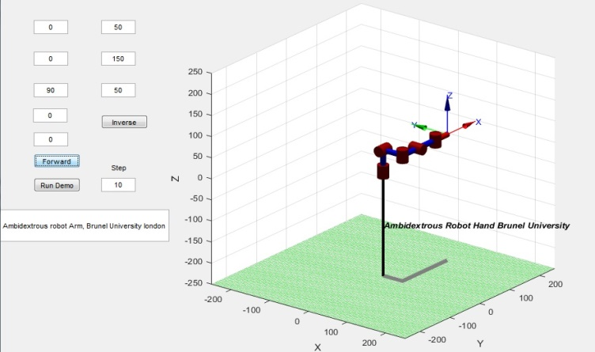

(a)

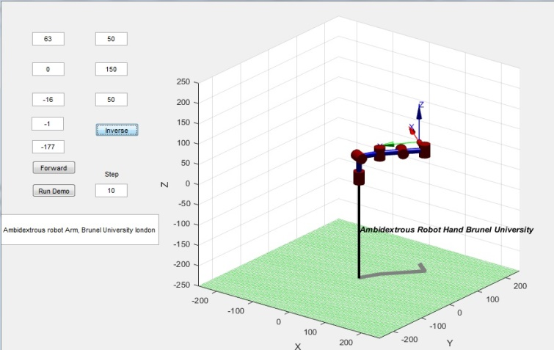

(b)

Figure 10. Graphical user interface (GUI) is designed in Matlab to simulate our ambidextrous robot arms Forward kinematic and inverse kinematic with single click.

REFERENCE

|  |  |
| --- | --- |
| [1] | M. E. Moran, "Evolution of robotic arms," *Journal of Robotic Surgery*, vol. 1, no. 2, pp. 103-111, 2007. |
| [2] | R. P. Paul, M. Rong, and H. Zhang, "The dynamics of the PUMA manipulator," *American Control Conference*, pp. 491-496, 1983. |
| [3] | W. Bluethmann, et al., "A robot designed to work with humans in space," *Autonomous robots*, vol. 14(2), pp. 179-197, 2003. |
| [4] | P. Corke, "Robot Arm Kinematics," *Robotics, Vision and Control. Springer Tracts in Advanced Robotics, vol 118. Springer*, 2017. |
| [5] | M. Mukhtar, E. Akyürek, T. Kalganova, and N. Lesne, "Implementation of PID, Bang–Bang and Backstepping Controllers on 3D Printed Ambidextrous Robot Hand. ," *Intelligent Systems and Applications (pp. 173-194). Springer International Publishing.*. |
| [6] | M. Mukhtar, E. Akyürek, T. Kalganova, and N. Lesne, "Control of 3D printed ambidextrous robot hand actuated by pneumatic artificial muscles," *SAI Intelligent Systems* Conference *(IntelliSys), 2015. IEEE, 2015*. |

[7] Bingul Z, Ertunc HM, Oysu C. Applying Neural Network to Inverse

Kinematic Problem for 6R Robot Manipulator with Offset

Wrist.Adaptive and Natural Computing Algorithms, 2005: 112-115.