Hydrophilic and hydrophobic materials and their applications
Darem Ahmad ª, Inge van den Boogaert ª, Jeremey Miller ^{b}, Roy Presswell ^{c}, Hussam Jouhara ª
ª College of Engineering, Design and Physical Sciences, Brunel University London, Uxbridge, Middlesex UB8 3PH, UK
^{b} Technology Centre, Spirax-Sarco Engineering Plc, Runnings Road, Cheltenham, Gloucester, GL51 9NQ, UK
^{c} H2O Technology Limited, Victoria House, Clarendon Road, Watford, WD17 1HX, UK

Abstract
Wettability of a material’s surface plays a significant role in how fluids interact with such surfaces. Wetting behaviour is universal but can vary depending on the chemical nature of the solid and liquid phases. Plants and animals adapt to their environment through having evolved special properties. These properties are such as hydrophilic and hydrophobic. Hydrophilic surface has a strong affinity to water and spreading of water on such surface is preferred. The degree of hydrophilicity of the substance can be measured by measuring the contact angle between the liquid and solid phases. Hydrophobic materials are known as non-polar materials with a low affinity to water, which makes them water repelling. A contact angle of less than 90° indicates hydrophilic interaction where as an angle greater than 90° indicates a hydrophobic interaction. More recently, superwetting such as superhydrophilicity has been receiving an increased focus in literature due to its potential significance. Superhydrophilic surface has a contact angle of less than 5°.
The fabrication of hydrophilic materials can be carried out in two main ways: depositing molecules on surfaces or modification of surface chemistry. Both methods have been successful historically in achieving their intended purposes. Hydrophobic and superhydrophobic materials can be produced with many fabrication methods such as layer-by-layer assembly, laser process, the solution-immersion method, sol-gen techniques, chemical etching and Hummer’s method.
The applications of such an important property are significant. For example, hydrophilic surfaces can be used in anti-fogging applications, biomedical, filtration, heat pipes, and many others. Hydrophobic and superhydrophobic materials have been successfully applied in many sectors, such as: (I) the removal of petroleum from aqueous solutions, (II) applied to plastic, ceramics and mesh to contribute to the oil removal from aqueous solutions, (III) hydrophobic layers have a strong self-cleaning effect on plastics, heat pipes, metals, textiles, glass, paints and electronics, (IV) hydrophobic layers improve the anti-freezing behaviour of heat pipes which prevents unwanted build-up and (V) they function as a water and dust protecting coat on electronics
The presence of this property is historic but there is still a huge potential for development for its applications in many sectors such as water treatment, heat transfer applications, biomedical devices, and many more.
Keywords: Hydrophilic, hydrophobic, superhydrophilic, superhydrophobic, water droplet angle, hysteresis.

Nomenclature
SHO | Super hydrophobic | ED | Electro dialysis
LBL | Layer-by-layer | MD | Membrane distillation
CAH | Contact angle hysteresis
PU | Polyurethane | Variable definition
PE | Polyethylene | θ | Angle
TEFLON | Polytetrafluoroethylene | s | Solid
RO | Reverse osmosis | l | Liquid
MSF | Multi-stage flash distillation | v | Vapour

Table of Contents
Executive summary 2
Nomenclature 2
1. Introduction 4
2. Theories of wetting and spreading 6
3. Characteristics of hydrophilic materials 7
3.1 Solubility criterion 7
3.2 Polar spreads on polar 7
3.3 Contact angle value criterion 7
4. Characteristics of hydrophobic materials 8
5. Fabrication of hydrophilic materials 10
5.1 Deposited molecular structures 10
5.2 Modification of surface chemistry 11
6. Fabrication of hydrophobic 11
6.1 Layer-by-layer assembly 12
6.2 Laser process 13
6.3 Solution-immersion method 13
6.4 Sol-gel technique 13
6.5 Chemical etching 14
6.6 Hummers’ method 14
7. Applications of hydrophilic materials 15
7.1 Glass/ Anti-fogging surfaces 15
7.2 Bio-fouling and its prevention 16
7.3 Enhanced boiling heat transfer 16
7.4 Other Applications in Biomedical Field 17
7.5 Heat pipes 18
7.6 Hydrophilic property for filtration 18
7.7 Road marking paint 19
7.8 Mesh 19
7.9 Sample pre-treatment 20
8. Applications of hydrophobic materials 21
8.1 Petroleum 21
8.2 Plastic 22
8.3 Heat pipes 22
8.4 Other metal applications 23
8.5 Textiles 24
8.6 Glass 24
8.7 Ceramics 25
8.8 Mesh 26
8.9 Paint 27
8.10 Electronics 28
8.11 Other applications 29
9. Conclusion 30
References 31

1. Introduction
Wettability of a material’s surface plays a vital role in how fluids interact with such surfaces. Wetting behaviour is universal but varies in a rather peculiar nature. Plants and animals adapt to their environment through having evolved special wettability characteristics, showing distinctive wetting and non-wetting properties [1–5]. A Lotus leaf exhibits the “never wetting” or “ultra-ever dry” property. In a non-wetting situation, water can roll around freely on the leaf's outer surface. The water droplet exhibits an almost spherical shape enabling this rolling behaviour. This introduces a self-cleaning property, as the contaminants can be removed by the rolling drop [6]. A similar water rolling behaviour is also observed in rice leaves. They display anisotropic non-wetting state, which enables an easier rolling of the water droplets due to the longitudinal direction rather than the perpendicular direction on the surface [7].
Wetting behaviour is also very important for animals and it has a direct impact on their survival. Some examples of mammals which incorporate this characteristic include desert lizards which make use of scale hinges to transport drinking water [8]. Capillary ratchet plays an important role with the wetting properties of Shorebird’s beaks in order to move water drops from the tip of the beak to the mouth [9]. Water can then be transported in one direction, continuously on the surface of the ‘peristome’ of Nepenthes alata with no energy input [10], and certain mammals, such as Namib desert beetles, have adapted themselves to survive in very dry environment primarily due to their ability to collect water from humid air by hydrophobic and hydrophilic phase-to-phase patches on their backs [11]. These animals have only been able to survive due to the unique characteristics of their surfaces. The unique surfaces observed in nature allows scientists to artificially fabricate and investigate such phenomena.
The terms “hydrophilic surface” and “hydrophobic surface” have been used extensively in literature for many years, which describe opposite effects of the behaviour of water on a solid surface. A hydrophilic surface has strong affinity to water molecules, whereas hydrophobic surfaces repel water [12].
A primary indicator that is used to classify if the wetting behaviour of fluid is hydrophilic or hydrophobic is the measurement of the contact angle. The surface contact angle is the angle formed at the intersection of the liquid-solid and liquid-vapour interface. Depending on the water droplet contact angle, the material is classified as either: hydrophilic (θ_{e} < 90˚), hydrophobic (90˚< θ_{e} < 150˚) or superhydrophobic (θ_{e} > 150˚). The higher the contact angle is, the bigger the strength of the liquid-liquid interaction becomes, making the material more hydrophobic [16–18]. The contact angle range for each wetting and non-wetting scenario is shown in Figure 1.
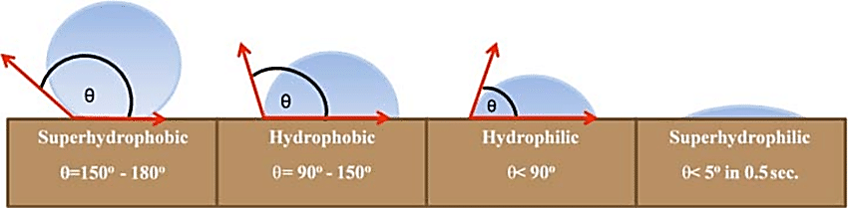
Figure 1. Schematic of water droplet's contact angle with different surface wettability [13].
Surface treatment technology has many different applications as it can be applied in medical, and technological ways [14,15]. To alter the wettability characteristics of any material, certain liquids can be, very simply, applied as coatings to various types of materials, and thereby change the wetting ability these materials. Treated surfaces can be classified into three different categories depending on their water droplet contact angle (θ_{e}), as discussed previously.
Biomimetic of such surfaces of animals have always been the way to create new technologies and enhance people's lives. Hydrophilic and hydrophobic materials play a crucial role in oil-water separation in environmental and energy aspects [19]. Active membranes can be used to achieve sea water desalination, energy conversion and fuel cell processes [20]. Wetting and spreading characteristics found in nature is an area of increased interest due to the wide applications that this phenomenon could be applied to. Development opportunities of wide range of products can be exploited at industrial level.
To enable to implement wetting and spreading of liquids onto surfaces, Young’s equation was introduced in 1805 [21]. The initial wetting models, Young's equation, have been altered to describe and explain various wetting conditions. Dynamic and static wetting have both been explored due to their applicability in different settings. Many concepts, such as contact angle hysteresis, tri-phase contact line theory, have been proposed [22–24]. Chemical composition of the surface as well as the micro-scale topography are the two main parameters that determine the liquid’s wettability. Technological development and advances along with scientific research have unitized high speed video imaging and high-resolution microscopes enabling wettability phenomena to be observed. 3D printing and micro-fabrication enabled the design and manufacturing of artificially wet materials.
Objectives
Hydrophilic and hydrophobic properties are rather well-known and these are applied in many different industries. This article is a comprehensive state-of-the-art on hydrophilic and hydrophobic materials. The focus of this article will be on the fabrication and characteristics of hydrophilic, hydrophobic and superhydrophilic and superhydrophobic materials and reviewing the applications of these materials in many domains, such as petroleum, plastic, heat pipes, other metal applications, textiles, glass, ceramics, mesh, paint, electronics and miscellaneous materials. The objectives of this article are (I) to compile findings on this subject that are applied in different industries and (II) to draw conclusions as well as giving recommendations for further investigations.

2. Theories of wetting and spreading
The importance of hydrophilic and hydrophobic characteristics extend into many disciplines such as chemistry, physics and engineering. Determining the wetting capacity of a liquid onto a surface is determined by the surface and interfacial interactions between the two media, and extensive research have been carried out in this field to examine the forces influencing the wetting and spreading behaviour patterns. Forces such as van der Waals, electrostatic forces and other intermolecular forces dictate the wetting capability of a liquid. Many techniques have been developed to give insights into the wetting and spreading behaviour. Such techniques include atomic force microscopy, surface force apparatus, and molecular dynamics [3,4,25]. In 1805, Thomas Young had established the first laws for flat, solid surface that are chemically homogeneous. Specific energy at the interface between the liquid, gaseous and or solid phases is described as the surface tension. The condensed phase is denoted by γ_{IJ}. Subscripts of the γ_{IJ} are the interfaces between the solid (s), liquid (l), and vapor (v). Liquid/vapor surface energy can be denoted as γ simply. When liquid drops are placed in contact with a solid surface, they tend to reach equilibrium state with lowest energy. The equilibrium contact angle (θeq) measured at the edge of the drop on the solid surface (shown in Figure 2a) can be described by the Young Eq. (1): d
$cosθ_{eq}=\frac{γ_{SV}-γ_{SL}}{γ_{VL}}$
Fabrication processes may generate undesired characteristics of the surface such as pore, striations, microgrooves or irregular convex. To determine the contact angle of a rough surface, the Wenzel model was developed and used since 1936. The Wenzel model states that the liquid is in contact with the entire solid surface and completely penetrates into cavities (as shown in Figure 2b). To describe this model mathematically Young’s equation was modified as follows [22]:
$cosθ_{W}$=$cosθ_{eq}$
where, r is the roughness factor, which equals the quotient of actual surface and geometric surface. Increasing surface roughness will promotes liquid spreading for hydrophilic surfaces. Considering a realistic viewpoint, solid surfaces are un-homogeneous in nature and have a rough surface, as well as being chemically heterogeneous causes the contact angle to be slightly different than theoretical values [26].
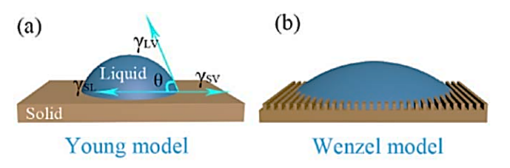 Figure 2. (a) Young's model. (b) Wenzel model [22].
Superhydrophobicity and superhydrophilicity (superwetting properties) are topics that have received an increased attention in wetting studies in recent years. Many of the literature carried out in this field aim to understand and explain the physics behind liquid penetrating (or suspending on) the surfaces of certain geometry. These are controlled at sub-microscopic level. The core principles of superhydrophobicity, superhydrophilicity and fabrication of such surfaces and coatings and their applications were reviewed by many research studies [12,27–39]. This paper will discuss many of the research studies carried out in this subject area.

3. Characteristics of hydrophilic materials

3.1 Solubility criterion
Any substance is categorised as hydrophilic if they readily dissolve in water. This is the opposite for hydrophobic substances, where substances are poorly soluble in water [40]. The ability of hydrophilic solids to pick up water from the air is described as hygroscopic [41]. Table salt and sugar exhibits the characteristics of hydrophilic, as they can be easily dissolved in water. The surface chemistry of such substances is identical to the bulk of their crystal which in-turn makes the entire chemical substance hydrophilic. Halite, which is a natural NaCl salt, has long been observed by the mining and mineral community to have hydrophilic nature [42]. Research studies have shown that finite contact angles were observed for hydrophilic solutions which included KI, KCl and NaHCO₃ [43,44]. Many other organic and inorganic substances as well as polymers are known to dissolve in water. Dissolution can tell the extent of the wettability of a substance, however, it could also be misleading. The main reason for this is that solubility of any substance is governed by the balance of intermolecular forces between molecules in liquid and solid phases, together with an entropy change that accompanies the dissolution and solvation [41]. For example, washing up liquid is soluble in water but it is categorised as an amphiphilic molecule due to the presence of a polar and non-polar regions giving rise to hydrophobic properties as well [45]. Complete spreading of water drops on compressed detergents discs is prevented due to the hydrophobic regions on the surfactant molecules [46].

3.2 Polar spreads on polar
‘‘Like dissolves like’’ can be used to determine if a liquid will or not dissolve in another. For example, polar molecules will be able to dissolve in water as water is a polar molecule. This helps in predicting whether or not a substance will dissolve in water. This also applies for liquids spreading on surfaces. Surfaces containing polar groups have an electric dipole or multipole moment. This is a qualitative method to define a hydrophilic surface or ‘‘polar spreads on polar.’’ However, predicting hydrophilicity of metals using this method is more complex. Metal surfaces don’t have any polar chemical groups and if they are not covered with an oxide layer, water spreads almost completely on the surface of the metal. The reason for water spreading on metals surface is due to the dispersion forces, and these are adequate to induce water spreading on clean surfaces of noble metals [47].

3.3 Contact angle value criterion
Polar liquids such as water prefers to spread on hydrophilic surfaces. The contact angle of water on a hydrophilic surface is less than 90° in a solid–water– air system. Any contact angle higher than 90° describes the system to have water on a hydrophobic surface [42,48]. Contact angle hysteresis is defined as the difference between the advancing contact angle and the receding contact angle. Its value is dependent on whether the measurements are done under static or dynamic conditions. The rate of liquid movement also influences contact angle hysteresis [49]. Contact angle hysteresis may not always be demonstrated on smooth and homogeneous surfaces [50,51]. To measure static contact angle of bulk materials with smooth surfaces, sessile drop and captive-bubble techniques are often used [52,53]. The sessile-drop technique is a simple technique that is commonly used. However, captive-bubble method has its own advantages. Both solid and gas phases, in the captive-bubble method, are already saturated with water or water vapor, and measurements of contact angle are carried out under more stable and reproducible conditions [48]. Representative contact angle values can be used for to identify the wetting behaviour of the liquid in-terms of hydrophilic and hydrophobic surfaces. Hydrophilicity is found in abundance in nature and is one of many characteristics that animals have to help their survival. Hydrophobicity is also found in nature but not as abundant as hydrophilicity. Artificially synthesised hydrophobic substances are saturated hydrocarbon-based products such as wax, polyethylene, polypropylene, self-assembled monolayers with hydrocarbon functional groups as well as fluorine-based polymers, hydrocarbons, and monolayers. The addition of heteroatoms, such as oxygen, into the hydrocarbon structure, adds a polarity to the molecule enhancing hydrophilicity of the surface [31].

4. Characteristics of hydrophobic materials
It is important to ensure that the fabrication methods for hydrophobic coatings result in coatings with the correct characteristics, as these determine the degree of hydrophobicity of the materials. Hydrophobic coatings have specific characteristics and these will be discussed in this section.

Hydrophobicity is commonly known for being water repelling. This characteristic is often linked to the material being non-polar. As water is polar, the non-polar material will repel water [54–57]. Non-polar materials do have an affinity with other non-polar materials, making hydrophobic materials/coatings usable to attract alkanes (fats and oils), noble gasses and other homonuclear diatomic elements [58].

The hydrophobicity is characterised by three properties: the water droplet contact angle (θ_{e}), hysteresis and the surface roughness. The contact angle of the water droplet describes the angle between the liquid-solid and liquid-vapour interface. The bigger the angle becomes, the more hydrophobic the material is [59–61]. Figure 3 shows images of water droplets that spread on surface with different characteristics. Figure 3a shows the intersection between the liquid-solid and the liquid-vapour phase. As the water droplet contact angle increases, the material becomes more hydrophobic. This would result in a droplet that can be seen in Figure 3b. Figure 3c shows a water droplet with a decreased contact angle, which results in a less hydrophobic/more hydrophilic material [59].
Figure 3. Water droplet spreads onto a surface depending on the interaction of the surface with the water molecules. 3(a) shows the contact angle between liquid-vapour and solid-liquid. The figure also shows a very strong hydrophobic/SH material (b) and a very weak hydrophobic or hydrophilic material (c) [59].

The wetting of rough surfaces can be predicted with Young’s equilibrium contact angle, which can be found with Young’s equation. Young’s equation can be written as equation 1 shown in section 2.

The water droplet contact angle (θ_{e}) is determined by the surface tension of the solid-vapour (ɣ_{SV}), the solid-liquid (ɣ_{SL}) and the vapour-liquid (ɣ_{VL}) phase. As the water droplet contact angle is determined, the tested material can be characterized as either hydrophilic (θ_{e} < 90˚), hydrophobic (90˚< θ_{e} < 150˚) or SHO (θ_{e} > 150˚) [59,62–65]. These materials can either present the ‘’lotus effect’’ or the ‘’petal effect’’. The expression of these effects strongly depends on the contact angle hysteresis (CAH). The CAH describes the surface adhesion where a small CAH means weak surface adhesion. This can be translated to the lotus and petal effect, as they both are SHO but the petal effect has a very strong adhesion to water droplets and the lotus effect hasn’t. Therefore, CAH is bigger in materials with the petal effect than in materials with the lotus effect [17,66–69]. The CAH can be determined by measuring the advancing angle θ_{a} and the receding angle θ_{r}. With a small CAH (θ_{a >} θ_{r}) the water droplet slides down the inclined platform (lotus effect). In contrast is the high CAH (θ_{a <} θ_{r}) which results in the water droplet being unable to slide down the inclined platform (petal effect). Figure 4 shows the water droplet with the advancing and receding angle on an inclined platform [17,60,70].
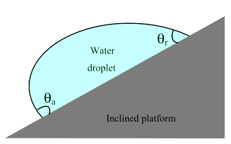

Figure 4. An experimental set-up of how the CAH can be measured. The figure shows the slope, the advancing angle θ_{a} and the receding angle of the water droplet θ_{r}.

Both, the water droplet contact angle and the CAH are caused by surface heterogeneity and surface roughness. This surface roughness can be divided into either micro or nanoscale roughness and both help to increase the water droplet contact angle [18,56,71]. Different fabrication methods can improve the macro, micro and nano-roughness of the material roughness, which results in a more hydrophobic material [64,72–74]. Nanoscale roughness is often modified with techniques as etching, which adapts particle size, coverage and etch time. These can provide the material with the required roughness parameters [62,65,75–77]. Macro- and micro-roughness can be achieved with other techniques such as laser processing and Hummers’ method. Figure 5 gives an overview of surface roughness and the hydrophobic effect. It can be seen that larger pillars(c) result in a low water droplet contact angle, making the affinity of water to the material larger than in the other two (a, b) materials. The finer the pillars and structures become, the more the higher the hydrophobic effect is achieved [77,78].

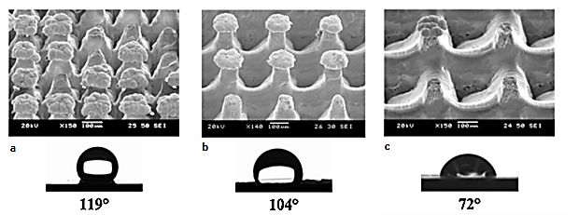

Figure 5. Three different structured materials and their hydrophobic effect. It can be seen that finer pores and more and smaller micro-pillars have the biggest hydrophobic effect [77].

5. Fabrication of hydrophilic materials
Generally, enhancing hydrophilicity of surfaces can be performed in two ways: either deposition of a molecular film of a new material that is more hydrophilic than the substrate, or by modification of the substrate’s surface chemistry. Deposition of coatings onto surfaces is the more common method for inorganic substrates. However, modification of surface chemistry is used in the case of polymeric materials. In this section, the most commonly used methods for making surfaces hydrophilic are briefly reviewed.

5.1 Deposited molecular structures
Monolayers can be formed from organic molecules which adsorb onto the solid surface. The organic molecules can be sourced from a solution or a vapour phase. This ultimately changes the wetting characteristics of the surface [79]. Many research studies have been conducted on densely pack molecular structures that are used on metals. Alkanethiols have been generally used on gold [80,81], silver [82–84], copper [82–84], platinum [85,86], and palladium [87]. Chlorosilanes have been used on silicon oxide [88–91], aluminium [92,93], and titanium [94]. Phosphoric acids can also be used on titanium [95,96], and aluminium [97,98].
Langmuir-Blodgett film technique is used to mechanically deposit mono and multi-layers. However, one major disadvantage of using this method is that it suffers from poor stability when the multi-layers are contacted by liquids [79].
Hydrophilic surface is achieved if the end of the deposited organic layers are polar. If saturated hydrocarbon-based group or fluorinated group are at the end of the layer, then water will not be attracted to the surface giving rise to hydrophobic conditions. Hydrogen bonding is the way in which water molecules will be attracted to the surface if the surface has chemical groups such as –OH, –COOH and POOH [80,81,99]. A contact angle of zero has never been recorded. Beside arranging self-assembled monolayers of chemically bonded short functional molecules on inorganic surfaces, increased research recently has focused on the coating of materials using macromolecules and biomacromolecules. These are popular in altering polymers contacting the biofluids, such as blood [100]. Biomacromolecules, such as Albumin [101–103] and heparin [104–106], have been widely used in the health sector to provide the hydrophilic characteristics which complement the body’s needs. Synthetic polymers such as polyethylene glycol [100,107,108] and phospholipid [107,109–112] macromolecules have been investigated extensively. The presence of hydrophilic layer in bioengineering applications may lead to proteins being adsorbed onto the surface, which is highly undesirable. Therefore having such protective coatings prevents protein adsorption when materials come into contact with biological fluids [113].

5.2 Modification of surface chemistry
Modifying surface chemistry has been investigated for the past few decades. Plasma, corona, flame, photons, electrons, ions, X-rays, g-rays, and ozone are methods that were investigated to alter the chemistry of polymer surfaces without affecting their bulk properties [114,115]. Oxidation of polymer surfaces can be carried out using plasma treatment, in air or oxygen environment [116,117] corona [118,119] and flame [118,120,121].
In both plasma and corona treatments, the electrons are accelerated which then bombard the polymer with energies 2–3 times that necessary to break the molecular bonds, producing free radicals. This generates cross-linking and react with surrounding oxygen to produce oxygen-based functionalities [116]. Hydroxyl, peroxy, carbonyl, ether and ester groups are the typical polar groups which are created at the surface [119]. In the flame treatment, surface combustion of the polymer takes place with formation of radicals such as hydroperoxide and hydroxyl [120,122]. An oxidation depth through flame treatment is approximately 5–10 nm. This increases to over 10 nm for air plasma treatment [123]. Plasma, corona and flame treatments result in extensive surface oxidation and ultimately highly wettable surfaces. Due to the chemistry of the environment, polar groups produced during surface oxidation have a tendency to be buried away in the bulk when in contact with air for extended period of time. However, their presence remains on the surface when in contact with water or any other polar environment [124]. Many polymers undergo oxidation and degradation under ultraviolet (UV) light. For example, outdoor consumer products made from polymers need the incorporation of UV absorbers when exposed to the sunlight to inhibit discoloration, cracking, and fading [125,126]. Wavelength of light ranges from 10 nm to 400 nm, the incident photons have sufficient energy to break the intermolecular bonds of most of the polymers. This enables structural and chemical changes of the macromolecules [127]. The exposure of the polymer to UV radiation ultimately results in making the surface more hydrophilic due to the chain scission, crosslinking, and increases the density of oxygen-based polar groups [128–131]. Surface hydrophilicity can be enhanced by alkali treatment of polymers at elevated temperature [132,133]. Polymer surface such as polyethylene terephthalate contain groups such as hydroxyl and carboxyl groups which contricute to the hydrophilicity of the interaction during etching with concentrated bases [134,135]. Conductive oxide surfaces can be electrochemically treated using anodic potential to control its wetting characteristics [136,137].

6. Fabrication of hydrophobic materials
Fabrication of hydrophobic materials has been an active research topic since many researchers have tried to recreate the ‘’lotus’’ and ‘’petal’’ hydrophobic characteristics. This research included expensive and toxic processes, making them unattractive to apply on an industry-scale. Since the production of most hydrophobic and SHO coatings are costly, environmentally harmful and are very time-consuming, researchers are now looking for a cheaper, sustainable way to produce hydrophobic and SHO coatings [62,138].

Y. Zhang et al. [139] described the fabrication of hydrophobic surfaces as a two-step fabrication where (I) the rough material is constructed and (II) the material is chemically modified to meet the desired characteristics. A great number of fabrication techniques have been reported, such as layer-by-layer assembly, laser process, the solution-immersion method, sol-gel techniques, chemical etching and Hummer’s method. This chapter shortly reviews all the named fabrication techniques.

6.1 Layer-by-layer assembly
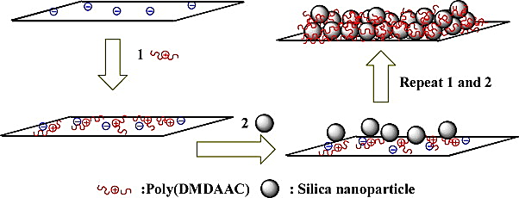
Layer-by-layer (LBL) assembly is a rather attractive fabrication method because of its ability to create multifunctional films on materials while maintaining bulk properties [140,141]. LBL can be applied on a wide variety of substrates such as noble metals, oxides and synthetic polymers. Applying LBL layers on synthetic polymers has been found to be rather challenging as the polymers often require aggressive pre-treatment such as plasma treatment, oxidative chemical reactions or polymeric adsorption. LBL deposition typically consists of four steps: adsorption of a positive component, washing, adsorption of a negative component and final washing. These steps can be repeated multiple times to build a thicker film [140,142]. The LBL deposition can be seen in Figure 6 where the first arrow shows the adsorption of positive components, the second arrow shows the washing and adsorption of negative components and the repeat 1 and 2 arrow shows the end result [78,143,144].

Figure 6. An overview of the layer-by-layer assembly method where it can be seen that a thick layer of silica nanoparticles is built on the material by multiple steps [144].

6.2 Laser process
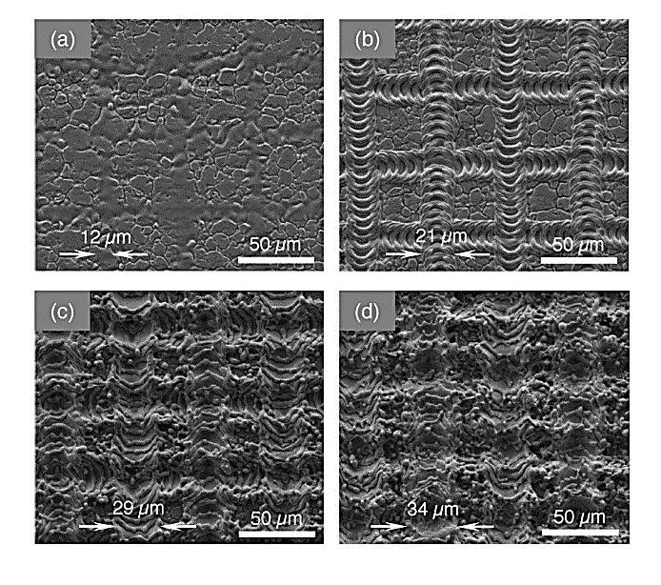
Laser processing has found to be a promising fabrication technique due to three main factors: (I) its excellent control of surface roughness from nano to microscale, (II) it’s a single-step processing under the right conditions and (III) the ability to work with various types of materials [77,145,146]. Laser treatment can be used to increase the static water droplet contact angle by increasing the material’s surface roughness [147]. Lasers are usually used to apply complex structures to the material, where the material is often coated with a fluorine-based material afterwards to create an SHO surface. The fluorine-based material and the surface roughness result in a very hydrophobic material [14,62,147–150]. Figure 7 shows different SEM images of laser-textured surfaces with various laser powers. Figure 7a has the lowest laser power, resulting in a less defined grid compared with b, c and d [77].
Figure 7. SEM pictures of laser textures after treatment with different laser powers [77].

6.3 Solution-immersion method
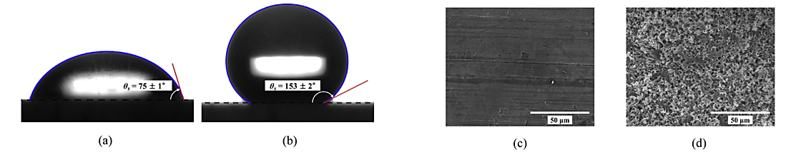
The solution-immersion method can be applied to coat multiple materials with a SHO layer. The solution-immersion method makes it very easy to fabricate hydrophobic coatings. Many research studies [73,76,151–153] have been able to apply a hydrophobic coat to multiple materials such as wood and metals. The solution-immersion method often contains multiple steps. Research by M. Kim et al. [73] applied a hydrophobic layer to wood by immersing the sample in 1M alkaline solution, followed by a 0.3M acidic solution and finished by coating it with a 2H-perflurodecyltrichlorosilane solution. Figure 8 shows the hydrophobic effect before and after the solution-immersion method. It can clearly be seen that the smooth surface (8c) became very rough (8d). This results in a SHO surface, which is shown (8b) as the water droplet contact angle is bigger than 150˚.

Figure 8. Before the solution-immersion method, the material is smooth and not hydrophobic (θ < 90˚), after the solution-immersion method the material became very rough which, in combination with the polymer layer applied on top, creates a very SH surface [73].

6.4 Sol-gel technique
The sol-gel technique can be applied to various types of materials. The sol-gen technique can be divided into multiple steps where (I) the sample will be washed, (II) the cleaned sample will be immersed into a solution, (III) the coated sample will be washed again and (IV) the sample will be dried [56,138,154–156]. The research of S. Wang et al. [72] used the sol-gen technique to apply a wood surface with silica particles. Afterwards, the silica got a fluorination treatment with a surface modifying agent of 1H, 1H, 2H, 2H-perfluoroalkyltriethoxysilanes which resulted in a SHO coating on the wood [157,158].

6.5 Chemical etching
Chemical etching is a type of surface treatment that is commonly applied to metals. Many researchers have conducted experiments with applying hydrophobic layers onto metals, and most researchers preferred using magnesium alloy [61,159–162]. The etching process consists of multiple steps where (I) the sample is cleaned, often ultrasonically, and dried, (II) the material is etched in a aqueous solution, often containing copper, (III) the material is rinsed with water and often with ethanol, (IV) the material will be dried and finally (V) the material will be modified with a silica-containing solution, making the end product SHO [61,159–163].

6.6 Hummers’ method
The Hummers’ method is an alternative oxidation method developed by Hummers’ and Offeman in 1958. The method used a solution of NaNO₃ and KMnO₄ dissolved in H₂SO₄ to oxidize graphite into graphite oxide. The Hummers’ method was a very fast way of oxidizing. As the Hummer’ method is very easy and quick to perform, it is now a widely used method [164–166]. N. Cao et al. [167] used Hummer’s method to produce a hydrophobic aerogel. After the Hummers’ method, various applications of solutions and drying processes have been applied, finishing with a reaction with 1H, 1H, 2H, 2H-perfluorodecanethiol. Although the product is highly hydrophobic, the reaction takes up much more effort and time than the other methods previously mentioned [168,169].

Besides the six named fabrication techniques, there are plenty of other techniques that can be applied to fabricate a hydrophobic coating. Each described method has its pros and cons, where some methods are very easy and fast but can only be applied to specific types of materials and others are complex but achieve high-quality results on many types of materials. Table 1 is an overview of each technique with the advantages and disadvantages for each of the techniques.

Table 1. Advantages and disadvantages of each fabrication method.
Technique | Advantages | Disadvantages
Layer-by-layer assembly | - Can be applied to various materials  - Bulk properties remain | - Requires many steps, slow technique  - Often very challenging to apply to certain materials
Laser processing | - Can be applied to various materials  - Excellent control on surface roughness  - Can be done in 1 step  - Fast technique | - The technique is very expensive
Solution-immersion method | - Can be applied to various materials  - Simplistic and easy technique | - Requires many steps, slow technique
Sol-gen technique | - Can be applied to various materials | - Requires many steps, slow technique
Chemical etching | - Many researches available about this technique | - Only really applied to metal materials  - Requires many steps, slow technique
The Hummers’ method | - Fast technique | - Can’t be applied to many materials

7. Applications of hydrophilic materials
As discussed previously, the hydrophilic property has many uses in the natural and artificial environments. It has highly been investigated in various animals and this information is being used to produce synthetic materials that have a wide range of uses. This section will discuss specific uses of hydrophilic materials.

7.1 Glass/ Anti-fogging surfaces
High humidity reduces visibility drastically, which can be dangerous depending on the setting. Anti-fogging surfaces can be used to reduce fogging. Swimming goggles is a scenario where fogging occurs on the inner surface of the goggles due to the humidity build up in the enclosed space. Relative humidity is a function of temperature, allowing water to reach its dew point when encountering a cold surface. This results in the formation of water droplets due to the condensation taking place. Optical clarity of the transparent surface will be reduced significantly, shown in Figure 9 left. Recently, anti-fogging surfaces has been becoming a necessity and it is highlighted by micro- and nanofluidic applications. Visualization of two phase flow in the cathode micro-channels of proton electrolyte membrane fuel cells [170].
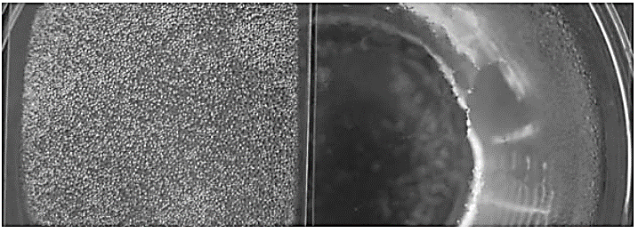
Figure 9. Left: untreated polyester film showing low optical clarity. Right: plasma-treated superhydrophilic polyester with high optical clarity [2].
Cell cultivation has similar challenges in-terms of fogging. This has been resolved due to the innovation of hydrophilic materials [137]. Humidity inside food packaging increases when they are refrigerated. This occurs due to the decrease in temperature. Consequently, condensation occurs on the inner surface of packaging. A superhydrophilic surface can be anti-fog because water spreads on the rough hydrophilic surface to form a thin film instead of droplets. Superhydrophilic treatment is different from traditional anti-fogging coating that is widely used for swimming goggles and eyeglasses. The later usually employs various surface coatings to treat the surface hydrophobic, which tends to have low adhesion with the tiny water droplet formed on it. Hydrophobic anti-fog surfaces are usually more effective than the superhydrophilic surfaces [40]. However, a coating approach might be undesirable in many conditions, such as inside a microchannel. Safety concerns arise due to chemical agencies used for biomedical sample and food, especially when the surface is subjected to environments of high temperature and high humidity.

7.2 Bio-fouling and its prevention
The continuous water thin film formed on a hydrophilic or superhydophilic surface has a profound impact on their interactions with molecules and micro-organisms, including biofouling and biocompatibility. In marine engineering, the growth of microorganisms such as algae on a surface of a ship immersed in the sea can cause fouling. Fouling is significant in biomedical devices because they are subject to fouling of cells and biomolecules, such as proteins. Fouling negatively impacts the performance of such devices. It is desired to reduce or avoid or reverse biofouling using anti-fouling and fouling-release [171]. When observing the hydrophilic parts of the surface, a trend is clearly seen that for high-surface energy materials, the degree of fouling is reduced with surface energy. This is explained by the strong attraction between surface and water molecules, establishing a barrier to prevent interaction between fouling agent and surface and thus delaying the fouling [172–174]. Research studies have shown significant decrease of fouling by using fluorescein and fluorescent proteins after the surfaces being treated to be superhydrophilic [172]. However, these results have been obtained in a relatively short period of 30 minutes with static liquid. Therefore, they are not a true indicator for long-term prevention and release of biofouling [172]. The main difference between short-term and longer-term fouling of hydrophilic and superhydrophilic surfaces can be attributed to the quick degradation of hydrophilicity, which tends to be unstable [175].

7.3 Enhanced boiling heat transfer
Enhanced boiling is the most efficient mode of heat transfer. It is being implemented in a broad range of power generation and thermal management devices, such as nuclear power plants, refrigeration, cooling of electronics and chemical reactors [176–179]. Surface wettability has a significant effect on boiling heat transfer. Figure 10 shows a boiling curve which correlate the heat flux with wall superheat. Point A is the beginning of nucleate boiling, where vapour bubbles form on the overheated surface. The nucleate boiling continues to fully develop from B to C. At point C, the het flux eventually reaches its maximum value, known as critical heat flux (CHF). This is due to the continuous vapour film forming as an effective thermal insulation layer. Further heating beyond point C will lead to dramatic increase of wall temperature and ultimately result in device failure. Therefore, CHF marks the maximum heat flux that can be provided by a boiling-based cooler.
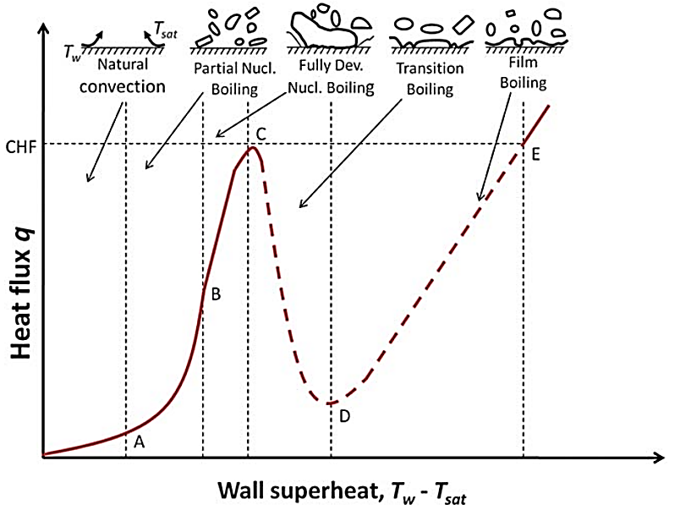
Figure 10. Propagation of boiling stages [114].
However, having a hydrophilic or superhydrophilic surface forms a continuous water film which delays the formation of vapour film in boiling and thus improve CHF. Many studies on vertically aligned nanoforests of hydrophilic/superhydrophilic nanorods, nanowires and CNTs have shown a significant improvement in boiling heat transfer [180–183]. For example, both CHF and heat transfer coefficient (HTC) have been improved by more than 100%. This improvement has been primarily due to the increased density of nucleation sites, high surface tension force of superhydrophilic nanostructures. This allows the liquid to be pumped and the cavity stability provided by the nanopores [180,184]. Furthermore, it has been shown that a surface with mixed hydrophilic and hydrophobic micro-patterns result in enhanced pool boiling to almost the same degree. For example, 65% and 100% improvements were achieved on CHF and HTC, respectively, with a hydrophilic and hydrophobic network [183]. The combination of both wettabilities prevent the formation of vapour film by attracting liquid onto the hydrophilic region, while nucleation is promoted at the hydrophobic regions. This help to remove gas bubble efficiently [183].

7.4 Other Applications in Biomedical Field
Hydrophilic coatings have been widely used in the medical field. The main components used in hydrophilic coatings are polyvinylpyrolidone, polyurethanes, polyacrylic acid, polyethylene oxide, and polysaccharides. The development of these types of coatings have more recently moved towards anti-fouling, antimicrobial and biologically active surfaces. Biomedical applications of polymers include vascular heart valves, artificial hearts, catheters, contact lenses, intraocular lenses, and plasmapheresis units. The pharmaceutical industry widely applies coatings for tablets and capsules, adhesives, and blood substitutes [12]. The major advantage of using hydrophilic coatings is that they provide better lubricity compared to hydrophobic coatings [185,186]. Contact lenses must be wetted by tear fluid to move relatively freely on the eye. This provides comfort to the wearer [187]. The applied research on surface modification of contact lenses is substantial [122-124] and mostly deals with making surface of polymer hydrophilic. However, due to hydrophobicity of silicone hygrogels, they require hydrophilic coatings for improved wettability with tear fluid, wearing comfort and biocompatibility.
Surface coatings included neutral hydrophilic polymers such as polyacrylamide and polyethylene oxide (PEO), phospholipids, dextran, pullulan, and others [188–191].

7.5 Heat pipes
An experiment conducted by Hao et al. [192] which investigated the effects of hydrophilic surface on heat transfer performance for an oscillating heat pipe (OHP). An image of the oscillating heat pipe is shown in Figure 11.
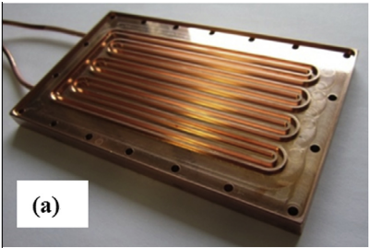
Figure 11. Photo of a four turn copper plate OHP [192].
The experimental results showed that the surface wettability remarkably influences slug motion and thermal performance of OHPs. A stronger liquid slug movement was observed in both superhydrophilic and hydrophilic OHPs in comparison with copper OHP. The global heat transfer performance of the superhydrophilic and hydrophilic OHPs increased in the sixth turn OHP. For six-turn OHPs, the maximum displacement of the liquid slug in the hydrophilic OHPs and superhydrophilic OHPs increased by 5–60% and 25–60%, respectively, relative with that of copper OHPs. An increase by 5–15% and 15–25% of the heat transfer performance of superhydrophilic OHPs and hydrophilic OHPs, respectively, has been observed, in comparison with that of copper OHPs. This investigation has clearly shown that hydrophilic surface improved the heat transport capability of OHPs.

7.6 Hydrophilic property for filtration
Commercial hydrophilic membranes used to filter aqueous and organic solvents used in HPLC offer maximum chemical and pH resistance. The membranes are a thin, unsupported, highly porous films. High flow rates can be permeated through this type of membrane with minimal aqueous extractables [193].
Since the filter is optically clear when wet it is ideally suited for culture and microscope examination of cells/particles captured on the filter surface without requiring a separate step to render the filter optically clear. This area requires further research for potential use of hydrophilic membranes to filter pathogens from water.

7.7 Road marking paint
Due to local climatic conditions such as variations in temperature, the structure of asphalt, vehicles, drivers’ behaviour, exposure to ultraviolet radiation (UV) and to pollutants road marking paint loses its fundamental properties. Therefore, superhydrophilic materials used within the paint enables self-cleaning” paint using photocatalytic titanium dioxide (TiO2). Super-hydrophilic property allows dirt to be easily washed off with water or rain [194–196].
The superhydrophilic property is capable to prevent pollutants from adhering to the substrate through the formation of a uniform water film over the solid surface. The synergism of hydrophilic and photocatalytic results could maintain aesthetical properties; improve surface maintenance and reduce degrading processes [195].

7.8 Mesh
Liu et al. [197] have demonstrated facile fabrication method to synthesize aluminium-introduced MFI-type zeolite-coated mesh to separate oily water. The membrane’s hydrophilicity was controlled by adjusting the ratio of Al/Si in precursor solution. Their results have shown that increasing the aluminium content in the zeolite has led to a larger contact angle. Oil was the non-wetting phase in this experiment. Oil rejection rate was over 99% at flux of >80000 L m⁻² h⁻¹ for hexane water mixture. Other mixtures of oil with water such as n-hexane, cyclohexane, mineral oil, and vegetable oil have all shown rejection rates of over 96%. The exact results are shown in Figure 12.
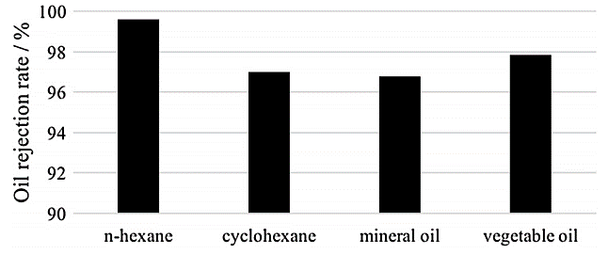
Figure 12. Oil rejection rates of the hydrophilic zeolite mesh for various oils [197].
The results shown in Figure 12 indicate a promising method for oil/water separation that could potentially be used at industrial level. To show the experiment at laboratory scale, Figure 13 shows the before and after of the oil water mixture.
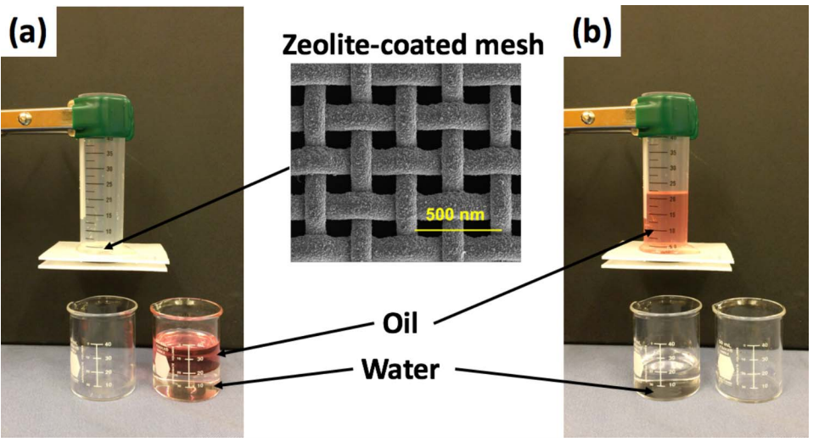
Figure 13. Oil/water separation using zeolite-coated mesh (a) before separation; (b) after separation [197].
The mechanism in which the separation takes place is that the hydrophilic mesh has a very high affinity to water which allows it to pass through easily. However, the oil which is the non-wetting phase is repelled away from the mesh and is rejected above it.

7.9 Sample pre-treatment
Sample pre-treatment is a fundamental and essential step in almost all chemical analytical techniques, especially for the analysis of biological and environmental samples with complex matrix. The development of hydrophilic interaction liquid chromatography (HILIC) in the separation of polar compounds, hydrophilic materials have been extensively implemented in sample pre-treatment in various disciplines, such as pharmaceutical, clinical, toxicological, food and environmental analysis [198].
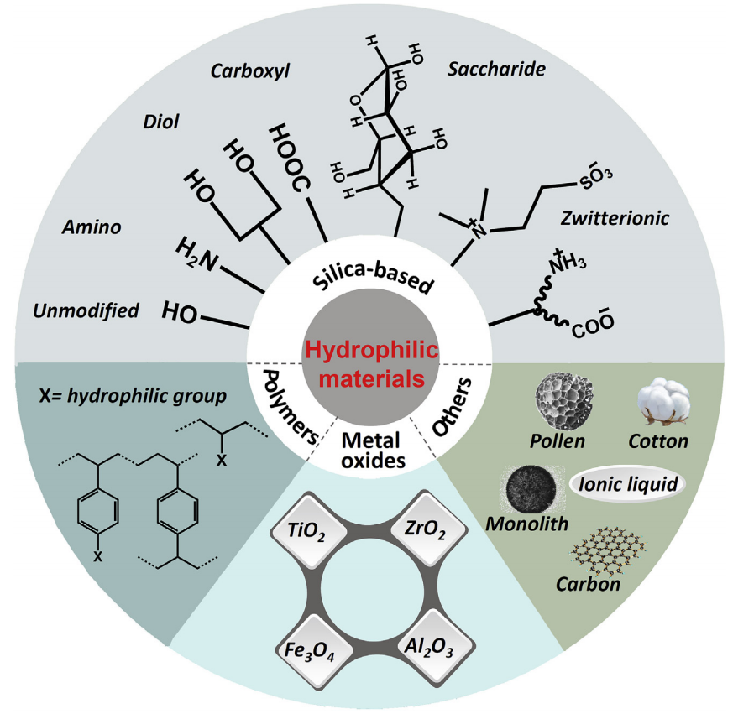
Figure 14. Hydrophilic materials used in sample pre-treatment [198].
The most frequently used hydrophilic materials in HILIC-based sample pre-treatment is silica based materials. Other hydrophilic based materials are shown in Figure 14. These materials, such as amino-, diol, zwitterionic, carboxyl and saccharide silica type materials, have proven their practical application for HILIC-based sample pre-treatment.

8. Applications of hydrophobic materials
Hydrophobic coatings can be applied to many materials and can be used in various situations. Since SHO coatings repel water, it can be useful in many everyday situations which will be discussed in this section.

8.1 Petroleum
Hydrophobic coatings could play an important role in the cleaning up of oil spills. Oils spills on freshwater can bring many problems environmentally and economically. Since the behaviour of oil in water is very hard to predict, cleaning up oils spills can be a hard task. The clean-up of oil spills depends on the type of oil that is spilt, the type of water, water turbulence and water temperature [55]. Petroleum consists of different hydrocarbons: aliphatic hydrocarbons (40-80%), aromatic hydrocarbons (15-50%) and resins and asphaltenes (0 – 20%) [199]. Petroleum also contains harmful polycyclic aromatic hydrocarbons (PAHs) and monoaromatic hydrocarbons (MAHs) which can be released into the environment where it pollutes the air, water and soil.

Hydrophobic materials can be applied to solve both problems. Research by C. Filho et al. [199] used mesoporous aerogels, made during a sol-gel process, to adsorb PAHs from an audacious solution. The adsorption by aerogels is found to contain both chemi- and physisorption mechanisms. The research found that the sorption remained the same for all solutions although the use of different starting concentrations.

Other researchers [200–205] also made SHO sponges and gels that were capable of adsorbing oil from aqueous solutions. The research by L. Zhang et al. [205] shows the fabrication of a hydrophobic sponge. The experiment has shown that the sponge was successfully capable to adsorb toluene and chloroform from an aqueous water solution. Figure 15 shows pictures from the experiment, where it is clear to see that the sponge adsorbed the toluene completely.
Figure 15. Experiment from L. Zhang et al. [205] showing that the SH sponge fully adsorbed toluene.

Since many research studies have already shown the capability of fabricating (academic size) sponges and gels that are capable of adsorbing alkenes, the application of SHO materials for bigger problems is very interesting and promising.

8.2 Plastic
Plastic materials are heavily used in both everyday household items, as well as functional industrial materials. Plastic can be used in packaging, bottles, containers, buckets, dishware, glasses, cups, electrical circuit boards, cushions and more. The application of plastic in everyday household items is very common and the use of hydrophobic and SHO coatings can improve the quality of these items [206].

As there are many different types of plastic, they can be applied in various ways. Polyurethane (PU) sponges can be applied to adsorb organic solvents from water surfaces due to their high porosity and low density, resulting in a high adsorption ability at low costs. PU is naturally hydrophilic, but modifying the PU sponges with TiO₂ increases the PU sponges’ roughness which increases the hydrophobicity [154,203,204]. Sponges as such can be applied as a selective filter to separate oil from water. Polyethylene (PE) can be applied as a hydrophobic coating to paper and paperboard packages, ensuring that the porous cellulose networks of paper are more water-resistant. One of the major applications of this technology are the single-use paper cups [207–210]. Since the hydrophobic coating normally is petroleum derived, the usage of the coatings is not environmentally friendly. Current research is in progress for single-use paper cups with bio-derived PE [211–213]. Other applications of hydrophobic plastic coatings could be their self-cleaning property. This property can be applied in both the biotechnology and the household sector:
- The biotechnology sector can apply plastic hydrophobic coatings to control droplets that contain biologically relevant molecules such as DNA and proteins while minimizing the chance of contamination.
- The household sector can apply plastic hydrophobic coatings to cutting boards, cups, cushions and food containers to make them self-cleaning. The water repelling effect will result in fewer stains and makes the cleaning of kitchen items easier [154,214].

As hydrophobic coatings are heavily applied in packaging, everyday household items and technology industries, it is important that bio-derived plastic coatings replace the traditional petroleum based-coatings. This will ensure a more sustainable future.

8.3 Heat pipes
Heat pipes are widely applied in various heat exchange systems such as air-conditioners and heat pumps. In air conditioners, moisture condenses and accumulates on the heat transfer surface of either an evaporator or cooling coil when the surface temperature is below the dew point of the conditioned air [18,215]. Air-conditioners often have a water hold-up, which is caused by remaining water droplets on the air-conditioners’ surface. Water hold-up can lead to unwanted conditions: it can increase the air-side pressure drop, reduces the air-side heat transfer coefficient, degrades the cooling capacity, leads to corrosion and provides an attractive environment for biological activity [216,217]. Frost layers can occur on the heat transfer’s surface during colder days, which increases the heat transfer resistance, which can lead to the shutdown of the heat pump [218,219]. Hydrophobic and SHO coatings could be applied to heat pipes to increase their performance.

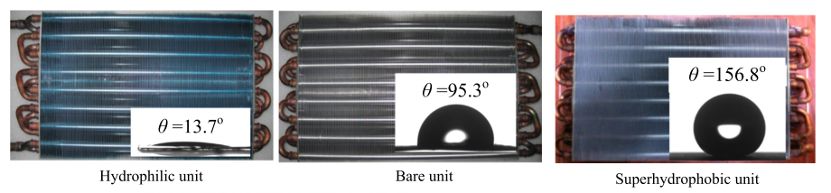
Many researchers have investigated the application of hydrophobic and SHO coatings of heat exchangers and heat pipes to make the system more (energy) efficient. The application of these layers has been done through chemical etching. Many research studies [17,18,73,147,217,219] found that the heat transfer capability does not change after applying hydrophobic or SHO coatings. They also found that frost layers immediately shed from the SHO coatings at the beginning of frost melting. Hydrophobic surfaces contained water after the frost melting but there was no water retention seen on the SHO surface [220–222].
Figure 16. Experimental set-ups of each hydrophilic, normal and superhydrophobic units. It can clearly be seen that the SHO unit repels the water where the hydrophilic attracts the water droplet [220].

Hydrophobic and SHO coatings can be applied to heat pipes to improve the anti-freezing behaviour. Figure 16 shows three heat pipe systems, where the hydrophilic unit strongly attracts the water droplets and the SHO unit strongly repels the water droplets. Applying SHO coatings on heat pipe systems not only improves the performance of the system, it also prevents the unwanted build-up of water hold-up [182,223–225].

8.4 Other metal applications
Hydrophobic and SHO can be applied to various types of metal to improve their performance. Polytetrafluoroethylene (TEFLON) is often applied to aluminium alloys to increase the surface hydrophobicity. A very common application of TEFLON is pan coatings. The TEFLON coating is highly hydrophobic (θ_{e} ≈ 120˚), which results in a non-stick coating which prevents food to stick to the pan [59,223,226,227].

TEFLON and other hydrophobic and SHO coatings are also applied to metals for other purposes than cooking. As hydrophobic and SHO coatings have the characteristic that water drops roll off the surface with the slightest tilt which makes the application of these coatings interesting in other areas such as microfluidic devices and anti-icing applications [227,228]. SHO coatings can also be applied to prevent corrosion of metals that are vulnerable to corrosion. As SHO coatings repel water, it results in a high corrosion resistance property and stability. These conditions contribute to the chemical stability of a metal complex [229–231]. Another application of hydrophobic and SHO coatings can be found in nanotechnology. Research of Cho et al. [232] has found a method to produce memory devices based on multilayer stacks of densely packed hydrophobic coated metal arrays. The memory of these devices can be significantly enhanced by increasing the charge trap elementals with hydrophobic properties. Hydrophobic and SHO surfaces can also be applied in the capture of harmful (volatile) organic compounds. The surfaces can be applied to remove oils from surface water, but can also be applied to capture organic compounds in other moist environments such as steam [233,234].

There seems to be a large interest in metal hydrophobic coated materials and research studies, such as Cho et al. [232] are currently applying this technology to improve current technology.

8.5 Textiles
The use of hydrophobic and SHO coatings on textiles has increased drastically the last couple of years. The interest of self-cleaning clothes or clothes, that do not get dirty at all, has always been an interesting topic [235]. This technology developed rapidly the last decades and products as such are now widely available for the customers. An example is the hydrophobic shoe spray that has been on the market for some years now which has been loved and used by many customers as it makes their everyday life more convenient [236].

Many researchers have proven that it is possible to apply hydrophobic and SHO coatings onto textiles such as cotton, polyamide and polyester textiles [237–240]. All studies succeed in applying the hydrophobic coating, where most studies even reached SHO textile characteristics. Figure 17 gives an overview of the research by Joshi et al. [241] where it can clearly be seen that all treated coatings show a hydrophobic effect and the untreated sample is absorbed into the fabric. The research showed that the hydrophobic coatings successfully repelled water while retaining the air permeability of the fabric which maintains the comfortable characteristics of the fabric.

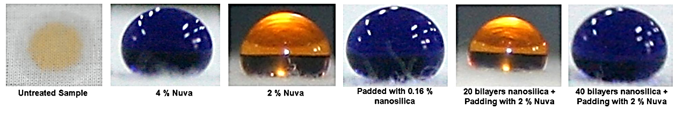
Figure 17. Research by Johsi et al. [241] showing that the untreated textile adsorbed the droplet, where all the treated samples showed the hydrophobic effect as they repel the liquid droplet.

Although the results of the application of hydrophobic and SHO coatings to textiles are very positive, it still has its downsides. As the application of the coating is a very pricey process, and it is likely that this technology will be applied to clothes. Another downside is that the hydrophobic/SHO coating slowly wears off. Research by Su et al. [242] found that applying friction to the material changes the structure of the coating. Even though the research showed that the hydrophobic characteristics were still present after 1000 times of friction, it is mandatory to understand that the hydrophobic layer slowly changes which can change the hydrophobic effect.

Applying hydrophobic and SHO coatings to both commercial as industrial textiles is an interesting concept, as it contains the self-cleaning characteristic. Applying these coatings to industrial textiles such as aprons, lab coats and uniforms ensures the material to remain stain-free or be safer as it does not absorb any liquid [240,243–245]. The application of these coatings is an interesting concept, yet, more research is required before it can be applied on a large scale.

8.6 Glass
Glass can be applied with hydrophobic and SHO coatings for various reasons. One of these reasons can, again, be the self-cleaning effect which simplifies the day to day life. The coating can be applied to outdoor glass and solar panel glass. During the application of hydrophobic coatings to glass, it is important that a good transparency and transmittance remains. Multiple research studies have shown that these characteristics remain after the application of the hydrophobic layer. The transparency remained higher than 80% and the optimal transmittance improved by 7%, this is caused by the anti-reflection effect of the coating [246,247].

Hydrophobic glass coatings can also be applied in various other ways, especially in the biotechnology sector. Various research studies have applied hydrophobic glass in their research:
- Zhang et al. [248] were successful to adsorb chromo-bacterium lipase by using hydrophobic glass beads.
- Garg et al. [249] used glass with different hydrophobic coatings and found out that SHO coatings had the least microbiological growth.
- Yayapour et al. [250] used hydrophobic glass surfaces to investigate the kinetics of cell adhesion between blood and the glass. The research showed that leukocytes adhere to hydrophobic surfaces, which can be applied to separate the leukocytes from the lymphocytes.

The technology sector also found ways to imply the hydrophobic layer on glass. The coatings can be used for anti-icing methods. The research of Hu et al. [251] investigated the effect of frozen water droplets on hydrophilic and SHO surfaces. One of the results is shown in Figure 18, where it clearly shows that the water density of the droplets on the SHO surface is decreased. The ice structure contains air chambers that are created in between the SHO droplets. These air chambers are the interfaces between the ice layer and the glass insulator, as these chambers are filled with air, the water density on the surface decreases. As the water droplets slightly melt, the droplets at the SHO surface easily slide off, where the droplets on the hydrophilic surface stay on [251,252].

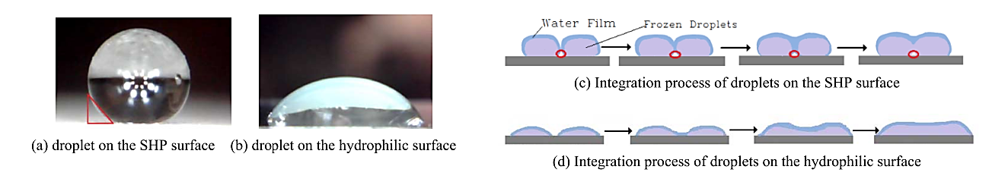
Figure 18. The shape of frozen droplets on both SH and hydrophilic surfaces. Due to the air chambers at the SHO surface, the over-all density is lower and as the ice droplets melt they will slide of the SH surface, while they will stay at the hydrophilic surface [251].

Glass has many applications, both industrial and domestic [248,253,254]. Although there are already so many ways to employ this technology, further improvement and development is needed to optimize them.

8.7 Ceramics
Ceramic materials become more popular in the application for water filtration. 70% of the earth’s surface consists of water which essentially comes from seawater and icebergs [255]. Only a small amount of this surface water is potable (3%) which has become a major concern as new fresh water producing techniques are required to offer a sustainable amount of fresh water [256–258]. Different techniques such as reverse osmosis (RO), electrodialysis (ED), membrane distillation (MD) and multi-stage flash distillation can be applied for the desalination of brackish and seawater. Especially MD has gotten an increased attention in the last couple of years for being a simple yet highly efficient technique. MD has shown salt rejection rates around 99-100% [259–262]. MD usually uses membranes made from different polymers but these do have disadvantages as they have poor thermal, mechanical and chemical stabilities, making it challenging to commercially apply them as membranes [260,263,264].

Ceramics can be applied as MD membranes, as their thermal, mechanical and chemical stabilities are more stable. In addition, their chemical inertness, porosity structure and good flux make them interesting for the application as MD membranes [265–267]. Ceramics are naturally hydrophilic, as they contain multiple metal oxides which are hydrophobic due to the presence of hydroxyl (OH-) groups on the surface. Surface modification, usually done by either immersion or grafting processes, reduces the pore size and forms the hydroxyl groups into organosilane compounds, which makes the surface hydrophobic [268–270]. Figure 19 shows the grafting process, where the hydrophilic hydroxyl groups are treated with perfluoroalkylsilane to form a hydrophobic coating [262]. Figure 20 shows the affinity of water droplets on a ceramic surface before and after the grafting process [263].
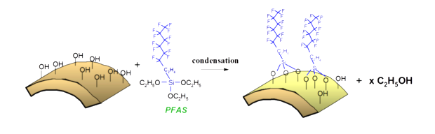

Figure 19. The grafting process where the hydrophilic hydroxyl groups are treated with perfluoroalkylsilane to form a hydrophobic coating [262].
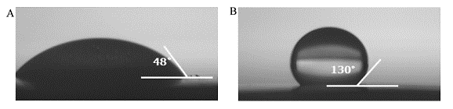
Figure 20. The water droplet affinity with a ceramic surface before (a) and after (b) the grafting process [263].

The hydrophobic ceramic membranes formed can be applied in different separation processes:
- The hydrophobic ceramic membrane can be applied in the production of fresh water from brackish and seawater. As the water condensates on one side of the membrane and goes through the pores, that are not permeable for salt ions and the water condensates on the other side of the membrane, the water is cleared from the salt ions [260,263,264].
- Hydrophobic and SH ceramic membranes can also be applied for the removal of volatile organic compounds from water by vacuum pervaporation. As the liquid streams encounter the membrane, the volatile organic compounds are absorbed into the membrane and permeate through the permeate side. This successfully removes volatile organic compounds from the liquid stream [261,262,267,268].

Hydrophobic ceramic coatings show great potential to be applied in many industries, however, it requires improvement before they can be applied in industries, as the techniques do not always show the highest efficiency.

8.8 Mesh
The increasing amount of industrial oily wastewater and oil spill accidents creates environmental, economic and social issues. Due to these issues, there is a constant search for effective and inexpensive clean-up methods [271]. Hydrophobic and SHO mesh has been widely applied for the separation of oil and water. Where other materials are often only coated with a hydrophobic or SHO coating, the coating of most mesh also contains super-oleophilic (SO) properties, resulting in an even higher affinity for oils. Wet chemistry or acid etch methods can be applied to the mesh to fabricate SHO and SO coatings. Most research studies focus on surface roughness or the application of hydrophobic agents, where often they are expensive, harmful and oleophobic chemicals were used, making it difficult to scale-up for industrial applications. In addition, during the application of polymer-based coatings, it is difficult to control both the surface structure and the coatings are not thermostable [272,273].

Materials with both SHO and SO characteristics are optimal for heavy oil/water separation as they exhibit stable water-resisting, anti-chemical erosion and anti-hot ageing properties. Successful oil removal requires a material with high separation capacity, with resistance to oil fouling that is easily recyclable. If the oil separation capacity is not high enough, the removing material can easily be fouled or blocked up by oils due to their oleophilic property. Especially high-viscosity oils tend to adhere to the material, which affects the separation efficiency, are hard to remove and results in secondary pollution during post-treatment processes which waste both the oils and oleophilic material [274–276].

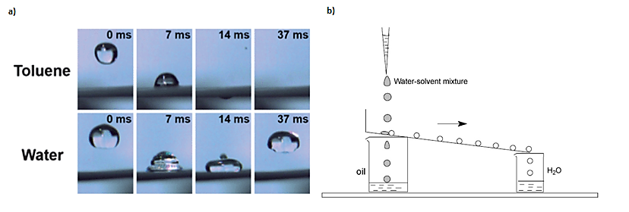
Figure 21.(a) Behaviour of a water droplet on SH and SO mesh and (b) a successful set-up to separate water and oil.
Many research studies have proven that an SHO and SO mesh is able to successfully separate oil from water. Figure 21 gives an overview of two of these experiments. Figure 21a shows the behaviour of a water droplet on an SHO and SO surface. It can be seen from the figure that the water droplet is strongly repelled, as it bounces back from the surface where toluene is strongly attracted and goes through the mesh. Figure 21b shows an experimental set-up for the separation of an oil/water solution where the SHO and SO mesh strongly attracts the oil, which permeates through the mesh and is collected in a beaker. The water is repelled and is collected in another beaker. This technology can, when further improved, be applied on a bigger scale as it has been proven to be highly effective [277–279].

8.9 Paint
Paint is initially hydrophilic and tends to be contaminated by pollutants in water. As paint is hydrophilic, it attracts water with dirt which make the visible appearance of the paint old and dirty. Therefore, cleaning is required and manpower is expensive. Due to this, the attention for self-cleaning paints have grown. The application of hydrophobic and SHO coatings is quite common, however, the production of a hydrophobic paint is still very uncommon. In addition, the processes to fabricate hydrophobic materials often requires expensive and environmentally-harmful chemicals, which is not suitable for large-scale applications [280].

Researchers have an interest in the application of hydrophobic and SHO paints in various domains:
- Hydrophobic and SHO paints can be applied to marine ships. The hydrophobic characteristic of the paint carries many advantages for ships: it is self-cleaning, repels water and other sea-creatures, and has anticorrosive protection and minimizes drag resistance which reduces the fuel consumption. The application of these paints is still in development, as earlier antifouling paints slowly degraded which spread paint particles through natural waters [281,282].
- Hydrophobic and SHO paints can be applied for a self-cleaning or protecting effect on various materials. The self-cleaning effect is desirable for building materials, as it improves the aesthetic appearance and reduces maintenance costs. The hydrophobic paint coat can also be applied as a protection layer, e.g. applying the paint to reduce the amount of tritium (³H) in concrete walls [280,283,284].
- The paint can be applied in the biotechnology sector so can chips with hydrophobic paint layers be used to measure different samples without mixing the tested solutions. The chip can test 9 different solutions and has 12 slots per solution, making them useful e.g. blood tests and DNA tests [285,286]. Figure 22 shows an overview of the chip and gives a schematic overview of the sensor’s active part.
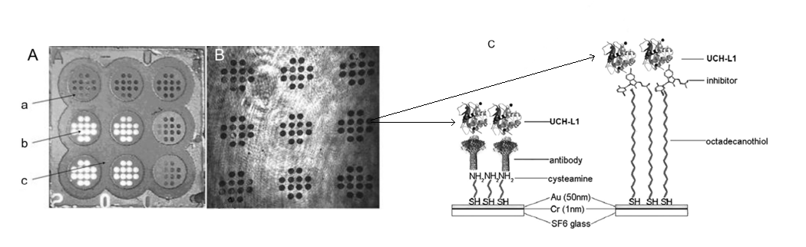
- Hydrophobic and SHO paints can also be applied to other sensors. Sakaue et al. researched the AA-PSP sensor, which is a fast responding global pressure sensor that consists of a pressure sensitive probe on a porous supporting matrix of anodized aluminium. As the sensor adsorbs water, the measurements have a higher uncertainty. Applying the hydrophobic/SHO paint can repel water, which will prevent the measurement uncertainty of the sensor [287].

Figure 22. The figure shows (A) a picture of the chip with (a) a photopolymer, (b) free gold surface and (c) the hydrophobic paint, (B) an image of the chip obtained by a charge-coupled device camera and (C) a schematic overview of the sensor active part [286].

8.10 Electronics
Hydrophobic and SHO coatings are slowly becoming more popular in the electronics industry as more handheld devices are protected against water and dust by applying these coatings. Not much research into the use of hydrophobic coatings on electronics has been done before, and most research is stand-alone research rather than follow up research. Some applications of hydrophobic and SHO coatings in the electronics industry that are currently in development are:
- Quesada-Gonzáles et al. [288] used hydrophobic printer material to print different hydrophobic bar channels made of alkyl ketene dimer where each channel can be used for another sample. This application is similar to the (III) paint application. This technology can be applied in the biotechnology sector and is much cheaper than the chip shown in Figure 22.
- The use of hydrophobic and SHO coatings to protect handheld devices is becoming more popular and advanced. Current high-end mobile devices present such coatings to protect the device to both water and dust. The hydrophobic layer often ensures the use of the mobile device to be underwater for 30 minutes with a maximal depth of 1.5 m [289–291].
- Bonfante et al. [292] and Luo et al. [293] researched hydrophobic and SHO coatings used in electro-wetting applications. The coatings were successfully applied and repelled and can be applied to various applications such as adjustable lenses, electronic (outdoor) displays and switches.

8.11 Other applications
Hydrophobic and SHO coatings have great potential and can be applied to various types of materials to improve their lifetime or make them more efficient. Even though many materials have already been covered, there are still more applications for hydrophobic and SHO coatings.

A common application of hydrophobic and SHO coatings is on wood. Wood can be applied in many fields and initially has a hydrophilic characteristic caused by natural pores and hydroxyl groups on the surface. This hydrophilic behaviour adsorbed water which can cause the wood to crack, rot and degrade [207,294]. Hydrophobic and SHO coatings could prevent the degradation process and potentially create more applications for the wood. Hydrophobic and SHO coatings are often made during the sol-gen process, where the wood is placed in a ɣ-aminopropyltriethoxysilane bath where the silination of present hydroxyl groups occurs. After the bath, the wood surface is modified with an SHO material such as ethanolic lauryl aldehyde/acid. The surface modification process of wood can also be seen in Figure 23 [72,76,152]. Wood with hydrophobic and SHO coatings can be applied in many fields as: (I) it shows great durability when exposed to acid rain, (II) it reduces the speed of moisture absorption and the amount of moisture that is absorbed is decreases, showing that it is much more water resistant, (III) the coating shows a strong self-cleaning effect which contributes to anti-contamination coatings and (IV) producing the hydrophobic and SHO coatings is a low-cost process, making it easy to apply this technology to many products [295–299]. Lourençon et al. [294] used bio-oil, a by-product of pyrolysis (waste-to-energy conversion method), to apply an SHO coating on wood. This coating has increased the overall stability of the wood, resulting in the increase of the lifetime of wooden products. Pyrolysis results in no net carbon emission, making the application of bio-oil interesting as it is not as (environmentally) harmful as other chemicals [300,301].
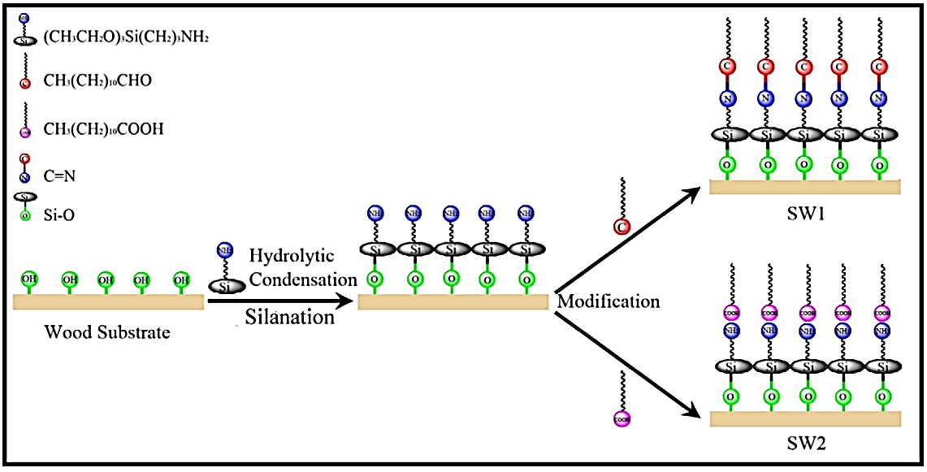

Figure 23. An overview of the production of hydrophobic and SH coatings on wood [76].
Hydrophobic characteristics are also observed in coal. Coal can be specified in different rankings, where especially high-ranked coals show hydrophobic characteristics and low-ranked coal normally shows more hydrophilic characteristics. The difference between the water repelling characteristics is mainly caused by the high amount of oxygen-rich groups at low-ranked coal which are not as much present in the high-ranked coal [302–304]. The lower number of oxygen-rich groups resulted in higher contact angle values in the high-ranked coals, making them more hydrophobic. The increased number of aliphatic compounds in high-ranked charcoal has also increased the coal hydrophobicity. The hydrophobicity is often applied to remove hydrophobic organic compounds out of liquids. Biochar, another pyrolysis by-product, has been proven to successfully absorb organic compounds out of aqueous solutions [305–308].

In addition to these two common applications, more research is currently executed on many other applications such as (I) the application of nano-silver coatings for antifouling and drag reduction applications [309], (II) the application of palm oil to create improved SHO coatings for windows, optical devices and solar panels [310], (III) the cell capture and antimicrobial effect of hydrophobic chitosan on E. Coli [311] and (IV) other miscellaneous applications [312–315].

9. Conclusion
Hydrophilic and superhydrophilic are properties that are present in nature. These are used as survival mechanisms for many plant and animal species. Close observation of how these species utilise such properties have enabled scientists to mimic this behaviour and allow the development of many novel products that have significant impact on our daily lives.
The two main methods of hydrophilic fabrication can be altered depending on the intended use. The applications of such property are applied across many disciplines. These vary from biomedical devices to paint used in road marking.
Hydrophobic and SHO coatings consist of strong water repelling characteristics that can be applied to various materials to enhance the product with self-cleaning, anti-fogging, anti-reflecting and pollutant adsorbing characteristic. Amongst all applications, the use of hydrophobic and SHO coatings are very much focussed on the purification of water, as there is a severe freshwater scarcity and industrial oil spills are common. The application of hydrophobic and SHO coatings can drastically change our current water treatment methods, as it is found to be very effective in the removal of both oil and salt.
Most of the current materials are being tested on academic scale, it has been observed that the application of hydrophobic and SHO coatings greatly increased the materials’ functionality. As the coatings show great potential, the attention for scale-up is still to be further investigated. However, most hydrophobic production methods are expensive and use environmentally hazardous chemicals, making the scale-up process very challenging. Research into inexpensive, sustainable production methods is needed for feasible scale-up.
Wetting and non-wetting behaviour can be further investigated in terms of membranes to identify their potential use in filtration of water, aqueous solutions, and oil/water separation. This could potentially result in separation step that allows the processes to occur at lower energy consumption, and thus lower costs.

References

[1] Su B, Tian Y, Jiang L. Bioinspired Interfaces with Superwettability: From Materials to Chemistry. J Am Chem Soc 2016;138:1727–48. doi:10.1021/jacs.5b12728.
[2] Ju J, Bai H, Zheng Y, Zhao T, Fang R, Jiang L. A multi-structural and multi-functional integrated fog collection system in cactus. Nat Commun 2012;3:1247.
[3] Quéré D. Wetting and Roughness. Annu Rev Mater Res 2008;38:71–99. doi:10.1146/annurev.matsci.38.060407.132434.
[4] Bonn D, Eggers J, Indekeu J, Meunier J, Rolley E. Wetting and spreading. Rev Mod Phys 2009;81:739–805.
[5] Taylor P. The wetting of leaf surfaces. Curr Opin Colloid Interface Sci 2011;16:326–34. doi:10.1016/j.cocis.2010.12.003.
[6] Barthlott W, Neinhuis C. Purity of the sacred lotus, or escape from contamination in biological surfaces. Planta 1997;202:1–8. doi:10.1007/s004250050096.
[7] Wu D, Wang J-N, Wu S-Z, Chen Q-D, Zhao S, Zhang H, et al. Three-Level Biomimetic Rice-Leaf Surfaces with Controllable Anisotropic Sliding. Adv Funct Mater 2011;21:2927–32. doi:10.1002/adfm.201002733.
[8] Sherbrooke WC, Scardino AJ, de Nys R, Schwarzkopf L. Functional morphology of scale hinges used to transport water: convergent drinking adaptations in desert lizards (Moloch horridus and Phrynosoma cornutum). Zoomorphology 2007;126:89–102. doi:10.1007/s00435-007-0031-7.
[9] Prakash M, Quéré D, Bush JWM. Surface Tension Transport of Prey by Feeding Shorebirds: The Capillary Ratchet. Science (80- ) 2008;320:931 LP-934.
[10] Chen H, Zhang P, Zhang L, Liu H, Jiang Y, Zhang D, et al. Continuous directional water transport on the peristome surface of Nepenthes alata. Nature 2016;532:85.
[11] Parker AR, Lawrence CR. Water capture by a desert beetle. Nature 2001;414:33.
[12] Drelich J, Chibowski E, Meng DD, Terpilowski K. Hydrophilic and superhydrophilic surfaces and materials. Soft Matter 2011;7:9804. doi:10.1039/c1sm05849e.
[13] Alharbi AR, Alarifi IM, Khan WS, Asmatulu R. Highly Hydrophilic Electrospun Polyacrylonitrile / Polyvinypyrro - lidone Nanofibers Incorporated with Gentamicin as Filter Medium for Dam Water and Wastewater Treatment. J Membr Sep Technol 2016;5:38–56. doi:10.6000/1929-6037.2016.05.02.1.
[14] Pan X, Shi Z, Shi C, Ling TC, Li N. A review on concrete surface treatment Part I: Types and mechanisms. Constr Build Mater 2017;132:578–90. doi:10.1016/j.conbuildmat.2016.12.025.
[15] Gallo J, Holinka M, Moucha CS. Antibacterial surface treatment for orthopaedic implants. vol. 15. 2014. doi:10.3390/ijms150813849.
[16] Shafrin EG, Zisman WA. CONSTITUTIVE RELATIONS IN THE WETTING OF LOW ENERGY SURFACES AND THE THEORY OF THE RETRACTION METHOD OF PREPARING MONOLAYERS ¹. J Phys Chem 1960;64:519–24. doi:10.1021/j100834a002.
[17] Wang F, Liang C, Zhang Y, Zhang X. Defrosting performance of superhydrophobic fin-tube heat exchanger. Appl Therm Eng 2017;113:229–37. doi:10.1016/j.applthermaleng.2016.11.028.
[18] Ganesan P, Vanaki SM, Thoo KK, Chin WM. Air-side heat transfer characteristics of hydrophobic and super-hydrophobic fin surfaces in heat exchangers: A review. Int Commun Heat Mass Transf 2016;74:27–35. doi:10.1016/j.icheatmasstransfer.2016.02.017.
[19] Chu Z, Feng Y, Seeger S. Oil/Water Separation with Selective Superantiwetting/Superwetting Surface Materials. Angew Chemie Int Ed 2015;54:2328–38. doi:10.1002/anie.201405785.
[20] Wen L, Tian Y, Jiang L. Bioinspired Super-Wettability from Fundamental Research to Practical Applications. Angew Chemie Int Ed 2015;54:3387–99. doi:10.1002/anie.201409911.
[21] Young T. An Essay on the Cohesion of Fluids. Philos Trans R Soc London 1805;95:65–87. doi:10.1098/rstl.1805.0005.
[22] Wenzel RN. RESISTANCE OF SOLID SURFACES TO WETTING BY WATER. Ind Eng Chem 1936;28:988–94. doi:10.1021/ie50320a024.
[23] Si Y, Guo Z. Superhydrophobic nanocoatings: from materials to fabrications and to applications. Nanoscale 2015;7:5922–46. doi:10.1039/C4NR07554D.
[24] Wang H, Liu Y, Li M, Huang H, Xu HM, Hong RJ, et al. Multifunctional TiO2nanowires-modified nanoparticles bilayer film for 3D dye-sensitized solar cells. Optoelectron Adv Mater Rapid Commun 2010;4:1166–9. doi:10.1039/b000000x.
[25] Thormann E. Surface forces between rough and topographically structured interfaces. Curr Opin Colloid Interface Sci 2017;27:18–24. doi:https://doi.org/10.1016/j.cocis.2016.09.011.
[26] Gambaryan-Roisman T. Liquids on porous layers: wetting, imbibition and transport processes. Curr Opin Colloid Interface Sci 2014;19:320–35. doi:https://doi.org/10.1016/j.cocis.2014.09.001.
[27] Tadanaga K, Morinaga J, Minami T. Formation of Superhydrophobic-Superhydrophilic Pattern on Flowerlike Alumina Thin Film by the Sol-Gel Method. J Sol-Gel Sci Technol 2000;19:211–4. doi:10.1023/A:1008732204421.
[28] Bhushan B, Jung YC. Natural and biomimetic artificial surfaces for superhydrophobicity, self-cleaning, low adhesion, and drag reduction. Prog Mater Sci 2011;56:1–108. doi:10.1016/j.pmatsci.2010.04.003.
[29] Guo Z, Liu W, Su B-L. Superhydrophobic surfaces: from natural to biomimetic to functional. J Colloid Interface Sci 2011;353:335–55. doi:10.1016/j.jcis.2010.08.047.
[30] Shirtcliffe NJ, McHale G, Atherton S, Newton MI. An introduction to superhydrophobicity. Adv Colloid Interface Sci 2010;161:124–38. doi:10.1016/j.cis.2009.11.001.
[31] Ma C-HX and S-TJ and JZ and J-Z. Large-area fabrication of superhydrophobic surfaces for practical applications: an overview. Sci Technol Adv Mater 2010;11:33002.
[32] Nosonovsky M, Bhushan B. Superhydrophobic surfaces and emerging applications: Non-adhesion, energy, green engineering. Curr Opin Colloid Interface Sci 2009;14:270–80. doi:https://doi.org/10.1016/j.cocis.2009.05.004.
[33] Ma M, Hill RM, Rutledge GC. A Review of Recent Results on Superhydrophobic Materials Based on Micro- and Nanofibers. J Adhes Sci Technol 2008;22:1799–817. doi:10.1163/156856108X319980.
[34] Roach P, Shirtcliffe NJ, Newton MI. Progess in superhydrophobic surface development. Soft Matter 2008;4:224–40. doi:10.1039/B712575P.
[35] Li X-M, Reinhoudt D, Crego-Calama M. What do we need for a superhydrophobic surface? A review on the recent progress in the preparation of superhydrophobic surfaces. Chem Soc Rev 2007;36:1350–68. doi:10.1039/b602486f.
[36] Ma M, Hill RM. Superhydrophobic surfaces. Curr Opin Colloid Interface Sci 2006;11:193–202. doi:https://doi.org/10.1016/j.cocis.2006.06.002.
[37] Genzer J, Efimenko K. Recent developments in superhydrophobic surfaces and their relevance to marine fouling: a review. Biofouling 2006;22:339–60. doi:10.1080/08927010600980223.
[38] Callies M, Quere D. On water repellency. Soft Matter 2005;1:55–61. doi:10.1039/B501657F.
[39] Quéré D. Non-sticking drops. Reports Prog Phys 2005;68:2495.
[40] Cooper G. The cell. Washington: ASM Press; 2000.
[41] Israelachvili J. Intermolecular and Surface Forces. London: Academic Press; 1992.
[42] Gaudin A. Flotation. New York: McGraw-Hill Book Company; 1957.
[43] O. Ozdemir, C. Karaguzel, A. V. Nguyen MSC, Miller JD. Contact angle and bubble attachment studies in the flotation of trona and other soluble carbonate salts. Miner Eng 2009:168–75.
[44] Ozdemir O, Du H, Karakashev SI, Nguyen A V., Celik MS, Miller JD. Understanding the role of ion interactions in soluble salt flotation with alkylammonium and alkylsulfate collectors. Adv Colloid Interface Sci 2011;163:1–22. doi:10.1016/j.cis.2011.01.003.
[45] B. Jonsson, B. Lindman, K., Holmberg BK. Surfactants and Polymers in Aqueous Solution. Chichester: John Wiley & Sons Ltd; 1998.
[46] K. Q. Fa, J. A. Tao, J. Nalaskowski JDM. Interaction forces between a calcium dioleate sphere and calcite/fluorite surfaces and their significance in flotation. Langmuir 2003;19:10523–30.
[47] Forrest E, Schulze R, Liu C, Dombrowski D. Influence of surface contamination on the wettability of heat transfer surfaces. Int J Heat Mass Transf 2015;91:311–7. doi:https://doi.org/10.1016/j.ijheatmasstransfer.2015.07.112.
[48] Sutherland, K. Wark I. Principles of Flotation. Melbourne: Australasian Institute of Mining and Metallurgy; 1955.
[49] Blake TD. The physics of moving wetting lines. J Colloid Interface Sci 2006;299:1–13. doi:10.1016/j.jcis.2006.03.051.
[50] Friberg SE. A Review of: “Wetting and Spreading Dynamics, by V. M. Starov, M. G. Velarde, and C. J. Radke.” J Dispers Sci Technol 2008;29:1180. doi:10.1080/01932690802313436.
[51] Diaz ME, Fuentes J, Cerro RL, Savage MD. Hysteresis during contact angles measurement. J Colloid Interface Sci 2010;343:574—583. doi:10.1016/j.jcis.2009.11.055.
[52] Drelich J. The Effect of Drop (Bubble) Size on Contact Angle at Solid Surfaces. J Adhes 1997;63:31–51. doi:10.1080/00218469708015212.
[53] Good RJ. Contact angle, wetting, and adhesion: a critical review. J Adhes Sci Technol 1992;6:1269–302. doi:10.1163/156856192X00629.
[54] Kronberg B. The hydrophobic effect. Curr Opin Colloid Interface Sci 2016;22:14–22. doi:10.1016/j.cocis.2016.02.001.
[55] Franco CA, Cortés FB, Nassar NN. Adsorptive removal of oil spill from oil-in-fresh water emulsions by hydrophobic alumina nanoparticles functionalized with petroleum vacuum residue. J Colloid Interface Sci 2014;425:168–77. doi:10.1016/j.jcis.2014.03.051.
[56] Oliveira AS, Kaizer MR, Azevedo MS, Ogliari FA, Cenci MS, Moraes RR. (Super)hydrophobic coating of orthodontic dental devices and reduction of early oral biofilm retention. Biomed Mater 2015;10:65004. doi:10.1088/1748-6041/10/6/065004.
[57] Doerr SH, Shakesby RA, Walsh RPD. Soil water repellency: Its causes, characteristics and hydro-geomorphological significance. Earth Sci Rev 2000;51:33–65. doi:10.1016/S0012-8252(00)00011-8.
[58] McMurry J. Organic Chemistry. 2003. doi:10.1016/B0-08-043751-6/08302-X.
[59] Elkhyat A, Courderot-Masuyer C, Gharbi T, Humbert P. Influence of the hydrophobic and hydrophilic characteristics of sliding and slider surfaces on friction coefficient: I vivo human skin friction comparison. Ski Res Technol 2004;10:215–21. doi:10.1111/j.1600-0846.2004.00085.x.
[60] Gao L, McCarthy TJ. A commercially available perfectly hydrophobic material (??A/??R = 180??/180??). Langmuir 2007;23:9125–7. doi:10.1021/la701097k.
[61] Song J, Lu Y, Huang S, Liu X, Wu L, Xu W. A simple immersion approach for fabricating superhydrophobic Mg alloy surfaces. Appl Surf Sci 2013;266:445–50. doi:10.1016/j.apsusc.2012.12.063.
[62] Davaasuren G, Ngo CV, Oh HS, Chun DM. Geometric study of transparent superhydrophobic surfaces of molded and grid patterned polydimethylsiloxane (PDMS). Appl Surf Sci 2014;314:530–6. doi:10.1016/j.apsusc.2014.06.170.
[63] Huang S, Xu J, Liang C, Zhang X. Size distribution measurement of packed tower drift based on hydrophobic materials. Appl Therm Eng 2016;99:873–9. doi:10.1016/j.applthermaleng.2016.01.080.
[64] Stanton MM, Ducker RE, MacDonald JC, Lambert CR, Grant McGimpsey W. Super-hydrophobic, highly adhesive, polydimethylsiloxane (PDMS) surfaces. J Colloid Interface Sci 2012;367:502–8. doi:10.1016/j.jcis.2011.07.053.
[65] Zhang Y, Sundararajan S. Superhydrophobic engineering surfaces with tunable air-trapping ability. J Micromechanics Microengineering 2008;18. doi:10.1088/0960-1317/18/3/035024.
[66] Yang P, Moloney MG, Zhang F, Ji W. Surface hydrophobic modification of polymers with fluorodiazomethanes. Mater Lett 2018;210:295–7. doi:10.1016/j.matlet.2017.09.008.
[67] Hong X, Gao X, Jiang L. Application of superhydrophobic surface with high adhesive force in no lost transport of superparamagnetic microdroplet. J Am Chem Soc 2007;129:1478–9. doi:10.1021/ja065537c.
[68] Jin M, Feng X, Feng L, Sun T, Zhai J, Li T, et al. Superhydrophobic aligned polystyrene nanotube films with high adhesive force. Adv Mater 2005;17:1977–81. doi:10.1002/adma.200401726.
[69] Zhao W, Wang L, Xue Q. Fabrication of low and high adhesion hydrophobic au surfaces with micro/nano-biomimetic structures. J Phys Chem C 2010;114:11509–14. doi:10.1021/jp102052e.
[70] Wang S, Jiang L. Definition of superhydrophobic states. Adv Mater 2007;19:3423–4. doi:10.1002/adma.200700934.
[71] Jiang J, Zhu L, Zhu L, Zhu B, Xu Y. Surface characteristics of a self-polymerized dopamine coating deposited on hydrophobic polymer films. Langmuir 2011;27:14180–7. doi:10.1021/la202877k.
[72] Wang S, Liu C, Liu G, Zhang M, Li J, Wang C. Fabrication of superhydrophobic wood surface by a sol-gel process. Appl Surf Sci 2011;258:806–10. doi:10.1016/j.apsusc.2011.08.100.
[73] Kim MH, Kim DR, Lee KS. Stochastic approach to the anti-freezing behaviors of superhydrophobic surfaces. Int J Heat Mass Transf 2017;106:841–6. doi:10.1016/j.ijheatmasstransfer.2016.10.015.
[74] Ducker WA, Mastropietro D. Forces between extended hydrophobic solids: Is there a long-range hydrophobic force? Curr Opin Colloid Interface Sci 2016;22:51–8. doi:10.1016/j.cocis.2016.02.006.
[75] Kwon MH, Shin HS, Chu CN. Fabrication of a super-hydrophobic surface on metal using laser ablation and electrodeposition. Appl Surf Sci 2014;288:222–8. doi:10.1016/j.apsusc.2013.10.011.
[76] Cai P, Bai N, Xu L, Tan C, Li Q. Fabrication of superhydrophobic wood surface with enhanced environmental adaptability through a solution-immersion process. Surf Coatings Technol 2015;277:262–9. doi:10.1016/j.surfcoat.2015.07.060.
[77] Ta VD, Dunn A, Wasley TJ, Li J, Kay RW, Stringer J, et al. Laser textured superhydrophobic surfaces and their applications for homogeneous spot deposition. Appl Surf Sci 2016;365:153–9. doi:10.1016/j.apsusc.2016.01.019.
[78] Kovtyukhova NI. Layer-by-layer assembly of ultrathin composite films from micron-sized graphite oxide sheets and polycations. Chem Mater 1999;11:771–8. doi:10.1021/cm981085u.
[79] Ulman A. An introduction to ultrathin organic films : from Langmuir-Blodgett to self-assembly. Boston : Academic Press, [1991] ©1991; n.d.
[80] Bain CD, Troughton EB, Tao YT, Evall J, Whitesides GM, Nuzzo RG. Formation of monolayer films by the spontaneous assembly of organic thiols from solution onto gold. J Am Chem Soc 1989;111:321–35. doi:10.1021/ja00183a049.
[81] Bain CD, Whitesides GM. A study by contact angle of the acid-base behavior of monolayers containing .omega.-mercaptocarboxylic acids adsorbed on gold: an example of reactive spreading. Langmuir 1989;5:1370–8. doi:10.1021/la00090a019.
[82] Laibinis PE, Bain CD, Whitesides GM. Attenuation of photoelectrons in monolayers of n-alkanethiols adsorbed on copper, silver, and gold. J Phys Chem 1991;95:7017–21. doi:10.1021/j100171a054.
[83] Laibinis PE, Whitesides GM, Allara DL, Tao YT, Parikh AN, Nuzzo RG. Comparison of the structures and wetting properties of self-assembled monolayers of n-alkanethiols on the coinage metal surfaces, copper, silver, and gold. J Am Chem Soc 1991;113:7152–67. doi:10.1021/ja00019a011.
[84] Laibinis PE, Whitesides GM. .omega.-Terminated alkanethiolate monolayers on surfaces of copper, silver, and gold have similar wettabilities. J Am Chem Soc 1992;114:1990–5. doi:10.1021/ja00032a009.
[85] Shimazu K, Sato Y, Yagi I, Uosaki K. Packing State and Stability of Self-Assembled Monolayers of 11-Ferrocenyl-1-undecanethiol on Platinum Electrodes. Bull Chem Soc Jpn 1994;67:863–5. doi:10.1246/bcsj.67.863.
[86] Lang P, Mekhalif Z, Rat B, Gamier F. Self-assembled alkylthiols monolayers onto platinum; Influence of the adsorbed oxygen. J Electroanal Chem 1998;441:83–93. doi:https://doi.org/10.1016/S0022-0728(97)00421-X.
[87] Love JC, Wolfe DB, Haasch R, Chabinyc ML, Paul KE, Whitesides GM, et al. Formation and structure of self-assembled monolayers of alkanethiolates on palladium. J Am Chem Soc 2003;125:2597–609. doi:10.1021/ja028692+.
[88] Sagiv J. Organized monolayers by adsorption. 1. Formation and structure of oleophobic mixed monolayers on solid surfaces. J Am Chem Soc 1980;102:92–8. doi:10.1021/ja00521a016.
[89] Goodwin JW, Harbron RS, Reynolds PA. Functionalization of colloidal silica and silica surfaces via silylation reactions. Colloid Polym Sci 1990;268:766–77. doi:10.1007/BF01411109.
[90] Fadeev AY, McCarthy TJ. Trialkylsilane Monolayers Covalently Attached to Silicon Surfaces: Wettability Studies Indicating that Molecular Topography Contributes to Contact Angle Hysteresis. Langmuir 1999;15:3759–66. doi:10.1021/la981486o.
[91] Sugimura H, Hozumi A, Kameyama T, Takai O. Organosilane self-assembled monolayers formed at the vapour/solid interface. Surf Interface Anal 2002;34:550–4. doi:10.1002/sia.1358.
[92] Kallury KMR, Cheung M, Ghaemmaghami V, Krull UJ, Thompson M. Silanization of oxidized silicon and aluminum surfaces with functionalized silanes with characterization by wettability, ellipsometry, XPS and quartz crystal microbalance studies. Colloids and Surfaces 1992;63:1–9. doi:https://doi.org/10.1016/0166-6622(92)80062-7.
[93] Kurth DG, Bein T. Monomolecular layers and thin films of silane coupling agents by vapor-phase adsorption on oxidized aluminum. J Phys Chem 1992;96:6707–12. doi:10.1021/j100195a034.
[94] Fadeev AY, Helmy R, Marcinko S. Self-Assembled Monolayers of Organosilicon Hydrides Supported on Titanium, Zirconium, and Hafnium Dioxides. Langmuir 2002;18:7521–9. doi:10.1021/la020178u.
[95] Adden N, Gamble LJ, Castner DG, Hoffmann A, Gross G, Menzel H. Phosphonic Acid Monolayers for Binding of Bioactive Molecules to Titanium Surfaces. Langmuir 2006;22:8197–204. doi:10.1021/la060754c.
[96] Pawsey S, Yach K, Reven L. Self-Assembly of Carboxyalkylphosphonic Acids on Metal Oxide Powders. Langmuir 2002;18:5205–12. doi:10.1021/la015749h.
[97] Pellerite MJ, Dunbar TD, Boardman LD, Wood EJ. Effects of Fluorination on Self-Assembled Monolayer Formation from Alkanephosphonic Acids on Aluminum: Kinetics and Structure. J Phys Chem B 2003;107:11726–36. doi:10.1021/jp0354200.
[98] Sun S, Leggett GJ. Micrometer and Nanometer Scale Photopatterning of Self-Assembled Monolayers of Phosphonic Acids on Aluminum Oxide. Nano Lett 2007;7:3753–8. doi:10.1021/nl072181+.
[99] Lee TR, Carey RI, Biebuyck HA, Whitesides GM. The Wetting of Monolayer Films Exposing Ionizable Acids and Bases. Langmuir 1994;10:741–9. doi:10.1021/la00015a024.
[100] Elbert DL, Hubbell JA. Surface Treatments of Polymers for Biocompatibility. Annu Rev Mater Sci 1996;26:365–94. doi:10.1146/annurev.ms.26.080196.002053.
[101] Feiler AA, Sahlholm A, Sandberg T, Caldwell KD. Adsorption and viscoelastic properties of fractionated mucin (BSM) and bovine serum albumin (BSA) studied with quartz crystal microbalance (QCM-D). J Colloid Interface Sci 2007;315:475–81. doi:https://doi.org/10.1016/j.jcis.2007.07.029.
[102] Roach P, Farrar D, Perry CC. Surface Tailoring for Controlled Protein Adsorption: Effect of Topography at the Nanometer Scale and Chemistry. J Am Chem Soc 2006;128:3939–45. doi:10.1021/ja056278e.
[103] Allen LT, Tosetto M, Miller IS, O’Connor DP, Penney SC, Lynch I, et al. Surface-induced changes in protein adsorption and implications for cellular phenotypic responses to surface interaction. Biomaterials 2006;27:3096–108. doi:https://doi.org/10.1016/j.biomaterials.2006.01.019.
[104] Nojiri C, Kido T, Sugiyama T, Horiuchi K, Kijima T, Hagiwara K, et al. Can heparin immobilized surfaces maintain nonthrombogenic activity during in vivo long-term implantation? ASAIO J 1996;42:M468-75.
[105] Peter K, Schwarz M, Conradt C, Nordt T, Moser M, Kübler W, et al. Heparin inhibits ligand binding to the leukocyte integrin Mac-1 (CD11b/CD18). Circulation 1999;100:1533–9. doi:10.1161/01.CIR.100.14.1533.
[106] Lappegård KT, Fung M, Bergseth G, Riesenfeld J, Lambris JD, Videm V, et al. Effect of complement inhibition and heparin coating on artificial surface&#x2013;induced leukocyte and platelet activation. Ann Thorac Surg 2018;77:932–41. doi:10.1016/S0003-4975(03)01519-4.
[107] Kumar N, Ravikumar MN, Domb AJ. Biodegradable block copolymers. Adv Drug Deliv Rev 2001;53:23–44.
[108] Park K, Shim HS, Dewanjee MK, Eigler NL. In vitro and in vivo studies of PEO-grafted blood-contacting cardiovascular prostheses. J Biomater Sci Polym Ed 2000;11:1121–34.
[109] Ho Ye S, Watanabe J, Takai M, Iwasaki Y, Ishihara K. High functional hollow fiber membrane modified with phospholipid polymers for a liver assist bioreactor. Biomaterials 2006;27:1955–62. doi:https://doi.org/10.1016/j.biomaterials.2005.09.041.
[110] Ye SH, Watanabe J, Iwasaki Y, Ishihara K. Antifouling blood purification membrane composed of cellulose acetate and phospholipid polymer. Biomaterials 2003;24:4143–52.
[111] Ueda T, Oshida H, Kurita K, Ishihara K, Nakabayashi N. Preparation of 2-Methacryloyloxyethyl Phosphorylcholine Copolymers with Alkyl Methacrylates and Their Blood Compatibility. Polym J 1992;24:1259.
[112] Lewis AL. Phosphorylcholine-based polymers and their use in the prevention of biofouling. Colloids Surfaces B Biointerfaces 2000;18:261–75. doi:10.1016/S0927-7765(99)00152-6.
[113] Castner DG, Ratner BD. Biomedical surface science: Foundations to frontiers. vol. 500. 2002. doi:10.1016/S0039-6028(01)01587-4.
[114] Chan C-M, Ko T-M, Hiraoka H. Polymer surface modification by plasmas and photons. Surf Sci Rep 1996;24:1–54. doi:https://doi.org/10.1016/0167-5729(96)80003-3.
[115] Ozdemir M, Yurteri CU, Sadikoglu H. Physical Polymer Surface Modification Methods and Applications in Food Packaging Polymers. Crit Rev Food Sci Nutr 1999;39:457–77. doi:10.1080/10408699991279240.
[116] Siow KS, Britcher L, Kumar S, Griesser HJ. Plasma Methods for the Generation of Chemically Reactive Surfaces for Biomolecule Immobilization and Cell Colonization - A Review. Plasma Process Polym 2006;3:392–418. doi:10.1002/ppap.200600021.
[117] Liston EM, Martinu L, Wertheimer MR. Plasma surface modification of polymers for improved adhesion: a critical review. J Adhes Sci Technol 1993;7:1091–127. doi:10.1163/156856193X00600.
[118] Strobel M, Jones V, Lyons CS, Ulsh M, Kushner MJ, Dorai R, et al. A Comparison of Corona-Treated and Flame-Treated Polypropylene Films. Plasmas Polym 2003;8:61–95. doi:10.1023/A:1022817909276.
[119] O’Hare LA, Leadley S, Parbhoo B. Surface physicochemistry of corona-discharge-treated polypropylene film. Surf Interface Anal 2002;33:335–42. doi:10.1002/sia.1217.
[120] Farris S, Pozzoli S, Biagioni P, Duó L, Mancinelli S, Piergiovanni L. The fundamentals of flame treatment for the surface activation of polyolefin polymers – A review. Polymer (Guildf) 2010;51:3591–605. doi:https://doi.org/10.1016/j.polymer.2010.05.036.
[121] Tuominen M, Lahti J, Lavonen J, Penttinen T, Räsänen JP, Kuusipalo J. The Influence of Flame, Corona and Atmospheric Plasma Treatments on Surface Properties and Digital Print Quality of Extrusion Coated Paper. J Adhes Sci Technol 2010;24:471–92. doi:10.1163/016942409X12561252292224.
[122] Briggs D, Brewis DM, Konieczko MB. X-ray photoelectron spectroscopy studies of polymer surfaces. J Mater Sci 1979;14:1344–8. doi:10.1007/BF00549306.
[123] Kirk S, Strobel M, Lee CY, Pachuta SJ, Prokosch M, Lechuga H, et al. Fluorine plasma treatments of polypropylene films, 1 - Surface characterizationa. Plasma Process Polym 2010;7:107–22. doi:10.1002/ppap.200900111107.
[124] Occhiello E, Morra M, Morini G, Garbassi F, Humphrey P. Oxygen-plasma-treated polypropylene interfaces with air, water, and epoxy resins: Part I. Air and water. J Appl Polym Sci 1991;42:551–9. doi:10.1002/app.1991.070420228.
[125] Andrady AL, Hamid SH, Hu X, Torikai A. Effects of increased solar ultraviolet radiation on materials. J Photochem Photobiol B 1998;46:96–103.
[126] Decker C, Zahouily K. Light-stabilization of polymeric materials by grafted UV-cured coatings. J Polym Sci Part A Polym Chem 1998;36:2571–80. doi:10.1002/(SICI)1099-0518(199810)36:14<2571::AID-POLA16>3.0.CO;2-F.
[127] Decker C, Zahouily K. Photodegradation and photooxidation of thermoset and UV-cured acrylate polymers. Polym Degrad Stab 1999;64:293–304. doi:10.1016/S0141-3910(98)00205-5.
[128] Shyichuk A V., White JR, Craig IH, Syrotynska ID. Comparison of UV-degradation depth-profiles in polyethylene, polypropylene and an ethylene-propylene copolymer. Polym Degrad Stab 2005;88:415–9. doi:10.1016/j.polymdegradstab.2004.12.006.
[129] Feldman D. Polymer Weathering: Photo-Oxidation. J Polym Environ 2002;10:163–73. doi:10.1023/A:1021148205366.
[130] White JR, Shyichuk A V. Effect of stabilizer on scission and crosslinking rate changes during photo-oxidation of polypropylene. Polym Degrad Stab 2007;92:2095–101. doi:https://doi.org/10.1016/j.polymdegradstab.2007.07.013.
[131] Hozumi A, Shirahata N, Nakanishi Y, Asakura S, Fuwa A. Wettability control of a polymer surface through 126 nm vacuum ultraviolet light irradiation. J Vac Sci Technol A Vacuum, Surfaces, Film 2004;22:1309–14. doi:10.1116/1.1701867.
[132] Drelich J, Payne T, Kim JH, Miller JD, Kobler R, Christiansen S. Selective froth flotation of PVC from PVC/PET mixtures for the plastics recycling industry. Polym Eng Sci 1998;38:1378–86. doi:10.1002/pen.10308.
[133] Mohanty AK, Misra M, Drzal LT. Surface modifications of natural fibers and performance of the resulting biocomposites: An overview. Compos Interfaces 2001;8:313–43. doi:10.1163/156855401753255422.
[134] Tao G, Gong A, Lu J, Sue H-J, Bergbreiter DE. Surface Functionalized Polypropylene: Synthesis, Characterization, and Adhesion Properties. Macromolecules 2001;34:7672–9. doi:10.1021/ma010941b.
[135] Zeronian SH, Wang H-Z, Alger KW. Further studies on the moisture-related properties of hydrolyzed poly(ethylene terephthalate). J Appl Polym Sci 1990;41:527–34. doi:10.1002/app.1990.070410306.
[136] Premkumar J, Khoo SB. Electrochemically generated super-hydrophilic surfaces. Chem Commun 2005:640–2. doi:10.1039/B414418J.
[137] Patel P, Choi CK, Meng DD. Superhydrophilic Surfaces for Antifogging and Antifouling Microfluidic Devices. JALA - J Assoc Lab Autom 2010;15:114–9. doi:10.1016/j.jala.2009.10.012.
[138] Di X, Zhang W, Zang D, Liu F, Wang Y, Wang C. A novel method for the fabrication of superhydrophobic nylon net. Chem Eng J 2016;306:53–9. doi:10.1016/j.cej.2016.06.137.
[139] Zhang Y, Wu J, Yu X, Wu H. Low-cost one-step fabrication of superhydrophobic surface on Al alloy. Appl Surf Sci 2011;257:7928–31. doi:10.1016/j.apsusc.2011.03.096.
[140] Kotov N a. Layer-by-layer self-assembly: the contribution of hidrophobic interactions. NanoStructured Mater 1999;12:789–96. doi:10.1016/s0965-9773(99)00237-8.
[141] Buck ME, Schwartz SC, Lynn DM. Superhydrophobic thin films fabricated by reactive layer-by-layer assembly of azlactone-functionalized polymers. Chem Mater 2010;22:6319–27. doi:10.1021/cm102115e.
[142] Richardson JJ, Cui J, Björnmalm M, Braunger JA, Ejima H, Caruso F. Innovation in Layer-by-Layer Assembly. Chem Rev 2016;116:14828–67. doi:10.1021/acs.chemrev.6b00627.
[143] Annis DS, Mosher DF, Roberts DD. NIH Public Access 2009;27:339–51. doi:10.1016/j.neuron.2009.10.017.A.
[144] Zhang M, Wang S, Wang C, Li J. A facile method to fabricate superhydrophobic cotton fabrics. Appl Surf Sci 2012;261:561–6. doi:10.1016/j.apsusc.2012.08.055.
[145] Jagdheesh R, Pathiraj B, Karatay E, Römer GRBE, Huis In’T Veld AJ. Laser-induced nanoscale superhydrophobic structures on metal surfaces. Langmuir 2011;27:8464–9. doi:10.1021/la2011088.
[146] Baldacchini T, Carey JE, Zhou M, Mazur E. Superhydrophobic surfaces prepared by microstructuring of silicon using a femtosecond laser. Langmuir 2006;22:4917–9. doi:10.1021/la053374k.
[147] Kim MH, Kim H, Lee KS, Kim DR. Frosting characteristics on hydrophobic and superhydrophobic surfaces: A review. Energy Convers Manag 2017;138:1–11. doi:10.1016/j.enconman.2017.01.067.
[148] Yong J, Yang Q, Chen F, Zhang D, Du G, Bian H, et al. Superhydrophobic PDMS surfaces with three-dimensional (3D) pattern-dependent controllable adhesion. Appl Surf Sci 2014;288:579–83. doi:10.1016/j.apsusc.2013.10.076.
[149] Khorasani M., Mirzadeh H, Sammes P. Laster induced surface modification of polydimethylsiloxane as a super-hydrophobic material 1996;47:881–8.
[150] Chun DM, Ngo CV, Lee KM. Fast fabrication of superhydrophobic metallic surface using nanosecond laser texturing and low-temperature annealing. CIRP Ann - Manuf Technol 2016;65:519–22. doi:10.1016/j.cirp.2016.04.019.
[151] Li S, Zhang S, Wang X. Fabrication of superhydrophobic cellulose-based materials through a solution-immersion process. Langmuir 2008;24:5585–90. doi:10.1021/la800157t.
[152] Liu C, Wang S, Shi J, Wang C. Fabrication of superhydrophobic wood surfaces via a solution-immersion process. Appl Surf Sci 2011;258:761–4. doi:10.1016/j.apsusc.2011.08.077.
[153] Joscelyne SM, Trägårdh G. Membrane emulsification — a literature review. J Memb Sci 2000;169:107–17.
[154] Wang P, Sun B, Yao T, Chen M, Fan X, Han H, et al. A novel dissolution and resolidification method for preparing robust superhydrophobic polystyrene/silica composite. Chem Eng J 2017;326:1066–73. doi:10.1016/j.cej.2017.06.058.
[155] Reetz MT, Zonta a., Simpelkamp J, Rufinska a., Tesche B. Characterization of hydrophobic sol-gel materials containing entrapped lipases. J Sol-Gel Sci Technol 1996;7:35–43. doi:10.1007/BF00401881.
[156] Ershad-Langroudi A, Mai C, Vigier G, Vassoille R. Hydrophobic hybrid inorganic-organic thin film prepared by sol-gel process for glass protection and strengthening applications. J Appl Polym Sci 1997;65:2387–93. doi:10.1002/(SICI)1097-4628(19970919)65:12<2387::AID-APP11>3.0.CO;2-Z.
[157] Faustini M, Nicole L, Boissière C, Innocenzi P, Sanchez C, Grosso D. Hydrophobic, antireflective, self-cleaning, and antifogging sol-gel coatings: An example of multifunctional nanostructured materials for photovoltaic cells. Chem Mater 2010;22:4406–13. doi:10.1021/cm100937e.
[158] Gill I, Ballesteros A. Bioencapsulation within synthetic polymers (Part 1): sol gel encapsulated biologicals. Trends Biotechnol 2000;18:282–96. doi:10.1016/s0167-7799(00)01457-8.
[159] Liu Y, Lu G, Liu J, Han Z, Liu Z. Fabrication of biomimetic hydrophobic films with corrosion resistance on magnesium alloy by immersion process. Appl Surf Sci 2013;264:527–32. doi:10.1016/j.apsusc.2012.10.058.
[160] Yin B, Fang L, Hu J, Tang AQ, Wei WH, He J. Preparation and properties of super-hydrophobic coating on magnesium alloy. Appl Surf Sci 2010;257:1666–71. doi:10.1016/j.apsusc.2010.08.119.
[161] Wang Y, Wang W, Zhong L, Wang J, Jiang Q, Guo X. Super-hydrophobic surface on pure magnesium substrate by wet chemical method. Appl Surf Sci 2010;256:3837–40. doi:10.1016/j.apsusc.2010.01.037.
[162] Wang Z, Li Q, She Z, Chen F, Li L, Zhang X, et al. Facile and fast fabrication of superhydrophobic surface on magnesium alloy. Appl Surf Sci 2013;271:182–92. doi:10.1016/j.apsusc.2013.01.158.
[163] Liu Y, Yin X, Zhang J, Wang Y, Han Z, Ren L. Biomimetic hydrophobic surface fabricated by chemical etching method from hierarchically structured magnesium alloy substrate. Appl Surf Sci 2013;280:845–9. doi:10.1016/j.apsusc.2013.05.072.
[164] Chen J, Yao B, Li C, Shi G. An improved Hummers method for eco-friendly synthesis of graphene oxide. Carbon N Y 2013;64:225–9. doi:10.1016/j.carbon.2013.07.055.
[165] Chen J, Li Y, Huang L, Li C, Shi G. High-yield preparation of graphene oxide from small graphite flakes via an improved Hummers method with a simple purification process. Carbon N Y 2015;81:826–34. doi:10.1016/j.carbon.2014.10.033.
[166] Chen T, Zeng B, Liu JL, Dong JH, Liu XQ, Wu Z, et al. High throughput exfoliation of graphene oxide from expanded graphite with assistance of strong oxidant in modified Hummers method. J Phys Conf Ser 2009;188. doi:10.1088/1742-6596/188/1/012051.
[167] Cao N, Lyu Q, Li J, Wang Y, Yang B, Szunerits S, et al. Facile synthesis of fluorinated polydopamine/chitosan/reduced graphene oxide composite aerogel for efficient oil/water separation. Chem Eng J 2017;326:17–28. doi:10.1016/j.cej.2017.05.117.
[168] Yu H, Zhang B, Bulin C, Li R, Xing R. High-efficient Synthesis of Graphene Oxide Based on Improved Hummers Method. Sci Rep 2016;6:1–7. doi:10.1038/srep36143.
[169] Aryal P, Sansom MSP, Tucker SJ. Hydrophobic gating in ion channels. J Mol Biol 2015;427:121–30. doi:10.1016/j.jmb.2014.07.030.
[170] Maharbiz MM, Holtz WJ, Howe RT, Keasling JD. Microbioreactor arrays with parametric control for high-throughput experimentation. Biotechnol Bioeng 2004;85:376–81. doi:10.1002/bit.10835.
[171] Yebra DM, Kiil S, Dam-Johansen K. Antifouling technology - Past, present and future steps towards efficient and environmentally friendly antifouling coatings. Prog Org Coatings 2004;50:75–104. doi:10.1016/j.porgcoat.2003.06.001.
[172] Ishizaki T, Saito N, Takai O. Correlation of Cell Adhesive Behaviors on Superhydrophobic, Superhydrophilic, and Micropatterned Superhydrophobic/Superhydrophilic Surfaces to Their Surface Chemistry. Langmuir 2010;26:8147–54. doi:10.1021/la904447c.
[173] Carman ML, Estes TG, Feinberg AW, Schumacher JF, Wilkerson W, Wilson LH, et al. Engineered antifouling microtopographies – correlating wettability with cell attachment. Biofouling 2006;22:11–21. doi:10.1080/08927010500484854.
[174] Baier RE. Surface behaviour of biomaterials: The theta surface for biocompatibility. J Mater Sci Mater Med 2006;17:1057. doi:10.1007/s10856-006-0444-8.
[175] Dee KC, Puleo DA, Bizios R. An introduction to tissue-biomaterial interactions. Hoboken, N.J. : Wiley-Liss; 2002.
[176] Lee J, Mudawar I. Two-phase flow in high-heat-flux micro-channel heat sink for refrigeration cooling applications: Part I - Pressure drop characteristics. Int J Heat Mass Transf 2005;48:928–40. doi:10.1016/j.ijheatmasstransfer.2004.09.018.
[177] Honda H, Wei JJ. Enhanced boiling heat transfer from electronic components by use of surface microstructures. Exp Therm Fluid Sci 2004;28:159–69. doi:https://doi.org/10.1016/S0894-1777(03)00035-9.
[178] E. B. Nauman. Chemical Reactor Design, Optimization, and Scaleup. McGraw Hill Professional; 2002.
[179] Li C, Wang Z, Wang P-I, Peles Y, Koratkar N, Peterson GP. Nanostructured Copper Interfaces for Enhanced Boiling. Small 2008;4:1084–8. doi:10.1002/smll.200700991.
[180] Chen R, Lu M-C, Srinivasan V, Wang Z, Cho HH, Majumdar A. Nanowires for Enhanced Boiling Heat Transfer. Nano Lett 2009;9:548–53. doi:10.1021/nl8026857.
[181] Ahn HS, Sinha N, Zhang M, Banerjee D, Fang S, Baughman RH. Pool Boiling Experiments on Multiwalled Carbon Nanotube (MWCNT) Forests. J Heat Transfer 2006;128:1335. doi:10.1115/1.2349511.
[182] Betz AR, Xu J, Qiu H, Attinger D. Do surfaces with mixed hydrophilic and hydrophobic areas enhance pool boiling? Appl Phys Lett 2010;97:14–6. doi:10.1063/1.3485057.
[183] Hegemann D, Brunner H, Oehr C. Plasma treatment of polymers for surface and adhesion improvement. Nucl Instruments Methods Phys Res Sect B Beam Interact with Mater Atoms 2003;208:281–6. doi:https://doi.org/10.1016/S0168-583X(03)00644-X.
[184] Y. Im, Y. Joshi, C. Dietz SL. Enhanced boiling of a dielectric liquid on copper nanowire surfaces. Int J Micro-Nano Scale Transp 2010;1:79–96.
[185] Wyman P. HYDROPHILIC COATINGS FOR BIOMEDICAL DEVICES : 2010.
[186] Shirafkan A, Woodward EG, Port MJA, Hull CC. Surface wettability and hydrophilicity of soft contact lens materials, before and after wear. Ophthalmic Physiol Opt 1995;15:529–32. doi:10.1016/0275-5408(95)00069-P.
[187] Guillon M, Styles E, Guillon JP, Maissa C. Preocular tear film characteristics of nonwearers and soft contact lens wearers. Optom Vis Sci 1997;74:273–9.
[188] Hasuda H, Kwon OH, Kang I-K, Ito Y. Synthesis of photoreactive pullulan for surface modification. Biomaterials 2005;26:2401–6. doi:https://doi.org/10.1016/j.biomaterials.2004.07.065.
[189] Thissen H, Gengenbach T, du Toit R, Sweeney DF, Kingshott P, Griesser HJ, et al. Clinical observations of biofouling on PEO coated silicone hydrogel contact lenses. Biomaterials 2010;31:5510–9. doi:https://doi.org/10.1016/j.biomaterials.2010.03.040.
[190] Cole MA, Voelcker NH, Thissen H, Griesser HJ. Stimuli-responsive interfaces and systems for the control of protein–surface and cell–surface interactions. Biomaterials 2009;30:1827–50. doi:https://doi.org/10.1016/j.biomaterials.2008.12.026.
[191] Iwata R, Suk-In P, Hoven VP, Takahara A, Akiyoshi K, Iwasaki Y. Control of Nanobiointerfaces Generated from Well-Defined Biomimetic Polymer Brushes for Protein and Cell Manipulations. Biomacromolecules 2004;5:2308–14. doi:10.1021/bm049613k.
[192] Hao T, Ma X, Lan Z, Li N, Zhao Y, Ma H. Effects of hydrophilic surface on heat transfer performance and oscillating motion for an oscillating heat pipe. Int J Heat Mass Transf 2014;72:50–65. doi:https://doi.org/10.1016/j.ijheatmasstransfer.2014.01.007.
[193] Thomas Scientific 1992;64:552 A-552 A. doi:10.1021/ac00034a700.
[194] Wang R, Hashimoto K, Fujishima A, Chikuni M, Kojima E, Kitamura A, et al. Light-induced amphiphilic surfaces. Nature 1997;388:431.
[195] Fujishima A, Rao TN, Tryk DA. Titanium dioxide photocatalysis. J Photochem Photobiol C Photochem Rev 2000;1:1–21. doi:https://doi.org/10.1016/S1389-5567(00)00002-2.
[196] Fujishima A, Rao TN, Tryk DA. TiO2 photocatalysts and diamond electrodes. Electrochim Acta 2000;45:4683–90. doi:https://doi.org/10.1016/S0013-4686(00)00620-4.
[197] Liu R, Dangwal S, Shaik I, Aichele C, Kim S-J. Hydrophilicity-controlled MFI-type zeolite-coated mesh for oil/water separation. Sep Purif Technol 2018;195:163–9. doi:https://doi.org/10.1016/j.seppur.2017.11.064.
[198] Tang F, Yu QW, Yuan BF, Feng YQ. Hydrophilic materials in sample pretreatment. TrAC - Trends Anal Chem 2017;86:172–84. doi:10.1016/j.trac.2016.10.007.
[199] Filho CMC, Matias T, Durães L, Valente AJM. Efficient simultaneous removal of petroleum hydrocarbon pollutants by a hydrophobic silica aerogel-like material. Colloids Surfaces A Physicochem Eng Asp 2017;520:550–60. doi:10.1016/j.colsurfa.2017.02.018.
[200] Xiao Z, Zhang M, Fan W, Qian Y, Yang Z, Xu B, et al. Highly efficient oil/water separation and trace organic contaminants removal based on superhydrophobic conjugated microporous polymer coated devices. Chem Eng J 2017;326:640–6. doi:10.1016/j.cej.2017.06.023.
[201] Chaudhary JP, Vadodariya N, Nataraj SK, Meena R. Chitosan-Based Aerogel Membrane for Robust Oil-in-Water Emulsion Separation. ACS Appl Mater Interfaces 2015;7:24957–62. doi:10.1021/acsami.5b08705.
[202] Su C, Yang H, Song S, Lu B, Chen R. A magnetic superhydrophilic/oleophobic sponge for continuous oil-water separation. Chem Eng J 2017;309:366–73. doi:10.1016/j.cej.2016.10.082.
[203] Zhou S, Hao G, Zhou X, Jiang W, Wang T, Zhang N, et al. One-pot synthesis of robust superhydrophobic, functionalized graphene/polyurethane sponge for effective continuous oil-water separation. Chem Eng J 2016;302:155–62. doi:10.1016/j.cej.2016.05.051.
[204] Cao N, Yang B, Barras A, Szunerits S, Boukherroub R. Polyurethane sponge functionalized with superhydrophobic nanodiamond particles for efficient oil/water separation. Chem Eng J 2017;307:319–25. doi:10.1016/j.cej.2016.08.105.
[205] Zhang L, Li H, Lai X, Su X, Liang T, Zeng X. Thiolated graphene-based superhydrophobic sponges for oil-water separation. Chem Eng J 2017;316:736–43. doi:10.1016/j.cej.2017.02.030.
[206] European commission. Plastic Waste in the Environment. Sci Environ Policy 2011:1–37. doi:KH-31-13-768-EN-N.
[207] Schoukens G, Breen C, Giacinti Baschetti M, Elegir G, Vähä-Nissi M, Liu Q, et al. Complex Packaging Structures Based on Wood Derived Products: Actual and Future Possibilities for 1-Way Food Packages. J Mater Sci Res 2014;3:58–67. doi:10.5539/jmsr.v3n4p58.
[208] Robertson GL. Food Packaging: Principles and Practice. vol. 32. 2006. doi:10.1177/0340035206070163.
[209] Pankaj SK, Bueno-Ferrer C, Misra NN, Milosavljević V, O’Donnell CP, Bourke P, et al. Applications of cold plasma technology in food packaging. Trends Food Sci Technol 2014;35:5–17. doi:10.1016/j.tifs.2013.10.009.
[210] Echegoyen Y, Fabra MJ, Castro-Mayorga JL, Cherpinski A, Lagaron JM. High throughput electro-hydrodynamic processing in food encapsulation and food packaging applications: Viewpoint. Trends Food Sci Technol 2017;60:71–9. doi:10.1016/j.tifs.2016.10.019.
[211] Hottle TA, Bilec MM, Landis AE. Sustainability assessments of bio-based polymers. Polym Degrad Stab 2013;98:1898–907. doi:10.1016/j.polymdegradstab.2013.06.016.
[212] Raquez JM, Deléglise M, Lacrampe MF, Krawczak P. Thermosetting (bio)materials derived from renewable resources: A critical review. Prog Polym Sci 2010;35:487–509. doi:10.1016/j.progpolymsci.2010.01.001.
[213] Fredon E, Granet R, Zerrouki R, Krausz P, Saulnier L, Thibault JF, et al. Hydrophobic films from maize bran hemicelluloses. Carbohydr Polym 2002;49:1–12. doi:10.1016/S0144-8617(01)00312-5.
[214] Blossey R. Self-cleaning surfaces - Virtual realities. Nat Mater 2003;2:301–6. doi:10.1038/nmat856.
[215] Jouhara H, Nannou TK, Anguilano L, Ghazal H, Spencer N. Heat pipe based municipal waste treatment unit for home energy recovery. Energy 2017. doi:10.1016/j.energy.2017.02.044.
[216] Liu L, Jacobi AM. Air-Side Surface Wettability Effects on the Performance of Slit-Fin-and-Tube Heat Exchangers Operating Under Wet-Surface Conditions. J Heat Transfer 2009;131:51802. doi:10.1115/1.2994722.
[217] Sommers AD, Yu R, Okamoto NC, Upadhyayula K. Condensate drainage performance of a plain fin-and-tube heat exchanger constructed from anisotropic micro-grooved fins. Int J Refrig 2012;35:1766–78. doi:10.1016/j.ijrefrig.2012.05.006.
[218] Sun L, Zhao Q, Xiang J, Shi J, Wang L, Hu S, et al. Adsorption of NO and NH3 over CuO/γ-Al2O3 catalyst by DRIFTS. Huagong Xuebao/CIESC J 2009;60:444–9. doi:10.1007/s11771.
[219] Hakkaki-Fard A, Aidoun Z, Ouzzane M. Applying refrigerant mixtures with thermal glide in cold climate air-source heat pumps. Appl Therm Eng 2014;62:714–22. doi:10.1016/j.applthermaleng.2013.10.033.
[220] Jo H, Ahn HS, Kang S, Kim MH. A study of nucleate boiling heat transfer on hydrophilic, hydrophobic and heterogeneous wetting surfaces. Int J Heat Mass Transf 2011;54:5643–52. doi:10.1016/j.ijheatmasstransfer.2011.06.001.
[221] Ding Y, Alias H, Wen D, Williams RA. Heat transfer of aqueous suspensions of carbon nanotubes (CNT nanofluids). Int J Heat Mass Transf 2006;49:240–50. doi:10.1016/j.ijheatmasstransfer.2005.07.009.
[222] Hsieh S-S, Lin C-Y. Convective heat transfer in liquid microchannels with hydrophobic and hydrophilic surfaces. Int J Heat Mass Transf 2009;52:260–70. doi:10.1016/j.ijheatmasstransfer.2008.05.021.
[223] Derby MM, Chatterjee A, Peles Y, Jensen MK. Flow condensation heat transfer enhancement in a mini-channel with hydrophobic and hydrophilic patterns. Int J Heat Mass Transf 2014;68:151–60. doi:10.1016/j.ijheatmasstransfer.2013.09.024.
[224] Ge Z, Cahill DG, Braun P V. Thermal conductance of hydrophilic and hydrophobic interfaces. Phys Rev Lett 2006;96. doi:10.1103/PhysRevLett.96.186101.
[225] Chu K, Enright R, Wang EN, Chu K, Enright R, Wang EN. Structured surfaces for enhanced pool boiling heat transfer Structured surfaces for enhanced pool boiling heat transfer 2013;241603:10–4. doi:10.1063/1.4724190.
[226] Chou Y-I, Siao Z-Y, Chen Y-F, Sung L-Y, Yang W-M, Wang C-C. Water permeation analysis on gas diffusion layers of proton exchange membrane fuel cells for Teflon-coating annotation. J Power Sources 2010;195:536–40. doi:10.1016/j.jpowsour.2009.07.049.
[227] Sarkar DK, Farzaneh M, Paynter RW. Superhydrophobic properties of ultrathin rf-sputtered Teflon films coated etched aluminum surfaces. Mater Lett 2008;62:1226–9. doi:10.1016/j.matlet.2007.08.051.
[228] Michaelides A, Morgenstern K. Ice nanoclusters at hydrophobic metal surfaces. Nat Mater 2007;6:597–601. doi:10.1038/nmat1940.
[229] Wang P, Zhang D, Qiu R, Wan Y, Wu J. Green approach to fabrication of a super-hydrophobic film on copper and the consequent corrosion resistance. Corros Sci 2014;80:366–73. doi:10.1016/j.corsci.2013.11.055.
[230] Wang P, Zhang D, Qiu R, Wu J. Super-hydrophobic metal-complex film fabricated electrochemically on copper as a barrier to corrosive medium. Corros Sci 2014;83:317–26. doi:10.1016/j.corsci.2014.02.028.
[231] Wang P, Qiu R, Zhang D, Lin Z, Hou B. Fabricated super-hydrophobic film with potentiostatic electrolysis method on copper for corrosion protection. Electrochim Acta 2010;56:517–22. doi:10.1016/j.electacta.2010.09.017.
[232] Cho I, Kim BJ, Ryu SW, Cho JH, Cho J. Transistor memory devices with large memory windows, using multi-stacking of densely packed, hydrophobic charge trapping metal nanoparticle array. Nanotechnology 2014;25. doi:10.1088/0957-4484/25/50/505604.
[233] Padial NM, Quartapelle Procopio E, Montoro C, López E, Oltra JE, Colombo V, et al. Highly hydrophobic isoreticular porous metal-organic frameworks for the capture of harmful volatile organic compounds. Angew Chemie - Int Ed 2013;52:8290–4. doi:10.1002/anie.201303484.
[234] Bernaudat F, Bülow L. Combined hydrophobic-metal binding fusion tags for applications in aqueous two-phase partitioning. Protein Expr Purif 2006;46:438–45. doi:10.1016/j.pep.2005.09.026.
[235] Liu Y, Tang J, Wang R, Lu H, Li L, Kong Y, et al. Artificial lotus leaf structures from assembling carbon nanotubes and their applications in hydrophobic textiles. J Mater Chem 2007;17:1071–8. doi:10.1039/B613914K.
[236] Crep protect 2018.
[237] Zimmermann J, Reifler FA, Fortunato G, Gerhardt LC, Seeger S. A simple, one-step approach to durable and robust superhydrophobic textiles. Adv Funct Mater 2008;18:3662–9. doi:10.1002/adfm.200800755.
[238] Mahltig B, Audenaert F, Böttcher H. Hydrophobic silica sol coatings on textiles-the influence of solvent and sol concentration. J Sol-Gel Sci Technol 2005;34:103–9. doi:10.1007/s10971-005-1321-5.
[239] Mahltig B, Böttcher H. Modified silica sol coatings for water-repellent textiles. J Sol-Gel Sci Technol 2003;27:43–52. doi:10.1023/A:1022627926243.
[240] Yu M, Gu G, Meng WD, Qing FL. Superhydrophobic cotton fabric coating based on a complex layer of silica nanoparticles and perfluorooctylated quaternary ammonium silane coupling agent. Appl Surf Sci 2007;253:3669–73. doi:10.1016/j.apsusc.2006.07.086.
[241] Joshi M, Bhattacharyya A, Agarwal N, Parmar S. Nanostructured coatings for super hydrophobic textiles. Bull Mater Sci 2012;35:933–8. doi:10.1007/s12034-012-0391-6.
[242] Su C, Li J. The friction property of super-hydrophobic cotton textiles. Appl Surf Sci 2010;256:4220–5. doi:10.1016/j.apsusc.2010.02.006.
[243] Caschera D, Cortese B, Mezzi A, Brucale M, Ingo GM, Gigli G, et al. Ultra Hydrophobic/Superhydrophilic Modi fi ed Cotton Textiles through Functionalized Diamond-Like Carbon Coatings for Self- Cleaning Applications 2013.
[244] Feng L, Li SH, Li YS, Li HJ, Zhang LJ, Zhai J, et al. Super-hydrophobic surfaces: From natural to artificial. Adv Mater 2002;14:1857–60. doi:DOI 10.1002/adma.200290020.
[245] Textor T, Mahltig B. A sol-gel based surface treatment for preparation of water repellent antistatic textiles. Appl Surf Sci 2010;256:1668–74. doi:10.1016/j.apsusc.2009.09.091.
[246] Dave V, Gupta HO, Chandra R. Nanostructured hydrophobic DC sputtered inorganic oxide coating for outdoor glass insulators. Appl Surf Sci 2014;295:231–9. doi:10.1016/j.apsusc.2013.12.153.
[247] Yuan Y, Yan GH, Huang SH, Hong RJ. Preparation of hydrophobic SiO2/PMHS sol and ORMOSIL antireflective films for solar glass cover. Sol Energy 2016;130:1–9. doi:10.1016/j.solener.2016.01.060.
[248] Zhang J, Wang G, Li H, Zhuang C, Mizuno T, Ito H, et al. NII-Electronic Library Service. Biosci Biotech Biochem 1994;58:1195–201. doi:10.1248/cpb.37.3229.
[249] Garg VR, Singh RN. Hydrophobic Coating of Polymethylmetha- Crylate ( PMMA ) on Glass Substrate for Reduced Bacterial Adhesion n.d.;32:503–12.
[250] Yayapour N, Nygren H. Interactions between whole blood and hydrophilic or hydrophobic glass surfaces: Kinetics of cell adhesion. Colloids Surfaces B Biointerfaces 1999;15:127–38. doi:10.1016/S0927-7765(99)00049-1.
[251] Hu J, Lan B, Xu K, Jiang X, Zhang Z, Shi B, et al. Artificial icing and AC flashover tests on glass insulators with silicone acrylate resin hydrophobic coatings. IEEE Trans Dielectr Electr Insul 2016;23:1038–47. doi:10.1109/TDEI.2015.005464.
[252] Chao M. Hydrophobic Nanostructured Glass Surfaces Using Metal Dewetting Process. Thesis 2017.
[253] Altankov G, Groth T, Krasteva N, Albrecht W, Paul D. Morphological evidence for a different fibronectin receptor organization and function during fibroblast adhesion on hydrophilic and hydrophobic glass substrata. J Biomater Sci Polym Ed 1997;8:721–40. doi:10.1163/156856297X00524.
[254] Kohl JG, Malicky DM, Jones AM. Adhesion of epoxy (pseudobarnacles) to glass that has been treated with hydrophobic carbosilane-based coatings. Prog Org Coatings 2017;107:1–4. doi:10.1016/j.porgcoat.2017.03.008.
[255] H. Gleick P. Water and conflict: Fresh water resources and international security. Int Secur 1993;18:79–112.
[256] Mekonnen MM, Hoekstra AY. Four billion people facing severe water scarcity. Sci Adv 2016;2:e1500323–e1500323. doi:10.1126/sciadv.1500323.
[257] Mukheibir P. Water access, water scarcity, and climate change. Environ Manage 2010;45:1027–39. doi:10.1007/s00267-010-9474-6.
[258] Rijsberman FR. Water scarcity: Fact or fiction? Agric. Water Manag., vol. 80, 2006, p. 5–22. doi:10.1016/j.agwat.2005.07.001.
[259] Cerneaux S, Struzyńska I, Kujawski WM, Persin M, Larbot A. Comparison of various membrane distillation methods for desalination using hydrophobic ceramic membranes. J Memb Sci 2009;337:55–60. doi:10.1016/j.memsci.2009.03.025.
[260] Gazagnes L, Cerneaux S, Persin M, Prouzet E, Larbot A. Desalination of sodium chloride solutions and seawater with hydrophobic ceramic membranes. Desalination 2007;217:260–6. doi:10.1016/j.desal.2007.01.017.
[261] Kujawa J, Cerneaux S, Kujawski W. Removal of hazardous volatile organic compounds from water by vacuum pervaporation with hydrophobic ceramic membranes. J Memb Sci 2015;474:11–9. doi:10.1016/j.memsci.2014.08.054.
[262] Kujawa J, Cerneaux S, Kujawski W. Highly hydrophobic ceramic membranes applied to the removal of volatile organic compounds in pervaporation. Chem Eng J 2015;260:43–54. doi:10.1016/j.cej.2014.08.092.
[263] Fang H, Gao JF, Wang HT, Chen CS. Hydrophobic porous alumina hollow fiber for water desalination via membrane distillation process. J Memb Sci 2012;403–404:41–6. doi:10.1016/j.memsci.2012.02.011.
[264] Koonaphapdeelert S, Li K. Preparation and characterization of hydrophobic ceramic hollow fibre membrane. J Memb Sci 2007;291:70–6. doi:10.1016/j.memsci.2006.12.039.
[265] Picard C, Larbot A, Guida-Pietrasanta F, Boutevin B, Ratsimihety A. Grafting of ceramic membranes by flourinated silanes: Hydrophobic features. Sep Purif Technol 2001;25:65–9. doi:10.1016/S1383-5866(01)00091-0.
[266] Brodard F, Romero J, Belleville MP, Sanchez J, Combe-James C, Dornier M, et al. New hydrophobic membranes for osmotic evaporation process. Sep Purif Technol 2003;32:3–7. doi:10.1016/S1383-5866(03)00023-6.
[267] Jo JO, Kim SD, Lee HJ, Mok YS. Decomposition of taste-and-odor compounds produced by cyanobacteria algae using atmospheric pressure plasma created inside a porous hydrophobic ceramic tube. Chem Eng J 2014;247:291–301. doi:10.1016/j.cej.2014.03.018.
[268] Kujawski W, Krajewska S, Kujawski M, Gazagnes L, Larbot A, Persin M. Pervaporation properties of fluoroalkylsilane (FAS) grafted ceramic membranes. Desalination 2007;205:75–86. doi:10.1016/j.desal.2006.04.042.
[269] Kujawski W. Water desalination using ceramic membrane distillation Andr6 Larbot a *, Laetitia Gazagnes a , Sebastian Krajewski b , Malgorzata Bukowska b , 2004;168:367–72.
[270] Picard C, Larbot A, Tronel-Peyroz E, Berjoan R. Characterisation of hydrophilic ceramic membranes modified by fluoroalkylsilanes into hydrophobic membranes. Solid State Sci 2004;6:605–12. doi:10.1016/j.solidstatesciences.2004.03.017.
[271] Li J, Li D, Yang Y, Li J, Zha F, Lei Z. A prewetting induced underwater superoleophobic or underoil (super) hydrophobic waste potato residue-coated mesh for selective efficient oil/water separation. Green Chem 2016;18:541–9. doi:10.1039/C5GC01818H.
[272] Feng L, Zhang Z, Mai Z, Ma Y, Liu B, Jiang L, et al. A super-hydrophobic and super-oleophilic coating mesh film for the separation of oil and water. Angew Chemie - Int Ed 2004;43:2012–4. doi:10.1002/anie.200353381.
[273] Yang H, Pi P, Cai ZQ, Wen X, Wang X, Cheng J, et al. Facile preparation of super-hydrophobic and super-oleophilic silica film on stainless steel mesh via sol-gel process. Appl Surf Sci 2010;256:4095–102. doi:10.1016/j.apsusc.2010.01.090.
[274] Xue Z, Wang S, Lin L, Chen L, Liu M, Feng L, et al. A novel superhydrophilic and underwater superoleophobic hydrogel-coated mesh for oil/water separation. Adv Mater 2011;23:4270–3. doi:10.1002/adma.201102616.
[275] Pan Q, Wang M, Wang H. Separating small amount of water and hydrophobic solvents by novel superhydrophobic copper meshes. Appl Surf Sci 2008;254:6002–6. doi:10.1016/j.apsusc.2008.03.034.
[276] Davis AMJ, Lauga E. The friction of a mesh-like super-hydrophobic surface. Phys Fluids 2009;21:1–8. doi:10.1063/1.3250947.
[277] Jiang ZX, Geng L, Huang YD, Guan SA, Dong W, Ma ZY. The model of rough wetting for hydrophobic steel meshes that mimic Asparagus setaceus leaf. J Colloid Interface Sci 2011;354:866–72. doi:10.1016/j.jcis.2010.11.006.
[278] Wang S, Song Y, Jiang L. Microscale and nanoscale hierarchical structured mesh films with superhydrophobic and superoleophilic properties induced by long-chain fatty acids. Nanotechnology 2007;18. doi:10.1088/0957-4484/18/1/015103.
[279] Wang Q, Cui Z, Xiao Y, Chen Q. Stable highly hydrophobic and oleophilic meshes for oil-water separation. Appl Surf Sci 2007;253:9054–60. doi:10.1016/j.apsusc.2007.05.030.
[280] Zhou L, Xu S, Zhang G, Cai D, Wu Z. A facile approach to fabricate self-cleaning paint. Appl Clay Sci 2016;132–133:290–5. doi:10.1016/j.clay.2016.06.015.
[281] Almeida E, Diamantino TC, de Sousa O. Marine paints: The particular case of antifouling paints. Prog Org Coatings 2007;59:2–20. doi:10.1016/j.porgcoat.2007.01.017.
[282] Turner A. Marine pollution from antifouling paint particles. Mar Pollut Bull 2010;60:159–71. doi:10.1016/j.marpolbul.2009.12.004.
[283] Guo MZ, Maury-Ramirez A, Poon CS. Self-cleaning ability of titanium dioxide clear paint coated architectural mortar and its potential in field application. J Clean Prod 2016;112:3583–8. doi:10.1016/j.jclepro.2015.10.079.
[284] Edao Y, Fukada S, Nishimura Y, Katayama K, Takeishi T, Hatano Y, et al. Effect of hydrophobic paints coating for tritium reduction in concrete materials. Fusion Eng Des 2012;87:995–8. doi:10.1016/j.fusengdes.2012.02.058.
[285] Gorodkiewicz E, Regulska E, Wojtulewski K. Development of an SPR imaging biosensor for determination of cathepsin G in saliva and white blood cells. Microchim Acta 2011;173:407–13. doi:10.1007/s00604-011-0569-4.
[286] Sankiewicz A, Laudanski P, Romanowicz L, Hermanowicz A, Roszkowska-Jakimiec W, Debek W, et al. Development of surface plasmon resonance imaging biosensors for detection of ubiquitin carboxyl-terminal hydrolase L1. Anal Biochem 2015;469:4–11. doi:10.1016/j.ab.2014.09.021.
[287] Sakaue H, Tabei T, Kameda M. Hydrophobic monolayer coating on anodized aluminum pressure-sensitive paint. Sensors Actuators, B Chem 2006;119:504–11. doi:10.1016/j.snb.2006.01.010.
[288] Quesada-González D, Merkoçi A. Mobile phone-based biosensing: An emerging “diagnostic and communication” technology. Biosens Bioelectron 2017;92:549–62. doi:10.1016/j.bios.2016.10.062.
[289] Irimia-Vladu M. “Green” electronics: biodegradable and biocompatible materials and devices for sustainable future. Chem Soc Rev 2014;43:588–610. doi:10.1039/C3CS60235D.
[290] Söderqvist F, Carlberg M, Hardell L. Biomarkers in volunteers exposed to mobile phone radiation. Toxicol Lett 2015;235:140–6. doi:10.1016/j.toxlet.2015.03.016.
[291] Bin-Meferij MM, El-Kott AF. The radioprotective effects of moringa oleifera against mobile phone electromagnetic radiation-induced infertility in rats. Int J Clin Exp Med 2015;8:12487–97.
[292] Bonfante G, Maillard M, Chevalliot S, Burger B, Berge B, Gablin C, et al. Failure mode analysis on thermally aged hydrophobic coatings applied to electro wetting. Thin Solid Films 2018;646:53–60. doi:https://doi.org/10.1016/j.tsf.2017.11.034.
[293] Luo C, Wang X. Conditions for Barrel and Clam-Shell Liquid Drops to Move on Bio-inspired Conical Wires. Sci Rep 2017;7:9717. doi:10.1038/s41598-017-10036-3.
[294] Lourençon T V., Mattos BD, Cademartori PHG, Magalhães WLE. Bio-oil from a fast pyrolysis pilot plant as antifungal and hydrophobic agent for wood preservation. J Anal Appl Pyrolysis 2016;122:1–6. doi:10.1016/j.jaap.2016.11.004.
[295] Kumar A, Staněk K, Ryparová P, Hajek P, Tywoniak J. Hydrophobic treatment of wood fibrous thermal insulator by octadecyltrichlorosilane and its influence on hygric properties and resistance against moulds. Compos Part B Eng 2016;106:285–93. doi:10.1016/j.compositesb.2016.09.034.
[296] Craven JM, Swithenbank J, Sharifi VN, Peralta-Solorio D, Kelsall G, Sage P. Hydrophobic coatings for moisture stable wood pellets. Biomass and Bioenergy 2015;80:278–85. doi:10.1016/j.biombioe.2015.06.004.
[297] Shah SM, Zulfiqar U, Hussain SZ, Ahmad I, Habib-ur-Rehman, Hussain I, et al. A durable superhydrophobic coating for the protection of wood materials. Mater Lett 2017;203:17–20. doi:10.1016/j.matlet.2017.05.126.
[298] Lozhechnikova A, Vahtikari K, Hughes M, Österberg M. Toward energy efficiency through an optimized use of wood: The development of natural hydrophobic coatings that retain moisture-buffering ability. Energy Build 2015;105:37–42. doi:10.1016/j.enbuild.2015.07.052.
[299] Xing Y, Xue Y, Song J, Sun Y, Huang L, Liu X, et al. Superhydrophobic Coatings on Wood Substrate for Self-Cleaning and EMI Shielding. Appl Surf Sci 2017;436:865–72. doi:10.1016/j.apsusc.2017.12.083.
[300] Pubchem. dodecanal compound safety n.d.
[301] Czajczyńska D, Krzyżyńska R, Jouhara H, Spencer N. Use of pyrolytic gas from waste tire as a fuel: A review. Energy 2017;134:1121–31. doi:10.1016/j.energy.2017.05.042.
[302] Duzyol S, Sensogut C. The relation between hydrophobic flocculation and combustion characteristics of coal. Fuel Process Technol 2015;137:333–8. doi:10.1016/j.fuproc.2015.03.021.
[303] Liu J, Holuszko M, Mastalerz M. Applications of micro-FTIR technique in studying hydrophobicity of coal. Int J Coal Geol 2017;178:74–83. doi:10.1016/j.coal.2017.04.015.
[304] Wang S, Tang L, Tao X. Investigation of effect of surfactants on the hydrophobicity of low rank coal by sliding time measurements. Fuel 2018;212:326–31. doi:10.1016/j.fuel.2017.10.063.
[305] Gray M, Johnson MG, Dragila MI, Kleber M. Water uptake in biochars: The roles of porosity and hydrophobicity. Biomass and Bioenergy 2014;61:196–205. doi:10.1016/j.biombioe.2013.12.010.
[306] Kang S, Jung J, Choe JK, Ok YS, Choi Y. Effect of biochar particle size on hydrophobic organic compound sorption kinetics: Applicability of using representative size. Sci Total Environ 2018;619–620:410–8. doi:10.1016/j.scitotenv.2017.11.129.
[307] Fu H, Wei C, Qu X, Li H, Zhu D. Strong binding of apolar hydrophobic organic contaminants by dissolved black carbon released from biochar: A mechanism of pseudomicelle partition and environmental implications. Environ Pollut 2017;232:402–10. doi:10.1016/j.envpol.2017.09.053.
[308] Xia W, Xie G. Changes in the hydrophobicity of anthracite coals before and after high temperature heating process. Powder Technol 2014;264:31–5. doi:10.1016/j.powtec.2014.05.016.
[309] Zhai M, Gong Y, Chen X, Xiao T, Zhang G, Xu L, et al. Mass-producible hydrophobic perfluoroalkoxy/nano-silver coatings by suspension flame spraying for antifouling and drag reduction applications. Surf Coatings Technol 2017;328:115–20. doi:10.1016/j.surfcoat.2017.08.049.
[310] Saharudin KA, Basiron N, Chun LK, Sreekantan S, Kumaravel V, Abdullah TK, et al. Improved super-hydrophobicity of eco-friendly coating from palm oil fuel ash (POFA) waste. Surf Coatings Technol 2017;337:126–35. doi:10.1016/j.surfcoat.2017.11.070.
[311] Vo D-T, Lee C-K. Cells capture and antimicrobial effect of hydrophobically modified chitosan coating on Escherichia coli. Carbohydr Polym 2017;164:109–17. doi:10.1016/j.carbpol.2017.01.093.
[312] Sorokin V V., Sokolov BO, Stepanov G V., Kramarenko EY. Controllable hydrophobicity of magnetoactive elastomer coatings. J Magn Magn Mater 2017. doi:10.1016/j.jmmm.2017.10.074.
[313] Smistad G, Nyström B, Zhu K, Grønvold MK, Røv-Johnsen A, Hiorth M. Liposomes coated with hydrophobically modified hydroxyethyl cellulose: Influence of hydrophobic chain length and degree of modification. Colloids Surfaces B Biointerfaces 2017;156:79–86. doi:10.1016/j.colsurfb.2017.04.061.
[314] Gao J, Huang X, Wang L, Zheng N, Li W, Xue H, et al. Journal of Colloid and Interface Science Super-hydrophobic coatings based on non-solvent induced phase separation during electro-spraying. J Colloid Interface Sci 2017;506:603–12. doi:10.1016/j.jcis.2017.07.089.
[315] Zhao X, Coulman SA, Hanna SJ, Susan Wong F, Dayan CM, Birchall JC. Formulation of hydrophobic peptides for skin delivery via coated microneedles. J Control Release 2016;265:2–13. doi:10.1016/j.jconrel.2017.03.015.

