Erehwon: A Digital Platform for Empowering Sociopolitical Interventions in Public Space

Introduction
Erehwon is an on-going practice-led research project being developed through interdisciplinary lenses of Aesthetics and Performance studies, which drive the research methodology, and Interaction Design, which supports the digital development. The project focuses on exploring the possibilities of digital tools as enablers and supporters of socio-political interventions that take place in the digital and physical public space.
We define as socio-political interventions small or large scale, local or international projects that enable, and in parallel discuss critically, different modes of participation, more often than not direct democratic practices, with the goal to inspire and inform new modes of governance. Projects such as the global Occupy movement, the Gezi Park occupation, and the Standing Man [i], and grassroot initiatives such as occupied theatres, artistic practices, neighborhood initiatives, community gardens, and community kitchens are all perceived as socio-political interventions within the scope of Erehwon.
Erehwon aims at creating a shared digital public space that intends to be a hub for the people who initiate these interventions, a digital commons populated by a plurality of singular individuals (being singular plural) where being in common translates as cohabitation of different singularities allowing the sharing of different modes of being and acting, creating the possibility of a forthcoming community in the digital realm (Nancy, 1991). A community freed from the constraints of the physical and the politics of territory, a ‘No-where’ community, and a utopian space for the political to occur. The title of the project is inspired on Samuel Butler’s Erewhon, an anagram of ‘No-where’, a satirical description of an utopian society, anonymously first published in 1872.
The platform is being designed since October 2015 through a series of workshops, at European Alternatives, Transeuropa Festival (Belgrade, 2015), Lisbon Architecture Triennale (Lisbon, 2016), and Queen Mary University (London 2016). The workshops are carried out using a combination of strategies, tools and methodologies from Performance and Design. The overall objective of the workshops is to work directly with our target community creating and facilitating interdisciplinary discussions in order to collectively identify specific needs rising up from the interventions and understand how Erehwon can best support them. These insights are then turned into design considerations for the online digital platform. The project received funding in 2016 by the Humanities and Social Sciences Collaborative Fund, Queen Mary University of London, to kick-start the workshops and develop a first prototype of the platform. It is currently supported by Osso Cultural Association in Lisbon and developed further by a team of volunteer web developers.
Although the platform aims to bring interventionists together, the focus is not on connecting the users directly but on connecting the projects the users add to the platform by uploading information and relevant material. The central part of the Erehwon platform is an interactive digital visualisation of the different projects that have been added showing details for each project and the connections between them. By making the projects instead of the users the central interaction point in the platform, we seek to identify and connect these interventions based on their common strategies and thematic content, moving away from the user-focused structure of social networking as it does not support our aim of easily enabling connections and mutual support for projects/actions. A project-focused model creates a specific context within which it is easier to create targeted calls for support in relation to specific project(s) than it is in user-focused social media.
The connections between the added projects in the visualisation are based on labels given by the users who upload them. The way that the projects are positioned is a result of their interconnections. One can think of the visualisation as an interactive cartography of the projects with the ability to record and display the progression of the projects across time and the virtual territories of action and thought. The cartography can also be used as a research tool to support reflection and critical discussion on a number of related areas. Keyword search across the visualisation of the projects can produce visual results about, for example, projects’ transformation across time, the changes in size, level of collaborations and endurance of the projects (active or not), the number of specific interventions or methods of intervention at a given time period or location.
By ‘gathering’ these ‘experimental labs’ on a digital commons, Erehwon creates the possibility for connecting the dispersed interventions across space and time, joining visible and invisible networks of interventionists, and facilitate their connection, collaboration, and mutual support. In addition, it contributes to increase the visibility for projects that are often invisible in the media due to being local, or having a small size team, but may have a huge impact by the use of innovative methods of intervention. Equally, the sharing of resources, and collectively built and owned archive aims at facilitating the sustainability of the interventions, build resilience across time and create bottom-up narratives, which can support and inform the long-term exploration of and experimentation on direct democratic practices. The archival dimension of the platform can be a powerful tool for shaping memory through time, and mirror communities back to themselves giving them the necessary tools for analysis and thinking through the different strategies and modes of intervention. As Derrida asserts in his work, Archive Fever, ‘there is no political power without control of the archive, if not memory. Effective democratization can always be measured by this essential criterion: the participation in and access to the archive, its constitution, and its interpretation.’ (Derrida, 1995, 4, n.1)
We started forming the initial idea of the project in 2010 when we observed the spread of the contestation movements across the globe resulting from the 2008 global economic crisis, such as the Occupy movement and the Arab Spring but also many small-scale local grassroot initiatives. Since then we have been studying the format and content of these initiatives, their cross-contamination, transformation and displacement across territories, and their potential as ‘experimental labs’ for envisioning new and fairer societies. We have observed that the majority of these interventions had the tendency to disappear due to the increase of state control and police violence in some countries, and to lose momentum and fade away in other places as a result of being ignored by the media and, consequently, the general public. Other, reasons that can often be the cause for the fragmentation of the collectives and the isolation of the individuals are people’s exhaustion from meeting the demands of everyday life, the lack of resources, and internal politics of the movements. Equally, their communication resources are often rendered obsolete because of the social networks’ rapidly shifting priorities, which are normally their channels of dissemination. We developed Erehwon in order to foreground these interventions on a digital commons space.
In the process of designing the platform, we have encountered many challenges. Through discussions with the workshop participants, relevant communities, and colleagues working on similar areas we have had the opportunity to critically address issues that are crucial to Erehwon’s cartography design, and that we discuss in this chapter: the constraints of language and the need to find appropriate translation strategies/tools, the challenge of creating a community around the platform, and sustaining it, issues of cyber security, anonymity, representation, and collection of data, and methods to include offline communities or cater for interventionists who wish to remain offline but can somehow use the platform to the advantage of their interventions.
In this chapter we reflect on these issues, and the opportunities we encountered when addressing them. We discuss the development of the platform until now, describing the evolution of its use and functionalities, and the elements of the visualisation as they have been shaped across the workshops. Alongside, we explore the potential and limitations of the platform as a tool to support activism.

Erehwon’s Aesthetic Framework
In the recent years we experience a spread of sociopolitical interventions by activists, artists, and citizens as an attempt to mobilize a movement for community-led political and social change across the globe. The Occupy Movement, Los Indignados, M15 in Spain, Gezi Park, and the Umbrella movement are a few examples that gained considerable fame due to the massive public response to their call. There are numerous other activities done by grassroots movements at a local level which may not be that well known but which explore alternative models of governance, often at a micro-level. For example, projects that are about peer production, alternative economy models, and new ecologies to name a few.
The driving force behind creating Erehwon is the will to support any communities that experiment with new or resurrected forms of direct participation, and explore several forms of governance at a local, micro-level. We primarily seek to contribute to the creation of spaces for communication, collaboration and mutual support, to the understanding of the overall picture through the projects’ and their data visualisation, to the exchange of methods and practices, and the quick spread of the results or insights of these experiments among peers, which are often common although the context and content of each intervention is different. The workshops we have organised in different countries and with different communities, have confirmed the urgency of making these communities and their interventions visible, and create a common interactive space for discussion, communication and collaboration between these communities and the public.
Erehwon, as a digital commons, is what Mouffe defines as a ‘political’ space, a space of liberty and common action (Mouffe, 2005). As Mouffe puts forward, an ideal for real democratic society, comes from what the author identifies as ‘pluralistic agonism’, as an alternative to ‘political antagonism’ that is characterized by the friend/enemy political relationship. For Mouffe, ‘political antagonism’ can only be solved through a smooth and artificial consensus of politics inside the power structures. Alternatively ‘pluralistic agonism’ is what is practiced by the people on a daily basis, by the sharing of common public spaces, spaces where politics cannot, and should not, stop the political from emerging, ‘a space where society iteratively and democratically negotiate and debate that which is common’ (J. Metzger et al., 2015, p. 10).
Erehwon’s digital cartography aims at mapping narratives of dissent by creating different modes of visibility, which, from an Aesthetics perspective, resonates with Rancière’s idea that the aesthetic power of the ‘political’ lies on the redistribution of the sensible and on dissensus. The redistribution of the sensible corresponds to the transformations of what Rancière identifies as the Distribution of the Sensible ‘spaces, times, and forms of activity that determines the very manner in which something in common lends itself to participation and in what way various individuals have a part in this distribution’ (Rancière, 2004, p.12). Dissensus is perceived as an activity that disrupts the forms of cultural and identity belonging, and established hierarchic relations, introducing ‘new subjects and heterogeneous objects into the field of perception’ (Rancière, 2010, p.2). With Erehwon, we create a space for Rancière’s ‘new subjectivities’ to emerge, consisting of those who operate through dissensus, and help them to become visible and to collectively create alternative ways of being and acting. A similar aesthetic and political strategy to Erehwon can be identified in Cartographies of the absolute (Toscano et al., 2015). The authors draw on Jameson’s landmark work on the aesthetics of ‘Cognitive Mapping’ (Jameson, 1992) to reflect upon a set of artistic works which have attempted to represent or ‘map’ late capitalism complexities. They assert, that aside from the inherent political problems of representation that transcend the arts, to ‘propose an aesthetic of cognitive mapping under conditions of late capitalism could be taken as an attempt to force into being a certain kind of political visibility and thus to counter the objective, material effects of a dominant regime of representation’ (Toscano et al, 2015, p. 26).
Erehwon’s interdisciplinary dialogue between Aesthetics and Performance Studies and Interaction Design, allows for a further transversal critical analysis of the different theoretical and practical aspects that should be taken into account when developing such cartography. Interaction Design principles and methods inform the design of the cartography, the user experience, and the interface design. Performance Studies and its cross disciplinary modus operandi (Schechner, 1988) offers us an interesting lenses, through which we can critically reflect on the ontological, aesthetic and political landscape as it appears through the visualization.
Performance Studies is not solely discussing performance in the traditional context of stage performance, but is also concerned with contexts and actions that have performative characteristics. Ana Vujanovic notes that politics ‘has become a keyword in the contemporary international performing arts world’ of today. The question Vujanovic puts forward is, ‘What does the metaphor of politics qua theatre mean and... what does teatrum mundi mean?’ (Vujanovic, 2011). For Vujanovic, it becomes crucial to understand these metaphors, because they evidence a conceptual and historical reference that reflects a ‘theoretical intuition’ of an existent proximity between politics and performance. The author adds that beyond any metaphor there are also many sociological, anthropological and political studies that indicate similar formal and procedural practices between politics and public practice, and theatre and performance. Coming from a specific performance studies field, Richard Schechner has also tried to clarify the distinction between the concepts of doing, which refers to all human actions, and showing doing, which refers to performance, both in art and beyond (Vujanovic, 2011). These diverse socio-political interventions their ‘formats’ and ‘spaces’ become important objects of analysis because they represent the desire to create new forms of society and enact ontological shifts through their creative and aesthetic power.

Visual cartography
Visualising information and providing interactive ways to search through the visualised content is a powerful way of researching, revealing, making sense, and discovering. The field of data visualisation experiences profound advances lately because of the capacity of visualisations to help people make sense of huge datasets. There are many open-source data visualisation libraries, such as D3 (D3, 2016), and map analysis platforms, such as Metamaps (Metamaps, 2016) which offer tools for easier, quicker and more in depth ‘organization, presentation, analysis and communication of spatially referenced information on a wide variety of topics of interest to society in an interactive, dynamic, multi-sensory format with the use of multimedia and multimodal interfaces’ (Taylor, 2006). These libraries contain useful resources for visually representing / mapping data in numerous interesting ways using design elements that are aesthetically pleasing to the eye.
Critical mapping of data is a useful tool to represent, reveal, and potentially enable a thorough understanding of the socio-political movements, their achievements and failures. The field of critical cartography has direct relevance to our work as it is concerned with the politics of representation. Cartographies are active; they actively construct knowledge, they exercise power and they can be a powerful means of promoting social change (Crampton, 2004). They can, though, equally reduce and flatten out the underlying qualitative complexities of the phenomena they seek to represent, especially in the case of visualising quantitative data. But even in the visualisation of qualitative data, many factors dictate which data will be visible and which not, such as political agendas, and priorities determined by the ones who create the cartographies. Therefore, often cartographies conceal as many complexities as they reveal. We construct the visualisation in the Erehwon platform together with the community that will be represented in it. Consequently, the aspects of the projects that will be visible or invisible are determined collectively. In the case of Erehwon, visibility/invisibility has been discussed based on the interventionists’ practices and practical needs, with the case for invisibility largely built around security concerns. Some level of exclusion in Erehwon cartography will be inevitable, because of challenges such as language barriers, groups who wish to remain offline, groups who cannot be online, and conflicting ideologies.
Erehwon’s visual cartography is not a geographical map of the territory. There are specific reasons for this choice. The first reason is the one implicit in its title, the creation of a utopian commons beyond the politics of territory and its physical borders (Dima and Cantinho, 2014). The second reason is that having a non-geo localised cartography representing the content that Erehwon calls for, allows for the production of narratives by the communities in the platform. As such, it gives them the power to change established but perhaps misleading narratives about themselves shaped based on the particularities of their location. A particular example brought up during the Lisbon workshop is the communities and individuals in the periphery of Lisbon who are constantly stigmatised because they live in or belong to impoverished places of usually high criminality. The third reason, and a very pragmatic one, is the protection of Erehwon’s users and their interventions from online exposure. A non-geolocalized cartography can protect, for example, political activists or artists that are exposed to totalitarian political regimes because it can conceal their real places of action. The fourth reason for not using geolocation is that the platform’s goal is not to pinpoint activities on a given territory. Rather, it is to critically address the aesthetic and political dimension of these interventions and their potential as narratives of change being location-agnostic, unless the users wish to reveal this information.
We intend to model the data visualisation and search parameters, and in-depth research on this will take place in upcoming workshops, in a way that will give us the possibility to understand and portray two aspects that we consider important to the Erehwon community and is what differentiates Erehwon from similar projects: first, an abstract visualization of the size, duration, and interaction of these interventions; and, second, the recording of their content and format across time.

Moving Cartography
Erehwon’s data visualisation uses a distinctive movement analysis methodology that distinguishes it from thematically similar projects. We consider movement analysis to be an important tool to inform both the design of the visualisation of the projects and to critically address its aesthetic political dimension. Introducing time-conditioned parameters to the design, allows us to trace a project’s progress, its contaminations, displacements, size, collaborations, and duration. Considering its aesthetic dimension, a cartography that aims at mapping action embodies the possibility of movement. Analysing movement allow us to grasp the aesthetic and political implications of thought and action in motion, if one could divide the two. We can perceive movement in this context in a dual way: movement composition as a strategy for action, and movement (of thought and action) as a result of (collective) action. The Inflatable Cobblestone actions of the Eclectic Electric Collective (EEC, 2017), the Public Movement (Public Movement, 2016) and, by paradox, the symbolic immobility of the Standing Man on Gezi Park, are examples of the first. the occupations of Occupy Movement, the Acampada at Puerta del Sol (Acampada, 2011), the resultant refugee crisis from the Arab Spring are all evidence of the latter. It is crucial to record and analyse both operative modes of movement and their symbolic power, and the significant transformations they bring to the public sphere (see Judith Butler, 2011). The rhizomatic landscape of people’s actions and thoughts that is formed then, creates a Utopian map of collective memory that voices a desire for change. A map which is inherently affective, political and aesthetic; where thought and action can be perceived as constant becomings, territorializations and deterritorializations (Deleuze and Guattari, 1980) that characterize the immanence between human movement and the movements of the world.
Digital platforms for sociopolitical action
There has been a multiplicity of research, community and local based projects that have appeared in the past years, creating databases and taxonomies of artistic and cultural networks, and techno-social platforms for collaboration and peer production. The Bitmind project (Bitmind, 2016) is developing production models for the peer-to-peer economy in order to help Open Enterprises, Cooperatives and Communities to distribute value between their members. They call these Open Value Models and they are also working towards ‘mapping workflows, ideas, donations and incomes in a common graph of value’. Democracy.earth (Democracy.earth, 2016) is an initiative that builds a protocol with smart contracts [i] that allows decentralized governance for any kind of organization. Civic Makers (Civic Makers, 2016) is a platform that helps people with a project idea around a civic cause connect with others who are interested in contributing, and provides tools to support the development of the project. Both projects and tools are available online.
Literature review has also demonstrated the existence of numerous tools focusing on creating networks, peer to peer collaboration, decision making, and community organisation such as Mobilize (Mobilize, 2016), CoMakery (CoMakery, 2016), Loomio (Loomio, 2016), MightyBell (MightyBell, 2016) and Colony (Colony, 2016), to name a few. Not all of the above are open source and free to use, some focus in production or fund raising, and the majority are built by private companies, which can have significant political implications for their users. In the practice-led research field two large-scale EU-funded projects have done considerable work towards digital tools for collaboration. The D-CENT project (D-Cent, 2016a/b) has created an ecosystem of modular, interoperable and decentralised tools based on open standards and free to use. The P2P Value project built a platform for collaborative production and participation (P2P Value, 2016). Its main focus is similar to some of the actions afforded by Erehwon, without the visual cartography.
During our research we identified a few challenging aspects for building such tools some of which the aforementioned projects have touched upon in different levels.
- Privacy by design. The need to build secure and encrypted communications free from surveillance and corporate/institutional control
- Focus. Create platforms that have no visual noise, like advertising, similar to the noise encountered in social media platforms
- Effective user experience. Create usable tools which have simple yet intuitive interaction mechanisms that respond directly to the diverse needs of their users
- Aesthetics. Create platforms that have playful and artistic visual engaging interface design
- Resilience and Continuity. Tools that are continuously informed by a tight collaboration between those in the field and those who document and research.
We have been in touch with the people behind some of the projects to exchange knowledge and discuss common issues and we are working towards connecting or integrating some of these tools in the Erehwon platform. However, what is novel in the Erehwon platform, which to the best of our knowledge has not been built in this context, is the interactive cartographic interface developed through movement analysis.

The design process
In our research we have observed that one of the main reasons users leave digital platforms is because most of them are created and maintained with a digital focus only in mind. We believe that a project that seeks to build a digital tool to support a physical community has to be constantly developed through both physical and digital activities. The types of spaces, interactions, and the graphic interface of the platform have been designed and developed through a continuous program of workshops, roundtable discussions, and hackathons with the communities of interest, artists, (h)activists, designers, urban planners, community developers, and many other creative practitioners.

Design methodology
Engaging with the community of interventionists we wish to design for was fundamental to our approach. Co-design, collaboration between the designers and the prospective users, is a fruitful user-driven method for exploration, ideation and development and emphasizes the exchange of the background knowledge of all collaborators in a design process. In addition, we approached the design from a perspective that considers the designers as participants in the whole design experience and not as experts who are called to provide a solution. In this approach, called Experiential Design (Woo, 2008), the designers’ existing design knowledge and the users’ existing knowledge of the context are brought together and dynamically interact creating new experiences, which, in turn, creates new knowledge.
For two years we researched and developed the concept of moving cartography keeping up to date with state-of-the-art research in data visualisation and graph-based search. In spring 2015 we begun running small scale workshops with interventionists which helped us understand the situation, revealed challenges that we should consider in the design, and inspired a new game-led method for the future workshops based on psychogeography and layered memory mapping. The series of workshops were designed to bring professionals involved in this type of projects into our research, to discuss the challenges and analyse existing projects and practices, listen to what matters to the participant communities of interest, what participation, collaboration, and co-creation means for them. The workshops helped us collectively interpret the insights into the platform’s design blueprint. The UX and the interface design follow the lean UX design framework (Gothelf, 2013).

Workshops
The first large scale workshop took place in October 2015 as part of the European Alternatives Festival – Beyond Fragments, in the city of Belgrade. The design method we created for the workshop invited participants to play a visual memory game where we asked them to draw different kinds of maps in layers, starting from the geographical map of Belgrade and moving on to visible and invisible maps of the city, of the city the participants are local to, of any city in the world. From this workshop, many interesting patterns emerged; patterns of values, practices, and lines of thought that helped us collectively structure the first design of the platform's interface. The next two workshops took place in Lisbon and London in Spring 2016. We also organised a radio talk in Lisbon with an invited panel of international artists, activists and scholars to discuss both the aesthetic framework of the platform as well as the crucial practical aspects to take in consideration throughout its development [xvi]. The focus of the Lisbon workshop was to understand how people are currently intervening in the physical space, which digital tools they are using, what kind of tools are missing, and the properties of these tools including those that make them useful in supporting action in the physical space. We focused on the needs of the users, considering issues of privacy and surveillance and how these tools should be developed, so that they can provide meaningful and useful resources to complement current practices. For this workshop, we updated our layered mapping method. Participants were divided in four groups and each group had three layers to fill in, represented in transparent paper positioned one on top of the other. For each layer we used an action verb as best translator for their practice:
- First layer - to do: Identifying/discussing existing tools they use for their interventions, possible combinations of these tools and their ability to meet needs
- Second layer - to communicate/to show: Current strategies for communication with the communities they work with and the wider audience, ‘making the invisible visible’. What kind of digital tools do they use and what challenges do these tools have?
- Third layer - To cartograph: How can the above two layers inform the interface and parameters of the visualisation?
The discussions evolved around different contexts of their practices and the specificities of the different public spaces, such as the square, the garden, the park, etc. They also stirred discussions about possible functionalities that are currently missing or are fragmented amongst existing tools built for specific purposes but re-appropriated to fit others. For example, urbanists would use Google Maps and Instagram to map a territory based on the uploaded geo-localised creative content. The tools they use, mostly mobile apps, often face issues of privacy, corporate control. Such practices are important because they surface community-led interventions which may be ignored by the media either because of the communities that create them (e.g. ostracised communities in Lisbon periphery) or deal with topics that the local press and council may not want to address because of political or economic reasons.
The London workshop focused on the interactions and aesthetics of the visualisation that would make it interesting, helpful, and innovative in representing the projects’ data, connections, and other elements of the interventions as they become available. Most of the participants had extensive experience in building digital tools or had been involved in projects which are directly concerned with building tools for community development, or engaged in research about visually representing their projects’ activities. We had shared and discussed a list of ideas and visualisations that were drawn in the Lisbon workshop during the third layer activity but found that data modelling is a difficult and long process to be tackled in one workshop. Starting to design different ways of visualising the information participants raised questions about the user sign up process, for example whether they will be signing up as users, as collectives, or as projects, the kind of information that would be useful to represent visually, the reasons for people wanting to connect to projects, and the workshop evolved into discussions about the relation between the user space and the visualisation space. This was a useful refinement of the understandings we held so far, and served as an initial appreciation of the complexity of modelling the data related to the projects and their interconnections. After the workshop in London, the User Experience and User Interface design of the platform were finalised. What followed was a weekend hackathon, a sprint weekend development of the alpha prototype based on these designs that would be used as a first step for building the platform and as material for future workshops. The hackathon engaged two web developers and a graphic designer who created the visual elements and branding of the platform. Figures 1-3 show aspects of the platform and visualisation.

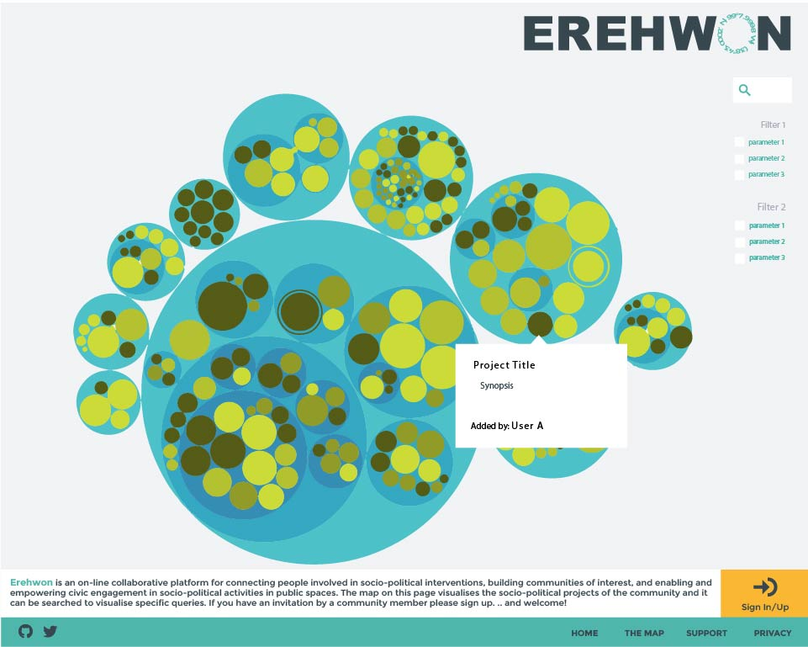
Figure 1. Erehwon’s landing page. The projects are represented with the circles and clicking each circle reveals default information about them: Title, synopsis and who has added it to the visualisation.

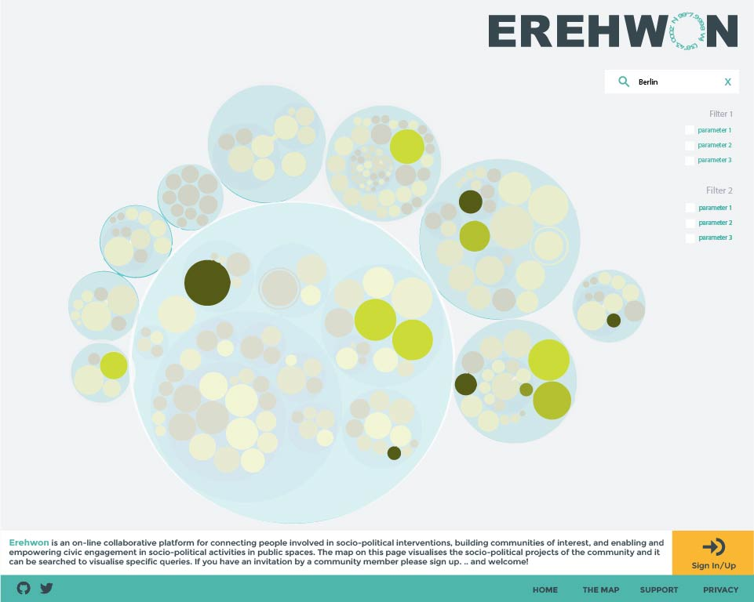
Figure 2. Visual search results using a keywo 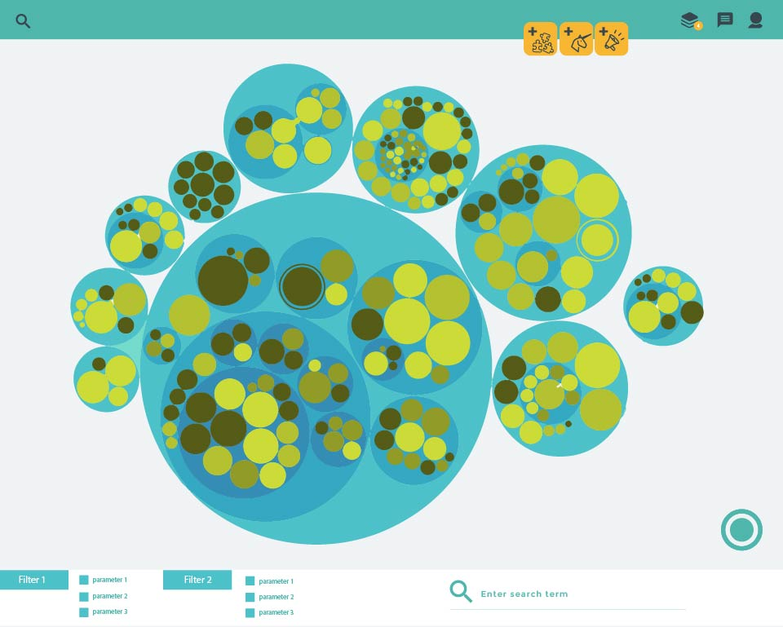
Figure 3. The logged-in view

5 Design Insights
Synthesising post-workshop the suggestions, drawings, and designs, we identified the following functionalities for the User space: the ability to add and share a project, add an idea and invite people to collaborate, post a call for Action, have a contacts list with people you are interested in following their project, and a simple way for messaging. Quite important point was the nature of the ‘User’: Is it a person or is it a project? How does one sign up? Remaining anonymous was a big concern for all workshop participants. How do we maintain the anonymity of the users in the platform? As Erehwon is about creating a community through the activities, our main concerns are the projects and methods used. People behind them have to remain anonymous, if they choose so, but able to connect to other members of the community. Therefore, it was decided that users will sign up only with a username and an email and will use the email as a method for logging in. No other information is asked at the point of login or at any other point. Their username is visible under the projects they add to the platform (and the cartography) and it is the only means by which other users can contact them using the platform’s messaging system. Visitors of the website are able to see and search the visualisation though not in as much detail as if they were logged in. Creating an account is, at the moment, by invitation. The reason behind this decision is to filter as much as possible the community to those who intent to support and may be committed to use the platform.
The formation and maintenance of a community of interest around the platform is a major challenge. Workshop discussions have emphasized the importance of connecting the physical activity with the digital space, and highlighted the necessity to identify design strategies to facilitate and strengthen this connection. Resilience and self-sustainability have been well known issues in similar communities of interest. Our current approach is twofold:
(a) To engage and gather an active community around Erehwon who will take over its maintenance and smooth operation
(b) To organize parallel physical activities together with its community and keep monitoring the effectiveness of the platform's design, and updating it when deemed necessary.
There are still issues related to security to be tackled on the server side which involve the ownership of the server that hosts the platform, and ways to encrypt the data that is being exchanged. We plan to organise a workshop dedicated to these issue and discuss further with cyber security experts. However, in some workshop exercises participants imagined ways to overcome the possibility of unsecure connections. For the projects with more sensitive information, the participant response was to choose to participate as users in the platform but withhold from uploading materials until after the project has ended. Still they would be participating in the platform’s community and possibly share material for their project with those they feel safe doing so. However, being in the platform but not participating in its community, by connecting with other’s projects and supporting calls for actions, is something we would wish to avoid having in Erehwon. It has also been discussed that members who are not active, for example have not uploaded a project, remain on a ‘visitor’ status for moderation purposes.
There is considerable work to be done on the aspect of moderation which we suspect will be an on-going process to ensure the platform is clear of bots, trolls and other unwanted ‘users’. One option will be to use secure identities for each user (but not real ones necessarily) via distributed architectures, such as those used by Democracy.earth (Democracy.earth, 2016). It was often concluded that the issue of moderation could be solved if there is potential for the community to regulate the space itself, but this will need to be tested live when there will be a community around the tool.
Some of the exercises moved into thinking about the visualisation and how to categorize the projects in order to start creating some sort of taxonomy that will help position projects on the cartography and creating their interconnections. The result was eight categories, which will act as the labels of the interventions once they are created, followed by free tags that interventionists can create and assign freely to projects. The eight categories are:
- Citizen movements
- Activism
- Digital activism
- Alternative economies
- Community development
- Urban planning
- New ecologies
- Artistic interventions
There was considerable debate on these so they will be revisited. Participants also provided some ideas experimenting with visual elements such as intensity, density, graphs, sizes, and colours. The design of the visualisation remains an open investigation for future workshops. To create a dynamic and critical understanding of the visual data and to structure it in a way that provides useful information to the participant communities of interest and to external researchers, we need to critically address the idea of ‘making the invisible visible’ as we discussed in the Visual Cartography section. This cartography is not a simple case of data visualisation. What makes it unique in relation to similar cartographic projects is the idea of movement within the cartography and is one of the main elements that inform its aesthetic research and design. It is necessary, therefore, to create specific parameters to model data and to research the kind of search functions that will surface aspects of the movement such as contaminations, displacements, intensities, dimensions, and offer an overview of their progression across time. As such the platform will be able to visualize movement as processes of thought as discussed previously.
Language is another important issue to consider. Some of these projects have a global drive, yet their manifestations can be local and vice versa. Consequently, they require linguistic and conceptual translation and the platform has to provide the ground or tools for this to happen. Part of the literal translation can happen automatically using existing online software but more in depth work needs to be done for fine-tuning.

Conclusion
Online platforms can be very powerful tools for direct connection and knowledge exchange, and for enabling and facilitating collaborations. We began this research with the vision to design and build an appropriate platform to support these effectively for interventionists. Our research perspective was to identify novel ways for creating an online database of interventions modelling it in the form of an online active and interactive cartography and to identify and construct different ways of searching it. In this chapter we described the theoretical framework behind our research, our design methodology, and the insights from our design process. In our vision, the Erehwon platform can be used for:
- Research: To identify, analyse and understand the ways in which socio-political performative interventions take place.
- Exchange: To share knowledge and experience, enhance collaboration, communication, and engagement for anyone who is involved in these projects. To facilitate the movement of thought and action, and break the isolation of those working within this type of thematic, extending the geographical territories by inter-changing physical with digital channels of information.
- Resilience: To offer a constantly updated overall view of the change across time on how citizens perceive and share common public space, while being a digital public space itself, an Agora, capable of receiving input from those involved and also open to reconfigurations and re-appropriations by them.
- Archiving: capture snapshots of the mobility of people, ideas, thought, and practices across different domains and territories. Act as a repository and timeline of change for future research. Create a public archive of the movements of people and thought that can act as a research playground on the different layers, processes, and shifts that happen as a result of small or large attempts to bring change.
The activities we described in this chapter constitute the start of a project we endeavour to grow into a large continuous research and development project with the collaboration of a growing number of researchers, activists, and interested parties from several disciplines.

Further developments
After a successful hackathon at the end of May 2016 where the alpha prototype of the platform was created and its source code made available on Github, we invited developers from Women Hack For Non Profits, a London-based community of women who volunteer coding and design skills and time to civic causes to contribute on a voluntarily basis to the next phase which is currently under development. However, we are actively seeking funding to speed up the development process to the next stage. The platform is being developed as a Digital Commons, an open-source, free for public use and commonly owned digital space. Once the beta prototype is ready we will invite the participants of our workshops and their networks to online user testing and then iterate based on the new insights. In addition, we will be seeking to engage with data scientists for designing the data visualisation, research and design experts on privacy and security implementations. It is our intention to create a community of interest around the platform and continue augmenting the platform’s capabilities based on feedback from its users. Its sustainability and future use is also part of our research and we are currently working on an activity plan for the coming years. We envisage that the Erehwon platform will provide the possibility for a sharable utopian territory of resistance, an ‘experimental laboratory’ where the multiple interventions interconnect and create new or resurrected narratives for the commons, empowering the involved communities for effective societal change.

Acknowledgements
The authors would like to thank the Queen Mary University of London Humanities and Social Sciences Collaboration fund for funding part of this research, Osso Cultural Association and Stress.fm for providing spaces, publicity, and technical assistance throughout the project, Lisbon Architecture Triennale for hosting the workshop in Lisbon, Creativeworks London, and all the people that have contributed to the project until now. Many thanks go to all workshop participants for their useful insights and enthusiasm for this project, the radio talk invitees, and the developers of the alpha prototype of the platform.

References
A. Toscano and J. Kinkle (2015) Cartographies of the absolute (UK & USA: Zero Books)

Acampada (2011), Acampada at Puerta del Sol, http://www.publicspace.org/en/works/g001-acampada-en-la-puerta-del-sol, date accessed 30 June 2016

Bitmind (2016), http://www.bitmind.co/(home page), date accessed 14 June 2016

Civic Makers (2016), https://app.civicmakers.com/ (home page), date accessed 14 June 2016

Colony (2016), https://colony.io/ (home page), date accessed 30 June 2016

Comakery (2016), https://www.comakery.com/ (home page), date accessed 14 June 2016

C. Mouffe (2005) On the Political, (London & NY: Routledge)

D.R.F Taylor (2006) ‘Cybercartography: Theory and practice’. Modern Cartography Series, 4

D-Cent (2016a), http://dcentproject.eu/ (home page), date accessed 30 June 2016

D-Cent (2016b), http://dcentproject.eu/wp-content/uploads/2016/06/D-Cent-toolsbox-final-spreads-1.pdf, p.25, date accessed 30 June 2016

D3 (2016), https://d3js.org (home page), date accessed 14 June 2016

Democracy.earth (2016), http://democracy.earth/ (home page), date accessed 14 June 2016

EEC (2017) Eclectic Electric Collective, http://www.toolsforaction.net/ (home page), date accessed 10 May 2017

F. Jameson (1992) The Geopolitical Aesthetic: Cinema and Space in the World System (USA: Indiana University Press)

G. Agamben (2005) State of Exception, (Chicago: University of Chicago Press)
G. Deleuze and F. Guattari (1987) A Thousand Plateaus: Capitalism and Schizophrenia, (Minnesota: University of Minnesota Press)

H.R. Woo (2008) ‘A Holistic Experiential Approach to Design Innovation’, Journal of Korean Society of Design Science, 21, 2

J. Butler (2011) ‘Bodies in Alliance and the Politics of the Street’, http://www.eipcp.net/transversal/1011/butler/en, date accessed 10 May 2017

J. Derrida (1995) Archive Fever: A Freudian Impression, trans. Eric Prenowitz, (Chicago and London: University of Chicago Press)

J. Gothelf (2013) Lean UX: Applying Lean Principles to Improve User Experience, 1st ed, (O'Reilly Media)

J. Metzger, P. Allmendinger and S. Oosterlynck (2015) Planning against the political, Democratic Deficits in European Territorial Governance, (London & N.Y: Routledge)

J.L. Nancy (1991) The Inoperative Community, (Minnesota: University of Minnesota Press)

J. Rancière (2004) The Politics of Aesthetics: The distribution of the Sensible, translated by Gabriel Rockhill, (Continuum International)

J. Rancière (2010) Dissensus, On Politics and Aesthetics, (Continuum International)

J.W. Crampton (2004) ‘GIS and geographic governance: Reconstructing the choropleth map’, Cartographica, 39, 41-53
K. Friedman (2000) ‘Creating design knowledge: from research into practice’, IDATER 2000 Conference

M. Dima and B. Cantinho (2014) ‘Erehwon: For a cartography of change’, In Proceedings of Performart 2014, Istanbul, Turkey

Loomio (2016), https://www.loomio.org/ (home page), date accessed 14 June 2016

Metamaps (2016), https://metamaps.cc/ (home page), date accessed 30 June 2016

MightyBell (2016), https://mightybell.com/home (home page), date accessed 14 June 2016

Mobilize (2016), https://mobilize.io/ (home page), date accessed 14 June 2016

Onename (2016), https://onename.com/ (home page), date accessed 30 June 2016

P2PValue project (2016), https://p2pvalue.eu/ (home page), date accessed 15 June 2016

Public Movement (2016), http://www.publicmovement.org/ (home page), date accessed 30 June 2016

R. Schechner (1988) Performance Theory, ( Taylor & Francis)

StressFM (2016), http://stress.fm/post/143446657254/erehwon1, date accessed 14 June 2016

A.Vujanovic (2011) ‘Vita performactiva, On the Stage of Neoliberal Capitalist Democratic Society’, http://www.anavujanovic.info/#!/2012/01/vitaperformactivaonthestageofneoliberalcapitalistdemocraticsociety/ , date accessed 26 July 2016
Endnotes

[i] ‘Standing Man’ was a performative action at Istanbul’s Taksim Square done by artist Erdem Gunduz on June 2013. The action followed the eviction of Gezi Park by the turkish police. For more information: http://www.bbc.com/news/world-europe-22949632 (date accessed 10 May 2017)
[ii] Smart contracts are software programs that can automatically execute a contractual agreement making the need for any intermediary unnecessary. For more information: http://www.fastcompany.com/3035723/app-economy/smart-contracts-could-be-cryptocurrencys-killer-app (date accessed 24th July 2016)

