Electro catalytic Oxidation of Reactive Orange 122 in Wastewater by Using Three-Dimensional Electrochemical Reactor (3DER)
Uğurlu, M^{1*}, Günbeldek, M¹., Yılmaz S.I¹., Vaizoğullar, Aİ², Abdul J. Chaudhary3
1Department of Chemistry, Faculty of Science, Mugla Sıtkı Koçman University, 48000 Muğla/Turkey
2Vocational School of Healthcare, Med Lab Program, Mugla Sıtkı Koçman University 48000 Muğla/Turkey
3Institute of Environment, Health and Societies, Brunel University London, UB8 3PH, UK

ABSTRACT.

The effect of different catalysts on the oxidation of Orange 122 in wastewater is investigated by using an electrocatalytic system. For this study, TiO₂/AC, V₂O₅/TiO₂/AC and WO₃/TiO₂/AC (over activated carbon) catalysts were prepared by a sol–gel method in aqueous solution. The oxidation process was optimised by investigating the effects of differemnt paperemeter, for example, time, voltage, suspension’s pH, dye concentration, the amount of supporting electrolyte (NaCl) and the type of catalysts used. Optimum values for these parameters were found as 120 min., 15 volt, 6.5, 250 mgL⁻¹ and 800 mgL⁻¹ respectively. During the experiment, samples were taken prediocally and the residual dye concentration present in aqueous wastewater samples was analysed to evaluate the efficiency of different catslysts. The results obtained show that after 30 minutes only 30% colour was removed in the absence of activated carbon and this value increased to 60% in the presence of activated carbon. However, the percentage removal increased to 98% in the presence of cataysts TiO₂/AC, V₂O₅/TiO₂/AC and WO₃/TiO₂/AC under the same experimental conditions. In addition, when used as the working electrode in a three-dimensional photoelectrochemical reactor, for all catalyst reacting, the pseudo-first-order rate constants were obtained amoung 1,12 ×10⁻² min⁻¹ and 3,87 ×10⁻² min⁻¹ with the individual use of the composite in electrocatalysis. The high degradation efficiency of this system is attributed to the synergistic combination of different chemical processess ocurring simultaneously, for example, adosprtion, electrocatalytic and electrochemical oxidations.
Keywords: Actived Carbon, TiO₂, Wastewater, TiO₂, V₂O₅, WO₃, Electrocatalytic

INTRODUCTION
Currently, there are many industries, for example, food, textile, paper and cellulose, chemical, oil, coal mines, metal finishing, and synthetic rubber/plastic which produce waswater containing different types of both inorganic and organic pollutants. Textile industry has served as a source of income for many developed and developing countries. The amount of money made in the textile industry runs into billions of US dollars due to the high demand by growing consumers in the clothing market. Major textile producers such as China, US, EU, India, Pakistan, Bangladesh and Turkey have increased production over the past many years. However, the discharge of synthetic textile dyes from textile industries into the aquatic ecosystem poses a threat to its habitants and human health (Uzal et al., 2005). The presence of dyes in the effluent at a very low concentration can be highly visible and undesirable in the wastes [Nigam et al., 2000 and Gürses et al., 2002]. The coloured wastewater damages the aesthetic nature of water and reduces the light penetration through the water's surface [Gürses et al., 2003]. Textile dyes are relatively resistant to microbial degradation due to their complicated structures [Yesilada., et al., 2002]. Consequently, the removal of dyes from effluent is required, usually through physiochemical means [Robinson et al., 20002]. Some treatment methods include oxidation using Fenton's reagent [Pak and Chang., 1999], ozone [Ugurlu., 2015], and adsorption which using synthetic or natural adsorbents [Gürses et al., 2004]. Many dyes used in industry are stable to light and oxidation, resistant to aerobic digestion and may be non-oxidisable due to their complex structure and large molecular size [Dincer et al., 2007].
Electrochemistry opens new horizons for the elimination of pollution problems in industrial processes. Reduction or removal of the pollutant-forming components is possible by directly or indirectly performing the electrochemical reduction and oxidation of the material in the electrochemical cell (Juttner et al., 2000). These processes also have the advantage of requiring lower temperatures than necessary in other treatment processes, reducing voltage drop in side-reactions in electrodes and cells, or minimizing power losses in the event of non-uniform distribution of current. In summary, it is suggested that electrochemical processes designed to remove pollution and clean up wastewater are promising, and that there will be no problem in integrating the environment with proper control of time, energy and other parameters (Fernanades et al., 1994; Matteson et al., 1995; Ugurlu., 2004)
Apart from the use of activated carbon as an adsorbent, in recent years catalytic removal studies have been found by bonding the semiconductors (TiO₂) with various adsorbent materials. In these studies, it is reported that active carbon adsorbs organic or inorganic substances in aqueous media, and organic substances can be removed from the media by using substances such as TiO₂ present on the surface (Zhang et al., 2005). In the literature, studies on the use of active carbon as a catalyst carrier are limited and usually consist of laboratory-scale studies. In addition, there are no studies on the treatment of wastewaters originating from paper and textile manfactruring industries. In the present study, the catalytic active TiO₂/AC material as an upper product was first loaded with TiO₂ under optimum conditions of commercial activated carbon (AC), and V₂O₅/ TiO₂/AC and W₂O₅/TiO₂ with high photocatalytic activity by loading this material (TiO₂/AC), V₂O₅ and W₂O₅/AC catalysts. Finally, these catalytic materials were used to investigate the decolourization of textile wastewater by using electrocatalytic oxidation process.

2. Materials and Methods
In this study, TiO₂/AC, V₂O₅/TiO₂/AC and W₂O₅/TiO₂/AC catalysts were obtained by loading V₂O₅ and W₂O₅, separately and together by using TiO₂ as semi-conductor material on the surface of activated carbon (AC) materials.

2.1 Synthesis of TiO₂/AC particles
Initially, 500 ml of a solution containing 30% isopropyl alcohol and 100 ml of titanium isopropoxide was prepared. Then, 50 ml from this solution were added over 30 g of AC sample and mixed at constant temperature. This mixture was first dried in a vacuum oven at 100 ºC for 2 hours and then left at room temperature. The impregnation process using a 50ml of solution was repeated 4 times under the same conditions and calcined for one hour at each temperature of 300 °C, 400 °C and 500 °C gradually. After this process, the sample was cooled in a desiccator and kept in dark.

2.1.2 Synthesis of V₂O₅/TiO₂/AC and W₂O₅/TiO₂/AC Particles
In this study, 120 ml ethanol and 20 ml tetra-n-butyl titanate were mixed and then 10 ml acetic acid, 2 ml distilled water and a few drops of acetone were added and stirred for 3 hours (solution A). After that, 8-20 mesh AC was activated with nitric acid, washed with distilled water and left for drying. Acid activated carbon was then stirred for three hours with the previously prepared solution A. After completion of the reaction, (NH₄)₁₀H₂ (W₃O₇)₆ solution was added drop-wise and kept under constant temperature to get TiO₂/W₂O₅/AC particles. Prepared particles were filtered and dried at 100°C for 3 hours. Dried samples were thermally activated at 300, 400 and 500°C each for one hour. Same procedure was repeated to prepare TiO₂/ V₂O₅/AC particles but NH₄VO₃ solution was used instead of (NH4)₁₀H₂(W₃O₇)₆. After these processes, the samples were cooled in a desiccator and kept in a light-free condition.

2.2. Electrocatalytic Experiments
In experimental process, TiO₂/AC, V₂O₅/TiO₂/AC and W₂O₅/TiO₂/AC materials were used as a catalytic agent. Aeactive Orange 122 (RO122) dye was used as a source of chemical contaminant and its chemical structure is shown in Fig 1. The electrolytic system consist of a round glass of 500 ml capacity containimng three dimensional graphite electrodes as shown in Figu 2. The anode and cathode (feeder electrodes) were situated 5.0 cm apart from each other. Stirring was done by using a magnetic stirrer (50 rpm). Compressed air was spared into the bed electrodes from the bottom of the reactor.
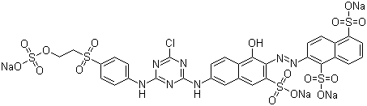
Fig. 1: Chemical structure of textile dye RO 122, λ_{max}: 488nm; solubility in water: 75gdm⁻³; degree of purity: 80-85 %.
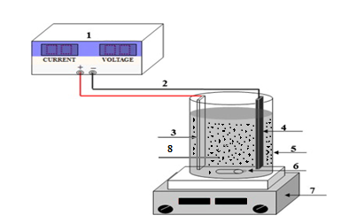
Fig. 2: Experimental 3D system for the electrocatalytic treatment of real printing wastewater (1.DC power supply, 2.copper wire, 3.anode, 4. cathode, 5. electrolysis reactor, 6. magnetic bar, 7. electromagnetic stirrer and 8. Catalysts (working electrode)

For process optimisation, the effect of parameters such as; initial pH, type of catalysts, voltage, wastewater concentration, and the amount of table salt as supporting electrolyte were investigated. Cell voltage was measured digitally by using Topward Dual-Tracking DC6303D, Keithley 2010 power supply. At the end of experiments, the treated solution was filtered and then color changes were measured before and after electrolysis by using a spectrophotometer. In addition, JEOL brand JSM-7600F model for SEM analysis and, JEOL brand JEM 2100F HRTEM model for TEM analysis were used.

2.4. Determination of Color Change
To deteremine the λ_{max} of RO122, the aqueous solution containing a know concentration of dye was analysed using a UV spectrophotometer. The λ_{max} of RO122 was found to be at 488 nm. All wastewater samples were analaysed at this λ_{max} value to determine the residual concentration of syes remaining in aqueous solutions. The percentage removal of RO122 was calculated by using the following formula.
% colour removal x 100
A⁰_{λ}: Initial absorbance
A_{λ}: Final absorbance.

RESULTS AND DISCUSSION
SEM analyses
The surface morphologh of the calaysts prepared as part of this project was investigated using a scanning electron microscopy (SEM) and the SEM images are given in Fig. 3(a, b, c and d). The SEM micrograph of AC at the lower magnification (Fig.3a) clearly show that the, AC structure has porous morphology. Fig.b shows the AC structure at the higher magnification. The SEM images of TiO₂/V₂O₅ and TiO₂/W₂O₅ doped AC samples are given in Fig.3c and 3d. As seen from these figures, TiO₂/V₂O₅ and TiO₂/W₂O₅ were attached to the AC surface. The proof of this adhesion was demonstrated by Energy Dispersive X-ray Spectroscopy (EDS) and compositional element rates obtained by EDS (Table 1).
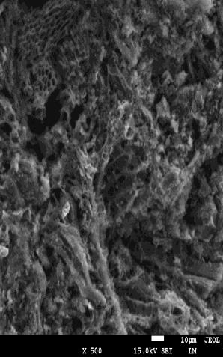 | 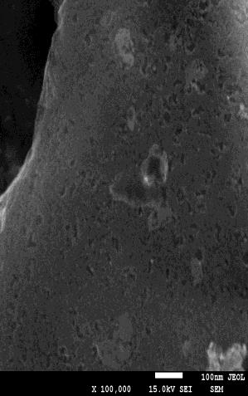 | 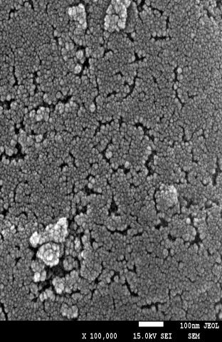 | 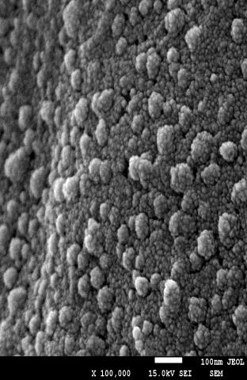
(a) | (b) | (c) | (d)
Fig. 3: SEM images belonging to Activated carbone (a)(b), TiO₂/V₂O₅/AC (c) and TiO₂/WO₃/AC(d).
Table 1: EDS results of the three catalytic samples
Element (Weight %)
 | C | O | Ti | V | W | Mg | Ca | Si | P | Totals
AC | 86.71 | 11.00 | - | - | - | 0.84 | 0.82 | 0.46 | 0.32 | 100.00
TiO₂/V₂O₅/AC | 65.47 | 21.37 | 12.10 | 1.07 | - | - | - | - | - | 100.00
TiO₂/WO₃/AC | 71.66 | 20.75 | 6.39 | - | 1.21 | - | - | - | - | 100.00

TEM analyses
The samples were also analysed using a transmission electron microscopy (TEM) for investigating the morphology of the prepared catalysts. Fig.4 (a, b, c) shows the images with increasing magnifications from the samples. Fig.4a shows the typical TEM micrograph of the amorphous AC. The TEM images of TiO₂/V₂O₅ and TiO₂/W₂O₅ doped AC samples were given in Fig.4b and 4c. As seen in the Fig.4b and 4c, TiO₂/V₂O₅ and TiO₂/W₂O₅ were attached to the AC as with SEM results.

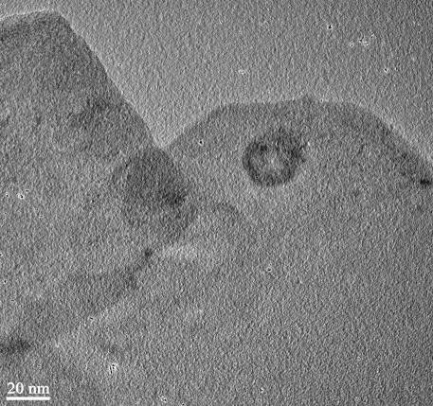 | 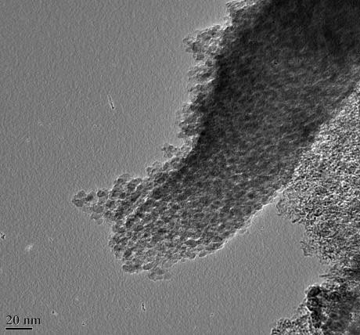 | 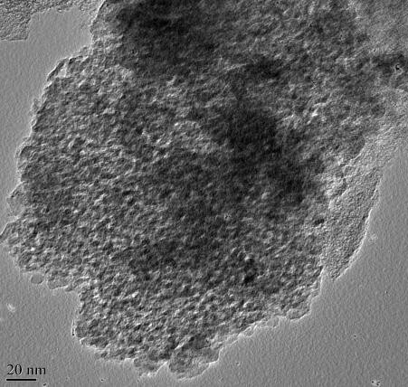
(a) | (b) | (c)

Fig. 4: TEM images belonging to AC (a), TiO₂/V₂O₅/AC (b) and TiO₂/WO₃/AC(c).
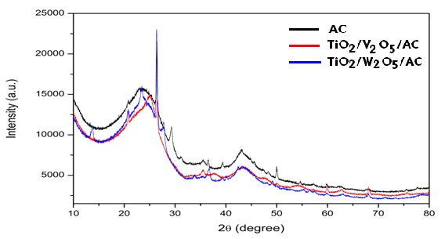
AC
TiO2/V2O5/AC TiO2/WO3/AC
Fig. 5: XRD spectra belonging to TiO₂/AC, TiO₂/V₂O₅/AC and TiO₂/WO₃/AC

Figure 5 shows the XRD patterns of TiO₂/AC (a), TiO₂/V₂O₅/AC (b) and TiO₂/WO₃/AC (c) which consist of amorphous and crystal structures. According to Figure 5, the X-ray patterns confirm that activated carbon samples were amorphous and TiO₂/V₂O₅ and TiO₂/W₂O₅ doped samples have crystal diffractions peaks.

FTIR Analysis
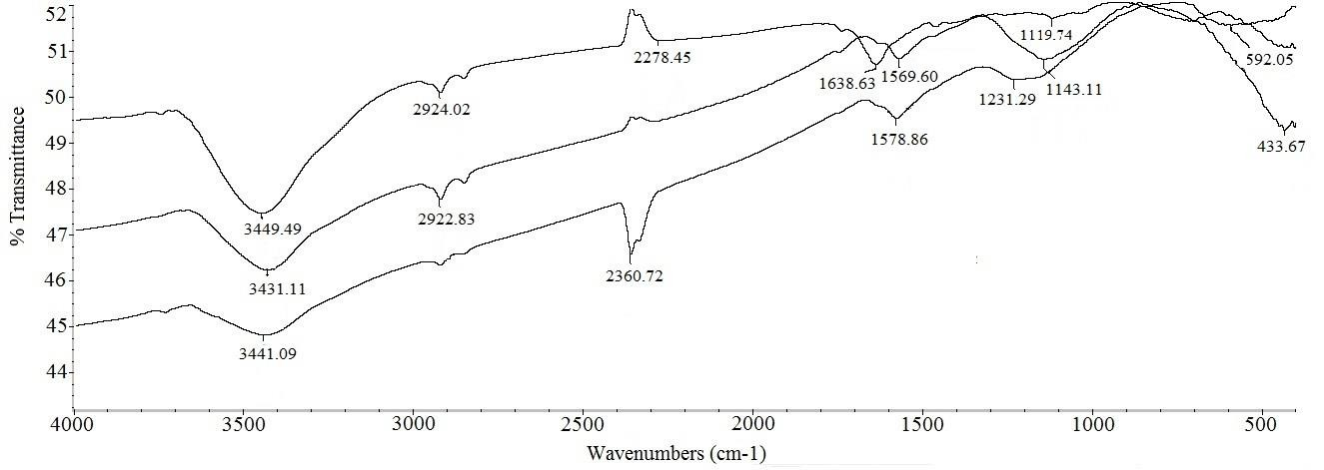
Fig. 6: FTIR spectra belonging to TiO₂/AC(a), TiO₂/V₂O₅/AC(b) and TiO₂/WO₃/AC (c)
When compared, both AC and TiO₂/AC spectra showed stretching vibration at 3440 cm-1 related to −OH. C−H stretching was also observed at 2923 cm-1 related to −CH₂. Band height and broadness reflects that these groups did not change after the application of TiO₂. The band at 1575 cm-1 disappeared that was related to aromatic C=C and a new band appeared at 1638 cm-1 related to titanium carboxylate. Disappearance of C=C related band and appearance of TiO₂ bands proves the impregnation of TiO₂ particles on the surface of AC (Figure 6a). Hydroxyl band on the surface of TiO₂/V₂O₅/AC decreased and shifted to 3431 cm-1 was also observed. It was different from WO₃ as −CH₂ bands did not disappear that means they were unaffected, only −OH groups were involved in reaction. Similar to WO₃ connectivity, bands at 1638 cm-1 related to titanium carboxylate disappeared. Similarly, the C=C band at 1575 cm-1 shifted to 1569 cm-1 after reaction with V₂O₅. The C−O band at 1156 cm-1 in pure AC also shifted to 1143 cm-1 after the removal of titanium carboxylate and reaction with V₂O₅ (Figure 6b). After comparing the spectrum of TiO₂/WO₃/AC, the band of −OH shifted from 3440 cm-1 to 3441 cm-1 and area under the peak is also decreased in addition to the disappearance of −CH₂ band at 2924 cm-1 after the addition of WO₃ (Figure 6c). Therefore, it can be believed that WO₃ affected these groups. Separately, the band related to titanium carboxylate after the addition of TiO₂ disappeared after heating and a small peak was observed at 1578 cm-1. Another band appeared at 1231 cm-1 that is related to W=O. It proved the addition of WO₃.

Effect of Experimental Parameters
The Effect of Salt Concentration
The study of the effect of salt concentration is important because it determines the electrolytic current. The enhancement of electrolytic current can improve not only the degradation of organic pollutants present in wastewater streams but also some side reaction such as producing H₂ at cathode. The results are shown in Fig 7 at varying NaCl amounts for color remaval.
TiO₂/AC  WO₃/TiO₂/AC  V₂O₅/TiO₂/AC |  | ( a )
TiO₂/AC  WO₃/TiO₂/AC  V₂O₅/TiO₂/AC  AC  Electro Oxidation | ( b )
TiO₂/AC  WO₃/TiO₂/AC  V₂O₅/TiO₂/AC  AC  Electro Oxidation | ( c )
Fig. 7: Changes in color removal rates over time depending on catalyst and salt concentrations. (a:0.4 g/L, b:0.8g/L and c:1.6 g/L) (voltage:15V, pH:6.5 and concentration: 250 mg / L)
The data in Figure 7 show that the percentrage removal of colour depends on the concentration of salt used during the reaction. The best removal percentage was obtained when 0.8 g/L salt was used in all catalyst examples. No advantages in the colour removal were achaived by increasing the salt concentration from 0.8 g/L to 1.6 g/L. In addition, it was observed that 90% colour removal was achieved at the end of 30 minutes, and then this percentage is constant. The addition of NaCl would also lead the decrease in power consumptions because of the increase in conductivity [Uğurlu et al., 2006; Morsia et al., 2011]. The main reactions occurring during the anodic oxidation of organic compounds in the presence of NaCl are given below
Anode | Cathode
Hypochlorite formation:  Cl⁻ + 2OH⁻ → OCI⁻ + H₂O + 2e⁻ | Hydrogen evolution:  2H₂O + 2e⁻ → H₂ + 2OH⁻
Chlorate formation:
6ClO⁻ + 3H₂O → 2CIO⁻₃ + 4CI⁻ + 6H⁺ + 3/2O₂ + 6e⁻
Oxygen evolution:
4OH⁻ → 2H₂O + O₂ + 4e⁻

Solution and/or near the anode surface, Indirect oxidation of organic compound and its oxidation intermediate with hypochlorite in electrochemical treatment of dye effluent via chlorine generation is: Dye + OCl⁻ → CO₂ + H₂ O + Cl⁻

4.3 Effect of Dye Concentration
Electrocatalytic experiments were carried out using wastewater streams containing three different concentrations (125mgL⁻¹, 250 mgL⁻¹ and 500 mgL⁻¹) of dye. The percentage removal of color observed over time depends on the initial concentration of dye present in wastewater streams (Figure 8).
TiO₂/AC  WO₃/TiO₂/AC  V₂O₅/TiO₂/AC | (a)
TiO₂/AC  WO₃/TiO₂/AC  V₂O₅/TiO₂/AC  AC  Electro Oxidation | (b)
TiO₂/AC  WO₃/TiO₂/AC  V₂O₅/TiO₂/AC | (c)
Fig. 8: Effect of intial concentrations of the dye on the percentrage removal of colour vs time (a: 125 mg/L, b: 250 mg/L and c: 500 mg/L). (NaCl: 0,8 g/L, voltage: 15V, pH: 6,5)

The data in Figure 8 show that the percentrage removal of colour increased with time. The percentage removl after 15 minutes was 90% when the dye concentration was 125 mg/L. However, the percentage removal decrsesed to 80& and 70% when the dye concentration was increased to 250 and 500 mg/L respectively. It was also observed that the percentage removal of colour reached to a maximum value 99% after 120 minutes for all concentrations under different catalytic conditions. At low initial concentrations, the electrocatayst reaction is faster than the diffusion. Too many dye molecules in solution could not be removed completely for the agglomeration of organics and the shortage of reactive oxidative species. Considering that the percentage removal of color reached 99% when the dye concentration was 250 mg L⁻1. All subsequent experiments were carried out using 250 mg L⁻1 of dye. The results indicate that the RO122 degradation at different initial concentrations ranging from 125 to 500 mgL⁻¹ is in good agreement with the pseudo-first-order kinetics. The rate constants for all catalyst samples are shown in Table 1

4.4 pH effect
The pH of solution in the electrocatalytic reactions taking place on the particle surface is an important parameter. The color removal for three catalyses was examined at different pH and the obtained results are plotted in Fig. 9.
( a )
( b )
( c )
Fig. 9: Effect of pH on the percentage removal of colour using using (a: TiO₂/AC, b: WO₃/TiO₂/AC, c:V₂O₅/TiO₂/AC, solid/liquid: 0.8 g/L, voltage: 15V, Initial cons.: 250 mg/L)

The results also showed that the color removal efficiency reached the highest level at pH:5.0 and pH:3.0. It is mainly because that quinoid structure may be more likely to be degraded, and quinoid structure is a main form at the low pH value [46]. In addition, it is well known that the increase of the solution pH is favorable for the occurrence of secondary reaction (oxygen evolution) meaning more energy consumption, which results in decreasing the current efficiency. The data in Figure 9a show that the optimum pH condition nearly 99% of the orginal colour was removed after 120 minutes.

4.5 Voltage Effect
Electrocatalytic experiments were carried out firstly with carbon electrode and then TiO₂/AC, WO₃/TiO₂/AC and V₂O₅/TiO₂/AC, using the catalyzers separately at different voltages (10, 15 and 20V).The results obtained are plotted in Fig.10 respectively.
TiO₂/AC  WO₃/TiO₂/AC  V₂O₅/TiO₂/AC | ( a )
TiO₂/AC  WO₃/TiO₂/AC  V₂O₅/TiO₂/AC  AC  ElectroOxidation | ( b )
TiO₂/AC  WO₃/TiO₂/AC  V₂O₅/TiO₂/AC | ( c )
Fig.10. Effect of voltage on the percentage removal of colour vs time (a:10 V, b:15 V, and c:20 V) (NaCl conc: 0,8 g/L, pH:6,5, Initial dye conc: 250 mg/L)
It was reached to the rate of %65 colour convergence in the first 5 minutes generally at the study made with optimum levels (0,2 gr katalizör, doğal pH, 0,2 gr tuz ve 15 volt). It was also reached to the rate of % 96 colour convergence after 60 minutes. The results obtained show that highest percentage removal of colour was was obtained with TiO₂/AC, closely followed by TiO₂/AC and WO₃/TiO₂/AC, V₂O₅/TiO₂/AC. It was also observed that the lowest percentage removal was achieved at 10 volts with the use of TiO₂/AC as catalyst. However, higher percentage removcal was achieved at the same voltage when WO₃/TiO₂/AC catalyst was used. When the voltage was increased to 20 colts then the highest percentage removal was abtained with the use of V₂O₅/TiO₂/AC catalysts. Overall, the percentage removal increased with increasing the voltage from 10 to 20 volt.

3.4. Catalytic Mechanism
Based on the experimental results and discussion above, TiO₂/AC, TiO₂/WO₃/AC and TiO₂/V₂O₅/AC have been demonstrated to possess a much higher electrocatalytic activity for oxidizing organic pollutants than only AC and electrooxidaton (as well as the 2D system). It is well known that the hydroxyl radical (*OH), a powerful oxidizing agent, plays a key role in the electrochemical oxidation of organic compounds. In the litertaure study, it was stated that the electrogeneration of *OH occurred on various granular activated carbon (GAC) based electrodes when current was applied and demonstrated that the usage of GAC-based granular electrodes can effectively improve *OH production in electrochemical oxidation systems (in 3D system) (Xinyang et al., 2016). When it is thought that all of sentezed catalyzers are typical “nonactive” electrocatalyst, at this “nonactive” metal oxide electrode (MOx) over granular activated carbon (GAC) surface, water molecules were easily decomposed to form strong oxidants, such as physisorbed *OH, MOx(*OH) which allow nonselective oxidation of organics and may result in complete oxidation of organic carbon to CO_{2.} In addition, *OH is a well acknowledged oxidant and its advantages in pollutant degradation include the high efficiency and low production of by-products. As schematic representation describing the possible mechanisms involving the 3D electrocatalytic process is therefore provided in Fig. 11.
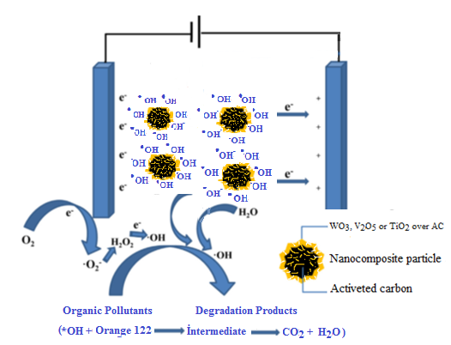
Fig. 11: A schematic representation describing the mechanisms of the charge separation and active species generation in a 3D electrocatalytic system with different nanocomposite particles used as the particle electrodes.

In the 3D reaction system with WO₃, V₂O₅ or TiO₂ over granuled activated carbon used, each particle electrode could act as a microelectrolysis cell. As a result, the 3D electrocatalytic system owns much higher electrode areas than 2D reaction, and the process performance is much improved (Jingke Songa et al., 2016). Overall, in the 3D photoelectrocatalytic system, the high degradation efficiency of orange 122 should be ascribed to the synergistic effect of activated carbon adsorption, electrocatalytic and electrochemical oxidation. Another advantage of the granular particle in practical application is relating to separable property of the particle electrodes. While the composite material could still be easily recovered from the bulk solution by using filter apparatus after the photoelectrocatalytic reaction, In the future work, comprehensive studies on the effect of the applied field on the properties of the composites are required.

4.6. Photdegradation kinetics
The degradation kinetics of wastewater by using four catalysts were evaluated using the linearised form of pseudo first- order rate
Ln (C_{t}/C_{o})= -kt | (5)
where C_{o} is the initial concentration (mg/L), C_{t} is the concentration (mg/L) at time t, t is exposure time and k is the first-order rate kinetics. Table 1 shows that the degradation process follows the pseudo first-order rate kinetics as evidenced from the regression (r2) analysis that is greater than 0.70. The higher rate constant achieved using TiO₂/AC can be attributed to the combined effects of adsorption of organic molecule over catalyst surface followed by oxidation using the generated hydroxyl radical and direct attack of photogenerated holes [36].

TABLE 1 - k and R² values for Colour removal to different parameters and nanoparticles
Parameters | TiO₂/AC |  | WO₃/TiO₂/AC |  | V₂O₅/TiO₂/AC
 | R² | kx10⁻² (min⁻¹) | R² | kx10⁻²(min⁻¹) | R² | kx10⁻² (min⁻¹)
Salt effect (gr/L)
0,1 | 0,99 | 2,19 | 0,99 | 2,23 | 0,99 | 2,05
0,2 | 0,75 | 2,77 | 0,82 | 2,83 | 0,92 | 2,55
0,3 | 0,78 | 3,21 | 0,80 | 2,63 | 0,91 | 3,55
Concentration (mg/L)
125 | 0,70 | 2,59 | 0,78 | 2,72 | 0,80 | 3,21
250 | 0,75 | 2,77 | 0,78 | 2,69 | 0,95 | 2,97
500 | 0,97 | 3,26 | 0,95 | 3,84 | 0,88 | 3,44
Voltage effect (volt)
10 | 0,86 | 3,71 | 0,88 | 2,72 | 0,96 | 2,94
15 | 0,96 | 2,89 | 0,88 | 3,34 | 0,96 | 3,06
20 | 0,94 | 1,12 | 0,99 | 3,97 | 0,86 | 3,87
pH effect
3 | 0,92 | 3,08 | 0,72 | 3,05 | 0,98 | 3,04
5 | 0,83 | 2,32 | 0,74 | 2,46 | 0,99 | 2,15
6.5 | 0,75 | 2,77 | 0,78 | 2,72 | 0,94 | 2,91
9 | 0,93 | 3,08 | 0,96 | 1,38 | 0,97 | 2,75
11 | 0,89 | 2,72 | 0,79 | 2,34 | 0,90 | 1,45

Conclusions
In this study, electrocatalytic systems have been optimized for the treatment of orange 122 present in aqueous wastewater streams under different conditions. The nanocomposite materials were prepared and their efficiencies were examined in the operation condition. As a result of this study, optimum values were found as reaction time; 120 min., voltage ; 15 volt, solution pH; 6.5; initial concentration; 250 mg/L and NaCl concentration; 0.8 g/L. The results indicated that only 30% percentage removal of colour was obtained after 30 minutes in the absence of active carbon. This value increased to 60% in the presence of AC. However, the percentage removal of colour was reached to 98% when the reactions were carried in the presence of cataysts (TiO₂/AC, V₂O₅/TİO₂/AC and WO₃/TİO₂/AC( under the same experimnental conditions. In addition, for all catalysts, the pseudo-first-order rate constants were obtained amoung 1.12 × 10⁻² min⁻¹ and 3.87 ×10⁻² min⁻¹ with the individual use of the composite in electrocatalysis. Moreover, the necessity to analyze and identify the formation of different intermediate products using mosern analytical tecahniques equppied with identification library is needed. It would also be useful to identify the structure of these intermediate products to fully understand the degradation mechanism dueing the electrocatalytic oxidation process using HPLC, gas chromatography, NMR and other analytical techniques in further studies.

Acknowledgements
This study was financially supported as a project (15/041) by Research Project Coordination Unit, Muğla Sıtkı Koçman University. The authors wish to thank Muğla Sıtkı Koçman University for XRD, BET, FTIR, SEM and TEM analyses.

Referances
Akbal, F. (2005) Adsorption of basic dyes from aqueous solution onto pumice powder, Journal of Colloidand Interface Science Volume 286, Issue 2, 15June 2005, Pages 455–458
Arslan-Alatona, İ, Gursoya, B.H.,Schmidt, J.H. (2004) Advanced oxidation of acid and reactivedyes: Effect of Fentontreatment on aerobic, anoxicandan aerobic processes, Dyes and Pigments, Volume 78,Issue 2, August2008, Pages 117–130
Atalık, A. (2006) The effects of global warming on water resources and agriculture. Science and Utopia, 139: 18-21
Atkins, F.A. Carey.(2009) Organic Chemistry “A Brief Course” 3rd Edition, Chapter 19, pp.477-478.
Avcu, F. (2010) Development of Electroactive Electrode for Purification the phenol by electrooxidation in waste water. (Master Thesis, Çukurova Üni. Institute of Science and Technology (Adana)
Banat, I. M., Nigam, P., Singh, D. ve Marchant, R. (1996) Microbial decolorization of textile–dye–containing effluents: a review, Bioresource Technology, 58, 217-227
Başer, I. ve İnanıcı, Y. (1990) Chemistry of dye, Publications of Marmara University Technical Education Faculty, 47-187.
Başıbüyük, M., Yüceer, A. ve Yılmaz, T. (1998) Advanced technologies used to remove color caused by textile waste water, Kayseri I. Wastewater Symposium 22-26 June, Kayseri, 82-86.
Başbuğ, M. (2008) Examination of dye adsorption from aqueous solution and textile wastewater with bentonite and ponza,Süleyman Demirel University, Institute of Sciences, Master Thesis, 78 s.
Bayar, S.Boncukcuoğlu R., Fil B.A., Yılmaz A. E.,(2012) Iğdır University,Magazine of Institute of Science 22
Catanho, M., Malpass, G.R.P., Motheo, A.J. (2006) Photoelectrochemical treatment of the dye reactivered 198 using DSA® electrodes, Applied Catalysis B:Environmental, Volume 62, Issues 3–4, 22 February 2006, Pages193–200.
Crittenden J.C., Liu, J., Hand, D.W. (1997). Photocatalytic oxidation of chlorinated hydrocarbons in water, water Research. 31(3), 429-438.
Doğar, Ç. (2000) The conceptual and statistical examination of electrocoagulation of some reactive dyes,Master Thesis, Ataturk University,Erzurum,70s
Esplugas, S.,Yue, P. L. ve Pervez M. I. (1994) Degradation of 4-chlorophenol by photolyticoxidation, WaterResearch, 28(6): 1323-1328.
Fernandes, A.,Morão, A., Magrinho, M., Lopes, A., Gonçalves, I. (2004) Electrochemical degradation of C. I. Acid Orange 7, Dye sand PigmentsVolume 61, Issue 3, June 2004, Pages 287–296.
H. Hart, L. E. Craine, D. J. Hart, C. M. Hadad (2011)Organic Chemistry, 12th Edition, Chapter 12, pp. 353-356.
Havıland, William.A. (2002) Cultural Anthropology (Interpreter: Hüsamettin İnaç, Seda Çiftçi). No: 143. Sociology Series : 3. İstanbul: Kaktüs Publications
Işık, M. ve Teresa Sponza, D. (2006) Biological treatment of acid dye ingwastewaterusing a sequential anaerobic/aerobic reactor system, Enzyme and Microbial TechnologyVolume 38, Issue 7, 2 May 2006, Pages 887–892
İnce, N. H. ve Tezcanlı, G. (1998) Treatability of textiledyebath effluents by advanced oxidation preparation for reuse, Fourth International Symposiumon Waste Management Problems in Agro-Industries, 23-25 September, İstanbul, Vol. 40: 113-120.
Jüttner, K., Galla, M., Schmieder, H. (2000) Electrochemical approachestoe nvironmentalproblems in the process industry, Electrochimica Acta Volume 45, Issues 15–16, 3 May 2000, Pages 2575–2594.
Karabacakoğlu B., Güvenç A. (2005); Use of electrodialysis to removesilverionsfrom model solutions and wastewater, Desalination 172(1), 7 – 17
Kaur, S., Singh, V. (2007) Visible light induced sonophotocatalytic degradation of ReactiveRed dye 198 using dye sensitizedTiO2, UltrasonicsSonochemistry, Volume 14, Issue 5, July 2007, Pages 531–537
Kaykıoğlu, G., Debik, E. (2006) Color Removal fromtextile waste water with anaerobic treatment processes, Sigma, 2006/4, 59-68.
Kılıç M.Y.,ve Kestioğlu K.(2008) Reseach of Applicability of Advanced Oxidation Processes in Industrial Wastewater purification,Magazine of Uludağ University Engineering-Architecture Faculty, Edition 13, Number 1, 2.
Kurbanova, R. ; Mirzaoğlu, R. ; Ahmedova, G., Seker, R. ; Özcan, E. (1998) Dye and Textile Chemistry and Technology, Publications of Selcuk University Science and Literature Faculty, Konya, 263.
Legrini, O., Oliveros, E., Braun, A. M., 1993. Photochemical processes for water treatment. Chemical. Reviews. 93, 671-698.
Li X., Yu J., Low J., Fang Y., Xiao J., Chen X. ( 2015), Engineering heterogeneous semiconductors for solar waters plitting”, J. Mater. Chem. A 3,2485-2534.
Matteson M. J.,Dobson R. L., GlennJr. R. W., Kukunoor N. S., WaıtsIıı. W. H.veClayfield E. J. (1995) Electrocoagulation and separation of aquenouns suspensions of ultrafine particles, Colloidsand Surfaces A.104, 101 – 109.
Meshko, Markorska, Mincheva, ve Rodrigues (2001) Adsorptionof basicd yes on granular activated carbon and naturalzeolite, Water Res., 35 (14)3357- 3366.
Moon J., Yun, C.Y., Chung, K., Kang, M., Yi, J. (2003) Photocatalytic activation ofTiO₂ under visible lightusing Acid Red 44, Catalysis Today Volume 87, Issues 1–4, 15 Pages 77–86., 9th Korea-Japan Symposium on Catalysis
Nas, M. Z., Demirbaş, E. ve Kobya, M. (2006) Removal of textile dyes by adsorption from aqueous solutions, Symposium on Environmental Pollution Priorities in Turkey V,Department of Environmental Engineering of Gebze Advanced Technology Institute , 11-12 May 2006,Gebze-Kocaeli
Ölmez, T. vd(2003) Determination of Factors Affecting Color Removal with ozone in Reactive dye Spaces of Textile Industry, Istanbul Technical University, SKKD volume number 13, 1 sh. 19-24.
Özcan, Y.(1978) Textile Fibers and Painting Techniques, Publications of Istanbul University Publications,İstanbul Panizzo, M., Bocca, C. and Cerisola, G., (2000) Electrochemical treatment of wastewater containing polyaromatic organic pollutants, Wat. Res., 34(9) 2601-2605.
Pouet, M.F. and Grasmick, A. (1995) Urban wastewater treatment by Electrocoagulation and flotation, Wat. Sci.Tech., 31:275-283.
Rehman, S., Ullah, R., Butt, A.M., Gohar, N.D. (2009) Strategies of making TiO₂and ZnO visible light active, Journal of Hazardous Materials, Volume170, Issues 2–3, 30 October 2009, Pages 560–569.
Seventekin, N. (1988) Introduction to Dyestuff Chemistry 1.Edition, Bornova.
Sheng, H.L. ve Chi F.P. (1994) Treatment of textilewastewaterby electrochemical method, WaterResearch, Volume 28, Issue 2, February 1994, Pages277–282.
Standfford, U.,Gray, K. A. ve Kamat, P.V. (1996) Photocatalytic degradation of organic contaminants halophenols and related model compounds, HCR Advanced–Education Rev., Het. Chem. Rev., 3: 77-104.
Şengül, F., Özer, A., Çatalkaya, E. Ç., Oktav, E., Evcil, H., Çolak, O., Sağer,Y.(2003) Zeytin Karasuyu Purification Project, , Dokuz Eylül University, İzmir.
Tsai, C.T., Lin, S.T., Shue, Y.C., Su, P.L. (1997) Electrolysis of soluble organic matter in leachate from landfills, Water Research Volume 31, Issue 12, December 1997, Pages 3073–3081.
Tutuş, A. ve Eroğlu, H.(1998) Environmental damage and treatment of paper wastewater, Kayseri 1st Wastewater Symposium, Kayseri, 87-92.
Environmental Pollution Priorities Symposium in Turkey (2006) Gebze Institute of Technology Department of Environmental Engineering, Gebze-Kocaeli
Uğurlu, M. (2002) elemination of Phenol and lign in paper factory wastewater using fly ash Sakarya Univ. Magazine of Institute of Science and Technology, 6/3:84-87
Uğurlu, M. (2004)G.Ü. The Removal Of Some Inorganıc Compounds From Paper Mıll Effluents By The Electrocoagulatıon Method Fen Bilimleri Dergisi17(3) 85-99.
Uğurlu, M. ve Karaoğlu, H. (2009) TiO₂/ Color and Phenol Removal Water Consumption "Treatment "and" Reuse Symposium " with Sepiolite Nanocomposite Materials as Photocatalytic in Zeytin Karasuyu Sepiyolit, İzmit Bursa,287-296.
Uğurlu, M. ve Karaoğlu, H. (2009) Removal of some compounds from bleached kraft mill effluent by UV oxidation in the presence of hydrogen peroxide utilizing TiO₂ as photocatalyst, Environ Sci Pollut Res., 16:265–273.
Uğurlu, M., M. H. Karaoğlu, İ. Kula (2006), Experimental Investigation of Chemical Oxygen Demand, Lignin and Phenol Removal from Paper Mill Effluents Using Three-Phase Three-Dimensional Electrode Reactor, Polish J. of Environ. Stud. Vol. 15, No. 4, 647-654]:
Uzal, N., Yılmaz, L. ve Yetiş, Ü. (2005) Pre- purification of indigo dyeing wastes,Comparison of pre-filtration processes of chemical precipitation, 24-26 November 2005, İstanbul, 6. National Environmental Eng.Congress. 429-437.Venkataraman, K.,(1952)The Chemistry of Synthetic Dyes, Academic Press, New York, 1 : 240-247.
Yalvaç, M.ve Kumbur, H.(1998) determination of drinking water quality and assesment of pollution level in use water around Mersin province and development of a model system, 1st International Workshop on Environmental Quality and Environmental Engineering in the Middle East Region., 5-7 October, Konya.
Zhang, S.J.,Yu, HQ. ve Zhao, Y. (2005) Kinetic modeling of the radiolytic degradation of Acid Orange 7 in aqueous solutions, Water Res., 39(5):839– 846.
Ziylan-Yavaş, A., Mizukoshi, Y., Maeda, Y., Ince, N. H. (2015) Supporting of pristine TiO₂withnoblemetalsto enhance the oxidation and mineralization of paracetamol by sonolysis and sono-photolysis, Applied Catalysis B:Environmental, 172/7-17.
Ziylan-Yavaş, A.,Ince, N. H. (2015) Catalytic ozonation of ibuprofen with ultrasoundand Fe-based catalysts, Catalysis Today, 240/A/2-8.
Zollinger, H., (1991) Color Chemistry: Synthesis, Properties and Applications of Organic Dyes and Pigments, 5th ed. New York : VCH Publishers, 187- 246.
Nigam, P., Armour, G., Banat, I M., Singh D, and Marchant R., Bioresour Technol., 72 (2000) 219.
Gürses A., Yalçın M, and Doğar Ç, Waste Manage., 22 (2002) 491.
Gürses A., Yalçın M, and Doğar Ç, , Fresenius Environ. Bull., 12 (2003) 16.
Yesilada O, Cing S and Asma D, Bioresour. Technol., 81 (2002) 155.
Robinson T, Chandran B and Nigam P, Bioresour. Technol., 85 (2002) 119.
Pak D and Chang W, Water Sci. Technol., 40 (1999) 115.
Lin S H and Lin C M, Water Res., 27 (1993) 1743.
Gürses, A., Karaca, S., Doğar, Ç., Açıkyıldız, M., Bayrak R, and Yalçın, M. J. Colloid Interface Sci., 269 (2004) 310.
Dincer, A R., Gunes, Y., Karakaya, N and Gunes, E., Bioresour. Technol., 98 (2007) 834.

Jingke Songa, Xuejiang Wanga,*, Jiayu Huanga, Jinxing Mab,*, Xin Wanga, Hao Wanga, Rongrong Maa, Peng Xiaa, Jianfu Zhao, High performance of N-doped TiO2-magnetic activated carbon composites under visible light illumination: Synthesis and application in three-dimensional photoelectrochemical process, Electrochimica Acta 222 (2016) 1–11)

Xinyang Lia,b, Yue Wua, Wei Zhua, Fangqing Xuec, Yi Qiana, Chengwen Wang, Enhanced electrochemical oxidation of synthetic dyeing wastewater using SnO2-Sb-doped TiO2-coated granular activated carbon electrodes with high hydroxyl radical yields, Electrochimica Acta 220 (2016) 276–284

M.S. Morsia , A.A. Al-Sarawyb , W.A. Shehab El-Dein, (2011) Electrochemical degradation of some organic dyes by electrochemical oxidation on a Pb/PbO₂ electrode, Desalination and Water Treatment; 26; 301–308

