Dielectric measurements on sol-gel derived titania films
Rifat Capan
Science Faculty, Physics Department, Balikesir University, 10100 Balikesir, Turkey

Asim K. Ray
Department of Materials, Queen Mary College, Mile End Road, London E1 4NS, UK

Abstract
Alternating current (AC) impedance measurements were performed on 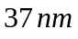thick nanostructured sol-gel derived anatase titania films on ultrasonically cleaned (100) p-silicon substrates at temperatures 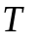 ranging from 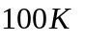 to 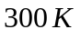over a frequency range between 20Hz and 1 MHz. The frequency dependent behaviour of the AC conductivity 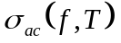 obeys the universal power law and the values of the effective hopping barrier and hopping distance were found to be 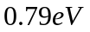and 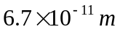 from an analysis due to the correlated barrier hopping model. The dielectric relaxation was identified as a thermally activated non-Debye process involving an activation energy of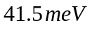.

Keywords: Metal–insulator–semiconductor device, hopping conduction, complex dielectric modulus, relaxation time

1. INTRODUCTION

Titania (TiO₂) has been extensively studied in thin film forms for potential applications in oxide electronics such as solar cells, electronic devices, chemical sensors and photo catalysts because of its robust chemical stability under acidic and oxidative environments, wide band gap 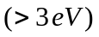 and low production cost ¹. Titania exists in a number of crystalline forms, the most important of which are anatase, rutile and brookite and the high optoelectronic properties of non-toxic oxides are found to be a phase dependent quantity ^{2, 3}. Thin film formulation of the materials can be achieved by using different techniques including DC reactive magnetron sputtering⁴ and electrodeposition⁵. The magnetron-sputtered TiO₂ layers on aluminium alloy 1050 substrates showed columnar growth with increasing crystallite sizes with increase in coating thickness leading to increase in photocatalytic activity⁶. An electrodeposited ultrathin anatase TiO₂ film on fluorine-doped tin oxide is found to demonstrate a power efficiency of 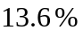 as a blocking layer in perovskite solar cell⁷.
Sol-gel derived TiO₂ films exhibit several physically interesting characteristics dependent upon the post deposition treatment. For example, the photosensitivity of sol-gel derived TiO₂ films annealed at 350 ⁰C was found to be higher than that of its powder by a factor as large as two orders of magnitude⁸. TiO₂ films became anatase in structure when subjected to heat treatment at 600 ⁰C and the grain sizes were found to be smaller than those found for microwave exposed films, resulting in the blue shift in UV visible absorption spectra⁹. However, the sol-gel synthesis of TiO₂ nanoparticles was performed with room temperature ionic liquid 1-n-butyl-3 -methylimidazolium hexafluorophosphate as a reaction medium and the anatase phase was achieved without heat treatment¹⁰. The photocatalytic efficiency increases with increasing concentration of nanostructure TiO₂, and the degradation percent can reach 100 % at the optimal catalyst concentration. Anatase TiO₂ nanowire arrays were deposited into the nanochannels of an anodic aluminium oxide template by an electrochemically induced sol-gel method¹¹. TiO₂ nanotubes were also prepared using the sol-gel technique for the fabrication of dye-sensitized solar cells and high surface area of the nanotubes produced an efficiency of 4 % under the Hg-Xe lamp irradiation¹². The real part of the dielectric permittivity of sol-gel derived anatase TiO₂ cylindrical pellets may be tuned by the application of increasing DC bias with a view to lowering barrier heights at the grain boundary. The tunability of for TiO₂ nanocrystals with grain sizes of 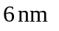is found to be in the order of ∼85 % at 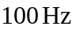and this value is believed to be suitable for phased array antenna applications¹³. The photocatalytic activity of sol-gel coated porous tetragonal anatase TiO₂/polystyrene thin films were deposited on indium tin oxide substrates using a templating method and these films showed improved photodegradation of methylene blue under ultraviolet light irradiation compared to porous TiO₂ films. This enhancement in photocatalytic activity may be attributed to an increased surface area of TiO₂/polystyrene¹⁴. Cystine-modified TiO₂ films are found to be more photocatalytically active than TiO₂ in splitting water under normal sunlight irradiation ¹⁵.
Metal–insulator–semiconductor (MIS) structures were prepared using solution processed 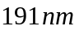thick TiO₂ films sandwiched between (100) n-gallium arsenide (GaAs) substrates and copper (Cu) counter electrodes. These devices exhibited rectifying steady state conduction behaviour with increasing barrier height from 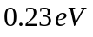to 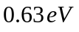 and decreasing ideality factor from 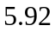 to 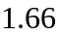 in the temperature 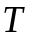 range of 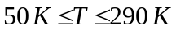¹⁶.
We have reported the preparation of non-porous nanostructured anatase titanium dioxide thin films by spin coating of a spreading solution of titanium isopropoxide, ethanol and acetic acid in the molar ratio of 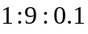onto a variety of substrates including microscopic glass slides, silicon and indium tin oxide coated glass substrates ^{17, 18}. A trap-controlled space charge limited mechanism was found to be responsible for charge transport at high field. Optical absorption was believed to be due to an allowed indirect transition over the optical gap of approximately 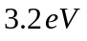¹⁹. MIS configurations were fabricated by depositing thick spun TiO₂ films on 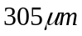 thick (100) p-type silicon (p-Si) substrates. The surface density at the Si/TiO₂ interface and threshold voltage were estimated to be 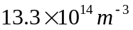 and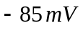, respectively²⁰. The influence of doping is found to be important because of the change in surface topographies in the MIS structures. Two orders of magnitude increase in rectifying ratio and simultaneous two fold decrease of ideality factor have recently been reported for TiO₂ films doped with 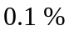zirconium 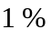 by mass in Al/TiO₂/p-Si MIS structures. No significant change was observed for interface surface density ²¹.

A non-destructive alternating current (AC) impedance spectroscopic technique is regarded as being very suitable for identifying the prevalent conduction mechanism, dielectric relaxation processes, the nature of barrier height and interfacial layer in the MIS structures when a small AC signal is applied as input perturbation over frequency and temperature ranges²². AC measurements were performed on 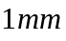 thick anatase TiO₂ pellets doped in situ with molybdenum nanoparticles (TiO₂-Mo) in the frequency () range of 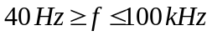 over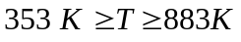. Proton conduction along the TiO₂-Mo surfaces is believed to be responsible for the increase in conductivity²³. DC magnetron sputtered 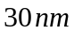 thick TiO₂ films on p-GaAs (110) in MIS structure showed the universal power-law dependence of AC conductivity 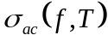 on (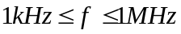) for a temperature range of 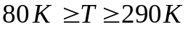. The results imply the existence of non-random distribution of hopping centres and surface states at the GaAs/TiO₂ interface^{24, 25}. However, reports of the AC impedance measurements on MIS structures involving sol-gel TiO₂ films are limited. The present article presents the results of AC electrical measurements to study the dielectric behaviour of TiO₂ on (100) p-type silicon substrates.
2. EXPERIMENTAL DETAILS
By employing a standard photoresist spinner (Microsystem model 4000) at a speed of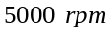, a small volume of the spreading solution was spin-coated on ultrasonically cleaned (100) p-type silicon (p-Si) substrates to form TiO2 films in the MIS structure of Fig. 1 for AC electrical experimental studies. The as deposited film was then annealed at 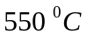for a further 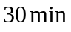after slow temperature ramping from room temperature and then the film was slowly cooled down from to room temperature in order to achieve the non-porous anatase structure. The film thickness was estimated to be 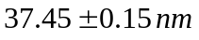 from the spectroscopic ellipsometeric measurement. The 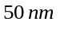 thick aluminium (Al) contacts were thermally evaporated at a rate of 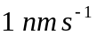 under vacuum of 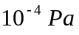 in an Edwards E306A evaporation system in order to complete MIS structure shown in Fig. 1 for electrical measurements. The active area 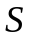 of the device was 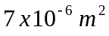. The details of the preparation of the MIS device structure involving sol-gel derived non-porous TIO₂ films are available from our earlier publications ^{17, 20}. AC measurements were made on the TiO₂ film as a function of frequency ranging from 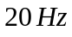 to 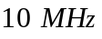 using a Hewlett Packard 4284 LCR meter and Oxford instrument constant bath cryostat in a microprocessor controlled measuring system over a temperature () range of 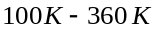. During the entire measurements, the temperature stability was maintained in the order of 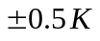. The direct current (DC) bias was maintained at zero volts during the measurement to allow the device to be operated in an accumulation regime.

3. RESULT AND DISCUSSIONS
Experimental results are presented along with the interpretation in order to identify the mechanisms responsible for charge transport and dielectric relaxation in Al/ TiO₂/p-Si/(100) MIS structures. New information has been elucidated from careful comparison of values of physical parameters estimated in this investigation with published data.
3.1 Dependence of conductivity on frequency and temperature
Fig. 2 presents a set of reproducible curves on double logarithmic scales showing the frequency dependence of AC conductivity 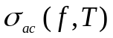 of spun TiO₂ thin films at eight different temperatures between 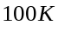and 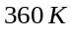. The temperature dependence of 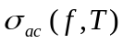became more pronounced for the low frequency compared to the high frequency regime with a transition frequency of 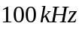. Three distinct regimes, characteristic of particular temperature and frequency ranges are found to exist for conduction behaviour. Firstly, a plateau region of frequency conductivity 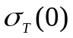 at temperature was observed over the low frequency range 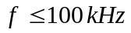 for 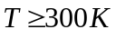. The existence of a similar region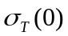 was observed in the 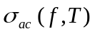curves for the chemical vapour deposited rutile TiO₂ films on silicon substrates at a temperature of 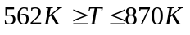 and a frequency of 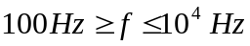²⁶. This value is believed to be contributing to the DC conductivity and this DC contribution becomes so dominant at 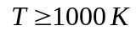 that = over 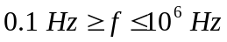^{27.} The second regime is related to an increase in from at a cross-over frequency of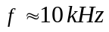. Thirdly, is found to be increasingly independent of temperature for the high frequency range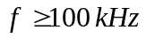. The frequency dependence of conductivity, for amorphous semiconductors and disordered systems is generally expressed in a form of the universal power law relation²⁸:
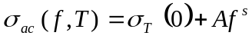 (1)
where 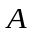 is a constant, which is dependent on temperature. The value of the frequency exponent usually lies between the values of zero and unity and the conduction mechanism can be identified from the temperature dependent behaviour of . Values of the exponent as a function of temperature were calculated from the slope of a 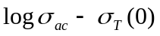 against 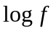plot and these values were found to lie in the range of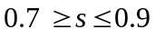 shown in Fig. 3. The exponent decreases smoothly with increasing and is independent of frequency in the investigated frequency range. The frequency-independent conductivity is obtained by extrapolation of the conductivity approaches to the frequency as zero.
Different theoretical models such as quantum mechanical tunnelling (QMT), classical hopping over barrier (HOB) and correlated barrier hopping (CBH) have been proposed for explaining AC conduction in disordered thin films. The QMT model involving electrons as carriers predicts a temperature independent value for . Small polarons are not believed to be responsible for the AC conduction in TiO₂ since the increase of with the rise of temperature is expected according to this model. According to large polaron QMT models, decreases to a minimum at a certain temperature and subsequently increases with and this is not a valid conduction mechanism in the present investigation. The HOB model predicts a constant value of unity for since the barrier heights are not dependent on the intersite separation²⁹. In the CBH models, bipolar hopping takes place involving two electrons or holes over the barrier height 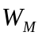 separated by a hopping distance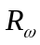. In this model, the exponent increases to unity as 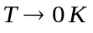³⁰. The observed dependence of on for the TiO₂ film under the present investigation is consistent with the prediction of the CBH model. CBH conduction has recently been reported for rutile TiO₂ thin films, deposited by RF magnetron sputtering using powder target, exhibiting the decrease of from 0.8 to 0.4 with the increment in within the range of 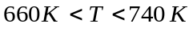³¹
The dependence of the frequency exponent, , on temperature is written in the form³²

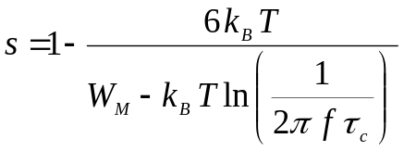 (2)

where 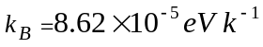 is the Boltzmann constant. and 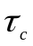 are the effective hopping barrier and the characteristic relaxation time, respectively. The inset in Fig. 3 shows the experimental and fitting data from Eq. (2) as a function of temperature and good agreement exists between theoretical and experimental values of. The values of 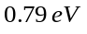 and 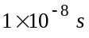are obtained for and 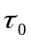 from the best fitted parameters to Eq. 2.
The hopping distance 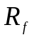 at a particular frequency and temperature respectively are given in the form³³:
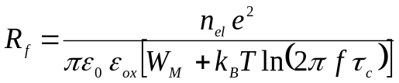 (3)
where 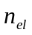 is the number of electrons involved in the process of hopping between centres and 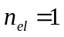 and 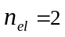for and for single polaron and bipolaron hopping, respectively. The quantities 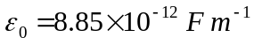and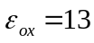 are the dielectric permittivity of the free space and the TiO₂ film²⁰, respectively. With the knowledge of 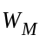and 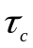 the hopping distance 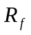 is found to be 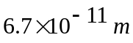 from Eq 3.
3.2 Dielectric relaxation
The variation in capacitance  with frequency within the range of 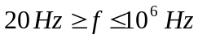 at various temperatures for the same MIS structure is shown in Fig. 4. The capacitance is found to be nearly independent of frequency within the temperature range of 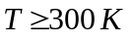, whereas the capacitance decreases rapidly with increasing frequency for 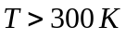. The capacitance subsequently approaches the low temperature value at high frequencies.
Experimental data were analysed in terms of the real 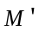 and imaginary 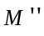 parts of the complex dielectric modulus. and can be defined in terms of the real (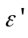) and imaginary (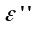) parts of the complex dielectric constant in the following forms:³⁴
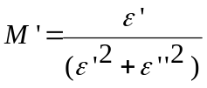 (4)
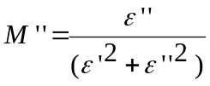 (5)
where 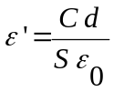 and 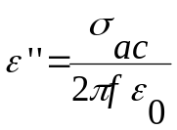 (6)
The modulus formalism is regarded as being a useful tool for interpretation of impedance data over the ranges of frequency and temperature in respect of electrode polarization, grain boundary conduction effect, bulk properties and electrical conductivity³⁵. Fig. 5(a) and 5(b) show the frequency dispersion of the real and imaginary parts of dielectric modulus for spun TiO₂ films at selected temperatures. The real part in Fig. 5(a) is found to decrease with the rise in temperature. A nearly temperature-independent maximum asymptotic value was observed at high frequency 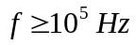while at low frequency 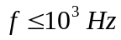, high temperature values of tend to zero faster than those corresponding to low temperatures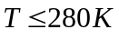. As shown in Fig. 5(b), the frequency dispersion of the imaginary part 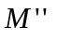 of the dielectric modulus exhibits broad asymmetrical peaks, systematically shifting towards higher frequencies with the increase of temperature. This implies that the relaxation process is thermally activated and the charge mobility increases with the rise in temperature leading to the reduction in dielectric relaxation. The broad nature of the peak represents the distribution of relaxation times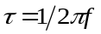 and the centre of the relaxation peak in Fig. 5(b) is usually identified by the most probable frequency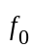. Charge carriers are mobile over long distances for 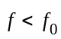 while the charge carriers, being confined within potential wells, are mobile over short range potential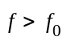. The Debye model is related to an ideal frequency response of localized relaxation and the absence of overlapping peaks in Fig. 5(b) indicates that the relaxation process is of non-Debye type³⁶. This frequency dispersive behaviour is generally described in term of the non-linear Kohlrausch–Williams–Watts decay function and the stretched constant 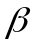 which can in principle be estimated from the full width of the bell –shaped curves in Fig. 5(b) at half maximum³⁷. The values of the stretched constant are found to increase from 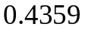to 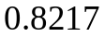 as temperature 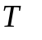is decreased from 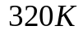to 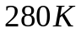 and 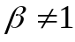 is also consistent with non-Debye type relaxation. Nearly semicircular behaviour is observed in the Cole-Cole plot in Fig. 5(c) of against for the temperatures possibly due to the decrease of modulus resistance. The decreasing temperature produced the relatively small shift of to higher values and this observation may be interpreted in terms of gradually increasing grain boundary contribution to conduction²⁴.
For further investigation into the effect of temperature on relaxation, the relaxation time 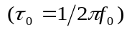 at the different temperatures was determined from the reciprocal of the peak frequency. The Arrhenius plot of 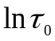 as a function of the inverse of temperature is shown in Fig. 6 and the relaxation is believed to be due to a thermally activated process given in the form:
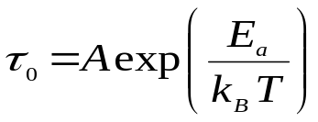 (7)
where 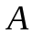 is the pre-exponential factor.
The decrease in dielectric relaxation time with the rise of temperature occurs due to the increasing charge mobility at high temperature. The value of activation energy of dielectric relaxation 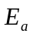is found to be 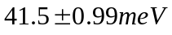. Dielectric relaxation behaviour of electrospun TiO₂ nanofibres between two Al electrodes on glass substrates has been investigated for the frequency range of 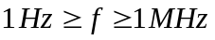 at selected temperatures over 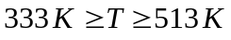 and resulting frequency dispersion of the dielectric moduli show the characteristic features similar to those observed in the present investigation. However the value of 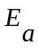is smaller than that obtained for TiO₂ nanofibres by nearly two orders of magnitude and the difference may be attributed to the quantum size effect in the nanofibres ³⁸.
4. Concluding remarks
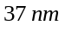 thick nanostructured sol-gel derived anatase titania films were deposited at room temperature on ultrasonically cleaned 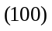 p-silicon substrates to fabricate metal–insulator–semiconductor (MIS) structures using thick thermally aluminium (Al) contacts. AC impedance measurements were performed on MIS structures at different temperatures ranging from 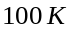to 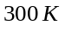over frequency range of 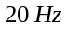 to 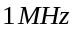. The dependence of AC conductivity on frequency was found to support the universal power law with the exponent decreasing with the rising temperature. This behaviour of the power law exponent was analysed in terms of the correlated barrier hopping model. The carrier transport was believed to be thermally assisted hopping over the potential barrier of across a distance of 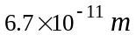 between defect centres. The dielectric relaxation was interpreted using the modulus formalism and the frequency corresponding to the peak of frequency dispersion of the imaginary part of the dielectric moduli was associated with the dielectric relaxation time and a value of 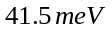 was obtained for energy required for thermally activated dielectric relaxation process.
Acknowledgment
Dr. R Capan is grateful to the Leverhulme Trust Foundation for the award of a fellowship to visit the UK. Gratitude is also due to Dr Lesley Hanna, Dr Myles Worsley and Miss Virginia Martin Torrejon of Institute of Materials and Manufacturing, Brunel University London for help in preparing the manuscript.

References
1. D. Koziej, A. Alessandro, and M. Niederberger, Adv. Mater. 26, 235 (2014).
2. K.K Saini, S.D. Sharma, Chanderkant, M. Kar, D. Singh, and C.P. Sharma, J. Non-Cryst. Solids 353, 2469 (2007).
3. J.Y. Kim, H.S. Jung , J.H. No, J.R. Kim, and K.S. Hong, J. Electrocer. 16, 447 (2006).
4. A. Vale, N. Chaure, M. Simonds, A.K. Ray, and N. Bricklebank, J. Mat. Sci.: Mat. in Elect. 17, 851 (2006).
5. C.F.C. Blanco, C. Pal, J.J. Ojeda, A.K. Ray, and A.K. Sharma, J. Electrochem. Soc. 159(2), E30-E36 (2012). doi:10.1149/2.016202jes
6 S. Daviosdottir, R. Shabadi, A.C. Galca, I.H.I. Andersen, K. Dirscherl, and R. Ambat, Appl. Surf. Sci. 313, 677( 2014) doi:10.1016/j.apsusc.2014.06.047
7. T.S. Su, T.Y. Hsieh, C.Y. Hong, and T.C. Wei, Scientific. Rep. 5, 16098 (2015). doi:10.1038/srep16098.
8. A.E.J. Gonzalez, and S.G. Santiago, Sem. Sci. Tech. 22, 709 (2007).
9. D.D. Claudio, A.R. Phani, and S. Santucci, Opt. Mat. 30, 279 (2007).
10. Y.G. Zhai, Y. Gao, F.Q. Liu, Q. Zhang, and G. Gao, Mat. Lett. 61, 5056 (2007).
11. L. Sun, J. Zuo, Y.K. Lai, C.G. Nie, and C.J. Lin, Acta Phys. Chim. Sinica 23, 1603 (2007).
12. I.C. Flores, J.N. de Freitas, C. Longo, M.A. de Paoli, H. Winnischofer, and A.F. Nogueira, J. Photochem. Photobio. A-Chem. 189, 153 (2007).
13. T. Prakash, A.T. Selvan, S.N.S. Begum, Superlattices Microstruct. 91, 182 (2016).
14 A. Bourezgui, I. Kacem, I. Ben Assaker, M. Gannouni, J. Ben Naceur, M. Karyaoui, and R. Chtourou, J. Porous Mat. 23, 1085 (2016). doi:10.1007/s10934-016-0166-3.
15 X. Liu, L.J. Chen, R.Y. Chen, Z. Chen, X. Chen, and X. Zheng, Res. Chem. Intermed. 41, 3623 (2015). doi:10.1007/s11164-013-1476-6.
16 S. Sonmezoglu, and S. Akin, Curr. Appl. Phys. 12, 1372 (2012). doi:10.1016/j.cap.2012.03.030.
17. Q. Fan, B. McQuillin, A.K. Ray, M.L. Turner, and A.B. Seddon, J. Phys. D 33, 2683 (2000).
18. A.K. Hassan, N.B. Chaure, A.K. Ray, A.V. Nabok, and S. Habesch, J. Phys. D 36, 1120 (2003).
19. R. Capan, N.B. Chaure, A.K.Hassan, and A.K. Ray, Sem. Sci. Techn. 19, 198 (2004).
20. N.B. Chaure, A.K. Ray, and R Capan, Sem. Sci. Techn. 20, 788 (2005).
21 I. H. Tasdemir, O. Vural, and I. Dokme. Philos. Mag. 96, 1684 (2016). doi:10.1080/14786435.2016.1178403.
22. J.R. Macdonald, Impedance Spectroscopy-Emphasizing Solid Materials and Systems, (New York: Wiley, 1987).
23. R. Bargougui, N. Bouazizi, S. Ammar, and A. Azzouz, J. Electron. Mater. 46, 85 (2017). doi:10.1007/s11664-016-4947-x.
24. Y.S. Asar, T. Asar, S. Altindal, and S. Ozcelik, Philos. Mag. 95, 2885 (2015). doi:10.1080/14786435.2015.1081301.
25. Y.S. Asar, T. Asar, S. Altindal, and S. Ozcelik, J. Alloy. Compd. 628, 442 (2015). doi:10.1016/j.jallcom.2014.12.170.
26. D.Y. Guo, A. Ito, T. Goto, R. Tu, C.B. Wang, Q. Shen, and L.M. Zhang, J. Mater. Sci.-Mater. Elect. 24, 1758 (2013).
27. D. Regonini, V. Adamaki, C.R. Bowen, S.R. Pennock, J. Taylor, and A.C.E. Dent, Solid State Ion. 229, 38 (2012).
28. A. K. Jonscher Nature 267, 673 (1977).
29. A.R. Long, Adv. Phys. 31, 553 (1982).
30. S.R. Elliott, Adv. Phys. 36, 135 (1987).
31. I. Ben Jemaa, F. Chaabouni, and M. Abaab, Phys. Status Solidi A-Appl. Mat. 214, 1600426 (2017).
32. N.F. Mott and E. Davis, Electronic Process in Non Crystalline Materials 2nd edn. (Oxford, Clarendon, 1979).
33 S.R. Elliott Philos. Mag., 37, 553 (1978).
34. S.R. Elliott, J. Non-Cryst. Solids 170, 97(1994).
35. V.C.V. Gowda, B.K. Chethana, and C.N. Reddy, Mat. Sci. Eng. B 178, 82 (2013).
36. R. Gerhardt, J. Phys. Chem. Solids 55, 1491 (1994).
37. C. K. K. Reddy, G. Suman, R. B. Rao, N. K. Katari and M. R. P. Reddy,, Appl. Nanosci. 6(7), 1043 (2016)
38. S.S. Batool, Z. Imran, M.A. Rafiq, M.M. Hasan, and M. Willander, Ceram. Int 39, 1775 (2013).

Figure captions
Fig. 1: A schematic diagram of the metal–insulator–semiconductor (MIS) structure containing 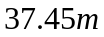 thick sol-gel derived TiO₂ film on thick (100) p-type silicon substrates sandwiched between two thick aluminium (Al) contacts (Al/p-Si/TiO₂/Al).
Fig. 2: Frequency dependence of ac conductivity 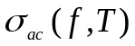for non-porous anatase TiO₂ in the Al/p-Si/TiO₂/Al MIS structure at temperatures increasing from to measured with the stability of 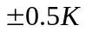.
Fig. 3: Frequency exponent as a function of temperature for TiO₂ sample and the best fitted parameters of the values of effective hopping barrier 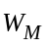 and characteristic relaxation time 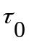in the inset.
Fig. 4: Frequency dependence of ac capacitance for TiO₂ the Al/p-Si/TiO₂/Al MIS structure at seven temperatures ranging from to measured with a stability of .

Fig. 5: (a) Real part 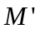 and (b) imaginary part 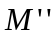 of the dielectric modulus 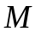as a function of frequency at specified temperatures increasing from to . (c) Cole–Cole plots of imaginary part vs real part at the selected temperatures.
Fig. 6: Arrhenius plot of as a function of the inverse of temperature.

p- Si (100) ((100((((((1000
Al contact
Al contact
TiO
2

Fig. 1: A schematic diagram of the metal–insulator–semiconductor (MIS) structure containing thick sol-gel derived TiO₂ film on thick (100) p-type silicon substrates sandwiched between two thick aluminium (Al) contacts (Al/p-Si/TiO₂/Al).

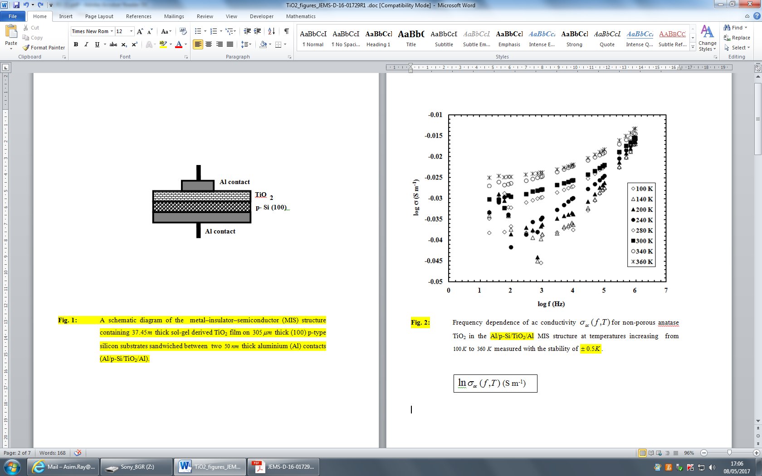
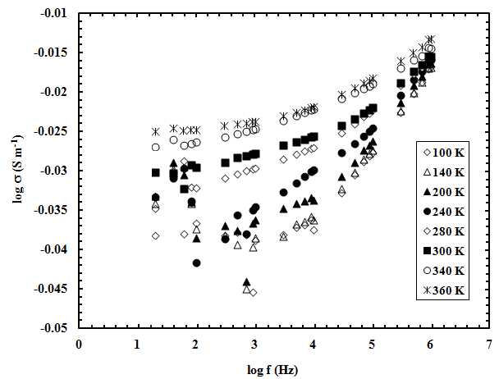
Fig. 2: Frequency dependence of ac conductivity for non-porous anatase TiO₂ in the Al/p-Si/TiO₂/Al MIS structure at temperatures increasing from to measured with the stability of .

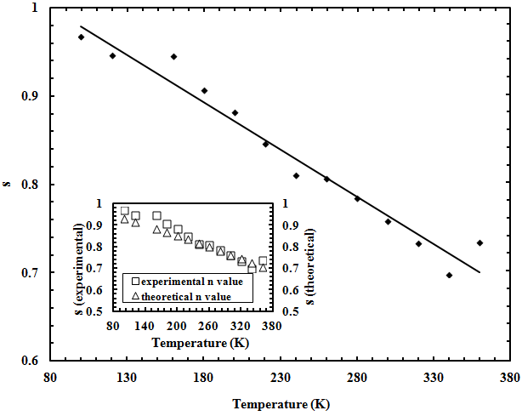

Fig. 3: Frequency exponent as a function of temperature for TiO₂ sample and the best fitted parameters of the values of effective hopping barrier and characteristic relaxation time in the inset

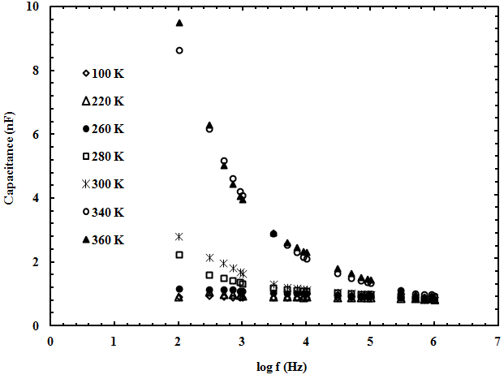

Fig. 4: Frequency dependence of ac capacitance for TiO₂ the Al/p-Si/TiO₂/Al MIS structure at seven temperatures ranging from to measured with the stability of .

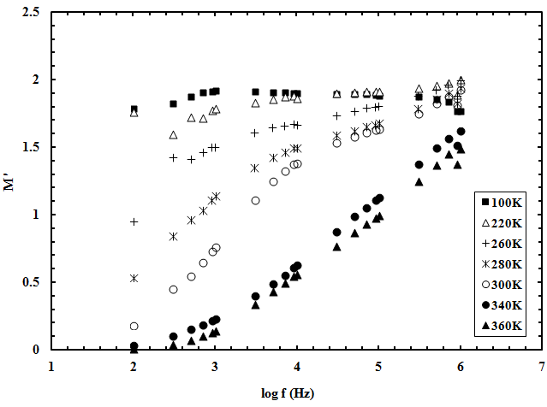
(a)
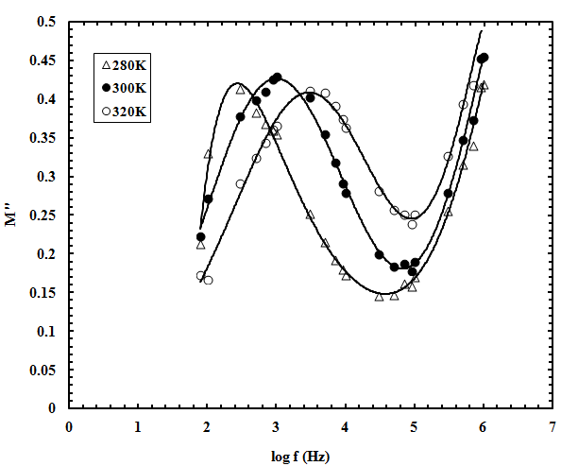
340K
300K
(b)
280K

340 K

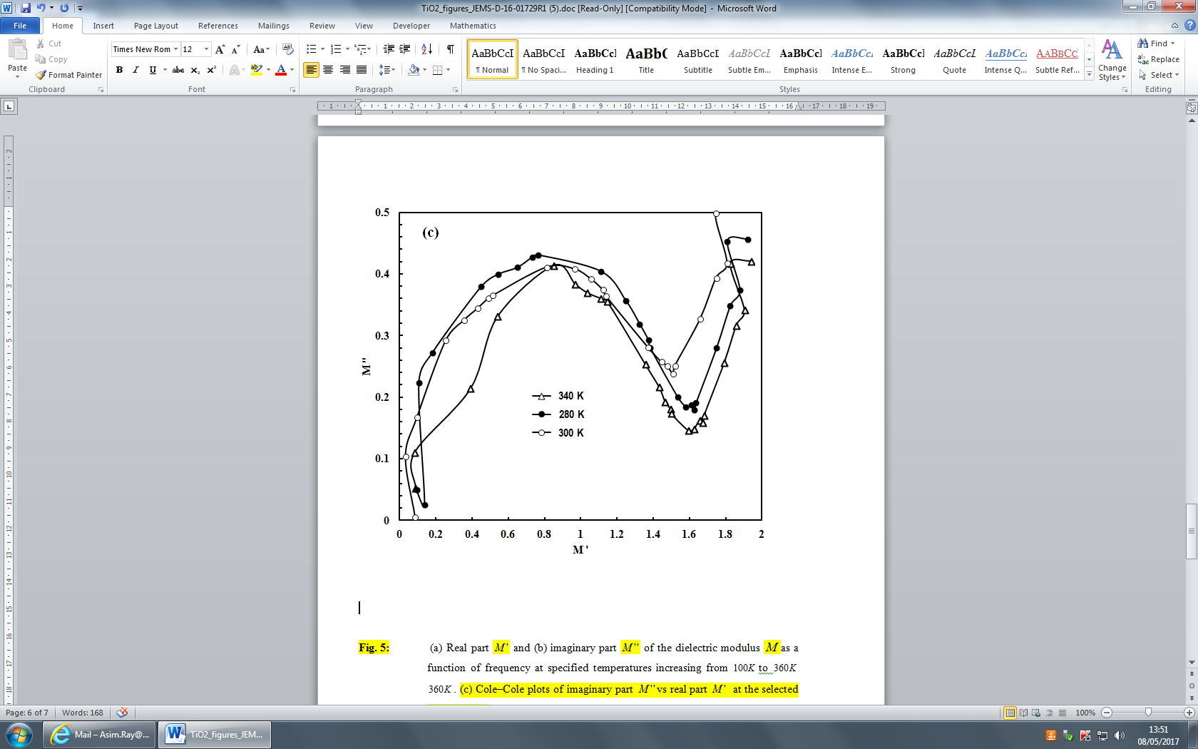
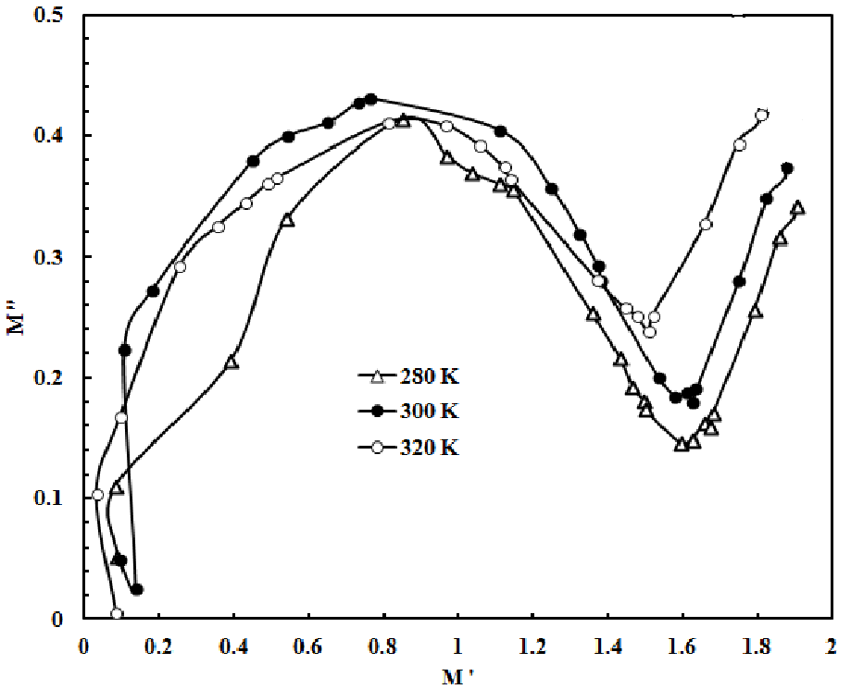
(c)

Fig. 5: (a) Real part and (b) imaginary part of the dielectric modulus as a function of frequency at specified temperatures increasing from to . (c) Cole–Cole plots of imaginary part vs real part at the selected temperatures.

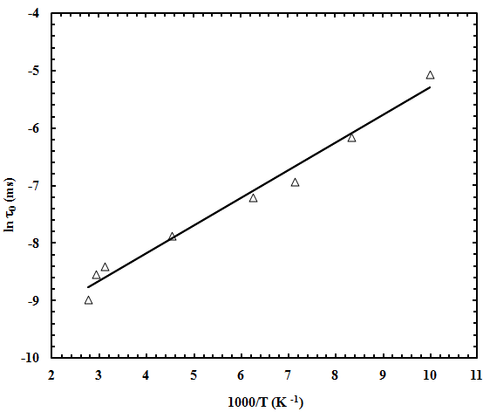

Fig. 6: Arrhenius plot of as a function of the inverse of temperature.

e-mail:rcapan@balikesir.edu.tr
Present address: Institute of Materials and Manufacturing, Brunel University London, Uxbridge, Middlesex UB8 3PH’ Asim.Ray@brunel.ac.uk

