Simulation of a New Proposed Voltage-Base Self-Intervention Technique with Increment and Decrement Voltage Conduction Method to Optimize the Renewable Energy Sources DC Output
Ranjit Singh Sarban Singh  Department of Electronic and Computer Engineering,  Brunel University London,  Uxbridge, UB8 9PH, United Kingdom  R.Singh@brunel.ac.uk | Maysam Abbod  Department of Electronic and Computer Engineering,  Brunel University London,  Uxbridge, UB8 9PH, United Kingdom  Maysam.Abbod@brunel.ac.uk | Wamadeva Balachandran  Department of Electronic and Computer Engineering,  Brunel University London,  Uxbridge, UB8 9PH, United Kingdom  Wamadeva.Balachandran@brunel.ac.uk

Abstract— A simple Voltage-Base Self-Intervention technique is introduced in this paper to perform the switching between the connected distributed generation renewable energy sources. The Voltage-Base Self-Intervention technique fetch maximum power from either the solar photovoltaic or wind energy systems under inhomogeneous conditions and output stable voltage for DC – AC inverter and DC – DC Boost Converter. In order to fetch the maximum power, the proposed Voltage-Base Self-Intervention technique is integrated after the stable DC voltage system. This is to ensure the DC bus can efficiently and effectively measure the voltage increment and decrement during the voltage conduction. To validate the performances of the proposed Voltage-Base Self-Intervention technique for solar – wind renewable energy sources, PROTEUS simulations are presented in this paper. Simulation results shows that the proposed technique effectively perform the Self-Intervention between the distributed generation solar – wind renewable energy sources using the voltage sensing and measurement.
Keywords-renewable energy sources; solar photovoltaic; wind energy; voltage – base; self - intervention

Introduction
Renewable energy sources have gained great attention because of disadvantages of fossil fuels based electricity power generation systems [1]. Therefore, in recent years renewable energy sources based system have been given great emphasis. The renewable energy sources power systems for electricity generations are among with minimal negative impact on the environment. Hence, among fastest growing renewable energy sources power system are undoubtedly the solar photovoltaic and wind energy system [2], [3], [4]. Therefore, the state-of-the-art of the solar and wind energy system as a hybrid power system development is to compensate between each another during their intermittency period [5]. System proposed and research conducted such as in [2], [6], [7], [8], [9], [10], [11] introduces the method of controlling the renewable energy sources at the Distributed Generation (DG). All of these researches have proposed new methods with the attention to increase the penetration level at the intermittent of renewable energy sources. In [12] has been mentioned, determination of an optimum hybrid renewable energy system highly dependable on the adaptability of renewable energy sources and energy management system to optimize the control strategy.
In this paper, a solar – wind renewable energy sources combinational are proposed at the DG level. As mentioned in [13], due to the intermittent nature of the solar – wind renewable energy sources, both sources requires a control strategy to compensate each other during climate change or intermittent period. Hence, a new voltage-base self-intervention technique is proposed to perform the control strategy for solar – wind renewable energy sources at the DG level. An increment and decrement hierarchical voltage management and control strategy is proposed to continuously measure the input voltages of solar – wind renewable energy sources based on the voltage conduction method to optimize the renewable energy sources Direct Current (DC) output.
Therefore following the introduction, an outline of the principle operation using the voltage-base self-intervention technique is given in Section II. In Section III, a method of developing the increment and decrement hierarchical voltage management and control strategy base on voltage conduction. This strategy is developed based on quantifying the input voltage the solar - wind renewable energy into FOUR stages and operation optimization is discussed. The simulation tests, results and discussion are presented in Section IV. Finally Section V will include some conclusion remarks.

Voltage – Base Self - Intervention
The voltage-base self-intervention technique is proposed to sense and measure the input voltage from the solar – wind renewable energy sources. In the proposed technique, two voltage dividers are connected after the output voltage stabilization. The stabilized output voltage from the solar –wind renewable energy sources conducts through the voltage dividers, sensed and measured voltage at the voltage dividers are proportionally rationed to 5 Volt. The proportionally rationed 5 Volt voltage is necessary to perform the voltage quantification in the next level. The voltage quantification will be discussed in Section III. The voltage quantification process is important to allow the voltage divider to sense and measure the 14 Volt voltage changes from the solar – wind renewable energy sources proportionally with 5 Volt. In the following, the calculation for analogue to digital (ADC) voltage changes is shown.

Where,

The microcontroller has 10 bit resolution of ADC, hence, 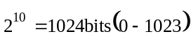

1 bit = 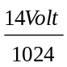

= 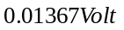

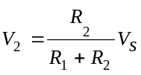

Lets 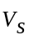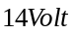

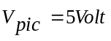

Let’s assume, 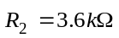

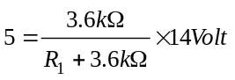

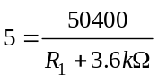

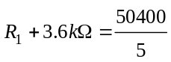

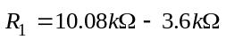

= 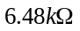

= 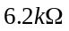+ 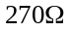+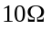

Based on the calculation shown and Fig. 1, every 1 Volt sensed and measured by the microcontroller ADC is equivalent to 2.8 Volt input voltage from the solar – wind renewable energy sources. Hence, the calculation also shows that every single bit is equivalent to 0.01367 Volt and it requires 205 bits to complete 2.8 Volt.

Therefore,
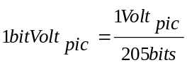

= 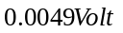

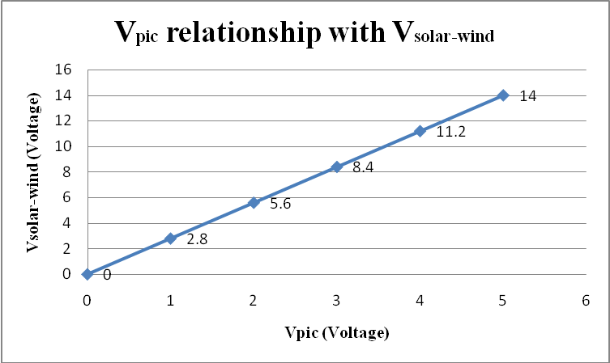
Figure 1. Vpic (Voltage) proportion relationship with Vsolar-wind (Voltage).
The voltage calculation is important to show the relationship between the input voltage from the solar – wind renewable energy sources and the operational of the voltage-base self-intervention at the microcontroller using the ADC function.

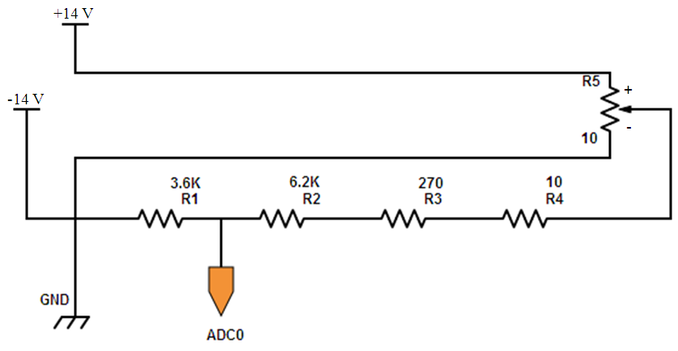
(a)
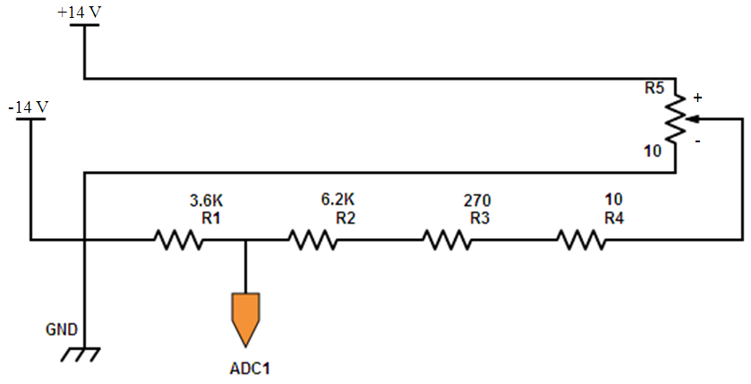
(b)
Figure 2. Solar – Wind Voltage Divider Circuits – Voltage - Base.
Fig. 2 is showing the voltage divider circuits for solar – wind renewable energy sources to perform the voltage – base self – intervention. Based on the voltage relationship shown in Fig. 1, 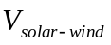 will output maximum of 14 Volt during 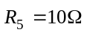 which is equivalent to 5 Volt measured at the ADCs channel of PIC16F877A microcontroller. Therefore, during 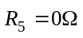 then, the ADCs channel measures 0 Volt.
Hence, this section has addressed the developed methodology for voltage – base self – intervention technique based on the input voltages from the solar – wind renewable energy sources. With that, in the next section the self – intervention controllability based of the voltage quantification is discussed.

Self – Intervention Controllability
The solar – wind self – intervention controllability is aimed to provide self control to solar – wind renewable energy sources based on their responsiveness to the climate. This technique is integrated after the output voltages have been stabilized. Two voltage divider circuits are integrated to continuously measure the stabled output voltages. The integration of the voltage – base voltage divider circuits are also to control the switching between solar – wind renewable energy sources for optimum operation. Besides that, the maximum energy harvesting would also help to minimize the dependency on the grid network power supply.
Fig. 3 shows the proposed integrated architecture of the solar – wind renewable energy sources using the PIC16F877A microcontroller. Based on the presented calculation in Section II, the ADCs are used to measure the 5 Volt input voltage of solar – wind renewable energy sources at 0.0049 Volt sensitivity per bit. Therefore, to perform the self – intervention of the solar – wind renewable energy sources the PIC16F877A microcontroller is programmed with predefined voltage measurement conditions based on the hierarchical voltage management and control strategy. The hierarchical voltage management and control strategy is base on the predefined voltage values that measured from the input.
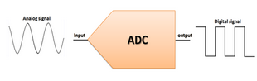
VSolar
VWind
Microcontroller
ADC0
ADC1
Figure 3. Solar – Wind Self – Intervention using ADC channel of Microcontroller.

Table 1 presents predefined voltage quantification to perform the increment and decrement hierarchical voltage management and control strategy for solar – wind renewable energy sources. There are FOUR stages of voltage quantification involved in the self – intervention process solar – wind renewable energy sources. In the following, each stage is explained in terms of the solar – wind renewable energy sources self – intervention process.
- Hierarchical Voltage Management and Control Strategy Conditions
Stages | Sources | Conditions
 | System Initialization
 | Solar Energy (SE) | 12 < SE ≤ 14
 | Wind Energy (WE) | 12 < WE ≤ 14
 | Solar Energy (SE) | 9 < SE ≤ 12
 | Wind Energy (WE) | 9 < WE ≤ 12
 | Solar Energy (SE) | 5 < SE ≤ 9
 | Wind Energy (WE) | 5 < WE ≤ 9

Stage 1: In the initial during the system start-up, the system will start searching for the available renewable energy sources.
Stage 2: If solar – wind renewable energy sources are available then, the ADCs will start sensing and measuring the available input voltages. When solar – wind renewable energy sources voltage is at 12 < solar – wind ≤ 14, 9 < solar – wind ≤ 12 and 5 < solar – wind ≤ 9 the increment and decrement hierarchical voltage management and control system make the solar energy as primary energy supplier (ADC0) and wind energy as secondary energy supplier (ADC1).
Stage 3: When one of the energy source is producing higher voltage than the other one, for instance solar (12 < solar ≤ 14) is higher than wind (9 < wind ≤ 12), then the higher voltage energy source will be the primary supplier and the lower voltage energy source will be the secondary supplier. During this stage, both ADCs are at active HIGH but have different tasks to perform and it goes vice versa as well.

Stage 4: If both renewable energy sources are less than and equal to 5 Volt, ADC0 and ADC1 will send a HIGH – HALT signal to the PIC16F877A microcontroller to temporarily stop any kind of activity that related to the overall system performances.

Simulation Tests, Results and Discussion
This section will present the designed simulation for the solar – wind voltage divider circuits using the PROTEUS software. In this simulation, cell batteries have been used as a condition to provide the solar – wind voltage divider circuits with constant 14 Volt voltage. Each condition presented in Table 1 is demonstrated and the simulation test results are captured.

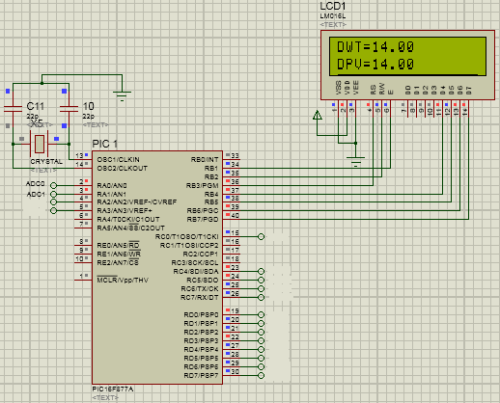
Figure 4. Solar – wind analogue voltage reading at 14 Volt.
Fig. 4 shows the input voltage from solar – wind renewable energy sources. Solar – wind renewable energy sources reading is showing 14 Volt input voltage as predefined in the Table 1.
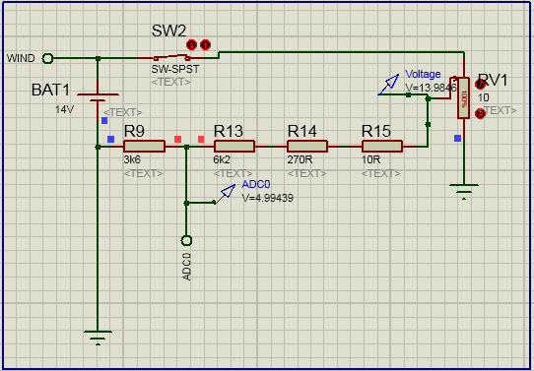
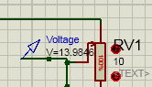
- Condition 1: 12 < solar ≤ 14
(a)
(a)

Meantime, during the 14 Volt input voltage from solar – wind renewable energy sources in Fig. 4, the condition 1 ADC0 (Wind – Fig. 4(a)) and condition 2 ADC1 (Solar – Fig. 4(b)) measured reading is showing 5 Volt. Which means, the relationship presented in Fig. 1 in Section II has been demonstrated.

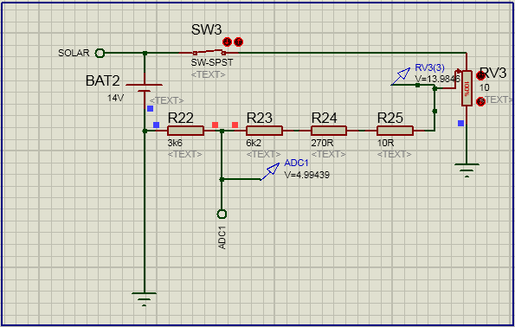
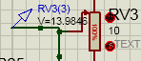
- Condition 2: 12 < wind ≤ 14
(a)

Figure 3. (a) and (b) 12 < solar – wind ≤ 14.
Fig. 5 demonstrates the condition 3 and 4 shown in Table 1. These conditions demonstrate the solar – wind renewable energy sources producing voltage between 9 Volt to 12 Volt. Fig. 5 shows the solar – wind renewable energy sources input voltage reading is showing 10.08 Volt as predefined in Table 1.

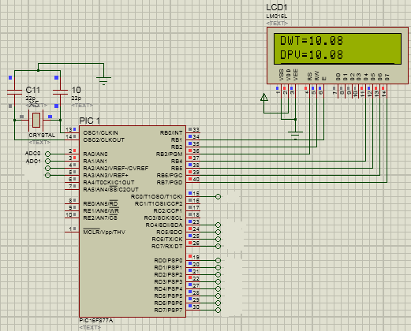
Figure 5. Solar – wind analogue voltage reading at 10.08 Volt.
- Condition 3: 9 < solar ≤ 12
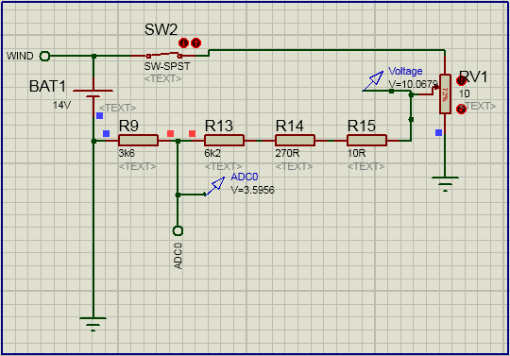
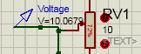
(a)

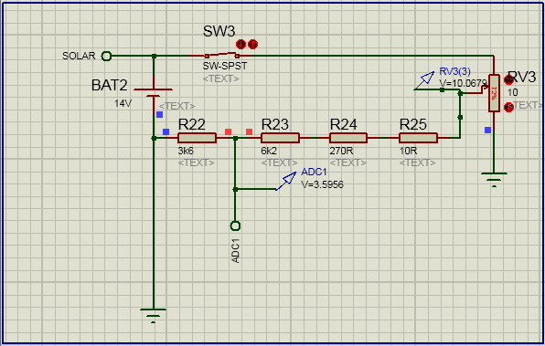
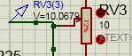
- Condition 2: 9 < wind ≤ 12
(b)

Figure 4. (a) and (b) Solar – wind analogue voltage reading.
Therefore, when the condition 3 ADC0 (Solar) Fig.5 (a) and condition 4 ADC1 (Fig. 5 (b)) measured value shows at 3.5956 Volt. This value represents the solar – wind renewable energy sources input voltage at 10.08 Volt at the DG level.
Fig. 6 demonstrates the condition 5 and 6 shown in Table 1. During these conditions, solar – wind renewable energy sources produces 6.43 Volt input voltage. In the following, the ADC0 and ADC1 calculation validate the proposed increment and decrement hierarchical voltage management and control strategy for solar – wind renewable energy sources self – intervention.

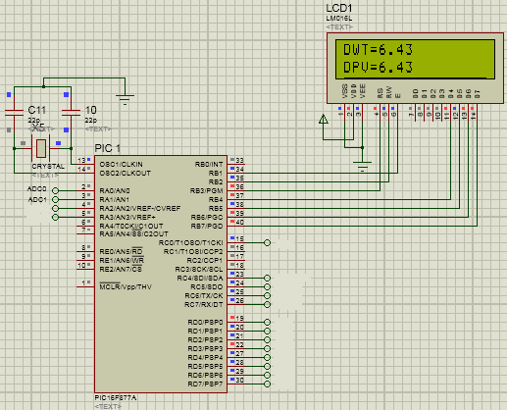
Figure 5. Solar – wind ADC voltage reading.
Solar and Wind input voltage = 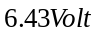

Number of Bits = 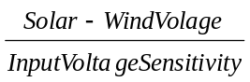

= 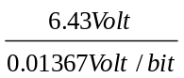

= 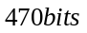

ADC0 and ADC1 Voltage = 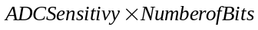

= 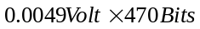

= 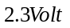

Fig. 7 shows the system goes into HALT MODE when the solar – wind renewable energy sources produces less than or equal to 5 Volt. During the system HALT MODE, overall system performance is temporarily STOPPED till the solar – wind renewable energy sources voltage increase above 5 Volt constantly for a period time. In the following section, the ADC0 and ADC1 measured voltage value is calculated which will validate the system is unable to perform the optimization process.

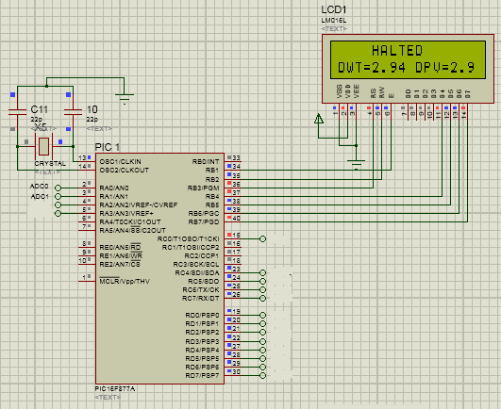
Figure 7. 0 < solar – wind ≤ 5.
Where,

Solar and Wind Voltage = 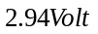

Number of Bits =

= 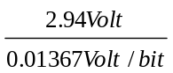

= 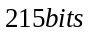

ADC0 and ADC1 Voltage =

= 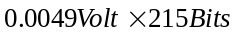

= 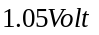

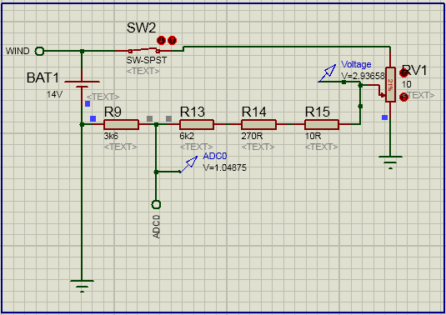
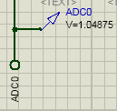

(a)
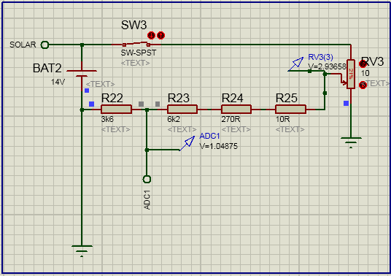
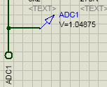

(b)
Figure 6. (a) and (b) Solar – wind ADC Voltage Reading.
Figs. 7(a) ADC0 – wind and (b) ADC1 – solar shows ADC voltage reading for equivalent solar – wind analogue input voltage. The measured solar – wind voltages at the ADCs is used to perform the increment and decrement hierarchical voltage management and control strategy in the microcontroller PIC16F877A. During this condition the ADC0 and ADC1 will send a HIGH-HALT signal to the system. This operation and functionality is important because when the solar – wind renewable energy sources input voltage is low the overall system underperforms. This will cause inefficiency and ineffectiveness to the overall system operation.

Conclusions
The research aims to propose the voltage – base self – intervention technique and the increment and decrement hierarchical voltage management and control strategy using the voltage – divider principle. The voltage dividers are integrated after the stabilized solar – wind voltage and simple voltage quantification method shown in Table 1 is used to program the PIC16F877A microcontroller using the increment and decrement hierarchical voltage management and control strategy. Presented simulation test results validate the proposed technique and strategy successfully performs the solar –wind renewable energy sources self – intervention for maximum power fetching.

Acknowledgments
The authors would like to thank the reviewers for their valuable comments in this paper. Also would like to thank Brunel University London, Ministry of Education Malaysia (MOE) and Faculty of Electronic and Computer Engineering (FKEKK), University Teknikal Malaysia Melaka.

References

[1] R. Srinivasan, D. Ph, M. Yogaselvi, and R. Arulmozhiyal, “Standalone Hybrid Wind-Solar Power Generation System Applying Advanced Power,” Int. J. Adv. Res. Electr. Electron. Instrum. Eng., vol. 3, no. 2, pp. 627–636, 2014.
[2] S. M. J. Mary, S. R. Babu, and D. P. Winston, “Fuzzy Logic Based Control of a Grid Connected Hybrid Renewable Energy Sources,” Int. J. Adv. Res. Electr. Electron. Instrum. Eng., vol. 3, no. 4, pp. 1043–1048, 2014.
[3] D. Shen, A. Izadian, and P. Liao, “A hybrid wind-solar-storage energy generation system configuration and control,” 2014 IEEE Energy Convers. Congr. Expo. ECCE 2014, pp. 436–442, 2014.
[4] M. Engin, “Sizing and simulation of PV-wind hybrid power system,” Int. J. Photoenergy, vol. 2013, 2013.
[5] J. B. V Subrahmanyam, P. Alluvada, K. Bhanupriya, and C. Shashidhar, “Renewable Energy Systems: Development and Perspectives of a Hybrid Solar-Wind System,” Eng. Technol. Appl. Sci. Res., vol. 2, no. 1, pp. pp. 177–181, 2012.
[6] A. Ali, S. Member, Y. Wang, W. Li, and X. He, “Implementation of Simple Moving Voltage Average Technique with Direct Control Incremental Conductance Method to Optimize the Efficiency of DC Microgrid,” in 2015 International Conference on Emerging Technologies (ICET), 2015, pp. 1 – 5.
[7] M. F. Almi, M. Arrouf, H. Belmili, S. Boulouma, and B. Bendib, “Energy management of wind / PV and battery hybrid system,” Int. J. New Comput. Arch. their Appl., vol. 4, no. 1, pp. 30–38, 2014.
[8] K. Strunz, E. Abbasi, and D. N. Huu, “DC Microgrid for Wind and Solar Power Integration,” Emerg. Sel. Top. Power Electron. IEEE J., vol. 2, no. 1, pp. 115–126, 2014.
[9] a Azizi, A. Salavati, H. Chalangar, and S. M. T. Bathaee, “Novel Control Method for Intermittent Renewable Source in Dc Microgrid,” Sci. Int., vol. 26, no. 1, pp. 211–216, 2014.
[10] S. D. Arco, R. Rizzo, and P. Tricoli, “Energy Management of Stand-Alone Power Systems with Renewable Energy Sources,” in Proceeding of ICREPQ, 2006, vol. 1, no. 1, pp. 1–7.
[11] B. V Aralakshmi and C. S. S. A. I. P. Rathyusha, “A Novel Control Strategy for Power Control and Management in AC / DC Micro Grid in Distribution,” Int. J. Sci. Eng. Technol. Res., vol. 04, no. 23, pp. 4425–4431, 2015.
[12] N. Kamal and S. S. Kumar, “Hybrid Power Generation for Distributed Grid Applications Principal of Vivekananda College of Technology for Women , Tiruchengode , India,” Middle-East J. Sci. Res., vol. 24, no. 1, pp. 51–58, 2016.
[13] J. Yu, C. Dou, and X. Li, “MAS-Based Energy Management Strategies for a Hybrid Energy Generation System,” IEEE Trans. Ind. Electron., vol. 0046, no. c, pp. 1–1, 2016.

