Int. J. Electrochem. Sci., 10 (2015) xx - yy

International Journal of
ELECTROCHEMICAL
SCIENCE
www.electrochemsci.org

Experimental Design to Optimise Electrical Performance of Strip Supercapacitors

Ruirong Zhang^{1,*}, Yanmeng Xu^{1,*}, David Harrison¹, John Fyson¹ and Darren Southee²
¹Cleaner Electronics Group, College of Engineering, Design and Physical Sciences, Brunel University London, Uxbridge, UK
²Loughborough Design School, Loughborough University, Leicestershire, UK
*E-mail: ruirong.zhang@brunel.ac.uk; yanmeng.xu@brunel.ac.uk

Received: 7 August 2015 / Accepted: 1 xxx 2015 / Published: 1 xxx 2015

Strip shaped electric double-layer supercapacitors (EDLCs) using activated carbon as electrode material have been successfully fabricated and optimised. Their electrochemical characteristics were studied using a VersaSTAT 3 electrochemical workstation. The experimental design software, JMP™, was used to optimise the main parameters of supercapacitors in order to maximise the electrical performance. Simultaneously, the relationship between the electrical performance and the key manufacturing factors of the EDLCs, including the binder concentration, the electrolyte concentration and the thickness of electrode materials was studied and discussed.

Keywords: Strip supercapacitors; Activated carbon; Optimisation; Experimental design

1. INTRODUCTION
In recent years, supercapacitors (also named electrochemical capacitors), as energy storage devices with a high power density, a high efficiency and a long life cycle, have been considered as a promising source for rapid energy storage and power delivery in electric vehicles, electronic devices and emergency power supplies [1-4]. Using the working mechanism, supercapacitors can be generally classified into two types: (1) electrical double-layer capacitors (EDLCs), in which capacitance arises from charge separation at the electrode/electrolyte interface, such as carbon-based supercapacitors [3, 5-9], and (2) pseudocapacitors, in which capacitance arises from reversible faradic reactions occurring at the electrode surface, such as transition metal oxide supercapacitors [6,7,10-12]. The energy storage in an electric double-layer capacitor (EDLC) relies on the accumulation of electrical charges on electrodes. Porous carbon materials with a high specific surface area are widely used for the electrode materials in EDLCs [3,5,7-9], e.g. certain grades of activated carbon. In general, the amount of energy stored in EDLCs is mainly determined by the properties of the porous carbon electrodes. Although some previous studies [3,8,13,14] had considered the relationship between the properties of activated carbon and the specific capacitance of the supercapacitors, very few studies had focused on other factors such as the electrolyte concentration, the thickness and composition of activated electrode materials [15], and it was not clear that how they would influence the performance of supercapacitors. The purpose of this research was to systematically investigate the influence of these key factors and further discuss the correlation among them. In order to optimise the electrical performance, the JMP™ software (‘statistical discovery’ software from SAS™), which were convenient to enable easy adjustment of the above parameters of the supercapacitors, was used to design strip shaped supercapacitors.

2. EXPERIMENTAL
2.1 Design and fabrication of strip EDLCs
The strip EDLC consists of two electrodes, a separator and an electrolyte, as shown in Fig. 1. The two electrodes, usually made of activated carbon, are separated by a layer of filter paper soaked in electrolyte which was ionically-conducting but electrically insulating. The energy is stored by the accumulation of electrical charges at the boundary between the porous electrodes and the electrolyte. In this study, each electrode consists of a grade AISI 316 stainless steel strip (100 mm long, 50 µm thick) purchased from Advent Research Materials Ltd as the current collector. The active electrode material was prepared by mixing activated carbon (AC) with CMC (carboxymethyl cellulose) binder to obtain homogeneous an AC slurry [16]. The AC slurry was coated on the 3 mm wide exposed surface of the steel strip by blade coating. The thickness of the slurry was controlled by two plastic shim spacers with a 3 mm gap between them. The electrodes were dried in an oven at 100 °C for 2 hours before the electrolyte was applied on to them.
Stainless steel

Spacer

Activated carbon

Separator
3 mm

Figure 1. Schematic diagram of the strip supercapacitor.

Fig. 2a shows a scanning electron microscope (SEM) image of the active carbon material used in this study. It can be seen that the size of the carbon particles ranges from hundreds of nanometres to tens of microns. Fig. 2b displays a magnified view of the carbon particle surface, which reveals the typical porous structure of the AC material. The diameter of the pores is about 100 nm. This porous structure will provide a large surface area for electrical charges to be stored.
b

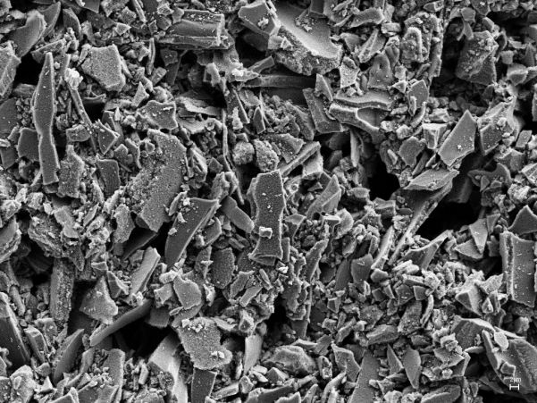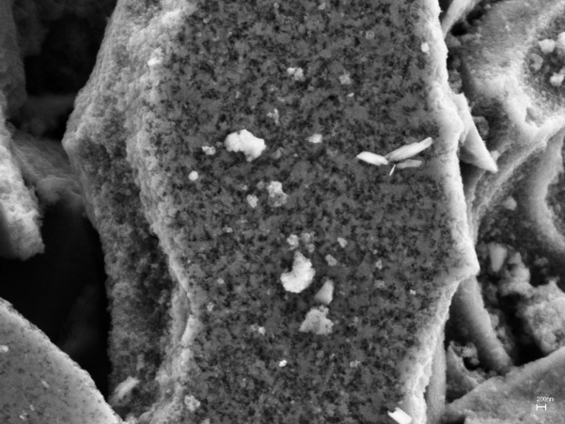
10 µm
1 µm
a

Figure 2. (a) SEM images of the activated carbon electrode material, (b) Magnified porous surface of a carbon particle shown in (a).

The electrolyte was made from the tetrabutylammonium tetrafluoroborate (C₁₆H₃₆BF₄N) dissolved in propylene carbonate (C₄H₆O₃). A solution of the electrolyte was dropped into the active materials. The electrodes with the electrolyte imbibed were put in a vacuum desiccator at room temperature for 0.5 hours to allow the electrolyte to fully access the porous structures of the AC material. Meanwhile, the filter paper, used as a separator, was also fully wetted with the electrolyte. Finally, the two electrodes separated by the separator were sealed together using a laminator filled with plastic laminating pouches to make a complete strip supercapacitor and to make it sealed against loss of electrolyte.

2.2 Measurement of the electrochemical performance
A galvanostatic charge-discharge test is the most preferred DC test performed on supercapacitors for the performance evaluation. The measurement consists of two steps: (1) charging a supercapacitor at a constant current, and (2) discharging over a specific voltage range or over certain charge-discharge time.
The capacitance, , can be calculated as
(1)
Where is the discharge current (A), is the discharge voltage (V) and is the scanning time in seconds.
The specific capacitance can be calculated as follows:
(2)
Where C_{s} is the specific capacitance of the electrode (F.g⁻¹), C is the capacitance calculated from equation (1), m is the average mass of activated carbon in each electrode.

2.3 Experimental Design
The JMP™ software, a tool for the design of experiments (DOE), can offer a practical approach for exploring multifactor experimental conditions. Some interacting factors may also be detected and a set of models can be developed to find the optimal conditions for the maximum output performance of the tested specimens. In this study, JMP™ was used to design the experimental conditions of the most expected significant parameters for EDLCs, which included the thickness (µm) of the AC slurry, the electrolyte concentration (mol/L), and the concentration (wt.%) of the CMC binder (based on the total mass of CMC and AC). The ranges of these three factors were set at 125 µm to 625 µm for the AC slurry thickness, 0.5 mol/L to 1.5 mol/L for the electrolyte concentration and 1% to 8% for the CMC concentration, which had been determined by a large number of initial experimental studies.

3. RESULTS AND DISCUSSION
20 EDLCs were fabricated based on the combination of conditions of the three important parameters designed by the JMP™ software which were listed in Table 1. Furthermore, the correlation among these parameters and their impact on the electrical performance of the EDLCs were studied and analysed using the software.

Table 1. Experiment parameters calculated by JMP.

No. | Thickness (µm) | Electrolyte (mol/L) | Binder (wt.%)
1 | 125 | 1.00 | 5
2 | 375 | 1.50 | 5
3 | 375 | 1.00 | 5
4 | 250 | 1.30 | 7
5 | 500 | 0.70 | 2
6 | 250 | 0.70 | 7
7 | 375 | 1.00 | 5
8 | 500 | 1.30 | 2
9 | 250 | 1.30 | 2
10 | 500 | 0.70 | 7
11 | 375 | 1.00 | 5
12 | 250 | 0.70 | 2
13 | 375 | 1.00 | 1
14 | 375 | 1.00 | 8
15 | 625 | 1.00 | 5
16 | 375 | 1.00 | 5
17 | 375 | 0.50 | 5
18 | 375 | 1.00 | 5
19 | 500 | 1.30 | 7
20 | 375 | 1.00 | 5

3.1 Effect of the electrolyte concentration
Fig. 3 shows the effect of the electrolyte concentration on the capacitance of the EDLCs with the thickness of the AC material of 375 µm and the binder concentration of 5%. The maximum capacitance of 0.31 F was achieved when the electrolyte concentration was 1.0 mol/L but there was no statistically significant change of the average capacitance from 0.26 F to 0.28 F when the concentration of the electrolyte changed from 0.5 mol/L to 1.5 mol/L. A linear fit was used to analyse these data. From this it was obvious that the fitting line is nearly parallel with the X-axis. This indicates that the electrolyte concentration has little effect on the capacitance of the EDLCs in this range of concentrations.

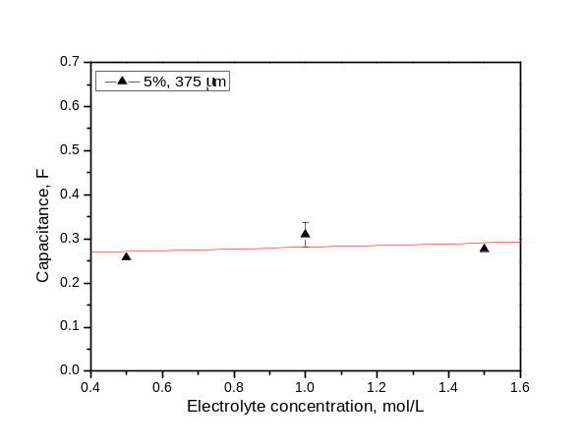

Figure 3. The effect of the electrolyte concentration on the capacitance of EDLCs.

3.2 Effect of the thickness of the AC material layer
The experimental results also disclosed the relationship between the thickness of the AC material layer and the capacitance. As shown in Fig. 4, the capacitance for all the EDLCs with the same CMC binder concentration increased with increases of the thickness of the AC layer in the range of 125-625 µm. Fig. 5 shows the mass of the AC material for the electrode with the same CMC binder concentration increased when the thickness of the active layer increased. e.g. when the CMC concentration was 5%, the thickness of the AC layer increased 3 times from 125 µm to 375 µm, the mass of the AC material increased nearly 4 times from 3.3 mg to 14.7 mg, which further resulted in the increase of capacitance from 0.121 F to 0.299 F. It can be seen that both the mass of the AC materials and the capacitance of the supercapacitor increased as the thickness of the active layer increased. The increase of the AC mass was approximately linearly proportional to the thickness of the AC material layer (Fig. 5) as expected. We know when the width and length of active layer was fixed (Fig. 2), the volume had a linear correlation with the thickness of the active layer, therefore, the mass of AC for the same CMC concentration electrode should theoretically have a linear growth related on the thickness of active layer. The experimental results nearly agreed with the theoretical predicted trend. This suggested that the process of fabrication of strip supercapacitors was reliable. The increase of the capacitance of the supercapacitor may not have been expected to increase proportionally with the increase of the thickness or the mass of the AC material, because the time of electrolyte diffusion processing will be prolonged when the thickness is increased. This might be the main reason for decreasing the specific capacitance when the thickness of the active layer increased (Fig. 6).

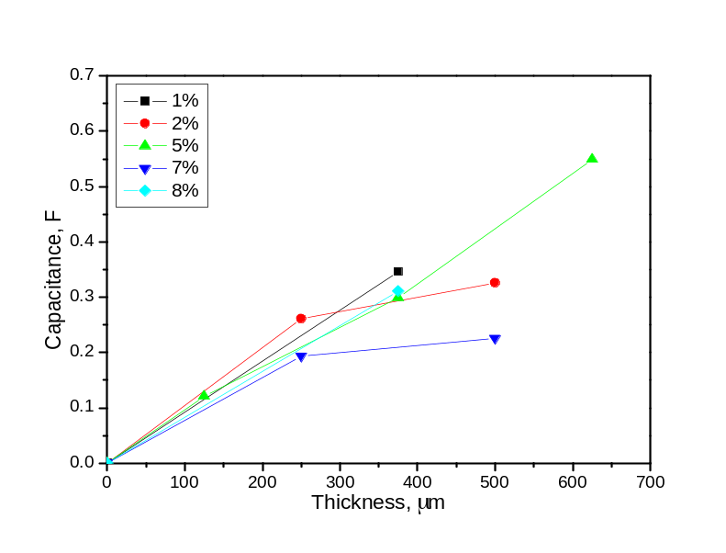

Figure 4. The effect of the thickness of activated carbon electrode layer on the capacitance of EDLCs.

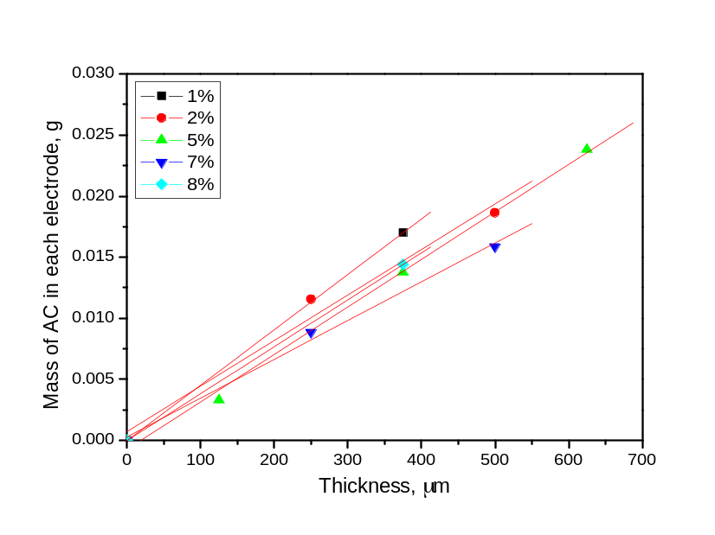

Figure 5. The relationship between the mass of AC in each electrode and thickness of activated carbon electrode layer.
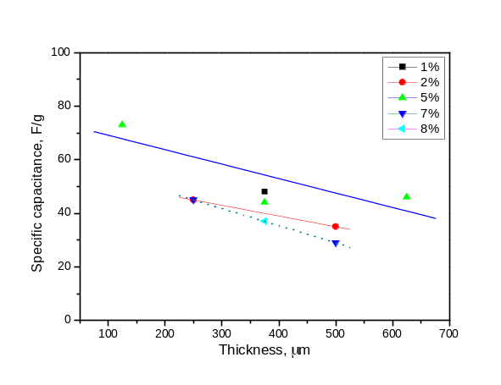

Figure 6. The effect of the activated carbon electrode layer thickness on the specific capacitance of EDLCs.

3.3 Effect of the concentration of the CMC binder
A binder in the electrode layer can hold the carbon particles together to forming a compacted porous layer, and further let these electrode materials adhere onto the current collector. As an important material which was part of electrode, the concentration of the CMC binder as the third main factor was studied in this work. Fig. 7 shows the effect of the concentration of the CMC binder on capacitance with different thicknesses of AC slurry. It can be seen that in general the capacitance of the strip EDLCs with the same thickness of active layer decreased when the binder concentration increased. Take the EDLCs with the active layer thickness of 500 µm for example, when CMC binder concentration increased from 2% to 7%, the capacitance decreased dramatically from 0.326 F to 0.226 F. This may be because that the increased concentration of CMC would block the pores or cover the surface of the AC particles resulting in reducing the effective specific surface area for adsorption of the electrolyte. Consequently, the capacitance of the EDLCs decreased when the concentration of binder increased.

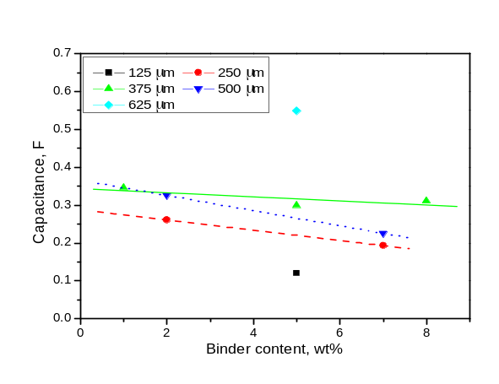

Figure 7. The effect of binder content on the capacitance of EDLCs.
3.4 Experimental design results
Considering there factors mentioned above, a best fitting model was obtained by the JMP software for the capacitance of all the corresponding EDLCs with the input experimental design conditions. The result with the best fitting model is displayed as a contour plot in Fig. 8, where the effect of the electrolyte concentration on the performance was not shown because it had little effect on the capacitance. This result showed a good agreement with the trend as shown in Fig. 3. It can be seen from Fig. 4 that the thickness of the active layer played a dominant role in the performance of the EDLCs. In addition, the contour plot also shows that when the concentration of the CMC binder increased the capacitance of the supercapacitor decreased. It was obvious that these experimental design results were consistent with the experimental results analysed and discussed in Fig. 3, Fig. 4 and Fig. 7.

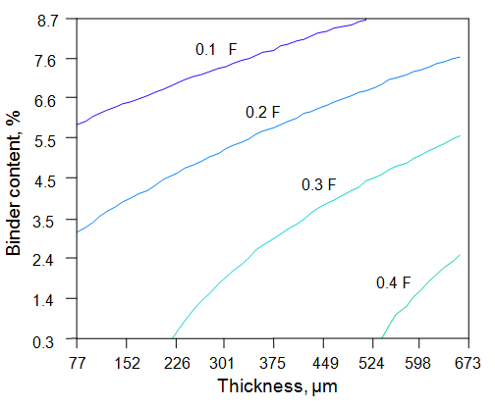
Binder concentration, wt%
Thickness, µm

Figure 8. The results of JMP optimisation for three parameters (Note the electrolyte concentration was not shown on the graph due to its ignorable effect).

4. CONCLUSIONS
Strip EDLCs (3 mm×100 mm) were successfully designed, fabricated and characterised in this study. The AC material was porous with an average size of the holes of about 100 nm, which allowed a good electrolyte accessibility to the inner surface of electrode and further provided a large surface area for electrical charge storage. Furthermore, the relationships between the performance and the key factors of the strip EDLCs including the CMC binder concentration, the electrolyte concentration and the thickness of active material layer were presented. The results showed that in the range of 0.5-1.5 mol/L, the electrolyte concentration had little effect on the capacitance; when the thickness of activated carbon electrode layer increased from 125 µm to 625 µm, the capacitance increased; and the capacitance decreased when the binder concentration increased from 1% to 8%.

ACKNOWLEDGEMENTS
We acknowledge funding support from the European Union Seventh Framework Programme (FP7/2007-2013) under grant agreement no. 281063.

References

- R. Kötz, M. Carlen, Electrochim. Acta, 45 (2000) 2483–2498.
- J. R. Miller, P. Simon, Science, 321 (2008) 651–652.
- J. Gamby, P. L. Taberna, P. Simon, J. F. Fauvarque and M. Chesneau, J. Power Sources, 101 (2001) 109–116.
- M. Jayalakshmi, K. Balasubramanian, Int. J. Electrochem. Sci., 3 (2008) 1196 – 1217.
- E. Frackowiak, Q. Abbas and F. Béguin, J. Energy Chem., 22 (2013) 226–240.
- S. Chen, R. Ramachandran, V. Mani and R. Saraswathi, Int. J. Electrochem. Sci., 9 (2014) 4072–4085.
- Y. Zhang, H. Feng, X. Wu, L. Wang, A. Zhang, T. Xia, H. Dong, X. Li and L. Zhang, Int. J. Hydrogen Energy, 34 (2009) 4889–4899.
- D. Qu, J. Power Sources, 109 (2002) 403–411.
- H. Shen, E. Liu, X. Xiang, Z. Huang, Y. Tian, Y. Wu, Z. Wu and H. Xie, Mater. Res. Bull., 47 (2012) 662–666.
- J. Jiang, A. Kucernak, Electrochim. Acta, 47 (2002) 2381–2386.
- X. Lang, A. Hirata, T. Fujita and M. Chen, Nat. Nanotechnol., 6 (2011) 232–236.
- H. Gómez, M. K. Ram, F. Alvi, P. Villalba, E. Stefanakos and A. Kumar, J. Power Sources, 196 (2011) 4102–4108.
- O. Barbieri, M. Hahn, A. Herzog and R. Kötz, Carbon, 43 (2005) 1303–1310.
- J. H. Kim, Y. S. Lee, A. K. Sharma and C. G. Liu, Electrochim. Acta, 52 (2006) 1727–1732.
- K. C. Tsay, L. Zhang and J. Zhang, Electrochim. Acta, 60 (2012) 428–436.
- R. Richner, S. Müller, M. Bärtschi, R. Kötz and A. Wokaun, J. New Mater. Electrochem. Syst. 5 (2002) 297–303.

© 2015 The Authors. Published by ESG (www.electrochemsci.org). This article is an open access article distributed under the terms and conditions of the Creative Commons Attribution license (http://creativecommons.org/licenses/by/4.0/).

