Intermittent Blood Pressure Prediction via Multiscale Entropy and Ensemble Artificial Neural Networks

Muammar Sadrawi, Jiann-Shing Shieh
Dept. Mechanical Engineering and Innovation Center for Big Data and Digital Convergence Yuan Ze University.
Chung-Li, Taiwan

Shou-Zen Fan
Department of Anesthesiology College of Medicine National Taiwan University
Taipei, Taiwan

Chien Hung Lin
Health and Beauty Research Center
Cal-Comp Inc.
New Taipei City, Taiwan

Koichi Haraikawa, Jen Chien Chien
Health and Beauty Research Center
Kinpo Electronics, Inc.
New Taipei City, Taiwan

Maysam F. Abbod
Dept. Electronic and Computer Engineering
Brunel University London
Uxbridge, UK

Abstract— This study evaluates the correlation between the intermittent blood pressure (BP) and the photoplethysmography (PPG). This study of a total of twenty-five cases is started by the partitioning of the PPG signal into a 5-minute segment. The segmented PPG is filtered by ensemble empirical mode decomposition (EEMD). The feature extraction method, multiscale entropy (MSE) is utilized for the purified signal to achieve some information. The seventy-five scale of MSE is taken into the input of the artificial neural network (ANN) modeling. The output of this system are the intermittent diastolic and systolic blood pressure. Originally, thousand models are created. The best model is chosen for the best single ANN model. In advanced, the ensemble artificial neural network (EANN) model is initiated to observe the testing data. The result, compared to the best single ANN model, shows that the EANN model recognizes better the testing data by producing lower mean absolute error (MAE).

Introduction
Hypertension is the essential aspect for the heart and kidney diseases [1-2]. A slight change in blood pressure (BP) will relate to the possibility of the cardiovascular disease as well [3].
Several studies investigated the correlation between BP and photoplethysmography (PPG) [4-6]. However, the noise is highly probably to disturb the signal. Hence, several studies have been conducted to reduce the noise and increase the quality of the PPG signal. The adaptive filter method has been utilized for the motion artifact cases [7]. Another study used the moving average method for the purifying technique [8]. For the increment of the PPG signal quality, time-frequency method has been applied in the previous studies [9, 10].
Huang et. al. originated the empirical mode decomposition (EMD) for the filtering system [11]. It has been implemented frequently for biological signal processing. A study evaluated the relationship between EMD, filter bank and Hurst exponent [12]. EMD-based algorithm has also been conducted for the baseline and high frequency noise in the electrocardiography (ECG) [13], as well in electromyography (EMG) for the background activity [14].
The non-linear feature extractions for the signal processing have been investigated for several years. One of the most popular algorithms is entropy-based algorithm. This algorithm, originally developed by Richman, et al., works based on the evaluation of the regularity of the time series [15]. The multiscale entropy (MSE), a modified sample entropy, has been applied the studies related to the physiological signal series. Studies related to the cardiovascular evaluation using MSE has been done by Costa et. al., [16, 17]. The utilization of MSE also has been applied in the seizure assessment by Lu et. al. [18].
Artificial neural networks (ANN) is one of the outstanding machine learning algorithms that utilized for the input-output modeling. The utilization of the EMD-based, entropy-based and ANN algorithms in anesthesia cases have been done previous studies [19-21]. Another technique for the modified ANN, named ensemble neural networks, has also done by several assessments [22-24].
This study proposes the new input-output relationship for the PPG as the input and the intermittent blood pressure as the output. In advanced, the ensemble neural network algorithm is applied to model this relationship.

MATERIAL AND METHODOLOGY
- Materials
The data collection was collected from twenty-five patients at the National Taiwan University Hospital (NTUH) of Taiwan. The IntelliVue MP60 (Philips Healthcare, USA) and a portable computer were utilized. This study was approved by Institutional Review Board.
- Methodology
This study is sequentially done as shown in Fig. 1. Initially, the raw PPG is purified by EEMD. Studies related to the IMF evaluation by FFT, with range in between 0.5 – 4 Hz, have been done by several previous works [25, 26]. However, in our study and in some cases as shown in Figs. 2 and 3, the IMF 6 corresponds to the frequency 0.7 Hz may be affected by some noise, which are highly in those ranges that belongs to its IMF. This circumstance can be seen by the signal regularization and the amplitude of the IMF itself. Based on this phenomenon, the IMF selection, in this whole study, has been ranged from 1 to 4 Hz.
The feature extraction mode is evaluated by the multi-scale entropy [16, 17]. A 5-minute of the filtered PPG signal is evaluated. Due to the considerably size of this sequence, the maximum scale is adjusted to 75. This scale will have the shortest length of 512 data when it has maximum scale. The input of this study will be the first scale to the seventy-five scale for the output of diastolic and systolic blood pressure collected each 5 minutes.

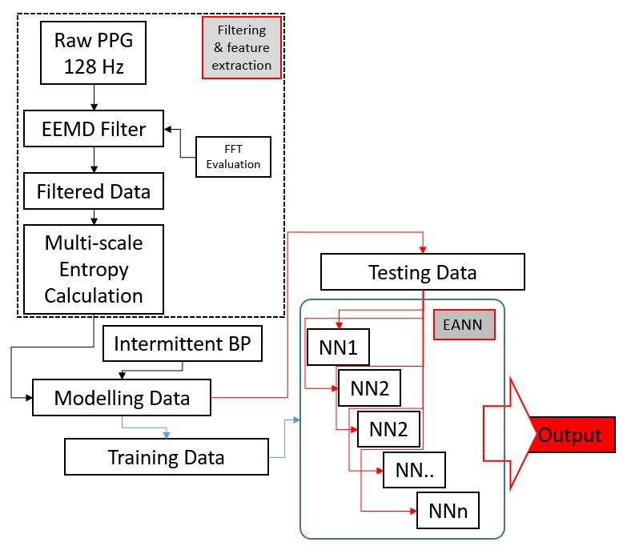
- The flowchart of the ensemble neural networks.

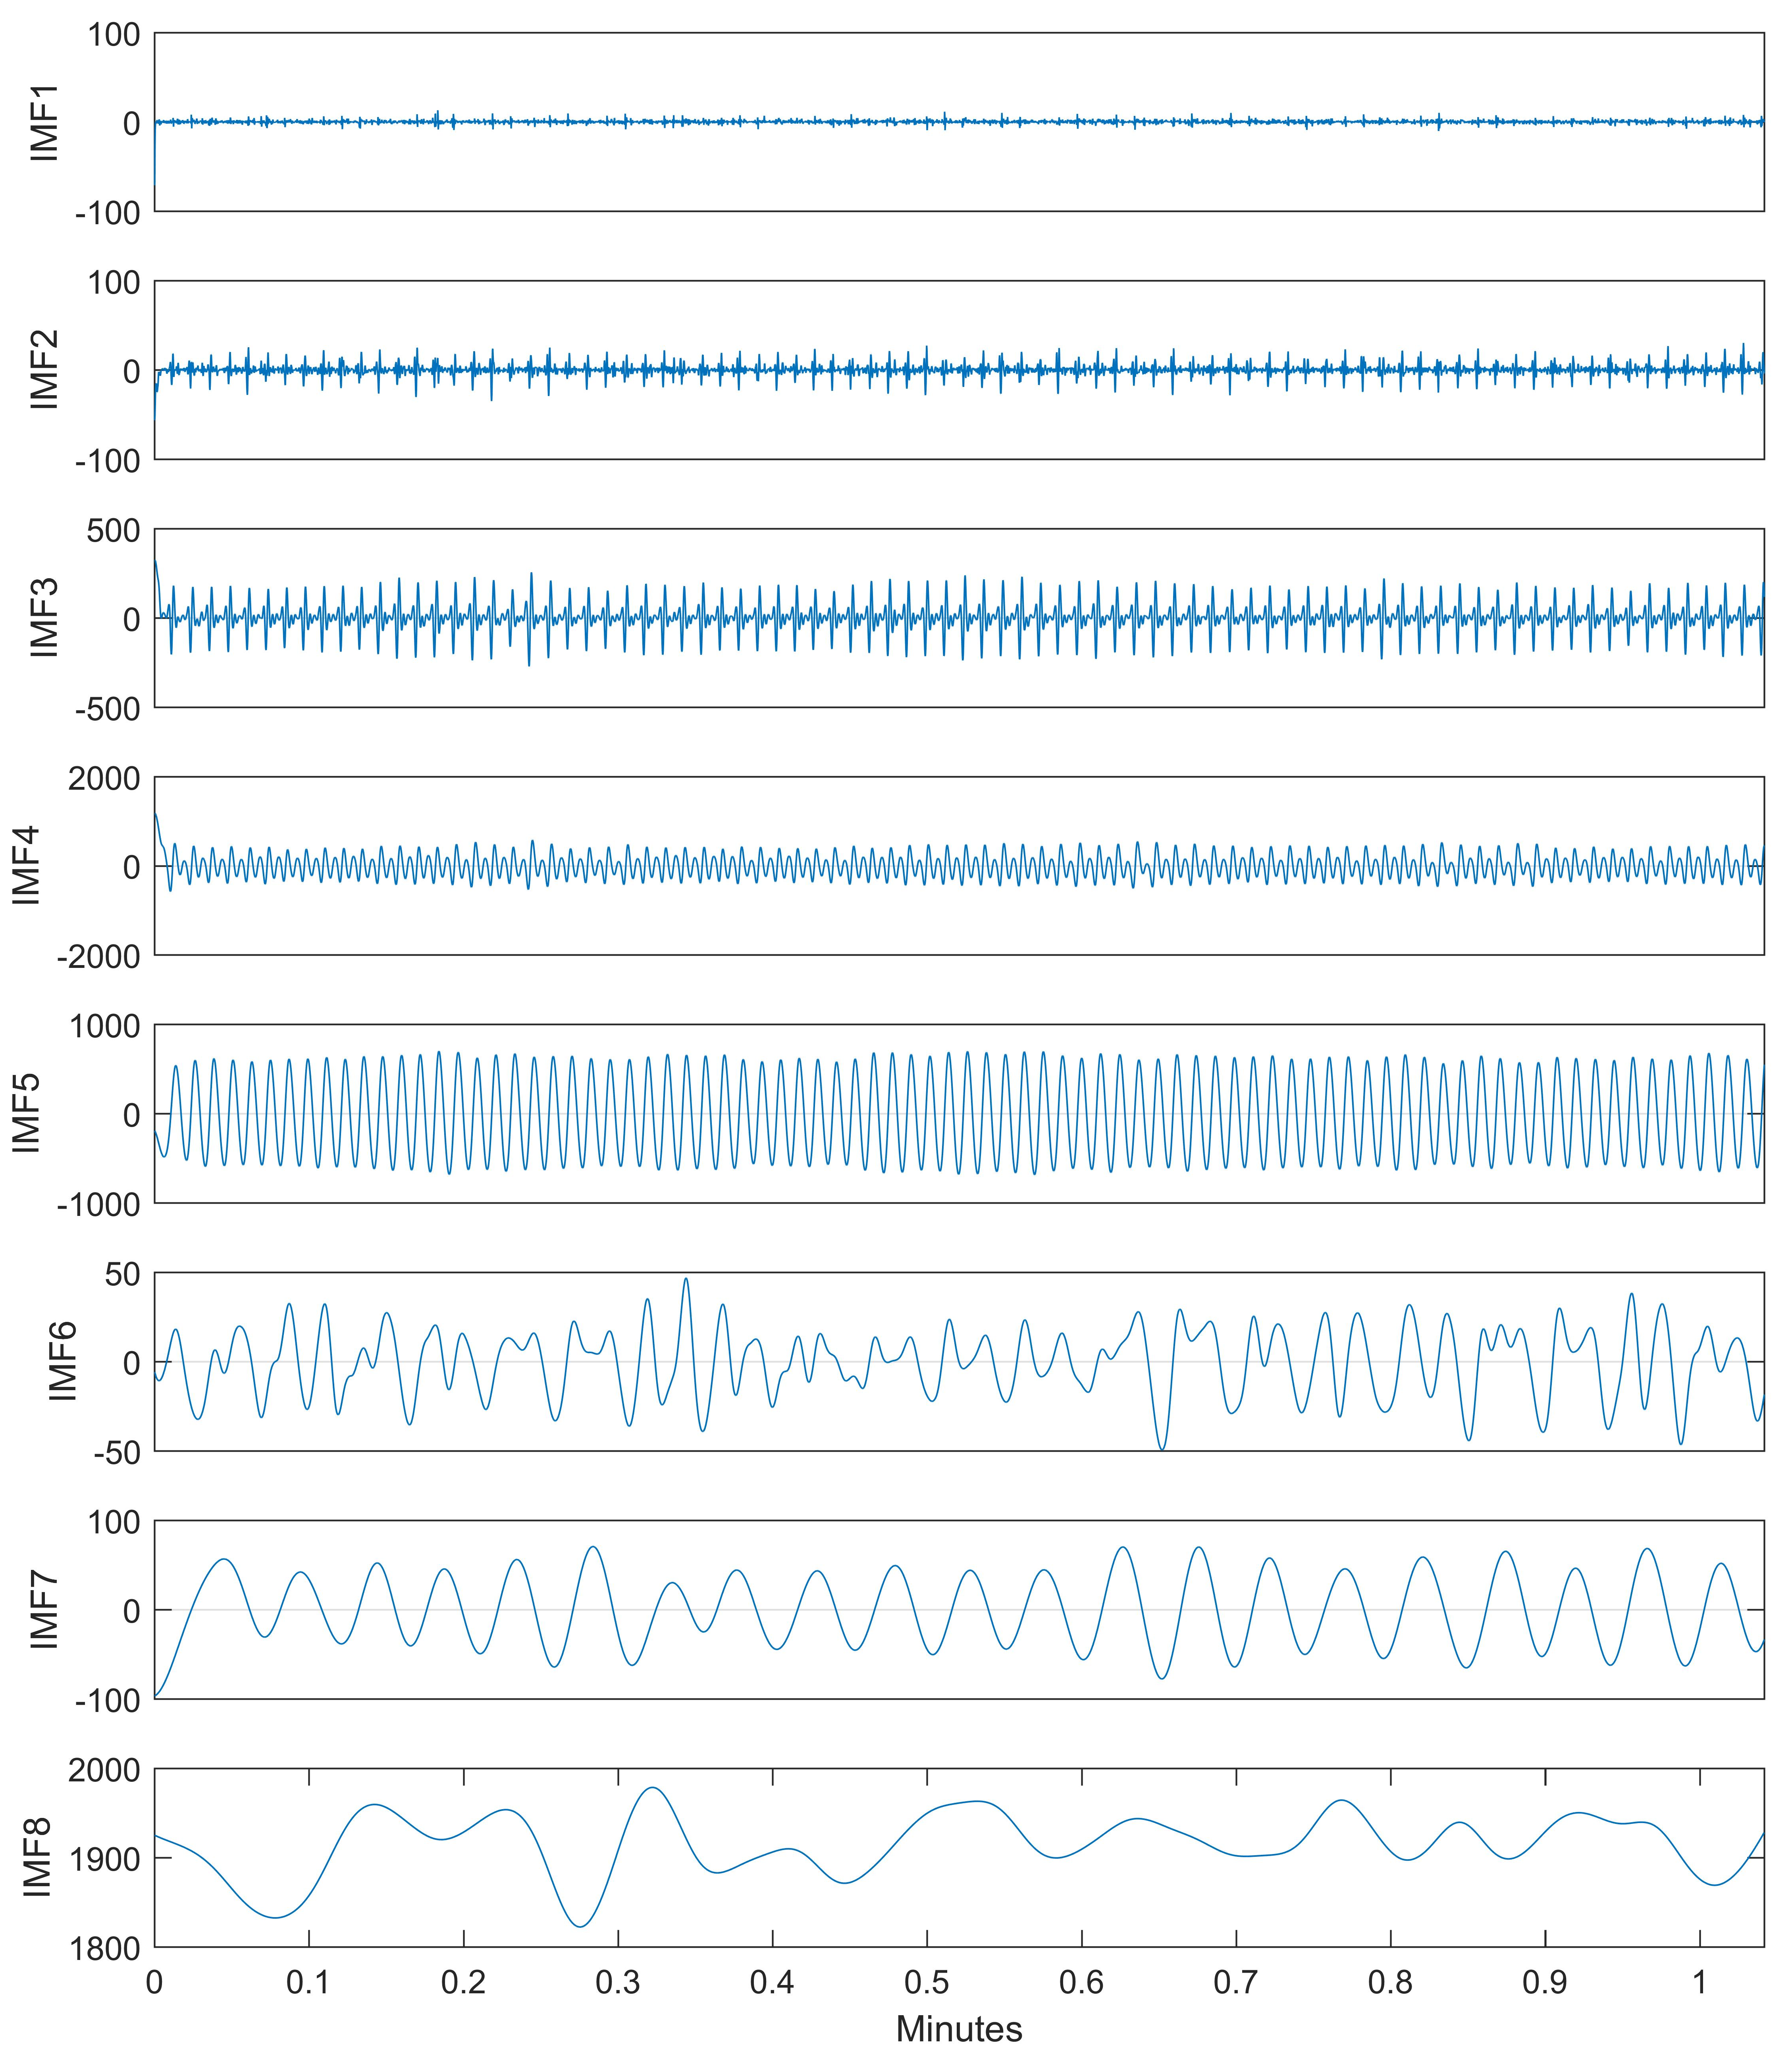
- Short period of PPG IMFs

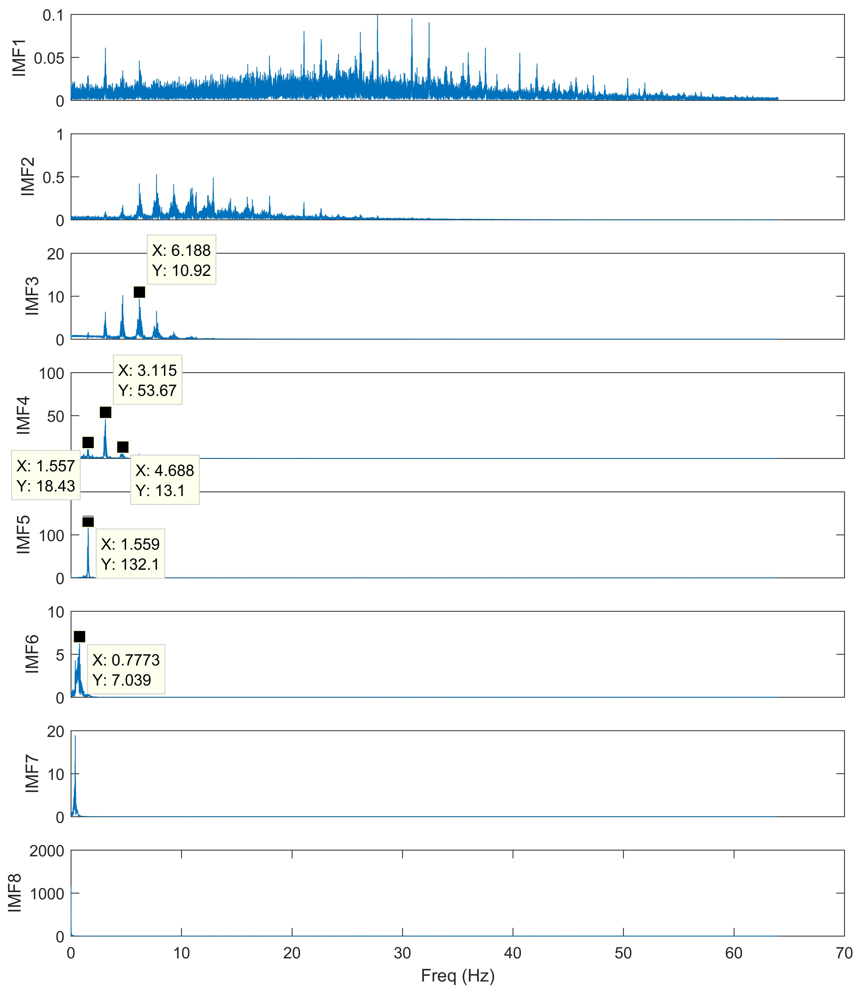
- Short period of PPG IMFs

RESULTS
This study evaluates the performance of the artificial neural networks in predicting the intermittent blood pressure by utilizing the multiscale entropy.
EEMD filter will generate the IMFs and can be seen by Fig. 2. These IMFs separated and started from the highest to lowest frequency. It can be seen by Fig. 3 of the IMF-corresponding frequency. In order to the IMF selection, the FFT algorithm is still applied. By evaluating the frequency of the IMF, it can be seen that the highest dominant peaks, according to the frequency selection ranges, exist for the IMF 4 and IMF 5. The next figures, Figs. 4 and 5, show the time-frequency analysis evaluation of the raw PPG signal and EEMD-filtered PPG. The signal has windowed for each 12 seconds for the calculation of fast Fourier transform (FFT). It can be seen that the EEMD algorithm has purified the higher frequency based signal. In order to make the figures clearer in the frequency evaluation, the frequency based, y-axis is trimmed to scale between zero to fifteen.

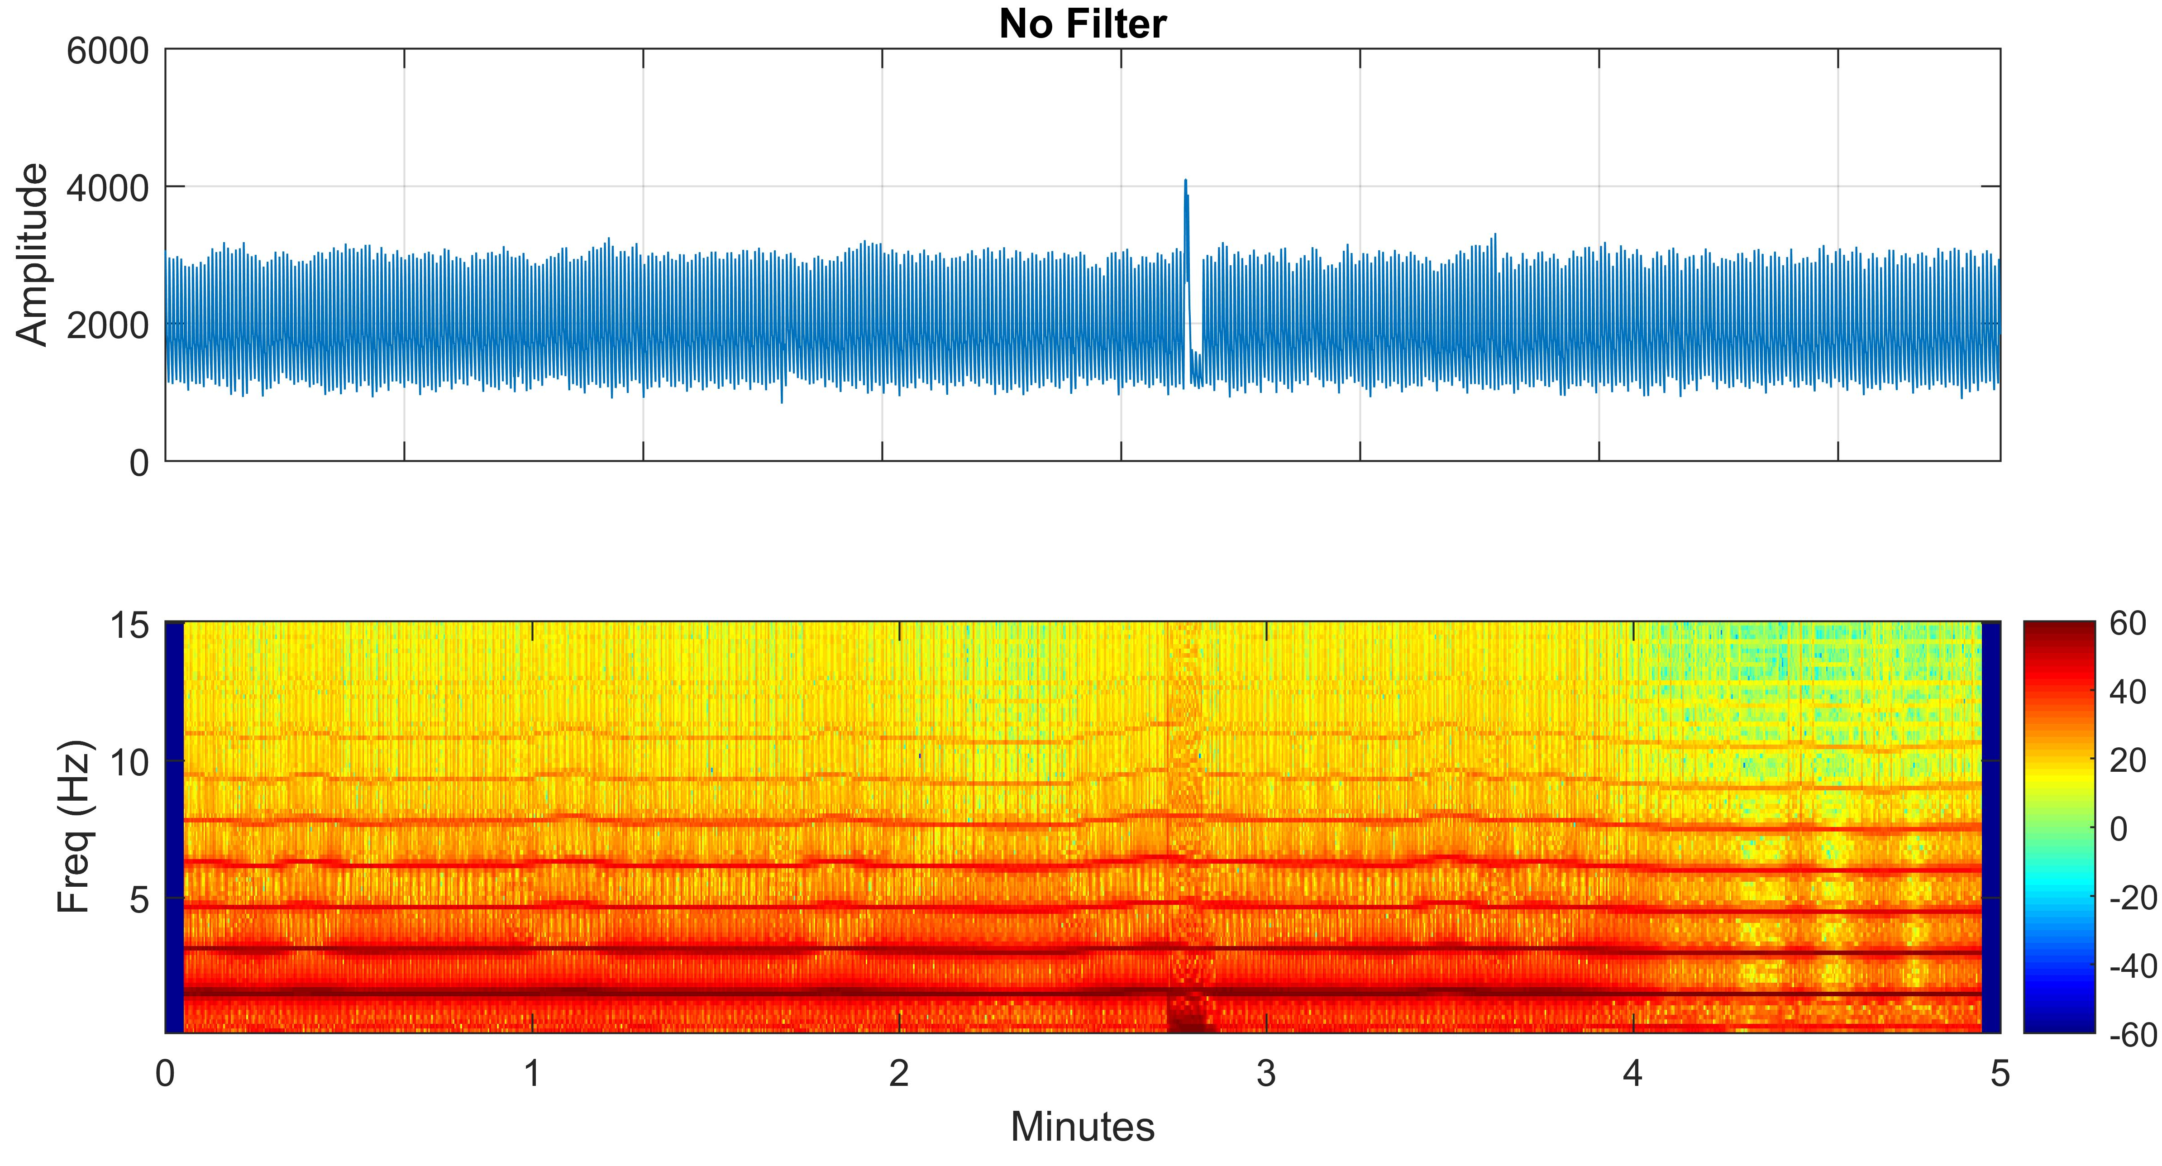
- Raw-PPG signal time-frequency analysis

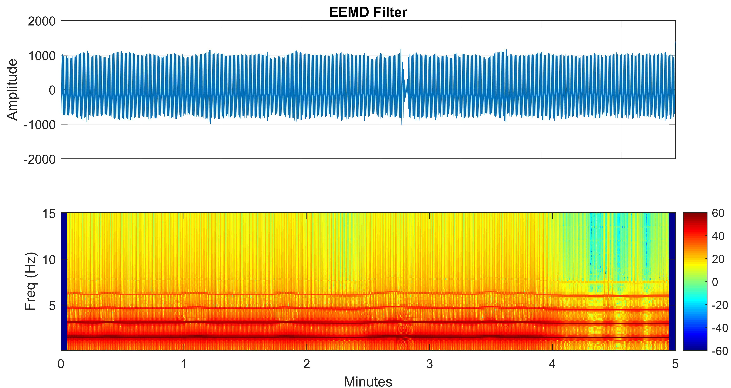
- EEMD-Filtered PPG time-frequency analysis

The models of artificial neural networks are originally trained for several numbers. In our study a thousand of dual-hidden layers, with randomly selected hidden neurons and initial weights are initiated. This method has a purpose to evaluate the correlation between the input variables and those two previously stated parameters. The whole of a thousand model results can be seen in Fig. 6. It can be seen that the slope of the figure close to testing error, meaning that the training models relatively hard to recognize the testing data.

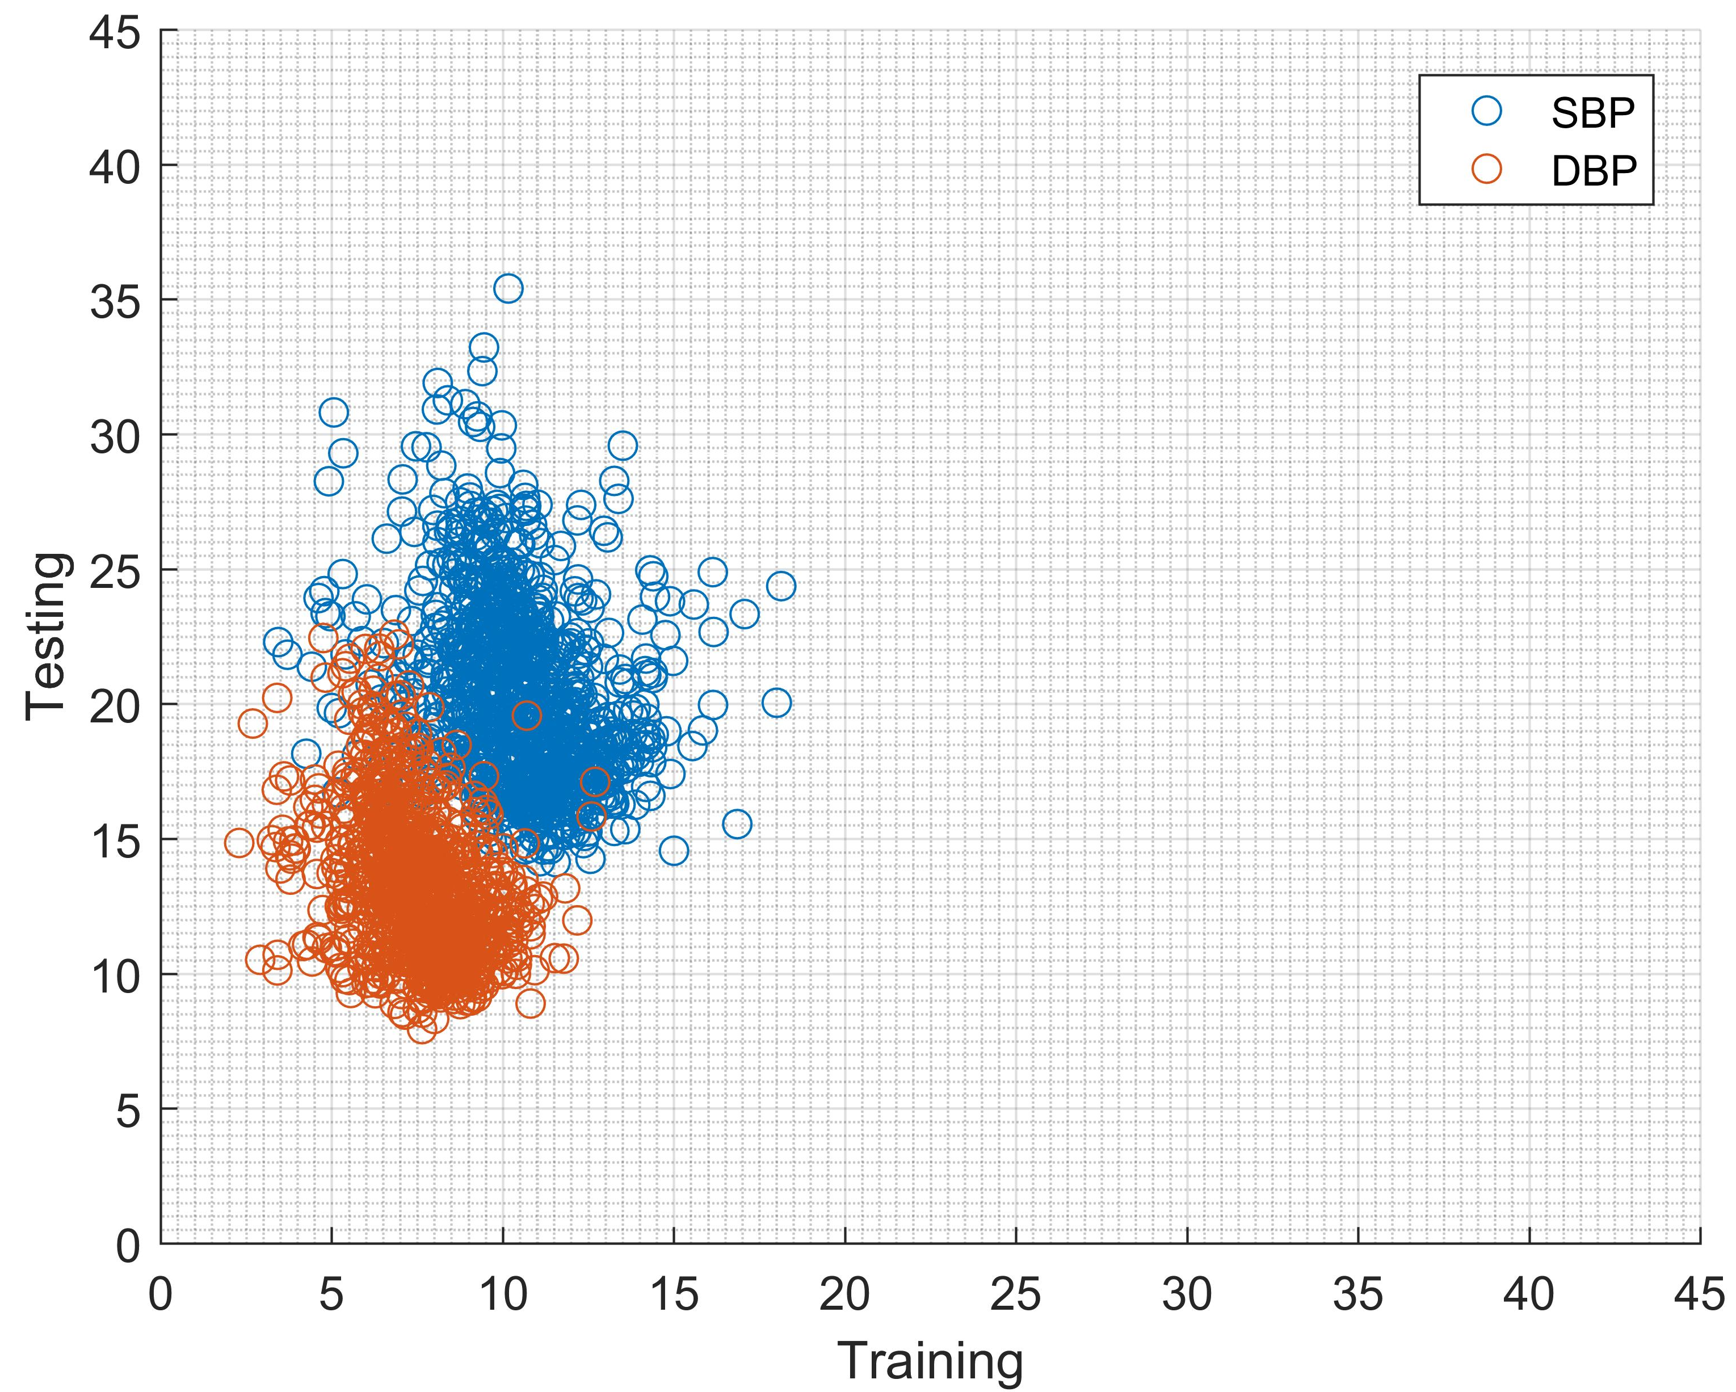
- Modelling result distribution for one-thousand trained models.

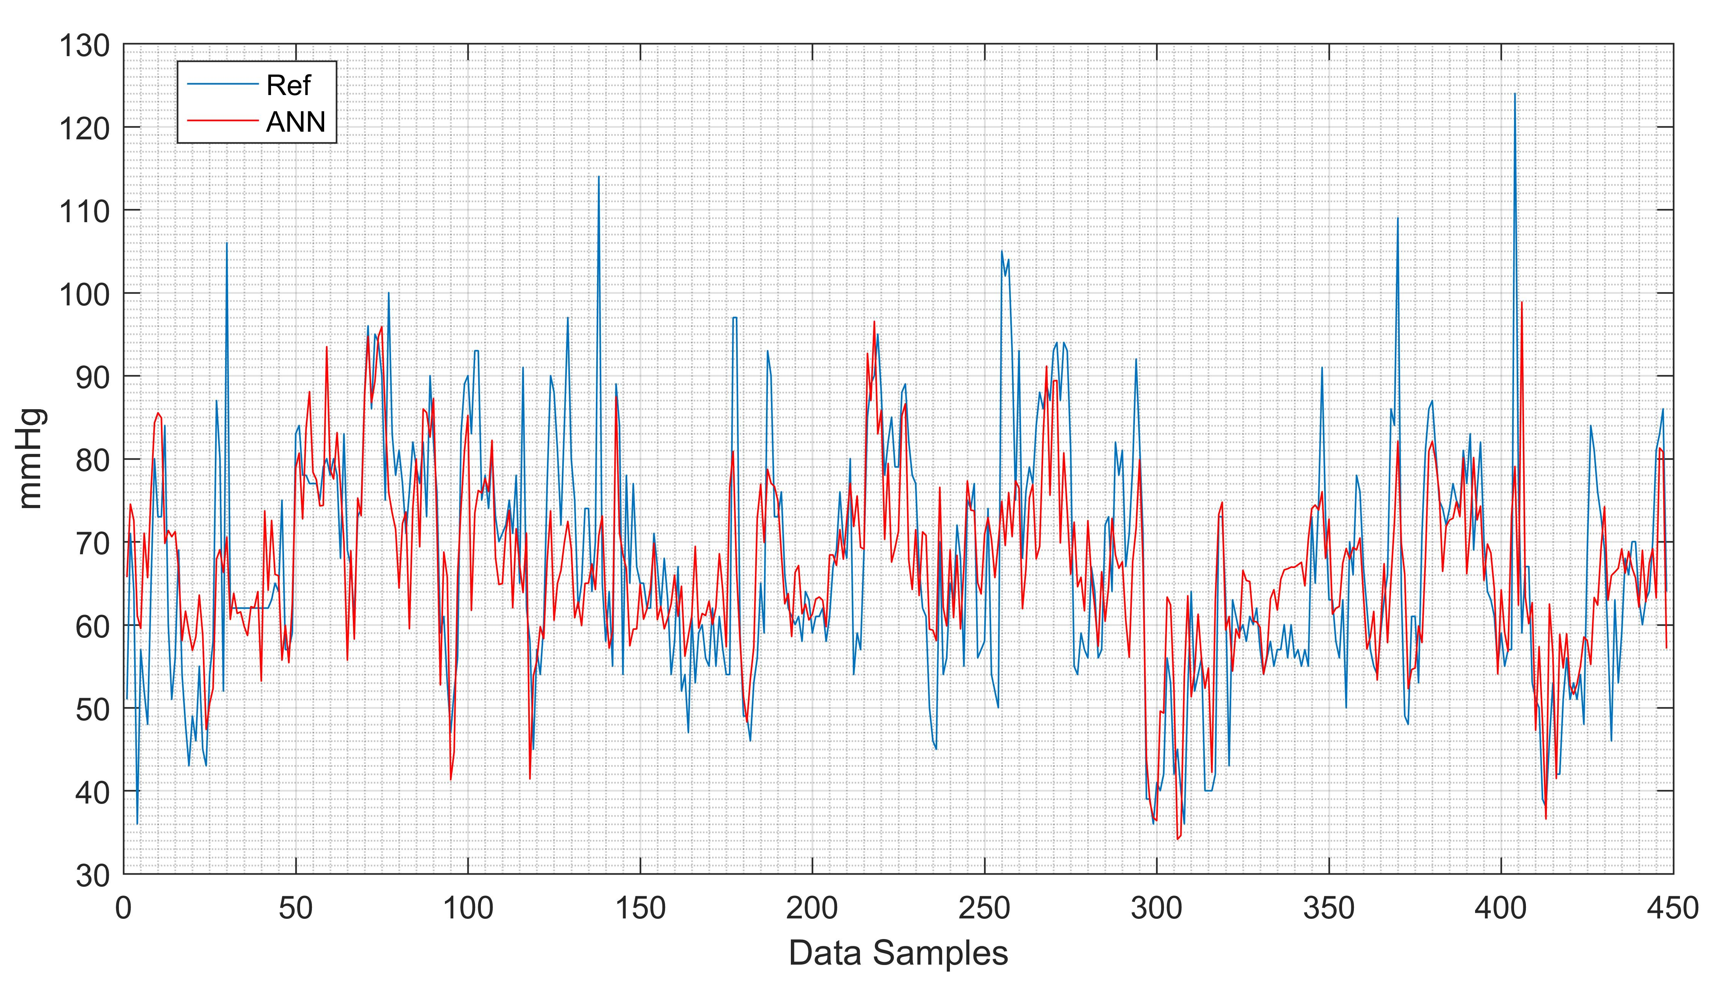
- Diastolic training results.

In order to minimize the error the single best model is evaluated for the diastolic and systolic blood pressure by investigating the mean absolute error (MAE) of the model by averaging both MAE of the diastolic and systolic. The best model creates 7.8 and 11.1 mmHg for training MAE of diastolic and systolic, respectively. The results are shown by Figs. 7 and 8. This best model produces 9.6 and 14.2 mmHg of the testing data respectively for diastolic and systolic blood pressure. The results are shown by Figs. 9 and 10.
After the evaluation of the best neural network model, in order to deal with the generalization of the data, the ensemble model is initiated. This model works based on the consideration of the 5-best model results. This ensemble provides better result by reducing the MAE to 8.3 and 13.6 mmHg respectively for the diastolic and systolic blood pressure. Visual comparison can be seen in Figs. 11 and 12.
This method will increase the robustness of the data due to some testing data are not fit in a single neural network model. This phenomenon may be helpful for the data diversity of training and testing model.

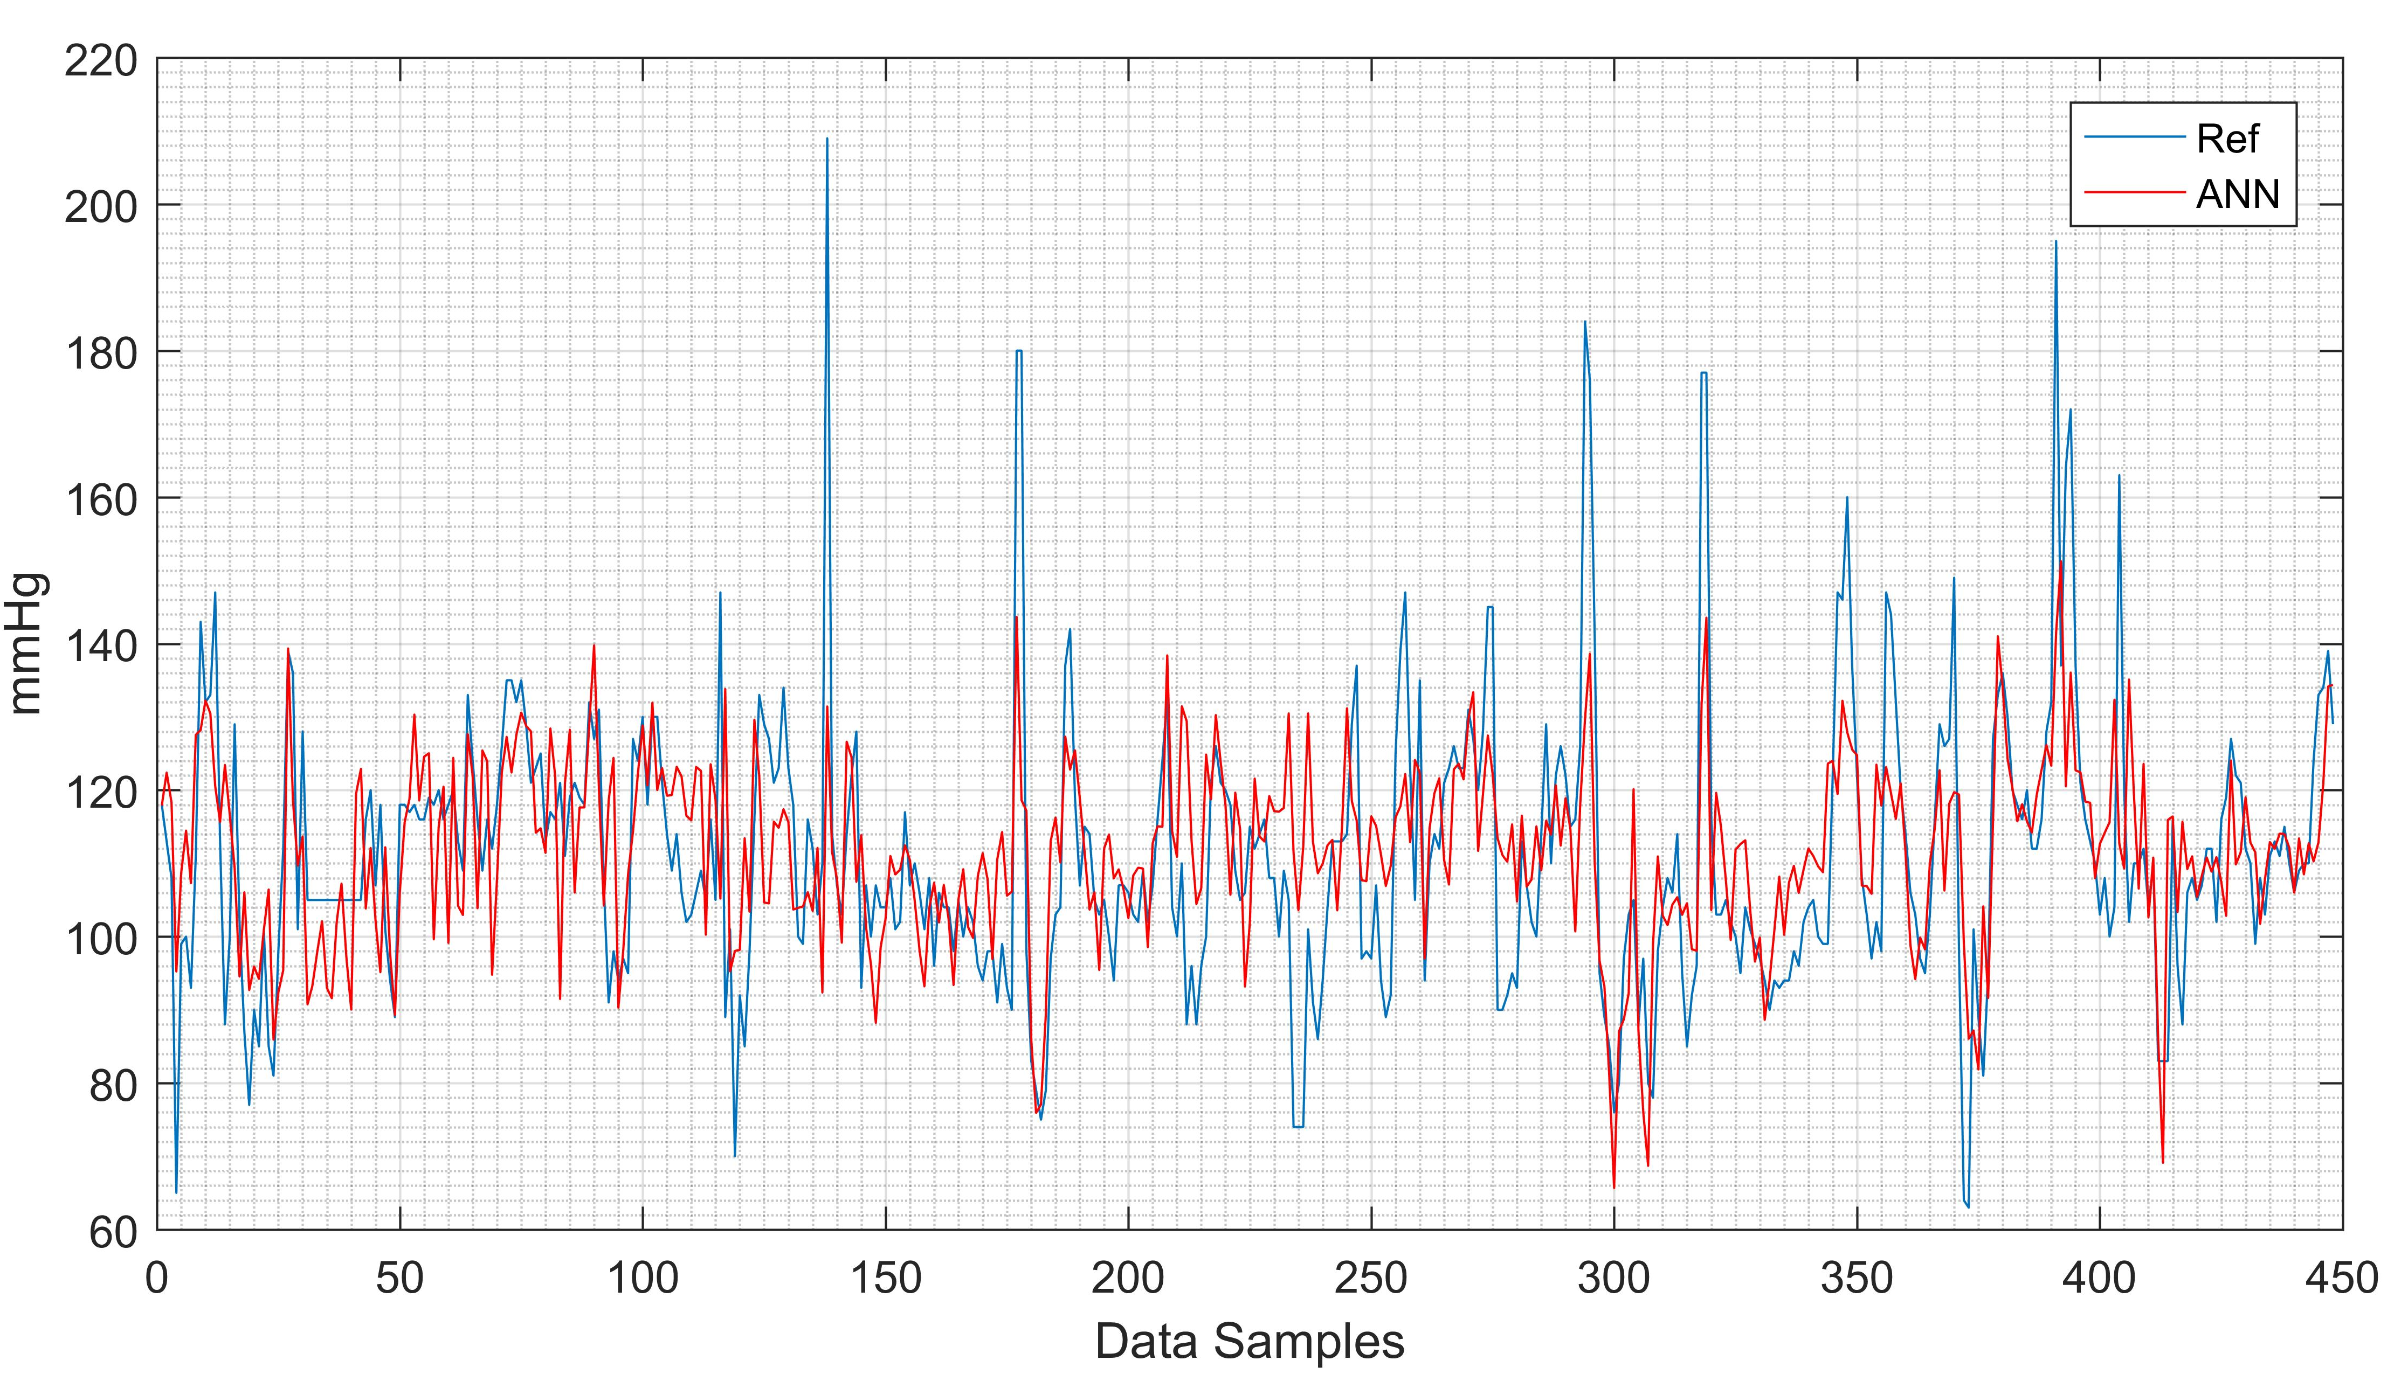
- Systolic training results.

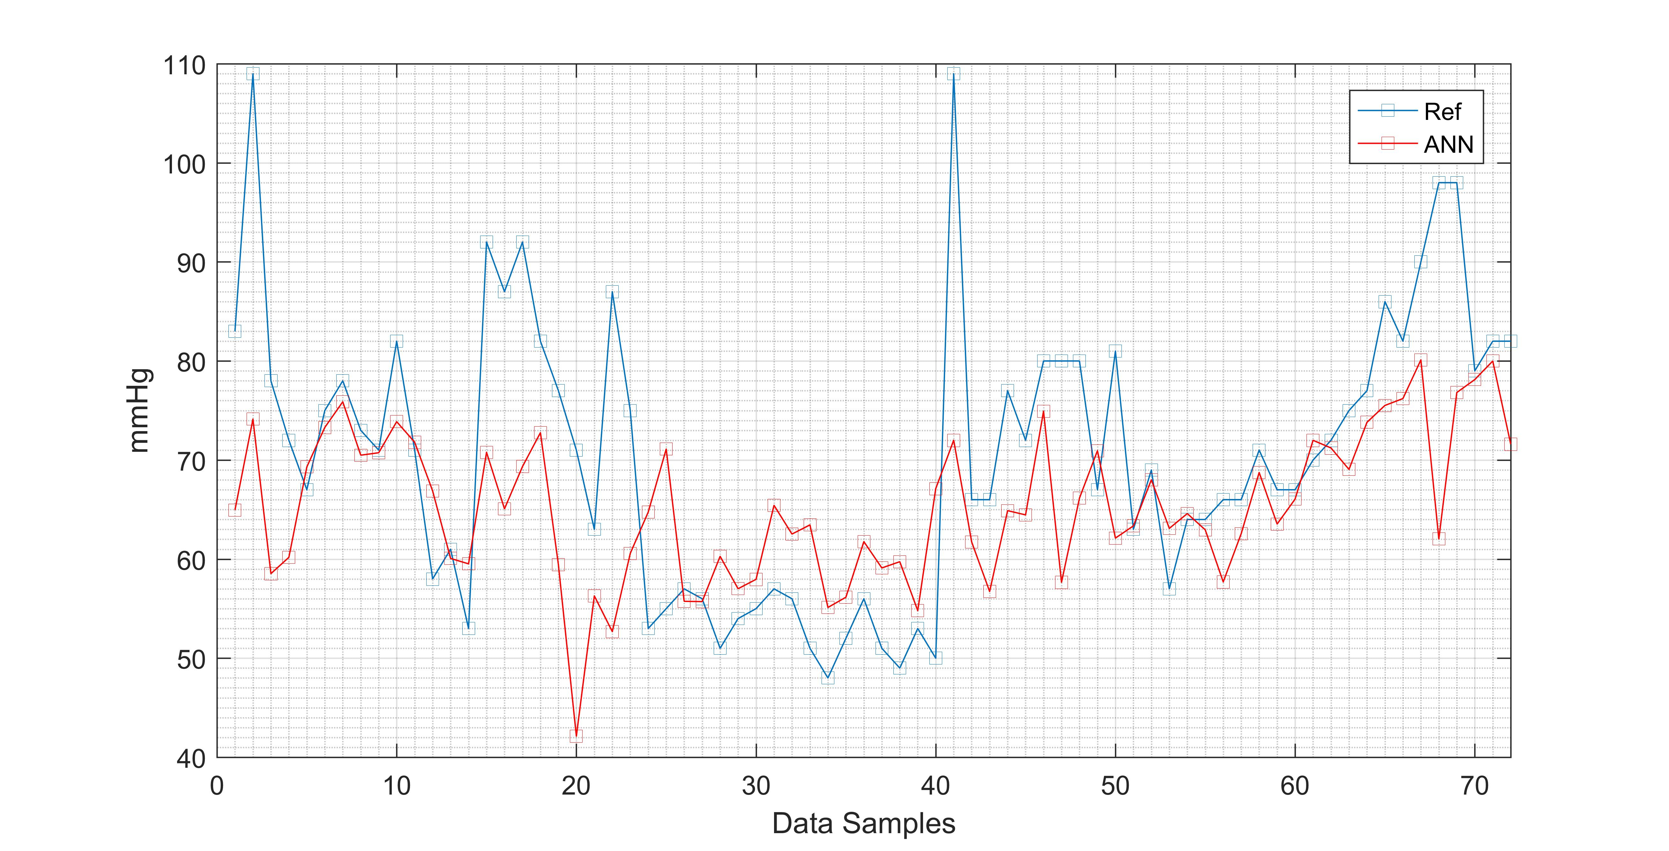
- Best single ANN diastolic testing result

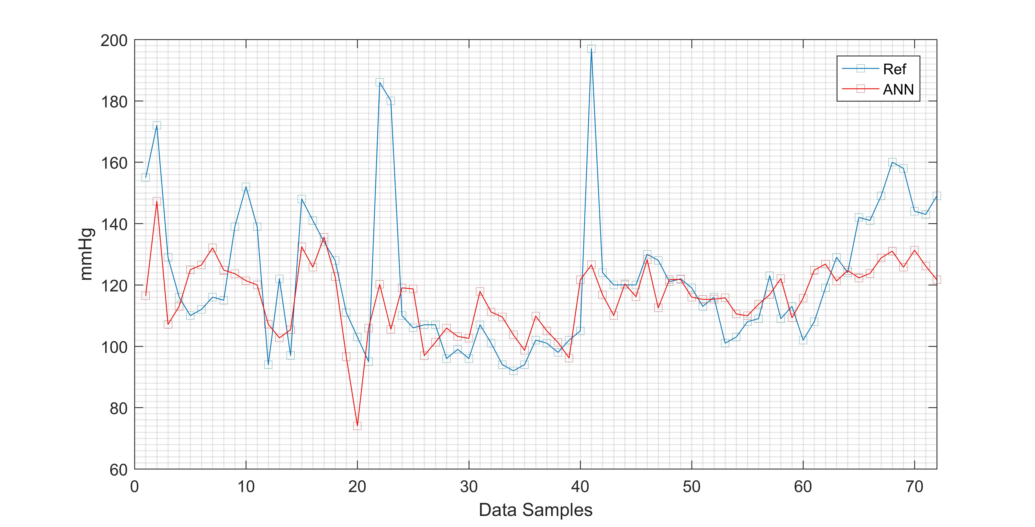
- Best single ANN systolic testing result

CONCLUSIONS
The evaluation of the intermittent blood pressure has been investigated. With the input of the extracted PPG continuous signal by multiscale entropy, the diastolic and systolic blood pressures are predicted. The result shows that the ensemble model produces better result than the single best model of neural networks. The ensemble model may become a better model while facing the diversity of the testing data. This study has limitation in recognizing the sudden big changes in the signal both for training and testing.
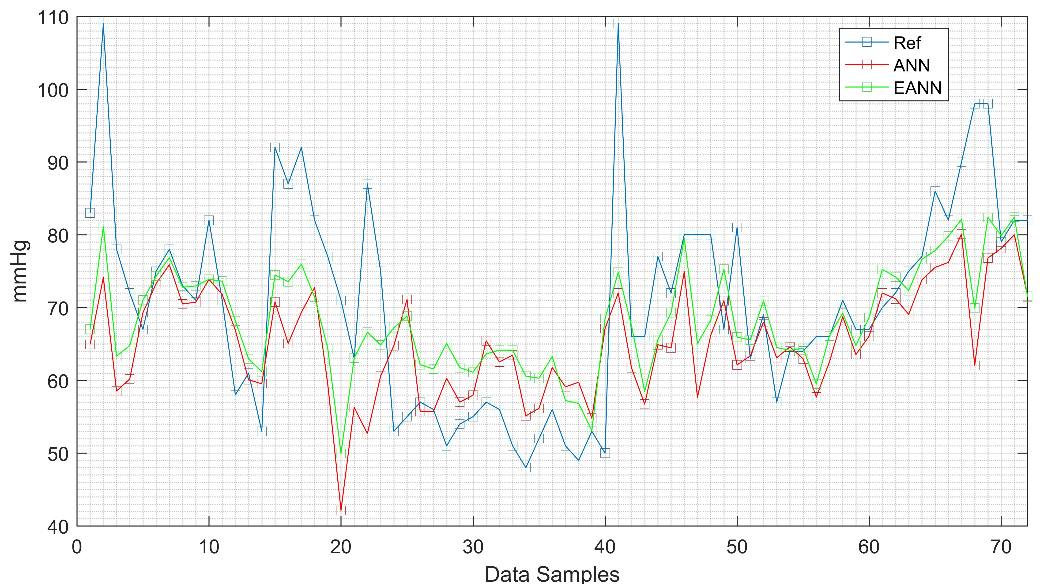
- Ensemble ANN diastolic result

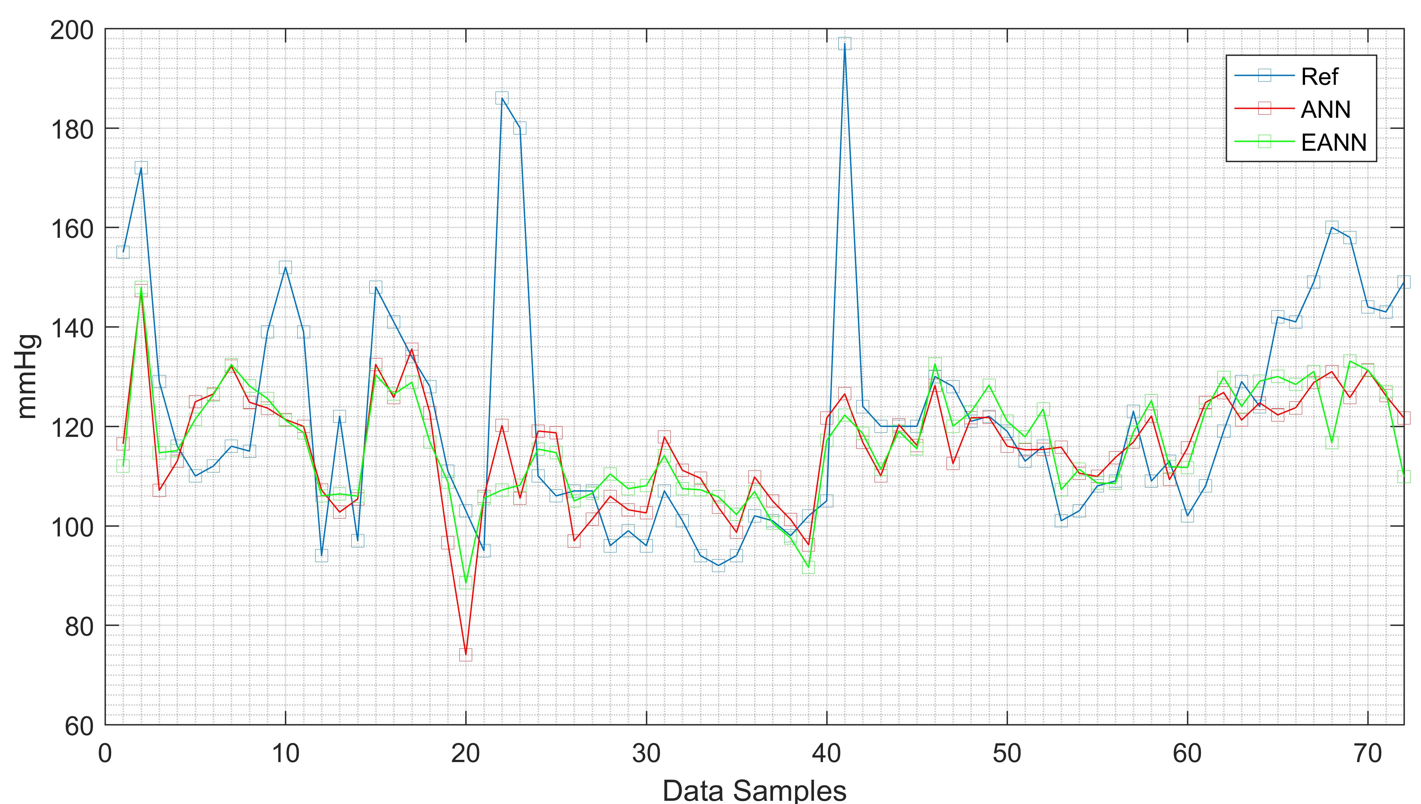
- Ensemble ANN systolic result

References
- G.D. Friedman, D.B. Loveland, S.P. Jr Ehrlich,” Relationship of stroke to other cardiovascular disease,” Circulation, vol. 38, pp. 533-541, 1968.
- J. He and P.K. Whelton, “Epidemiology and prevention of hypertension,” Medical Clinics of North America, vol. 81, pp.1077-1097, 1997
- R.S. Vasan, M.G. Larson, E.P. Leip, J.C. Evans, C.J. O'Donnell, W.B. Kannel, and D. Levy, “Impact of high-normal blood pressure on the risk of cardiovascular disease.,” New England Journal of Medicine, vol. 345, pp. 1291-1297, 2001.
- R. Samria, R. Jain, A. Jha, S. Saini, and S.R. Chowdhury,“Noninvasive cuff'less estimation of blood pressure using Photoplethysmography without electrocardiograph measurement,” Region 10 Symposium, IEEE pp. 254-257, IEEE. 2014
- Y.Z. Yoon, and G.W. Yoon, ”Nonconstrained blood pressure measurement by photoplethysmography,” Journal of the Optical Society of Korea, vol. 10, pp. 91-95, 2006.
- X.F. Teng, and Y.T. Zhang, “Continuous and noninvasive estimation of arterial blood pressure using a photoplethysmographic approach,” Proceedings of the 25th Annual International Conference of the IEEE, vol. 4, pp. 3153-3156, IEEE, 2003 .
- K.W. Chan and Y.T. Zhang, “Adaptive reduction of motion artifact from photoplethysmographic recordings using a variable step-size LMS filter,” Sensors, 2002. Proceedings of IEEE, Vol. 2, pp. 1343-1346, 2002.
- T.L. Rusch, R. Sankar, and J.E. Scharf, “Signal processing methods for pulse oximetry,” Computers in biology and medicine, vol. 26, pp.143-159, 1996.
- C.M. Lee, and Y.T. Zhang, “Reduction of motion artifacts from photoplethysmographic recordings using a wavelet denoising approach,” Biomedical Engineering, 2003. IEEE EMBS Asian-Pacific Conference, pp. 194-195, 2003.
- Y.S. Yan , C.C. Poon, and Y.T. Zhang, “Reduction of motion artifact in pulse oximetry by smoothed pseudo Wigner-Ville distribution,” Journal of NeuroEngineering and Rehabilitation, vol. 2, 2005.
- N.E. Huang, Z. Shen, S.R. Long, M.C. Wu, H.H. Shih, Q. Zheng, N.C. Yen, C.C. Tung, and H.H. Liu, “The empirical mode decomposition and the Hilbert spectrum for nonlinear and non-stationary time series analysis,” Proceedings of the Royal Society of London A: Mathematical, Physical and Engineering Sciences, vol. 454, pp. 903-995, The Royal Society, 1998.
- P. Flandrin, G. Rilling, and P. Goncalves, “Empirical mode decomposition as a filter bank,” IEEE signal processing letters, vol. 11, pp.112-114, 2004.
- M. Blanco-Velasco, B. Weng, and K.E. Barner, “ECG signal denoising and baseline wander correction based on the empirical mode decomposition,” Computers in biology and medicine, vol. 38, pp.1-13, 2008.
- A.O. Andrade, S. Nasuto, P. Kyberd, C.M. Sweeney-Reed, and F.R. Van Kanijn, “EMG signal filtering based on empirical mode decomposition,” Biomedical Signal Processing and Control, vol.1, pp.44-55. 2006.
- J.S. Richman, and J.R. Moorman, “Physiological time-series analysis using approximate entropy and sample entropy” American Journal of Physiology-Heart and Circulatory Physiology, vol. 278, pp.H2039-H2049, 2000.
- M. Costa, A.L. Goldberger, C.K. Peng,” Multiscale entropy to distinguish physiologic and synthetic RR time series,” Comput Cardiol, vol.29, pp. 137–140, 2002.
- M.D. Costa, C.K. Peng, A.L. Goldberger, “Multiscale analysis of heart rate dynamics: entropy and time irreversibility measures,” Cardiovasc Eng, vol. 8, pp.88–93, 2008.
- W.Y. Lu, J.Y. Chen, C.F. Chang, W.C. Weng, W.T. Lee, et al. Multiscale Entropy of Electroencephalogram as a Potential Predictor for the Prognosis of Neonatal Seizures,” PLoS ONE, vol. 10, 2015.
- J.R. Huang, S.Z. Fan, M.F. Abbod, K.K. Jen, J.F. Wu, J.S. Shieh, “Application of Multivariate Empirical Mode Decomposition and Sample Entropy in EEG Signals via Artificial Neural Networks for Interpreting Depth of Anesthesia,” Entropy, vol.15, pp. 3325-3339, 2013.
- M. Sadrawi, S.Z. Fan, M.F. Abbod, K.K. Jen, and J.S. Shieh, “Computational Depth of Anesthesia via Multiple Vital Signs Based on Artificial Neural Networks,” BioMed Research International, vol. 2015, 2015.
- Q. Liu, Y.F. Chen, S.Z. Fan, M. F. Abbod, and J.S. Shieh, “EEG Signals Analysis Using Multiscale Entropy for Depth of Anesthesia Monitoring during Surgery through Artificial Neural Networks,” Computational and Mathematical Methods in Medicine, vol. 2015, 015.
- M.F. Abbod, K.Y. Cheng, X.R. Cui, S.J. Huang, Y.Y. Han, and J.S. Shieh, “Ensembled neural networks for brain death prediction for patients with severe head injury,” Biomedical Signal Processing and Control, vol. 6, pp.414-421, 2011.
- Y.J. Jiang, M.H.M. Ma, W.Z. Sun, K.W. Chang, M.F. Abbod, and J.S Shieh, Ensembled neural networks applied to modeling survival rate for the patients with out-of-hospital cardiac arrest,” Artificial Life and Robotics, vol. 17, pp.241-244, 2012.
- X. Cui, C.W. Lin, M.F. Abbod, Q. Liu, and J.S. Shieh, “Diffuse large B-cell lymphoma classification using linguistic analysis and ensembled artificial neural networks,” Journal of the Taiwan Institute of Chemical Engineers, vol. 43, pp.15-23, 2012.
- MASIMo, Discrete Saturation Transform, Signal Extraction Technology of MASIMo Co., Technical Bulletin 1, 2001.
- J. J. Carr and J. M. Brown, Introduction to Biomedical Equipment Technology, Prentice Hall, Upper Saddle River, NJ, USA, 1998.

