Renewable Energy Resource Self-Intervention Control Technique using Simulink/Stateflow Modeling

Ranjit Singh Sarban Singh  Department of Electronic and Computer Engineering,  Brunel University London,  Uxbridge, UB8 9PH, United Kingdom  R.Singh@brunel.ac.uk | Maysam Abbod  Department of Electronic and Computer Engineering,  Brunel University London,  Uxbridge, UB8 9PH, United Kingdom  Maysam.Abbod@brunel.ac.uk | Wamadeva Balachandran  Department of Electronic and Computer Engineering,  Brunel University London,  Uxbridge, UB8 9PH, United Kingdom  Wamadeva.Balachandran@brunel.ac.uk

Abstract- Hybrid Renewable Energy Complementary Systems are gaining popularity as electricity power generation system. The Hybrid Renewable Energy Complementary Systems introductory was to overcome the intermittency during the energy harvesting process. Therefore, solar photovoltaic and wind turbine generator has been seen as one of the most promising Hybrid Renewable Energy Complementary System to overcome the intermittency compare to a typical Hybrid Renewable Energy System. The integration of solar photovoltaic and wind turbine generator as Hybrid Renewable Energy Complementary System can play an important role to reduce the dependency on the fossil fuel for electricity power generation and are seen as a solution to improve the shortage of electricity due to increasing demand. Thus, the advantages of Hybrid Renewable Energy Complementary Systems have gained attention from many researchers around the world. Research to improve the complexity complementary system performance is necessary to achieve well design control and autonomous system operation and systematic energy management in the system. With that, this paper presents a new voltage-divider balancing switching technique to control the self-intervention switching for the Hybrid Renewable Energy Complementary System. The self-intervention control strategy of the Hybrid Renewable Energy Complementary System is coordinated using the Simulink/Stateflow process. The Simulink/Stateflow modelling performs under different preset conditions which are based on the analogue voltage reading from the input of the Hybrid Renewable Energy Complementary System resources. Simulation results demonstrate the validity of the proposed research to control the self-intervention of the Hybrid Renewable Energy Complementary System under the preset conditions.

Index Terms--Solar Photovoltaic, Wind Energy, Self-Intervention Control, Simulink/Stateflow Design, Complementary System.
- Introduction
With the growing requirement for energy demand and depletion of fossil fuel to produce sufficient amount of energy is causing shortage of resources. The energy demand is increasing as the world’s population growth is increasing and the mankind is facing the difficulty to prevent the resources from depleting. Today over 65% of the world’s electricity is produced using the steam turbine generators by burning the fossil fuel as their source of energy to produce electricity. The fossil fuelled plants use either the coal (60%), gas (30%) and oil (10%) to produce the designated amount of electricity using the steam generator [1]. These are all the non-renewable sources whose resources will be largely exhausted within two or three centuries [2]. While the fossil fuel is being used to produce the energy, it also has been looked as principle cause to the carbon dioxide (CO₂) emission sources. Meanwhile, fossil fuel depletion has been discovered as the main challenge in the future. Although fossil fuels are still the main source to produce the electricity energy in most countries, renewable energy makes it as an alternative. A way to avoid the exhaustion of the fossil fuels, exploration or continuity to further develop and enhance the renewable energy harvesting and storing concept. Renewable energy sources such as sun, wind and water has been learnt as no shortage supply of energy. Continuous research on renewable energy has provided reasonable affordability to most of the consumers today compare to 25 years ago. Apparently, the cost of renewable energy such as wind energy has reduced to 5 cents from 40 cents per kilowatt-hour, cost of electricity harvested through photovoltaic’s has declined to 20 cents per kilowatt-hour from USD1 kilowatt-hour during the 1980s. In [3] is mentioned that the renewable energy is getting more attention now compare to it was in 20th century where many fossil fuelled powered plants are being shut down. It also shows that the used of coal have fallen by 24.9% in 2012, this is in favour of the renewable energy fast development especially the solar photovoltaic and wind energy. Solar photovoltaic and wind energy are said to be the world’s fastest growing renewable energy source. This is expected to continue with the continuity of research in these areas to further reduce the cost of the technology. Regardless of the types of the research and development, it can be fundamental, experimental or design and development, it must contribute to improve the performance and reduce the energy cost. As researchers tends to continue to improve the solar photovoltaic and wind energy in all the areas, research on the energy management or self-intervention or complementary system with renewable energy is not relatively developed [4], [5], [6], [7], [8], [10], [11], [12], [13], [14]. Since 2001 or before, complementary renewable energy resources system have been discussed but least relevant studied have been conducted. Typically, complementary system consists of solar photovoltaic unit, wind unit, hybrid charge controller unit, battery unit, inverters and monitoring system [8]. These systems are usually has no evaluation on the impact of the load as well as on the power output. These types of systems have an unintelligent structure to be linked with the grid network. One of the characteristics that is lacking is the self-intervention and adaptability when a complementary system is design and developed. Hence, the reliability on the battery storage system increases and the overall system is reliance on the battery storage system. In [8], the most recent studies using fuzzy logic based control was proposed to achieve an automatic balance between the supply and the demand electric energy based on the load requirements. In this research the author mentioned that some technical issues related to the solar photovoltaic – wind power system have been resolved but issue relating controlling the loading and unloading process in terms of solar photovoltaic – wind power system corresponding is still lacking [8]. The simulated and designed model uses the load as a measurement to control the self-intervention for complementing the hybrid system. In [9], two level fuzzy logic control system was proposed. The two-level technique also eliminates the requirement of Maximum Power Point Tracking (MPPT). This research proposed a complementary energy system based or according to the weather variations, load demand and State-of-Charge. It uses the fuzzy IF-THEN rules to control the energy complementary system. Studies shows mostly complementary systems are developed using the fuzzy logic control theory.

- Proposed Hybrid Renewable Energy System Configuration
A voltage divider switching configuration is proposed for self-intervention and complementary HRES system. Energy conversion from different renewable energy resources, especially from solar photovoltaic and wind turbine generator with suitable control system would make best use of their operating characteristics to achieve efficiency higher than a single renewable energy source. Figure 1 shows a solar photovoltaic-wind energy complementary system, the voltage divider circuits are elements to perform the self-intervention on the proposed HRES system. Besides that, analogue-to-digital (ADC) and a designated 12/9/6 volt master controller is integrated together to control the self-intervention.
- Voltage Divider Switching Circuitry
The voltage divider switching circuitries are connected to the solar photovoltaic and wind turbine generator sources. The voltage divider circuits are used to measure the analogue voltage values generated from the solar photovoltaic and wind turbine generator sources. Prior to that, the solar photovoltaic and wind turbine generator sources are connected to the input of the hybrid charge controller while the analogue voltage outputs are connected to the voltage divider circuitries. Analogue voltage outputs are measured and converted into digital values to perform the self-intervention for renewable energy system complementary. The 12/9/6 volt master controller will receive the digital voltage value and decision will be made based on the hierarchical sequential approach presented in figures 4 and 5. Therefore, the voltage divider circuitries concept and operation is explained in the following section.

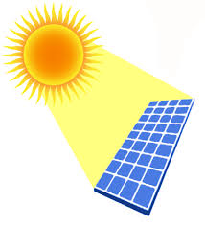
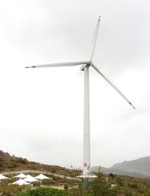
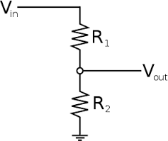
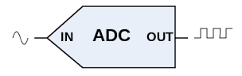
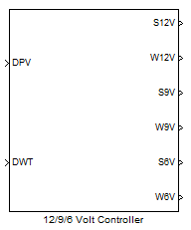
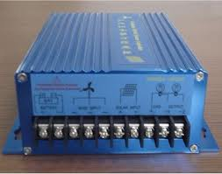
Voltage Divider A
Voltage Divider B
To LOAD Switching
Fig. 1. Proposed voltage divider switching configuration for self-intervention and complementary HRES system.

Solar
Wind

If Solar Photovoltaic = 14 volt (V_{in}) Analogue
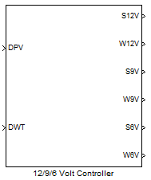
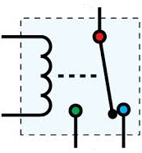
ADC’s Input RES
Load
Switching
Battery Storage
Systems
12/9 volts Inputs
6 volts Input
Fig. 2. Self-Intervention control switching using Sstateflow/ Ssimulink.

R₁ = 9.0KΩ
R₂ = 1.5KΩ

12 volt (Maximum)

Analogue to Digital Conversion

12 volt
1100 1101 1001

The respective voltage divider circuitry measures the maximum and minimum amount of voltage from the renewable energy resources which is to be supplied to the connected load. Hence, the voltage divider would allow the 12/9/6 volt master controller to operate and switch between 12/9 volt and 6 volt. With that, the 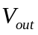from both solar photovoltaic source and wind turbine generator source will be measured repetitively in order to achieve the hierarchical sequential switching of the self-intervention control. Therefore, the detailed operation of the self-intervention among both the solar photovoltaic and wind turbine generator complementary system is explained in figures 4 and 5.
- Hierarchical Self-Intervention System
In order to perform the self-intervention on the complementary solar photovoltaic and wind turbine generator power system, Simulink/Stateflow control configuration is implemented to digitally measure and act as an interface between the complementary power systems input and the switching relay. Figure 2 shows 12/9/6 volt master controller system design using the Simulink/Stateflow configuration. The master controller manages the digital voltages measured from the solar photovoltaic and wind turbine generator sources. The master control system consists of 12/9 volt primary controller and 6 volt secondary controller. The 12/9/6 volt master controller also is integrated with the ADCs via the voltage divider circuits and switching relays to control the switching between the solar photovoltaic and wind turbine generator input voltages. The 12/9/6 volt master controller is divided into two controlling sections as depicted in figures 3 and 4. Figure 3 explains the hierarchical sequential switching method between 12 volt and 9 volt input from the solar photovoltaic and wind turbine generator. The power generated from the 12 volt and 9 volt inputs can be directly used to meet the load demand or during the off-demand the power generated can be directed to the battery storage systems. The hierarchical sequential switching steps are illustrated in figure 3 explains solar photovoltaic is preset as the first default power generation source when its voltage is more than or equal to 9 volt or else larger than the generated wind turbine generator source.

Figure 3 explains the hierarchical sequential switching condition between the solar photovoltaic and wind turbine generator based on their respective amount of input voltage. As shown in figure 3, at the initial state the primary controller will always measure the solar photovoltaic input voltage. The primary controller is divided into FIVE hierarchical sequential switching conditions and each condition which will be further explained in the following section.

YES
A
START
Solar ≥ 9 Volt?
Wind ≥ 9 Volt?
Solar ≥ 6 Volt?
Wind ≥ 6 Volt?
Solar & Wind ≥ 6 Volt?

Fig. 3. 12/9 volt switching method.
B
NO
NO
NO
NO
NO
YES
YES
YES
YES
To LOAD

Condition 1: Initially, if the solar photovoltaic source input voltage is more or equal to 9 volt compared with the wind turbine generator source, then the relay connected to S12V will be triggered from Normally Closed (NC) to Normally Open (NO). This will allow the 9 - 12 volt to start flowing directly from the solar photovoltaic source to the connected load such as via the DC to AC inverter to the load application.
Condition 2: Next, if the solar photovoltaic source input voltage is less than the wind turbine generator source, then the primary controller will measure the voltage from the wind turbine generator source. If the wind turbine generator source input voltage is more or equal to 9 volt compared with the solar photovoltaic source, then the relay connected to the W12V will be triggered from NC to NO. This will allow the 9 – 12 volt to start flowing directly from the wind turbine generator source to the connected load such as via the DC to AC inverter to the load application.
Condition 3: In this condition the solar photovoltaic source supply is usually measured at 6 – 9 volt. When both the S12V and W12V are at LOW condition the primary controller will switch to S9V. The S9V condition is switched when the solar photovoltaic source supply is more or equal to 6 volts and less than 9 volt. During this condition, the wind turbine generator voltage source supply is less than the solar photovoltaic source voltage supply. Therefore, the relay will be triggered from NC to NO and 6 – 8.99 volt will start flowing directly to the connected load.
Condition 4: When the wind turbine generator source supply is producing 6 – 8.99 volt, the solar photovoltaic source supply is producing less input voltage compare with the wind turbine generator source supply. The W9V will be triggered HIGH and the relay switch is triggered from NC to NO and 6 – 8.99 volt will flow directly to the connected load.
Condition 5: This condition will only occur when all the FOUR conditions are no longer in ACTIVE MODE. Therefore, the primary controller will search for any available input voltage source from either solar photovoltaic or wind turbine generator resources. If there is not any 6 – 12 volt from any of the resources then the primary controller will switch to 0 - 6 volt secondary controller. During this moment, the S12V, W12V, S9V and W9V are in INACTIVE MODE and neither of the voltage supply resources are supply any input voltage to the connected load.
Figure 4 will explain about the secondary controller hierarchical sequential switching between the solar photovoltaic source supply and wind turbine generator source supply at 0 – 5.99 volt. The hierarchical sequential switching shown in figure 4 is a continuity process from figure 3. The secondary controller performs the hierarchical sequential switching for the battery storage systems. The secondary controller is divided into FOUR hierarchical sequential conditions and each condition will be explained in the next section.
Condition 1: Initially, the secondary controller will always determine the preset solar photovoltaic source supply as the main voltage supply. If the solar photovoltaic source produces an input voltage from 3 – 5.99 volt, then the S6V will be switched to HIGH condition and the relay will be triggered from NC to NO. Therefore, the 3 – 5.99 volt input voltage from the solar photovoltaic source cannot be used for DC to AC conversion but instead is connected to charge the battery storage system.
Condition 2: Next, if the solar photovoltaic source input voltage is less than the wind turbine generator, then the secondary controller will measure voltage from the wind turbine generator source. If the wind turbine generator source input voltage is between 3 – 5.99 volt and the solar photovoltaic source is less than the wind turbine generator source, then the W6V will be switched to HIGH condition and the relay will be triggered from NC to NO. This voltage also is insufficient to be supplied to the load but instead is connected to charge the battery storage system.

Fig. 4. 6 volt switching method.
To Battery Storage System
NO
NO
YES
YES
YES
YES
NO
NO
A
B
3 ≤ Solar < 6 volt?
3 ≤ Wind < 6 volt?
Solar < 3 volt?
Wind < 3 volt?

Conditions 3 and 4: These TWO conditions are to inform the primary and secondary controllers about the LOW voltage output from both of the connected resources. Hence, during these conditions the primary and secondary controllers are placed under standby mode.

- Results and Discussion
- Primary Controller Outputs
Table I shows the self-intervention of the HRES switching simulation results based on the FOUR preset conditions of the primary controller and FOUR preset conditions of the secondary controller using the Simulink/Stateflow modelling. Based on the Table I, the solar photovoltaic source (DPV) is always preferred as a primary source during the system start-up. The wind turbine generator source (DWT) is always preferred as secondary. In the case when both of the resources are in the intermittent condition then the primary controller and secondary controller will determine which source is available to be supplied to the connected load. Hence, based on the preset conditions provided in Table I further describe the result of the self-intervention of the HRES and present graph for each condition is chronologically. Figures 5 – 8 demonstrate the self-intervention solar to wind and wind to solar based on the FOUR conditions provided in Table I using the MATLAB Simulink/Stateflow modelling simulation. This simulation is executed for 10 seconds to demonstrate the self-intervention for the available resources. Figure 5 shows 12 volt solar photovoltaic is switched to 12 volt wind turbine at time 5.05 seconds when the solar photovoltaic voltage is at 8.925 volt and vice versa for figure 6. Figure 7 shows the 9 volt solar photovoltaic is switched to 9 volt wind turbine at time 6 seconds when the solar photovoltaic is at 5.875 volt and vice versa for figure 8.

- Secondary Controller Outputs
Table II shows the self-intervention of the secondary controller when only 6 volt source is available from both of the resources. This condition will occur only when neither resource are able to supply voltage more than 6 volt. This condition is known as worst case condition for any of the HRES system and usually the 6 volt is insufficient to be supplied to the connected load. However, if the available 6 volt can be used to charge the battery storage system which will also help to top-up the battery storage charges and energy. Hence, based on the preset conditions provided in Table II further self-intervention of HRES simulation results are discussed and graphs are presented for each conditions described in the table. Figures 9 and 10 demonstrate the self-intervention solar to wind and wind to solar based on the TWO conditions provided in Table II using the MATLAB Simulink/Stateflow modelling simulation. This simulation is executed for 10 seconds to demonstrate the self-intervention for the available resources. Figure 9 shows 6 volt solar photovoltaic is switched to 6 volt wind turbine at time 6 seconds when the solar photovoltaic voltage is at 2 volt and vice versa for figure 10.

TABLE I
Primary Controller Results of Self-Intervention Hierarchical Sequential Switching for HRES Using Simulink/Stateflow Modelling
Resources | Conditions | Output Voltage | Results (Relay Switching)
Resources | Conditions | Output Voltage | DPV | DWT | DPV | DWT
Solar Photovoltaic (DPV) | 9 <=DPV<= 12, DWT<9 | DPV = 9-12 Volt, DWT = 8.9 Volt | 1 | 0 | 0 | 0
Wind Turbine Generator (DWT) | 9 <=DWT<= 12, DPV<9 | DWT = 9-12 Volt, DPV = 8 Volt | 0 | 1 | 0 | 0
Solar Photovoltaic (DPV) | 6 <=DPV<= 9, DWT<6 | DPV = 6-9 Volt, DWT = 5 Volt | 0 | 0 | 1 | 0
Wind Turbine Generator (DWT) | 6 <=DWT <= 9, DPV<6 | DWT = 6-9 Volt, DPV = 5 Volt | 0 | 0 | 0 | 1

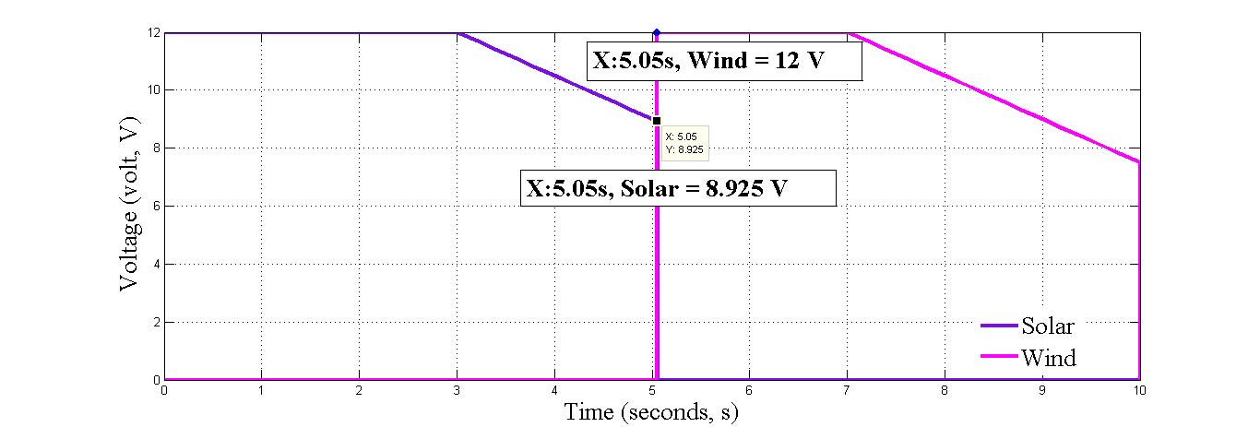 | 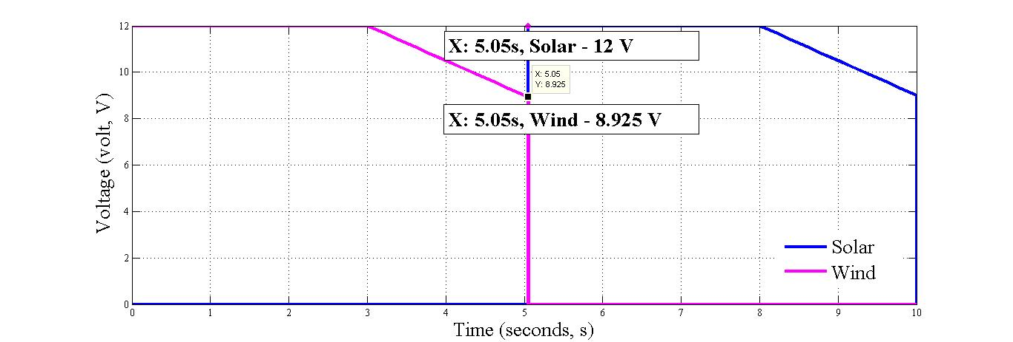
Fig. 5. 9 - 12 volt solar to wind switching. | Fig. 6. 9 - 12 volt wind to solar switching.
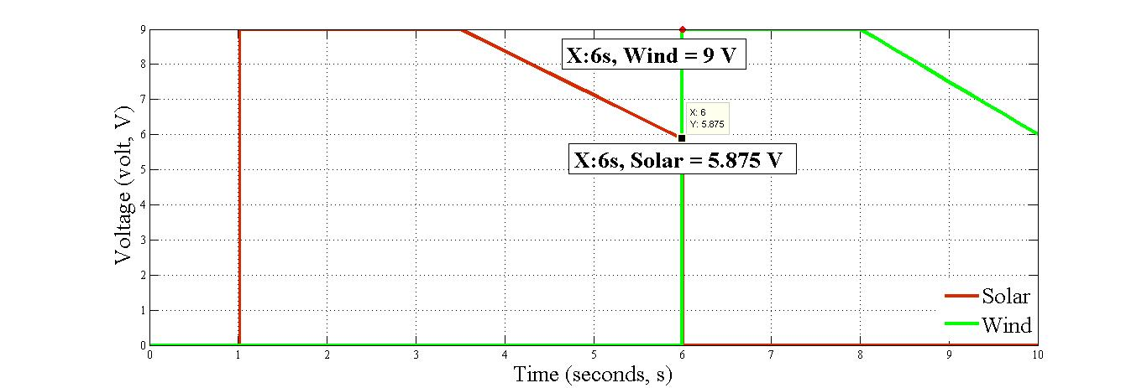 | 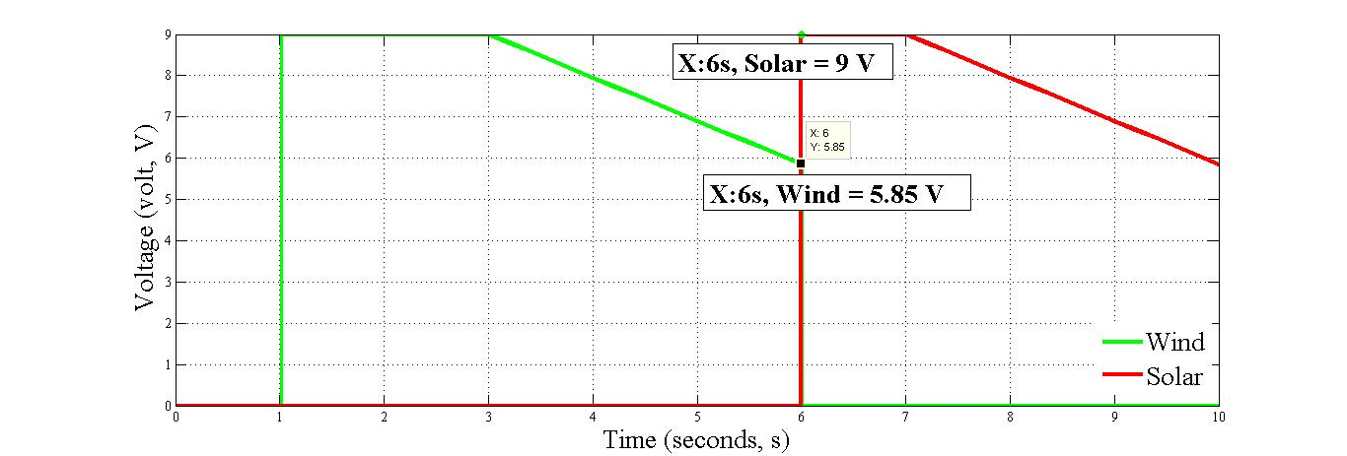
Fig. 7. 6 - 9 volt solar to wind switching. | Fig. 8. 6 - 9 volt wind to solar switching.

TABLE II
Secondary Controller Results of Self-Intervention Hierarchical Sequential Switching for HRES Using Simulink/Stateflow Modelling
Resources | Conditions | Output Value | Results (Relay Switching)
Resources | Conditions | Output Value | DPV | DWT
Solar Photovoltaic (DPV) | 3 <=DPV< 6, DWT = 2 | DPV = 3 - 6 Volts, DWT = 2 Volt | 1 | 0
Wind Turbine Generator (DWT) | 3 <=DWT< 6, DPV = 2 | DWT = 3 - 6 Volts, DPV = 2 Volt | 0 | 1

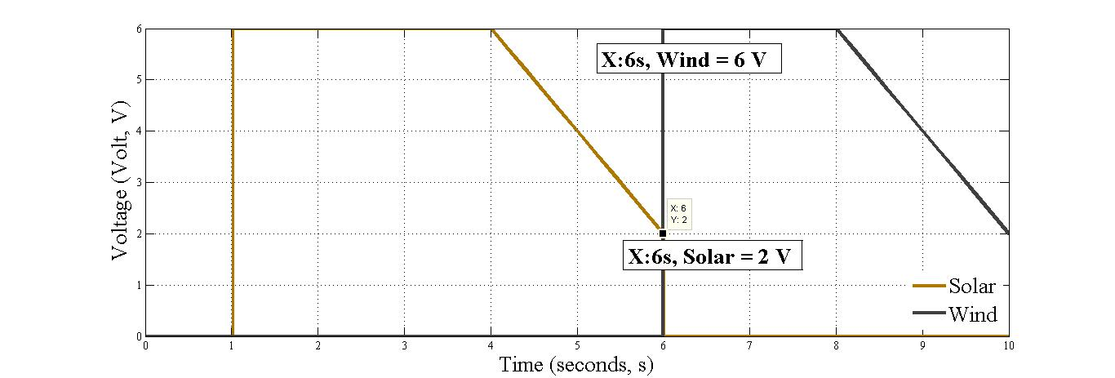 | 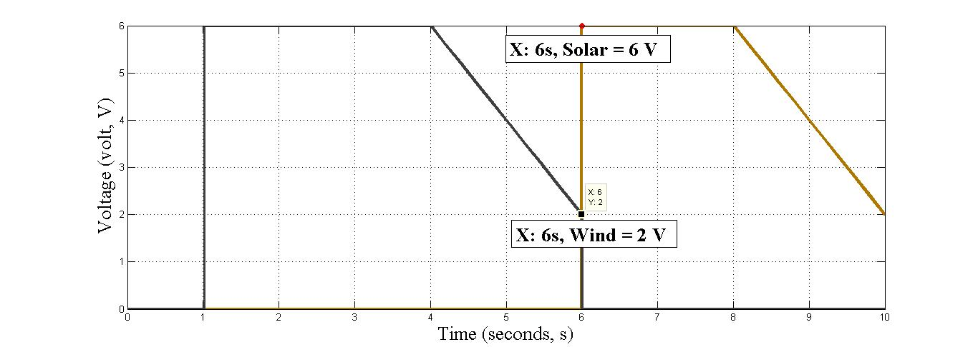
Fig. 9. 3 - 6 volt solar to wind switching. | Fig. 10. 3 - 6 volts wind to solar switching.

- Conclusions
This study aims at the self-intervention of the solar photovoltaic and wind turbine generator complementary power systems. The solar photovoltaic and wind turbine generator can be a reasonable complementary configuration to increase a power generation, furthermore can ensure electricity power generation and as well as reduce the electricity costing. It is shown that combining two or more renewable energy resource could perform self-intervention, hence strengthening the possibility of continuous electric power generation. Therefore, this paper put forward a new self-intervention control technique for solar photovoltaic and wind turbine generator complementary system using the Simulink/Stateflow modelling. According to the self-intervention hierarchical sequential switching control results presented, the Simulink/Stateflow successfully managed to perform the self-intervention between the solar photovoltaic source and wind turbine generator source.
Acknowledgements
The authors would like to thank the reviewers for their valuable comments in this paper. Also would like to thank Brunel University London, Ministry of Education Malaysia (MOE) and Faculty of Electronic and Computer Engineering (FKEKK), University Teknikal Malaysia Melaka.
References
[1] Ano, “Battery and Energy Technologies,” Electropedia, 2005. [Online].Available:http://www.mpoweruk.com/history.htm.
[2] Ano, “Exhaustion of Fossil Fuels,” 2000.
[3] T. Hoium, “Renewable Energy Gaining on Fossil Fuels,” The Motley Fool,US TODAY, vol. 2014, pp. 19–21, 2014.
[4] A. Beluco, P. K. de Souza, and e A. Krenzinger, “Hybrid Plants Based on Complementary Hydro and Photovoltaic Energy Resources,” in 17th European Photovoltaic Solar Energy Conference, 2001, pp. 2–5.
[5] K. Mousa, H. Alzu, and A. Diabat, “Design of a Hybrid Solar-Wind Power Plant Using Optimization,” in 2nd International Conference on Engineering Systems Management and its Applications (ICESMA) 2010, 2010, pp. 1–6.
[6] I. Hong, B. Kang, and S. Park, “Design and Implementation of Intelligent Energy Distribution Management with Photovoltaic System,” IEEE Transactions Consumer Electronics, vol. 58, no. 2, pp. 340–346, May 2012.
[7] M. Music, A. Merzic, E. Redzic, and D. Aganovic, “Complementary Use of Solar Energy in Hybrid Systems Consisting of a Photovoltaic Power Plant and a Wind Power Plant,” WSEAS Transactions Power System, no. 9, pp. 106–111, 2014.
[8] N. Chen, X. Qu, W. Weng, and X. Xu, “Design of Wind-solar Complementary Power System Based on Progressive Fuzzy Control,” Journal of Computer, vol. 9, no. 6, pp. 1378–1384, Jun. 2014.
[9] S. M. J. Mary, S. R. Babu, and D. P. Winston, “Fuzzy Logic Based Control of a Grid Connected Hybrid Renewable Energy Sources,” vol. 5, pp. 1043–1048, 2014.
[10] D. Boroyevich, I. Cvetković, D. Dong, R. Burgos, F. Wang, and F. Lee, “Future Electronic Power Distribution Systems - A Contemplative View,” Proceeding International Conference Optimal Electronics Electron Equipment, OPTIM, pp. 1369–1380, 2010.
[11] Y. Wang, J. Wu, J. Xu, Y. Zhang, and N. Chen, “Wind / Photovoltaic Hybrid Power Generator Based on Fuzzy Control,” vol. 3, no. 1, pp. 2284–2287.
[12] S. Paudel, J. N. Shrestha, F. J. Neto, J. a F. Ferreira, and M. Adhikari, “Optimization of Hybrid PV/Wind Power System for Remote Telecom Station,” 2011 International Conference Power Energy System ( ICPS) 2011, 2011.
[13] M. Li and C. Wang, “Research on Optimization of Wind and PV Hybrid Power Systems,” Proceeding World Congress Intelligent Control Automation, pp. 6420–6424, 2008.
[14] X. Li, N. Li, X. Jia, and D. Hui, “Fuzzy Logic Based Smoothing Control of Wind/PV Generation Output Fluctuations with Battery Energy Storage System,” 2011 International Conference Electrical Machine Systems, pp. 1–5, Aug. 2011.

